Domain Name System in detail-
The Domain Name System (DNS) is a hierarchical and distributed naming system that translates human-readable domain names (such as www.example.com) into IP addresses (such as 192.0.2.1) that computers and network devices use to communicate with each other. DNS plays a crucial role in the functioning of the internet and enables users to access websites, send emails, and perform various network activities. Here's a detailed overview of the Domain Name System: 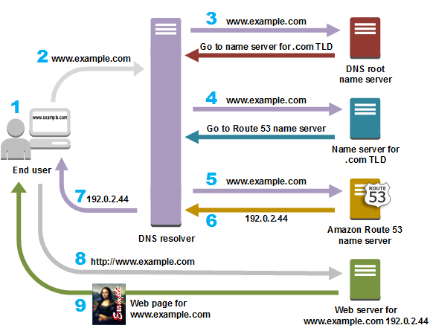
- Purpose of DNS:
- DNS serves as a distributed database system that associates domain names with IP addresses and other resource records (RRs).
- It provides a convenient and human-readable way to identify and locate resources on the internet, such as websites, email servers, and other network services.
- DNS Hierarchy and Structure:
- DNS follows a hierarchical structure consisting of multiple levels, known as domains.
- Domains are organized in a tree-like structure, with the root domain at the top and subsequent levels branching out into subdomains.
- Domains are identified by labels separated by dots, such as "com" in "example.com" or "www" in "www.example.com".
- DNS Components:
- DNS Server: A DNS server stores and manages DNS records. There are different types of DNS servers, including:
  - Recursive DNS Resolver: Resolves domain names on behalf of clients by recursively querying other DNS servers until it finds the IP address associated with the domain name.
  - Authoritative DNS Server: Stores the DNS records for a specific domain or zone and responds to queries for those domain names.
- DNS Record Types: DNS servers store various types of resource records (RRs) that contain different types of information. Common DNS record types include:
  - A (Address) Record: Maps a domain name to an IPv4 address.
  - AAAA (IPv6 Address) Record: Maps a domain name to an IPv6 address.
  - CNAME (Canonical Name) Record: Creates an alias or nickname for a domain name.
  - MX (Mail Exchanger) Record: Identifies the mail server responsible for accepting emails for a domain.
  - NS (Name Server) Record: Identifies the authoritative name servers for a domain.
- DNS Resolution Process:
- When a client wants to resolve a domain name, it sends a DNS query to a DNS resolver.
- The DNS resolver checks its cache to see if it already has the IP address for the domain name. If not, it recursively queries the DNS hierarchy to find the IP address.
- The resolver starts with the root DNS servers and iteratively queries the appropriate authoritative DNS servers until it obtains the IP address.
- Once the IP address is obtained, it is returned to the client, and subsequent queries can be directly addressed to the authoritative DNS server or cached for future use.
- DNS Zone Transfers:
- DNS zone transfers allow authoritative DNS servers to synchronize and replicate DNS records with other authoritative servers to maintain consistency.
- Zone transfers occur when changes are made to DNS records in a zone, ensuring that all authoritative servers have the same information.
- DNS Security:
- DNS security mechanisms, such as DNSSEC (DNS Security Extensions), provide authentication and data integrity for DNS responses, helping to prevent DNS spoofing and other malicious activities.
- DNSSEC uses cryptographic signatures to verify the authenticity and integrity of DNS data.
DNS is a critical infrastructure in the functioning of the internet, enabling users to access resources using domain names instead of relying solely on IP addresses. It provides scalability, fault tolerance, and efficient name resolution across the global network.

