ESTIMATION OF DIFFERENTIAL WHITE BLOOD CELL COUNT
(DLC/ Differential Leucocyte Count)

Background:
The differential white cell count is the determination of the different types of white blood cells or leucocytes present in blood.
White blood cells are classified into various groups depending on their size, features of the nucleus and features of the cytoplasm. The WBCs exist in two forms viz. granulocytes and agranulocytes. Granulocytes are further classified as eosinophil, basophil, neutrophil, while agranulocytes shows lymphocytes and monocytes.
Granulocytes (polymorphonuclear leukocytes) are subdivided according to the specificcoloration of granules:
► Neutrophils account for the largest percentage of leukocytes found in a normal blood sample. On a stained blood smear, the cytoplasm of a neutrophil has numerous fine lilac-colored granules and a dark purple nucleus. The diameter of a neutrophil is 10-15 μm. Neutrophils are subclassified according to their age or maturity, which is indicated by changes in the nucleus:
- metamyelocyte – is the youngest neutrophil generally reported, the nucleus is large, round or bean-shaped, the cytoplasm is abundant, pale blue;
- neutrophilic band or stab – the nucleus is elongated and curved (horseshoe or S-shape), cytoplasm is abundant, pink;
- segmented neutrophil – is a mature neutrophil, the nucleus is separated into 2-5 segments or lobes, the cytoplasm is pale red.
► Eosinophils have a diameter of 12-14 μm, the nucleus usually large, typically a bilobate (two-lobed), the cytoplasm is eosinophilic (pale red) with coarse round granules of uniform size which appear brick-red after staining with eosin
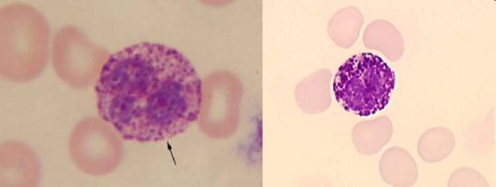
► Basophils have a diameter of 11-13 μm. Their nucleus is usually large, irregular, sometimes having three lobes, the cytoplasm is basophilic, containing scattered large, dark-blue granules which may overlay the nucleus

Basophil granulocytes
Agranulocytes (mononuclear leucocytes) are characterized by the apparent absence ofgranules in their cytoplasm. Although the name implies a lack of granules these cells do contain non-specific azurophilic granules.
► Lymphocytes have a diameter of 8-10 μm. The nucleus is large, generally round, oval, or slightly indented. The cytoplasm of a lymphocyte is basophilic, scanty, (in circle or “half moon” around the nuclues)
Monocytes are the largest of the normal white blood cells (the diameter is
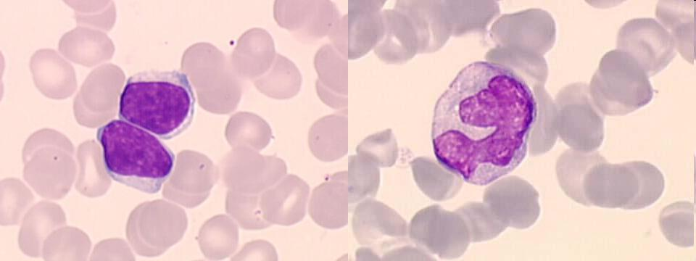
15-25 μm). The nucleus is large, round, indented or lobulated, the cytoplasm is muddy gray-blue

Normal distribution of different white blood cell types:
metamyelocytes | < 1 %
band neutrophils | 1-2 %
segmented neutrophils | 55-65 %
eosinophils | 2-4 %
basophils | 0-1 %
lymphocytes | 23-35 %
monocytes | 4-8 %

Significance: The DLC is of diagnostic importance as a particular cell count in certain diseases.
The aim of the experiment is to estimate the diffeential white blood cell count of a given blood sample.
REQUIREMENTS:
Cotton, spirit, needle, glass slide, distilled water, leishman’s stain, light microscope with oil immersion objective (90X).

PROCEDURE:
- Preparing the blood smear
- Sterilize the finger tip of the subject with a cotton swab dipped in 70% alcohol and is dried.
- Take a bold prick on the finger tip to have free flow of flood.
- Collect drops of blood on the end side of a glass slide.
- Spread the blood drop with another glass slide by placing it at an angle of 45 degree and move sidewise.
- Hold the spreader firmly and move it on the previous slide to the other end ina straight line with same force and pressure.
- Allow the glass slide to dry after formation of the smear.
- Staining the slide
- Keep the smeared glass slide on a flat surface with the smeared surface facing upwards.
- Pour drops of leishman’s stain on the glass slide to cover the smear or film.
- Keep it undisturbed for 2-5 minutes.
- Pour drops of distilled water on the slide and leave it for 10 minutes.
- Remove the dye and water. Remove the extra stain by keeping the slide under running water.
- Keep the slide aside for sometime to dry.
- Observation of the glass slide and counting of cells
- Keep the prepared glass slide is under low power of compound microscope and choose a good quality slide.
- Then identify different types of WBC under medium power.
- Draw a table with 10 boxes both on horizontal and vertical axis on a observation notebook.
- Fix the slide on the plateform and choose a area towards the corner.
- Note the different types of WBC found on the table in an abbreviated.
- Move downwards and in chain like manner till 100 cells are observed.
- After counting 100 cells prepare the report.

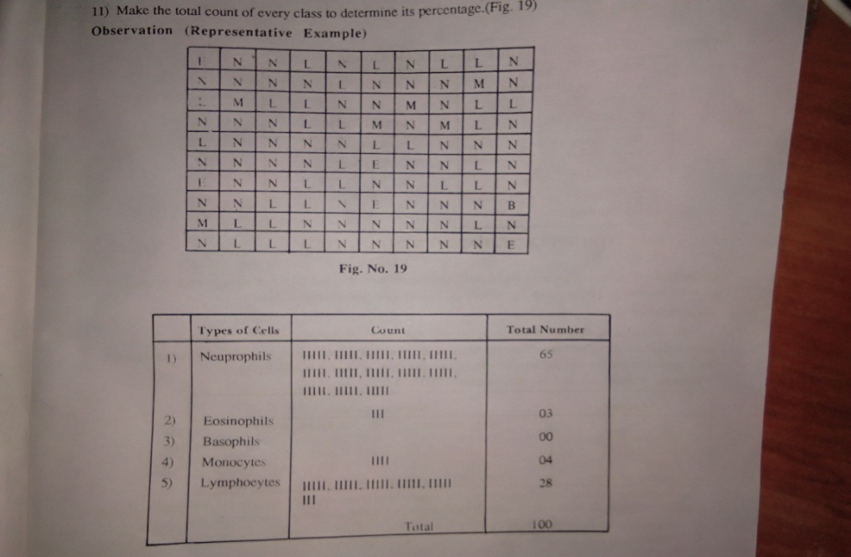

FIGURE: Showing an example of observation and recording table

REPORT: Differential count of given sample of blood is as follows:

Cells | Percentage
Neutrophils
Basophil
Eosinophil
Lymphocytes
Monocytes

REFERENCE:
- Haematology, Practical Human Anatomy And Physiology, S.R. Kale et al., Nirali Prakashan, Eight Edition, 2002, pp. 22-28

