EXPERIMENT 5
WIFI HACKING
INTRODUCTION:
- Wifi hacking is essentially cracking the security protocols in a wireless network, granting full access for the hacker to view, store, download, or abuse the wireless network. Usually, when someone hacks into a Wifi, they are able to observe all the data that is being sent via the network.
TOOLS:
- Kali Linux
- Wifi adapter

Step1:
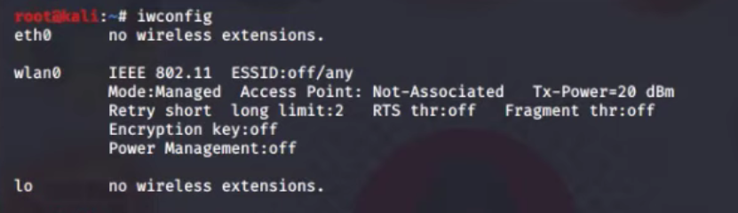
Figure 5.1
- Goto the kali Linux and open the terminal and type “iwconfig” if it show wlan0 then we go for next step.
- If it not show wlan0 disconnect the wifi adapter and again connect it.

Step2:
Figure 5.2
- Then we type check kill for kill all airmon-ng process.

Step3:
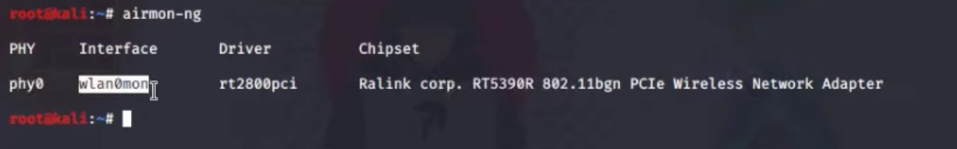
Figure 5.3
- In airmon-ng we find the interface wlan0 and chipset name of the wifi adapter we use.

Step4:
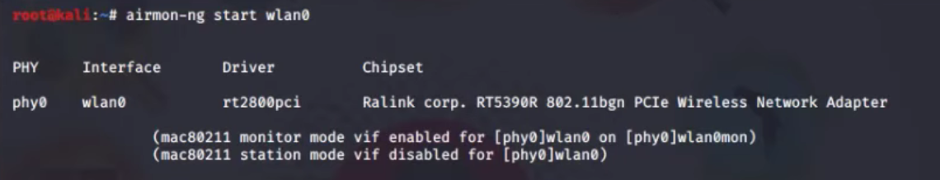
Figure 5.4
- In here we show that we are in monitor mode.
- It allows a computer with a wireless network interface controller (WNIC) to monitor all traffic received on a wireless channel.

Step5:
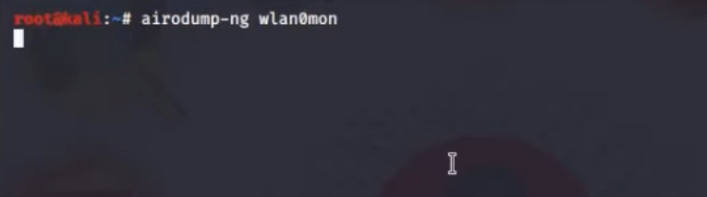
Figure 5.5
- In this step we try to catch wifi BBSID.

Step6:
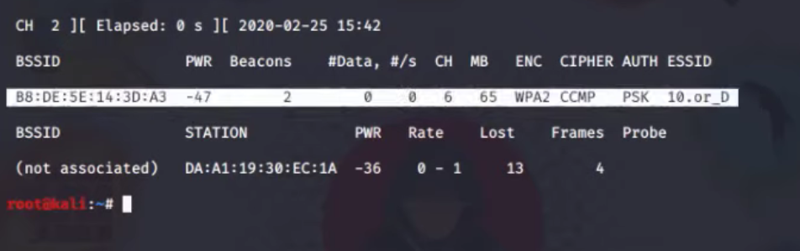
Figure 5.6
- Now we find one wifi BSSID and CH no 6.
Step7:
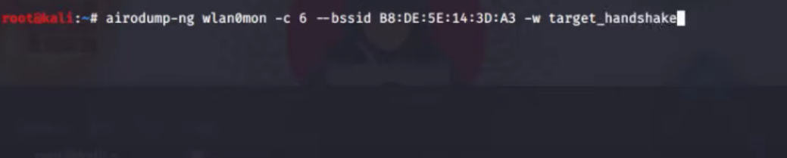
Figure 5.7
- Now we try to catch the WIFI handshake File name is target handshake.
- And it store.cap file format.
Step8:
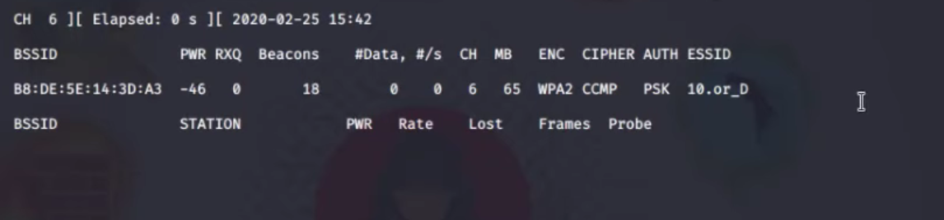
Figure 5.8
- Now our handshake capture process is start.
Step9:
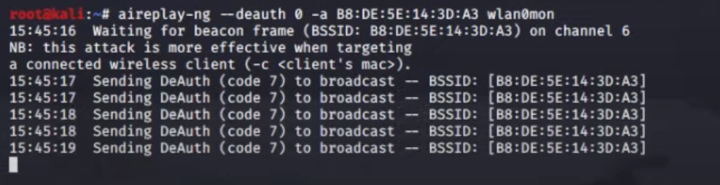
Figure 5.9
- In this step we send the multiple requests to router to disconnect the router to one any device which is connect to the router.
Step10:
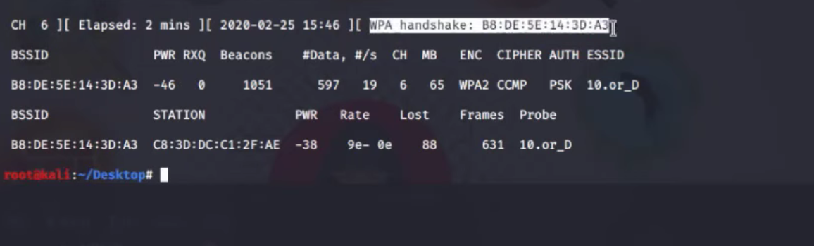
Figure 5.10
- In this step we disconnect one device which is connect to the router.
- And when the devices again connect to the router, we catch the handshake.
Step11:
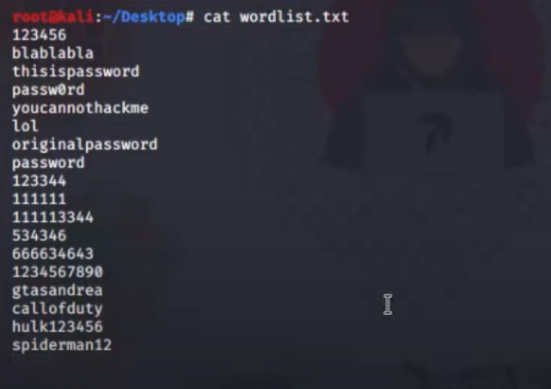
Figure 5.11
- We make a wordlist file to Which is using to catch the Wi-Fi password.
Step12:
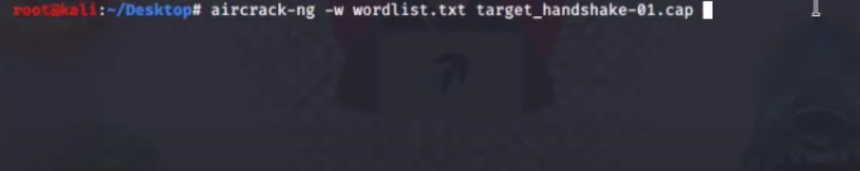
Figure 5.12
- We set our wordlist file path and our handshake file path.
- Then we start the Brute force attack to find the password of WIFI. Then press enter
Step13:
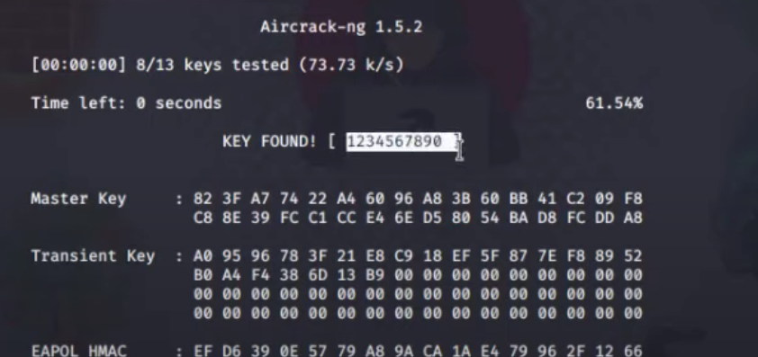
Figure 5.13
- Then our attack is start. And we got the Wi-Fi password in plane test.
Result: The Wi-Fi password was obtained which was found to be 123456790

