EXPERIMENT – 4
Advanced wire shark features
Aim of the experiment: How we use advance wire shark features
Learning Objective/Theory
At the end of the experiment, we will be able to
• Use one of the best packet sniffing tools i.e., “Wireshark”.
• Control upon ports, protocols and data packets.
• Quick protocol identification.
• Start capturing and analysing packets
Step: 1
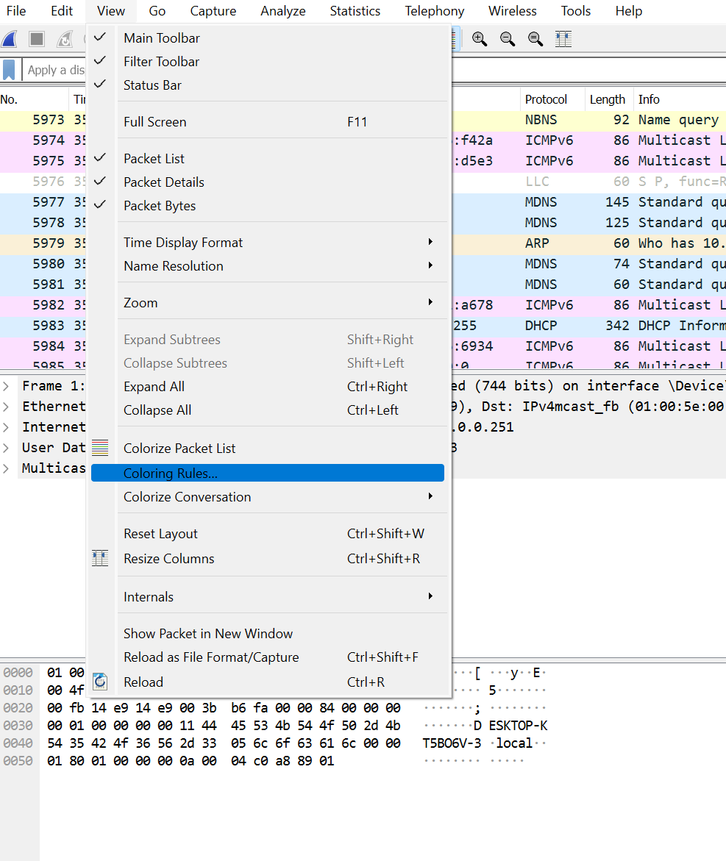

- First go to view then select coloring rules.
Step: 2
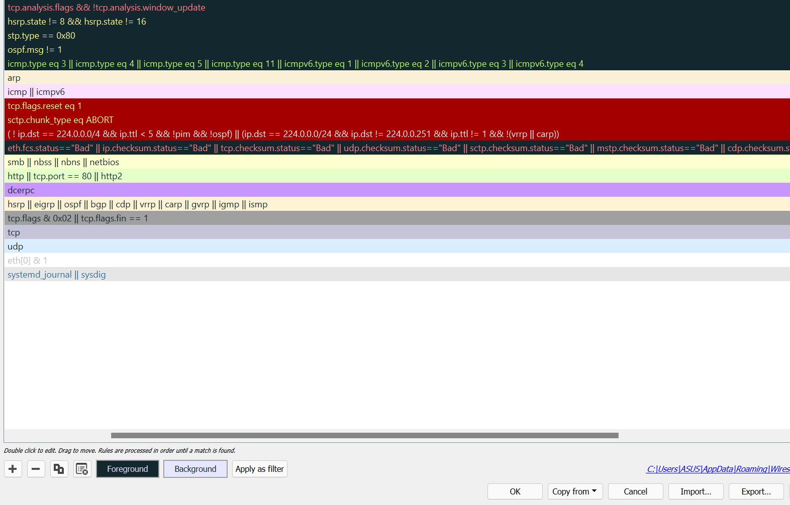
- Select any protocol to change its foreground and background colors for better analysis.

Step: 3
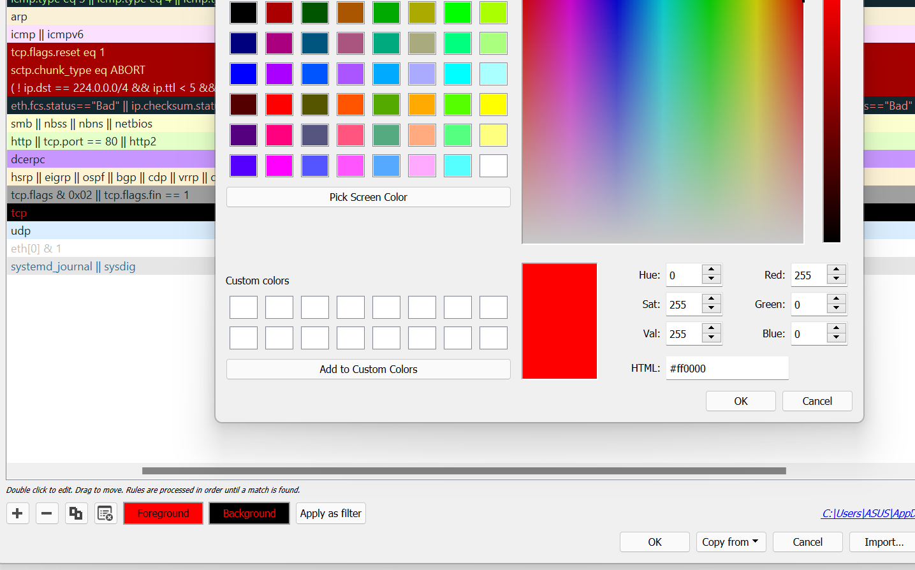
- Here we choose tcp protocol and changed its foreground color to red and background color to black.
Step: 4 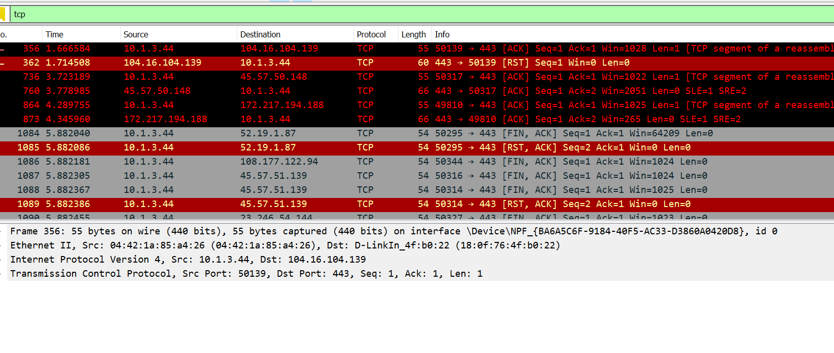
- In this step we found the tcp packet is colored according to the before preference that is foreground color red and background color black.
Conclusion: we success full coloring tcp packet

