EXPERIMENT-04
SYSTEM HACKING
AIM:
To study about system hacking using tools like Metasploit
THEORY
System hacking is the way hackers get access to individual computers on a network. ... This course explains the main methods of system hacking—password cracking, privilege escalation, spyware installation, and keylogging—and the countermeasures IT security professionals can take to fight these attacks.
TOOLS USED:
Operating System: Kali Linux
Softwares Used: Virtual machine (virtual box or vmware ), Windows 10 Metasploit

PROCEDURE

Step 1: Open kali linux vm using virtual box. Open the terminal and type “ifconfig” command which is used to find the ip address
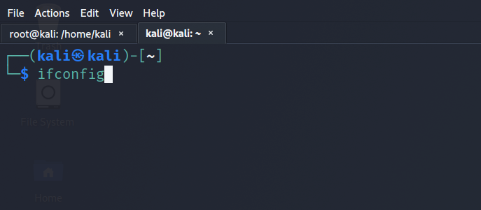
Figure 4.1

Step 2:
After running the command ifconfig we get the ip address that is: 192.168.1.6.

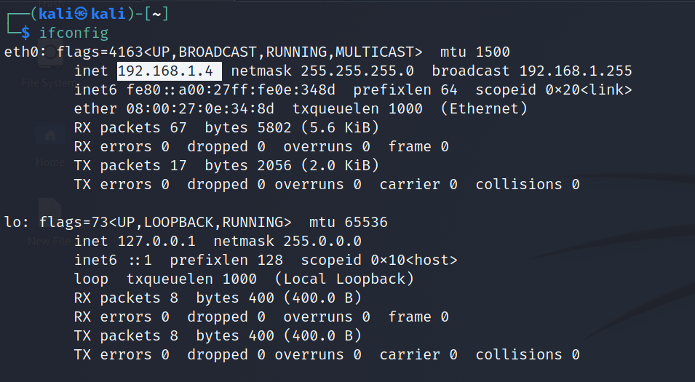
Figure 4.2
Step 3:
- Then we type “msfvenom” and type the whole payload cmd and create a windows payload.
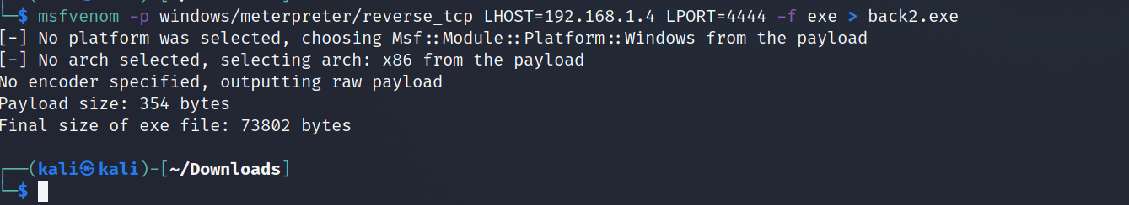
Figure 4.3
Step 4:
- To create a backdoor we typed the command “msfconsole”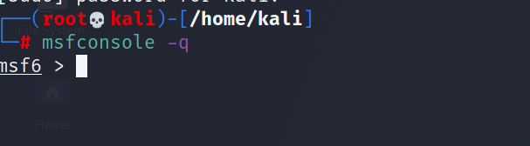
Figure 4.4
Step 5:
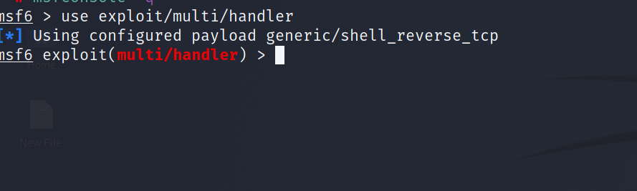
Figure 4.5
- In step 5 we set a backdoor connection. Which type of backdoor connection we want.
Step6:

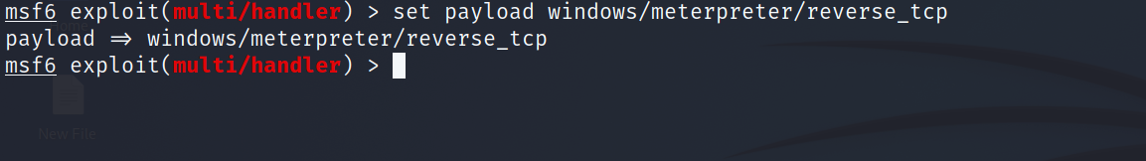
Figure 4.6
- In step 6 we set the payload type “reverse_tcp” in our backdoor connection.
Step7:
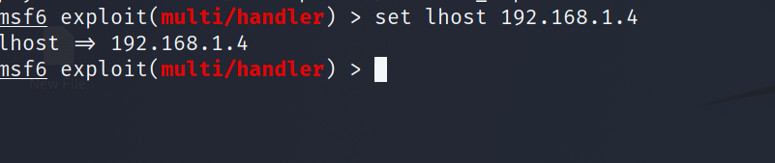
Figure 4.7
- In step7 we set the “LHOST:192.168..1.4” which is our kali machine IP address.
Step8:
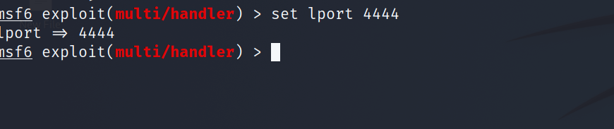
Figure 4.8
- In step 8 we set “LPORT:4444” to receive a payload connection to this port.
Step9:
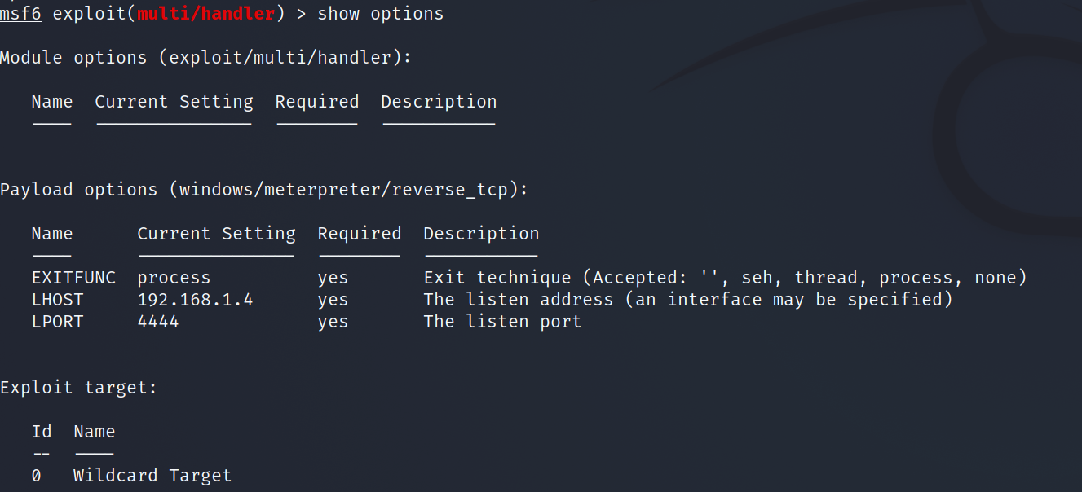
Figure 4.9
- In this step 9 we recheck the LHOST & LPORT is correct or not If they are correct now we are ready to exploit.
Step 10:
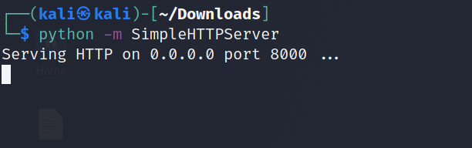
Figure 4.10

- Now we open the another terminal in kali linux and gave cmd“sudo su” to take the super user access on kali.

- Then we type “python” cmd to share our payload to the target machine in LAN.

Step11:
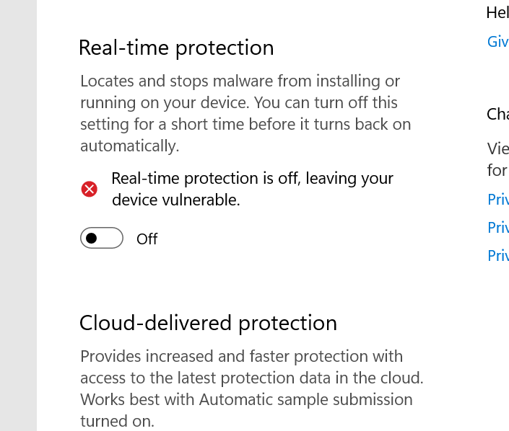
Figure 4.11

- Then we turn off the windows real time protection to undetectable the payload on windows machine.

Step12:

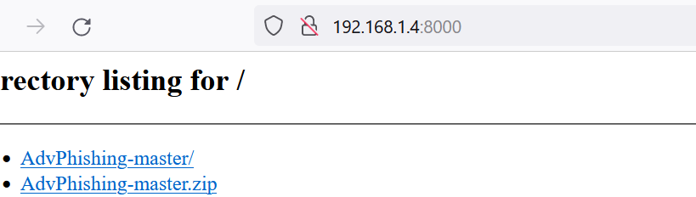
Figure 4.12
- Then we type in any browser the kali linux ip address and 8000 port number to access the kali linux file and download in LAN.
- Like: “192.168.1.4:8000”.

Step13:
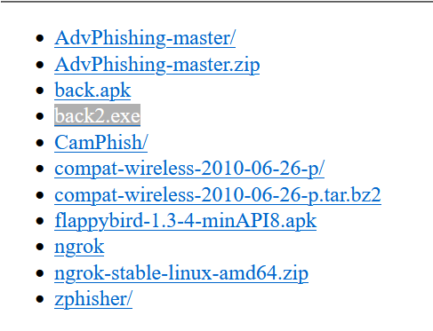
Figure 4.13
- In step 13 we search the payload name To download it.

Step14:
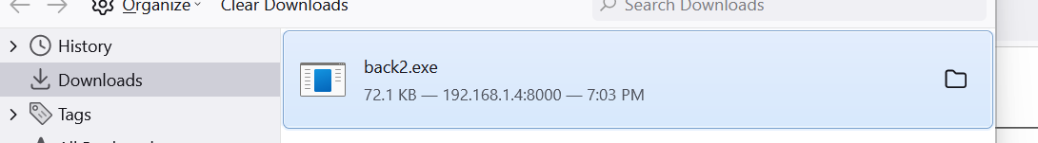
Figure 4.14

- Then we Download the payload on our windows machine.

Step 15:
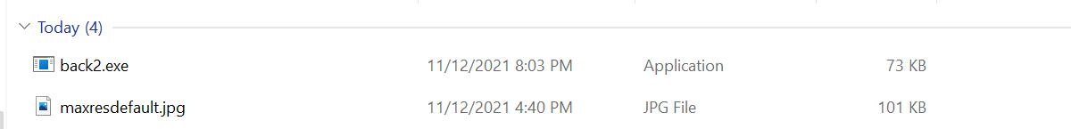
Figure 4.15
- In step 15 we go to the download folder in our windows target machine and run as administrator or open it. To install the virus on windows machine.

Step 16:
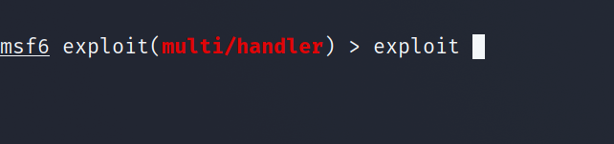
Figure 4.16
- We return to kali machine and type “exploit” cmd to send the exploitation request to our target machine.

Step17:
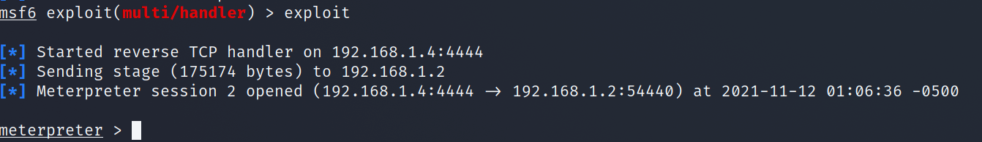
Figure 4.17
- When our payload is installed in target machine then we get the meterpreter section which is show that we got the backdoor connection to our windows machine to kali machine.
- Now we take whole control of the windows machine on kali linux.
Step18:
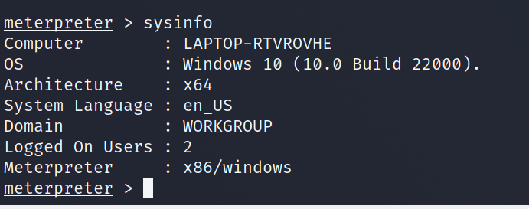
Figure 4.18

- Then we type the “sysinfo” cmd in kali linux terminal to see the windows machine details.

Step19:
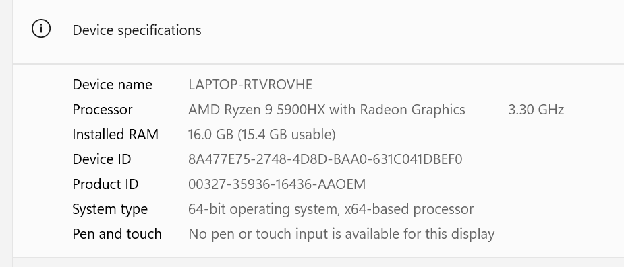
Figure 4.19
- Now we saw that the Device name of the windows machine and the device name which is show in kali terminal both are same
Result.
It shows that we successfully exploit the Windows machine.

