EXPERIMENT -5
Security packet analysis

Aim of the experiment – how to analysis a network packet
Step: 1
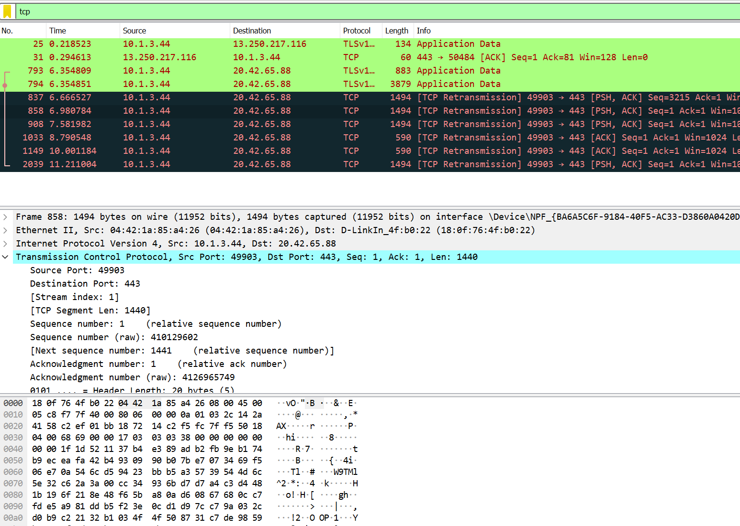

- Search the protocol that want to analysis
- Here we search for tcp protocol and the analysis it.
- Then source port is 49903 and destination port is 443

Step2:
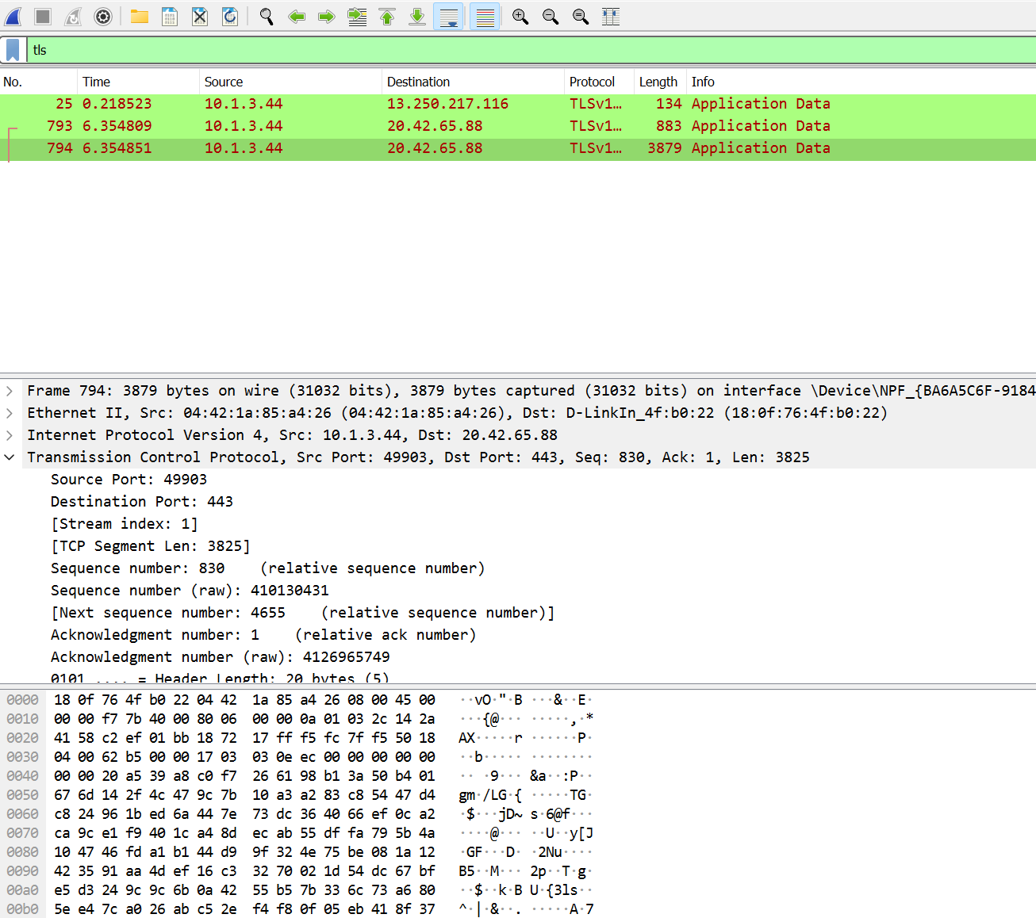
- In here we search TLS packet and analyzed it

Conclusion:
We successfully analysis a network packet.

