EXPERIMENT-6
PASSWORD SNIFFING
Password Sniffing
Password Sniffing is a hacking technique that uses a special software application that allows a hacker to steal usernames and passwords simply by observing and passively recording network traffic. This often happens on public Wi-Fi networks where it is relatively easy to spy on weak or unencrypted traffic.
Tools:
- Kali Linux
- Wire shark
: Wireshark is a widely used tool for network traffic analysis and can also be used to find credentials which are transported in plain text.
Step1:
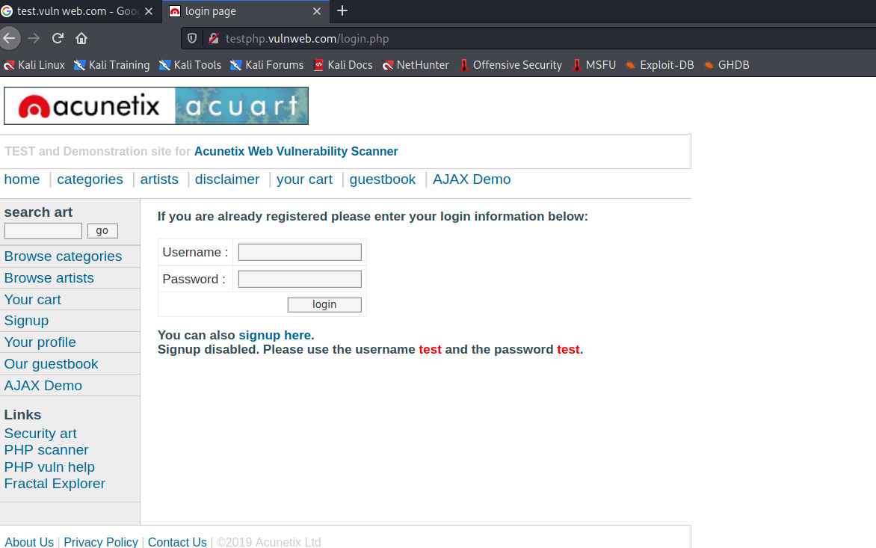
Figure 6.1
- First, Open a web browser and type a HTTP website “http://testphp.vulnweb.com/login.php”
Step2:
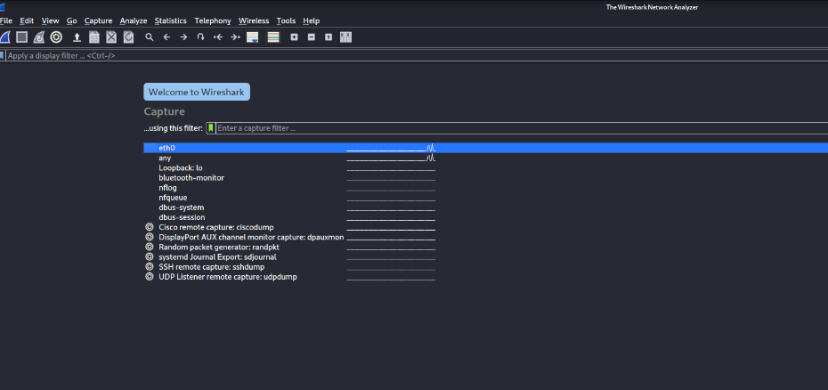
Figure 6.2
- In step2 we open Wireshark network sniffing tool on kali Linux.
- Then we click on blue button on Top left corner.
Step3:
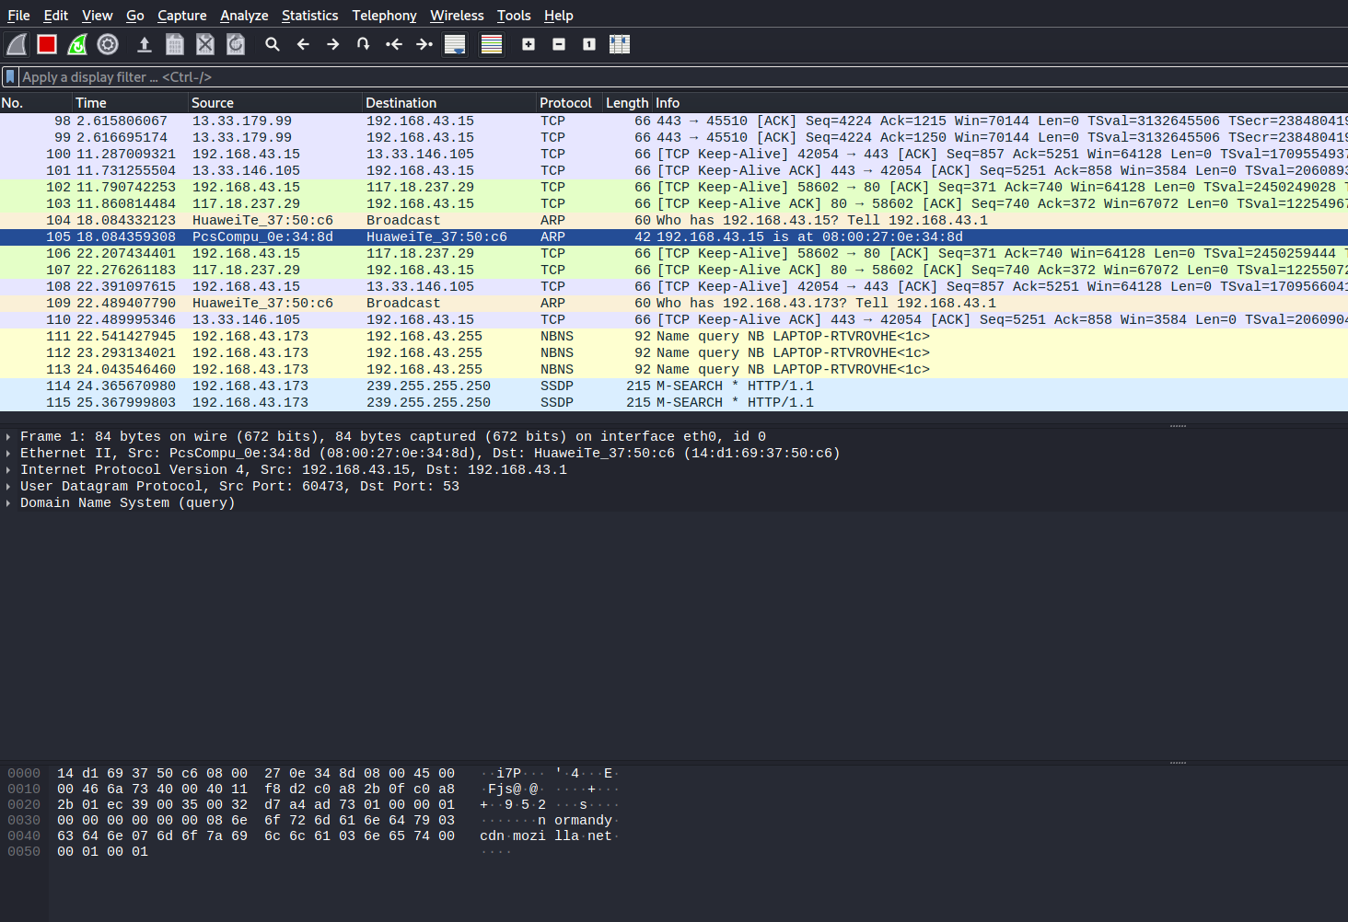
Figure 6.3
- After clicking the blue button, the wire shark tool captures the network packet on this particular LAN network.

Step4:
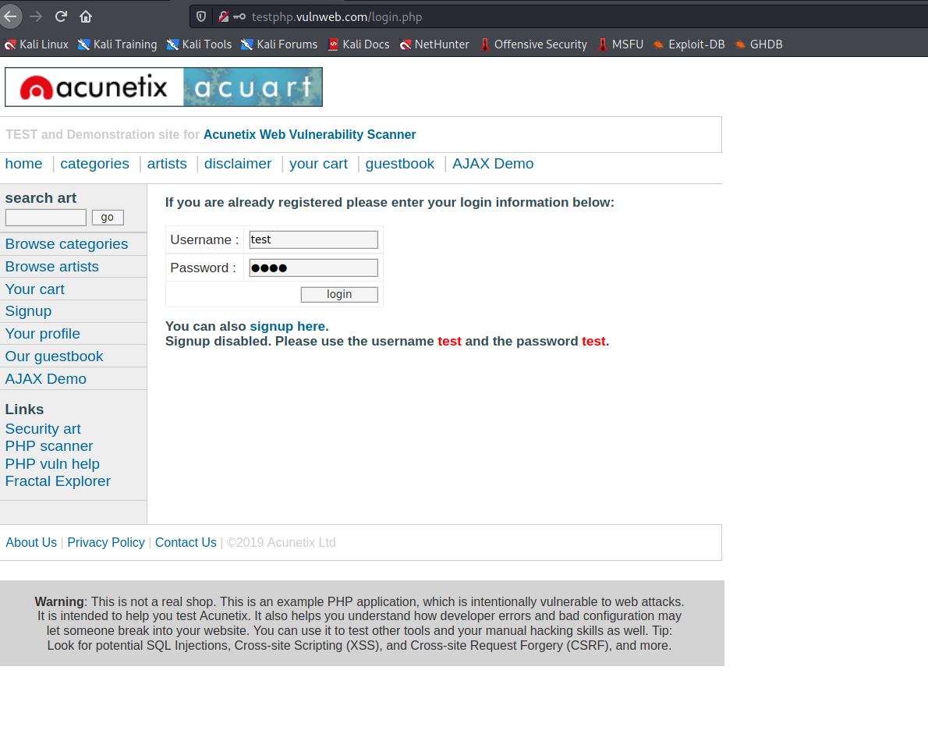
Figure 6.4
- Now we type username and password on this website and login.
- Username is test and the password is test.

Step 5:
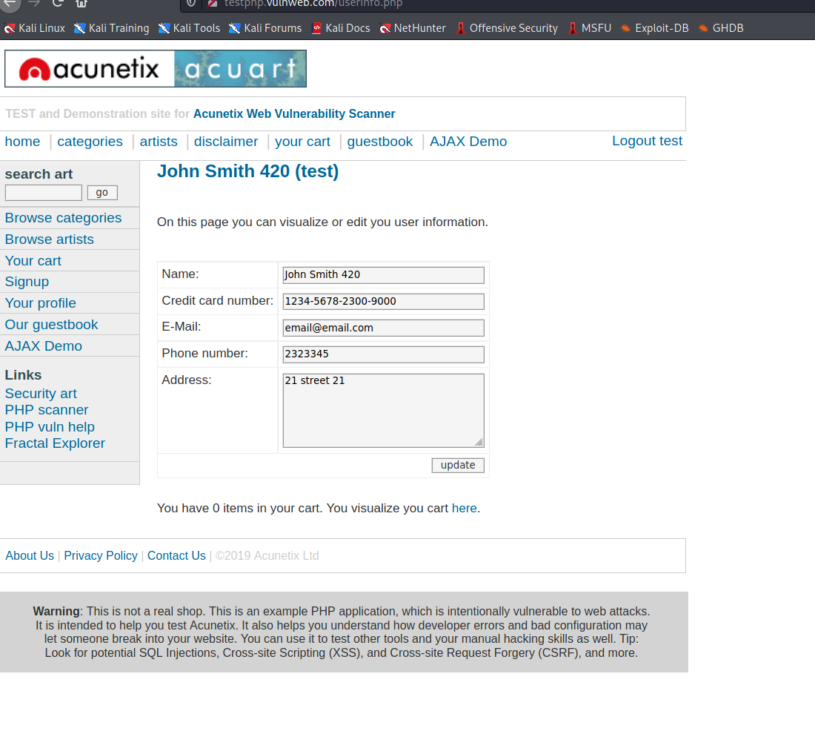
Figure 6.5
- Now we Logged in the website.
Step 6:
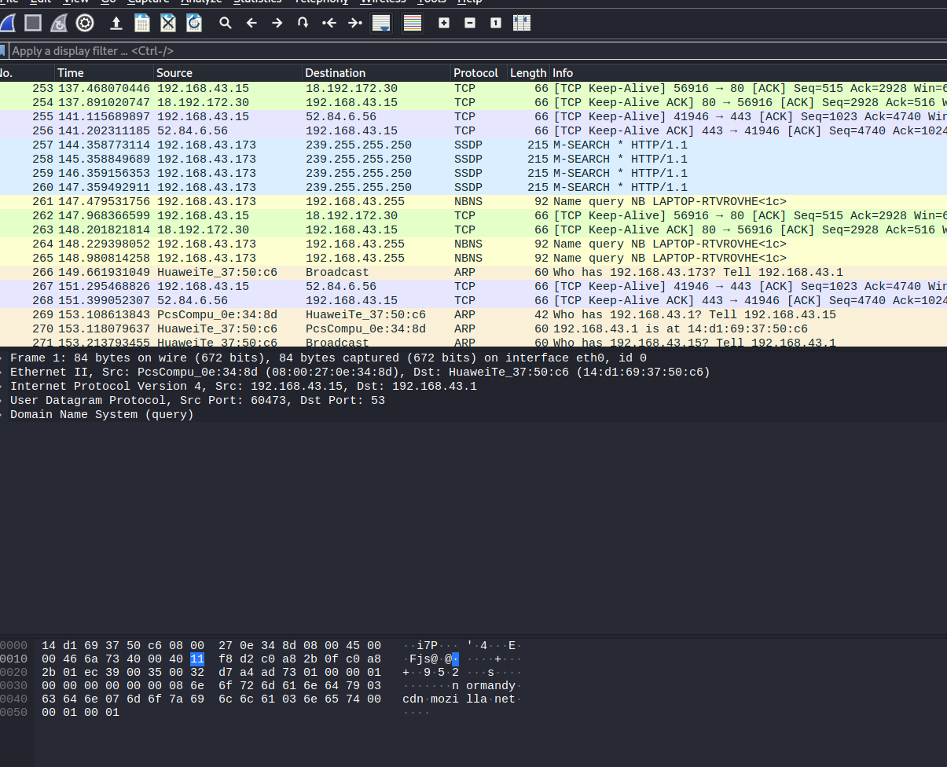
Figure 6.6
- After login we came back to the Wireshark tool and click on red button near by the blue button.
- After clicking the red button Wireshark stop capturing the packet in the particular network.
- Now we ready to analyses the network packet.

Step 7:
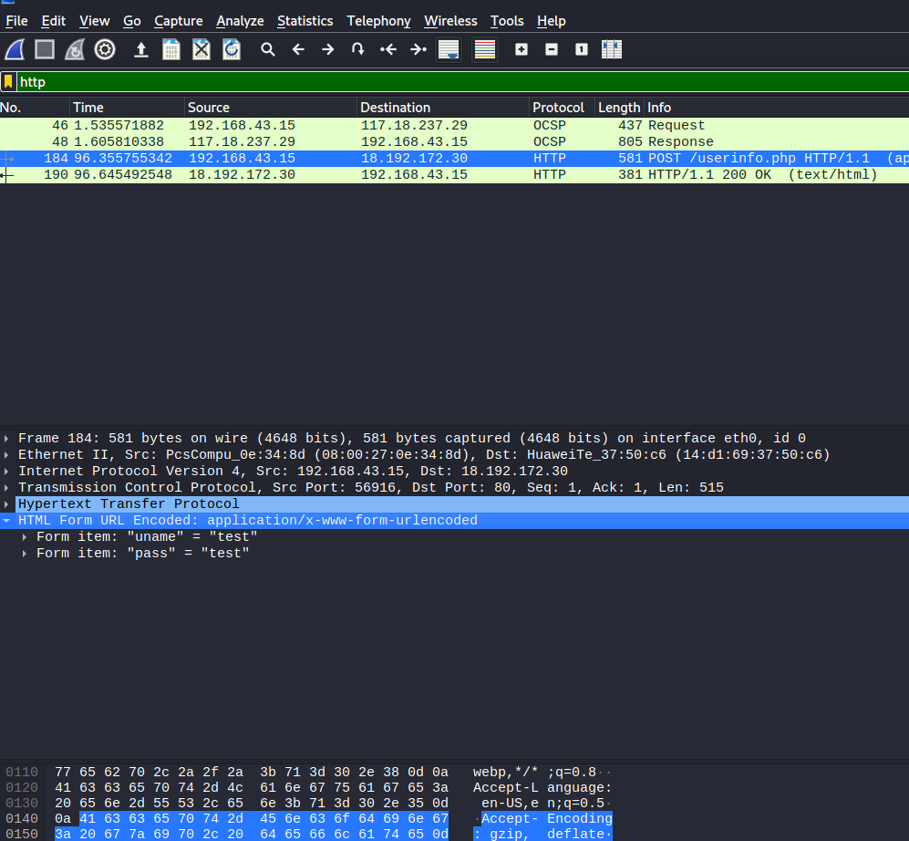
Figure 6.7
- After stop the network sniffing, we click on Apply a display filter and type http.
- After type http it show all http request on the network which are requested by the client to server.
- Then we check all the http request packets and we find the username & password which we are used to logged in a http website.
Result:
The username and password was obtained.

