Experiment-2
Study the Setup Installing Wire shark

Aim of the experiment: How to install wire shark
Step: 1
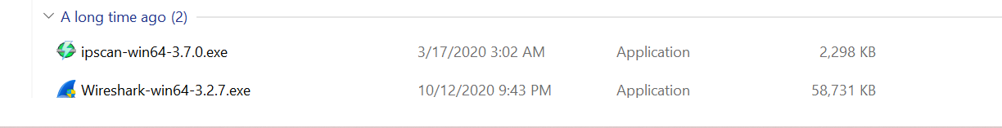
Download the wireshark.exe file
Step: 2
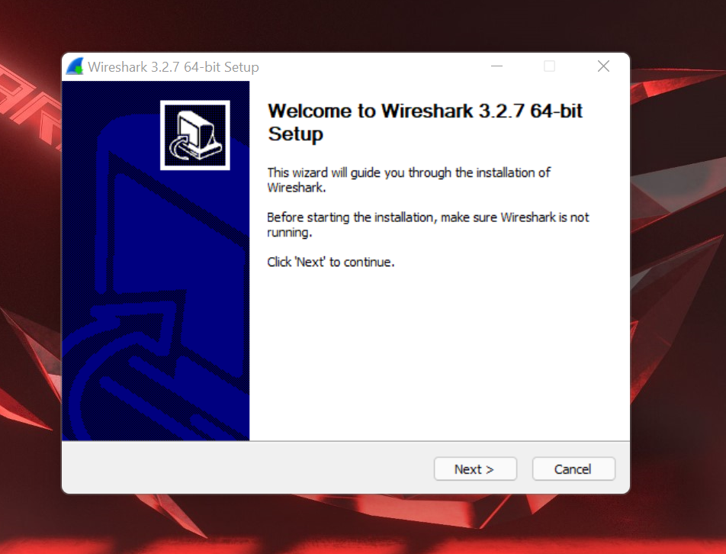
Click on Next
Step: 3
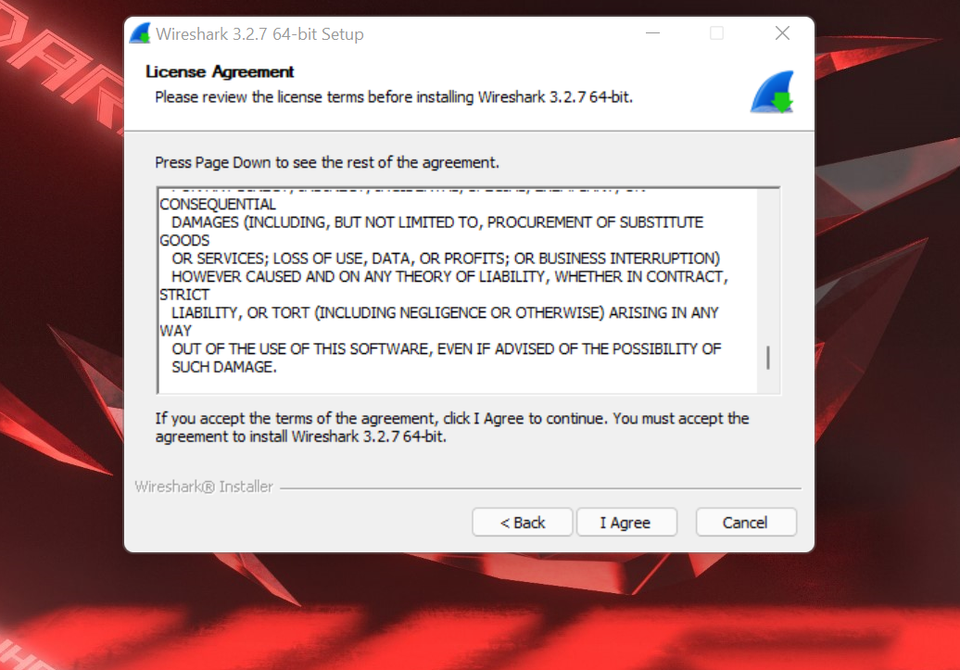
Accept terms and conditions “click on I Agree”
Step: 4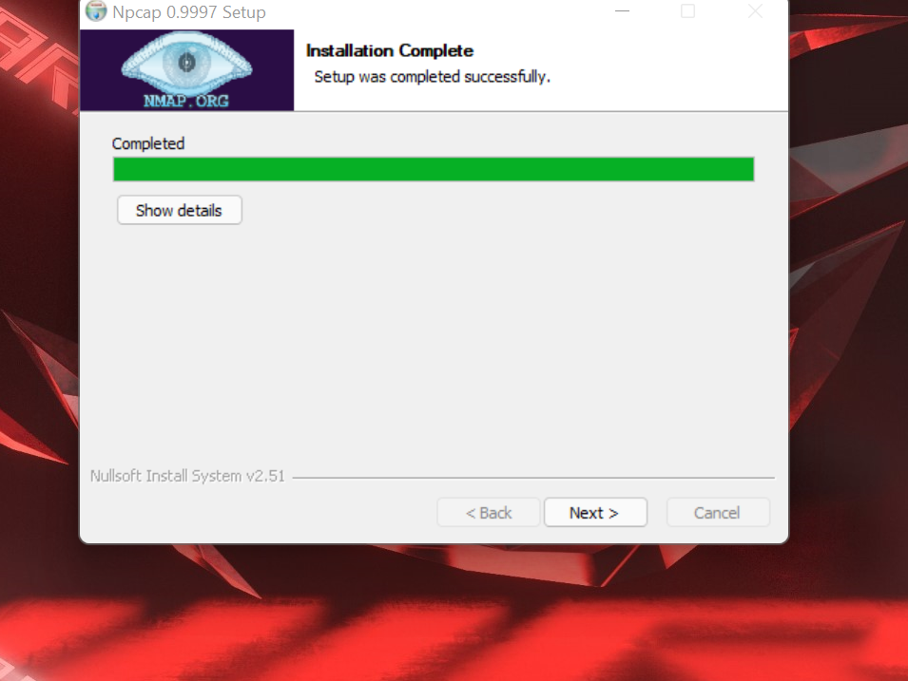
Now Installation Process is completed

Conclusion:
WE successfully install the wire shark.

