Experiment: 3
Study of working with captured packet

Aim of the experiment: How to capture the network packet
Learning Objective/Theory
At the end of the experiment, we will be able to
• Use one of the best packet sniffing tools i.e., “Wireshark”.
• Control upon ports, protocols and data packets.
• Quick protocol identification.
• Start capturing and analyzing packets.

Step: 1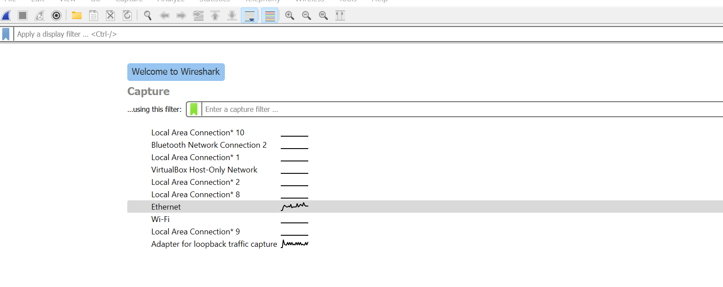
- Firs select on which network packet you want to capture. Then Click on Blue Button to start capture the packet.

Step: 2
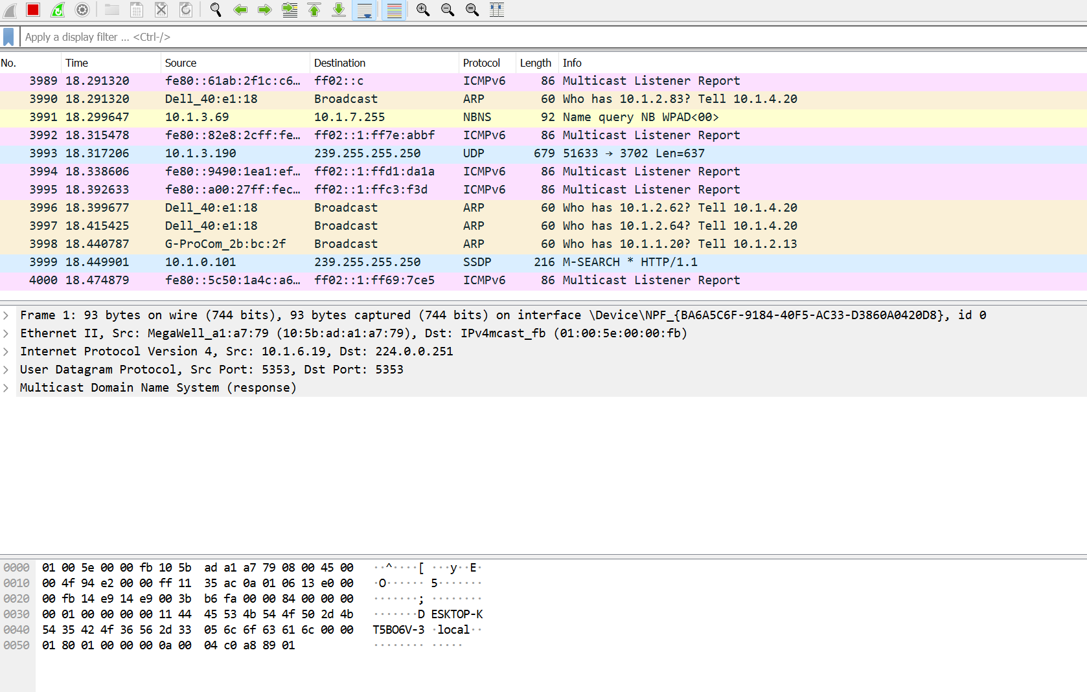
- Now the packet started capturing
- Click on the red button to stop capturing

Conclusion: -
We successfully capture the network packet

