Experiment 6
Study of operating system finger printing

Aim of the experiment: How to gather information about an operating system.
Step: 1
- In here we type sudo su to get super user permission “root” in kali linux
Step: 2
- After getting root level permission we typed “netdiscover” cmd to check how many device connected to our LAN network

Step: 3
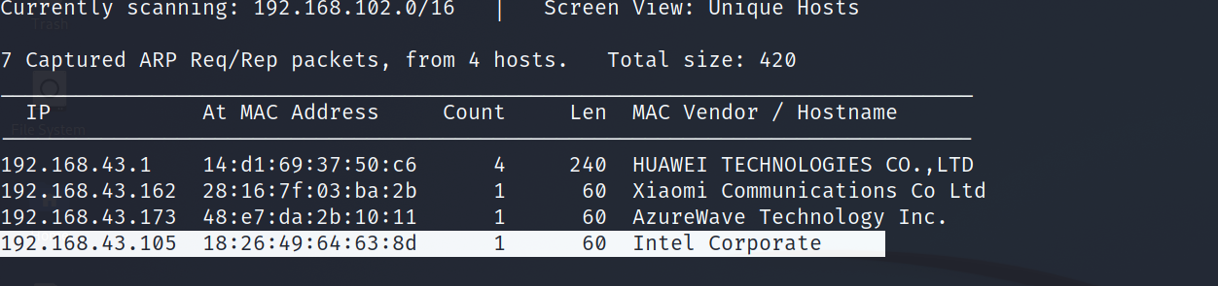
- In here we got our target ip address and its host name is intel corporate
Step: 4
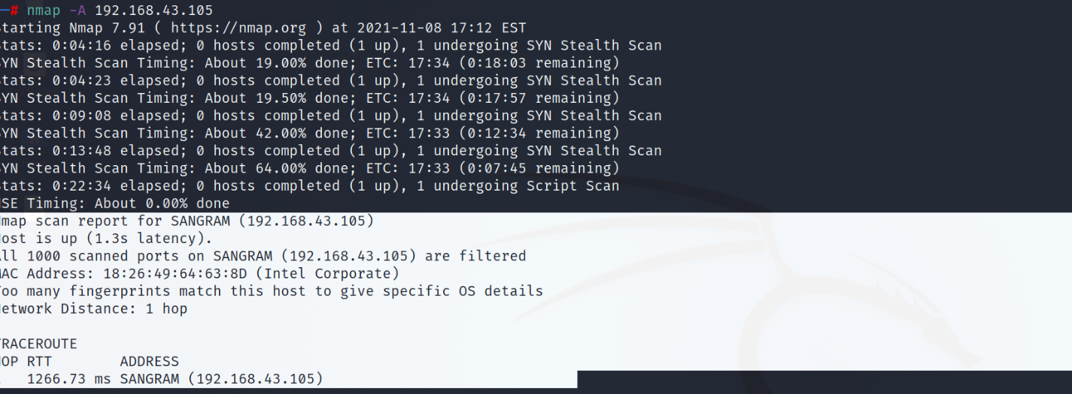
- In here we type nmap -A <target ip> to get its details.
- -A used forosdetection,virsion,script scann,traceroute (MISC scan).

Step: 5
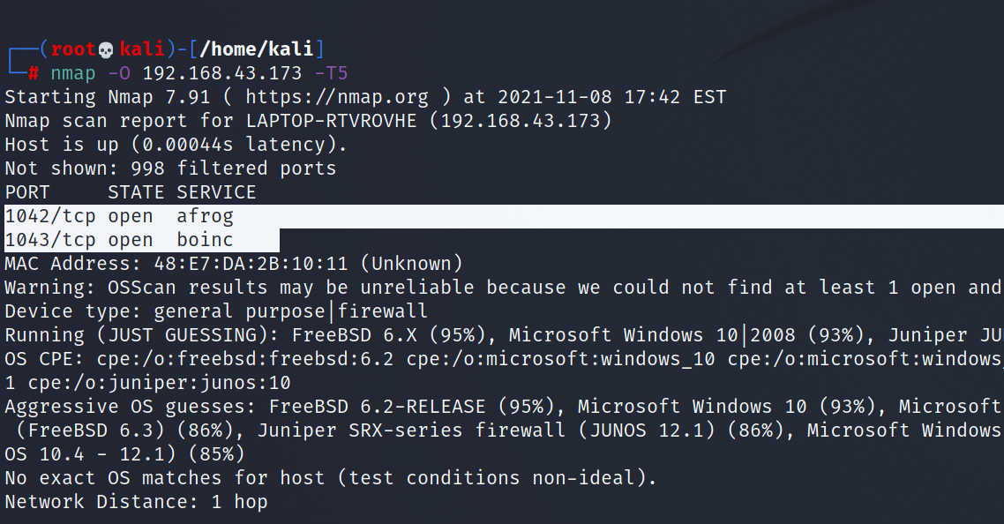
- In here we type nmap -O <target-ip> -T5.
- -O used for os scan it gives us os details of target os system.
- Now It give us two port number which are running in the os system and some os details i.e. 1042-tcp and 1043- tcp.

Conclusion: –
We successfully gathering the information.

