Experiment – 4.1
Packet merging

Aim of the experiment: How to merge to different network packet
Learning Objective/Theory
At the end of the Experiment we will be able to
    - work with capture files, packets, and time-display formats
    - Also cover more advanced options for capturing packets and dive into the world of filters.
    - Save your capture files to be analyzed later. You can also merge multiple capture files.

Step: 1

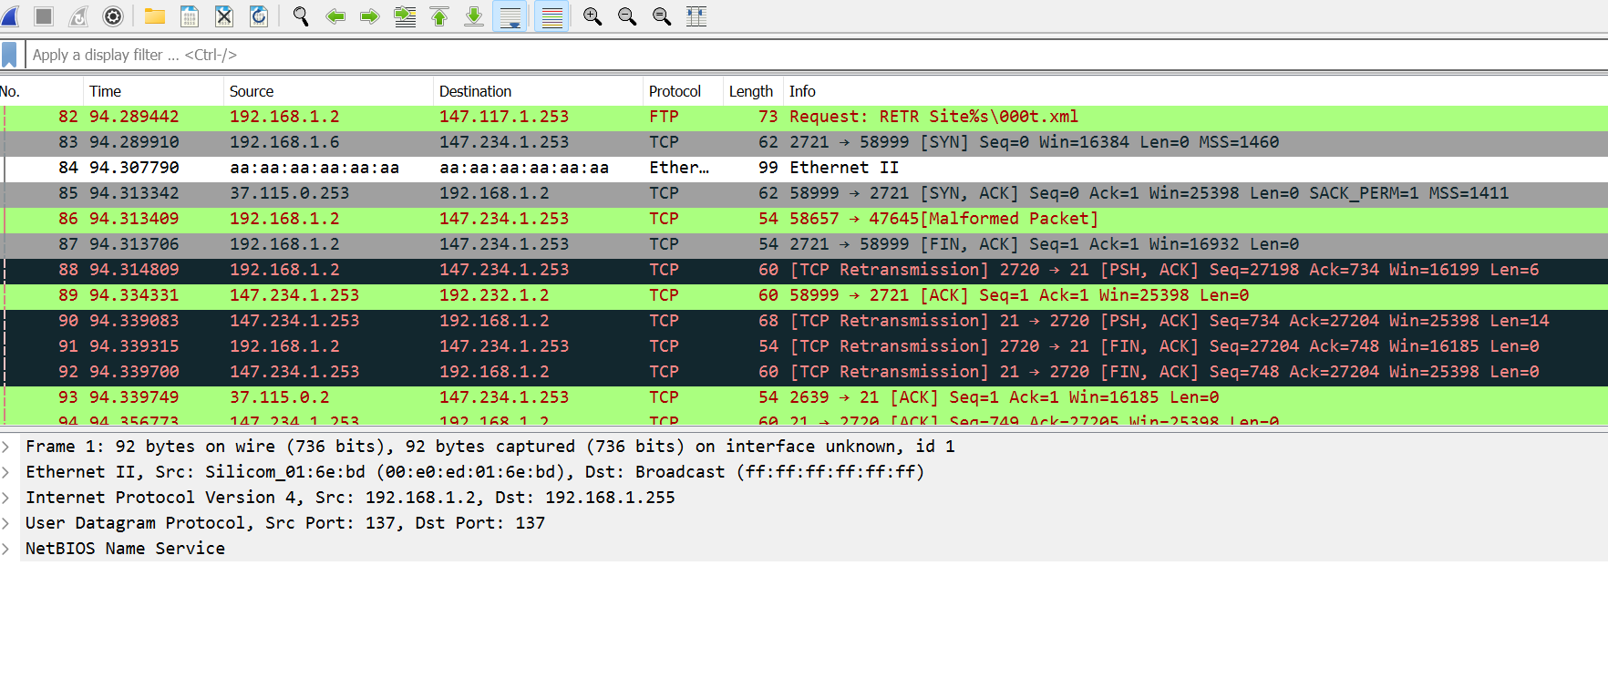
- First we catch some network packet.
Step:2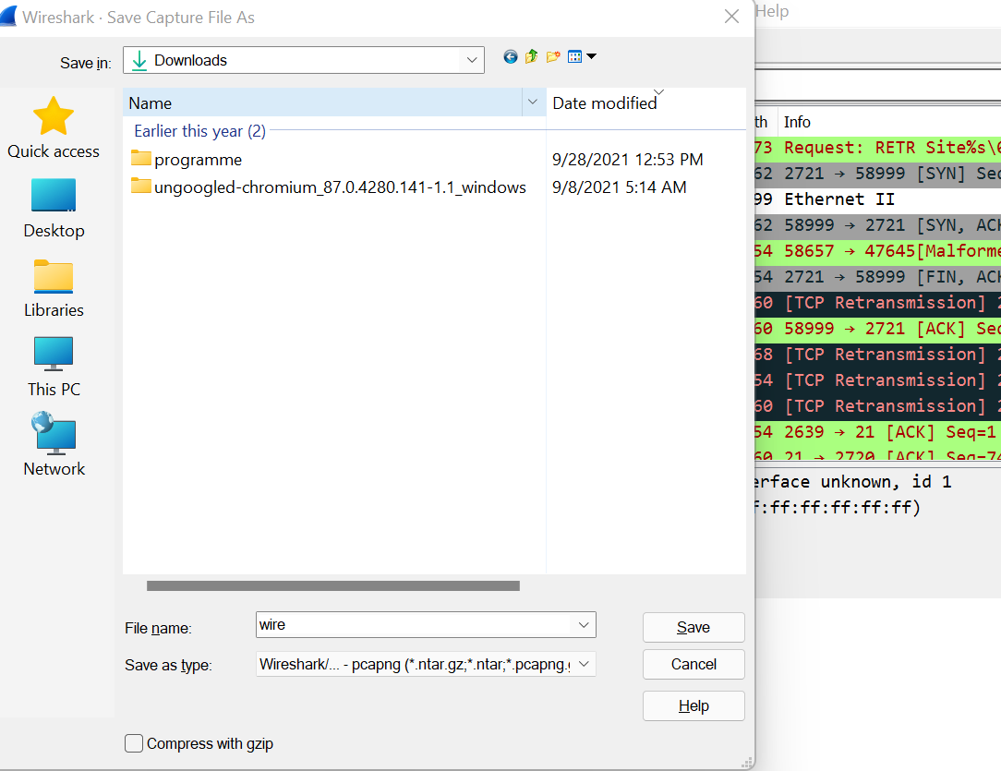
- Then we press windows +s to save the analysis packet and click save

Step:3

- In this step we save this wire.pcapng file.

Step:4
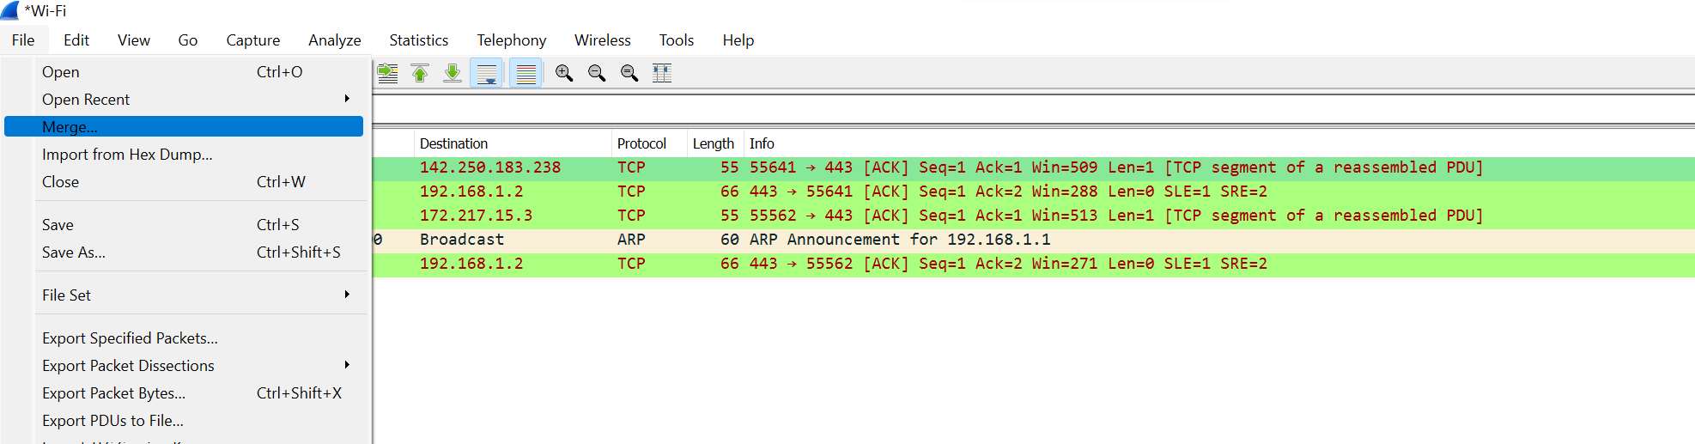Then we goto file and click on Merge options.
Step:5
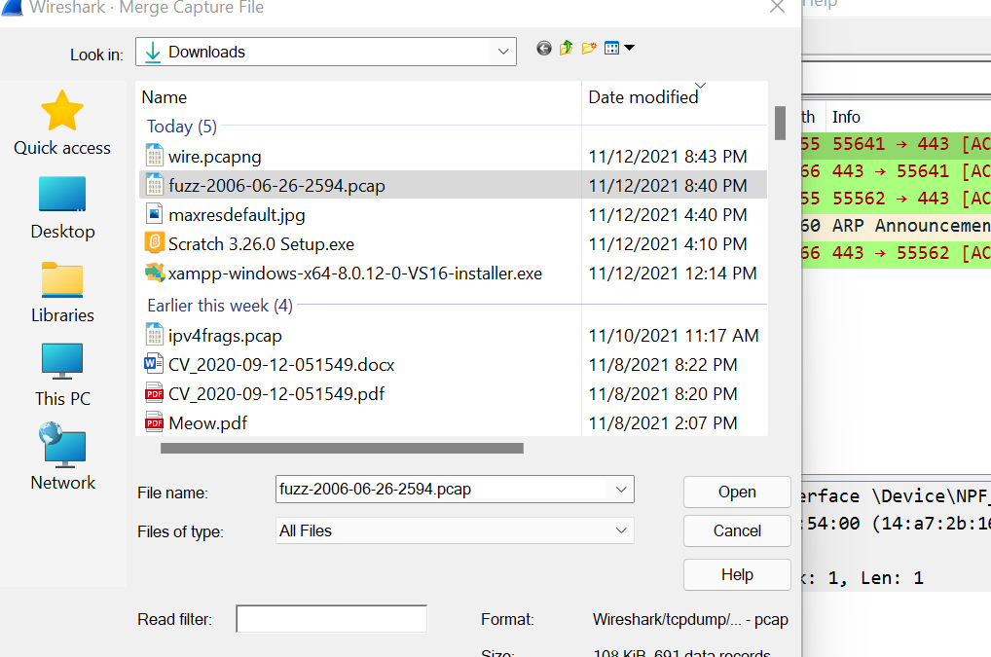
- Then we chose the network packet which we want to merge Then we click the open.

Step:6
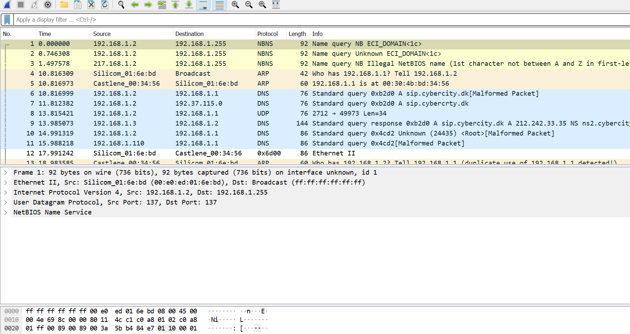
- Finally we merge the two different network packet.

Conclusion:
We successfully merge different network packet.

