Fundamentals of routing – Link State Routing - Distance Vector Routing-
Routing is the process of determining the optimal path for data packets to travel from a source to a destination across an interconnected network. Two common routing algorithms used in computer networks are Link State Routing and Distance Vector Routing. Here's an overview of each routing algorithm: 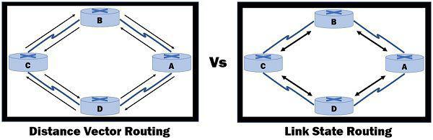
- Link State Routing:
- Link State Routing is a routing algorithm that builds a detailed map of the network by exchanging information about the network topology among routers.
- Each router collects information about its directly connected links, including their state, cost, and neighboring routers.
- The routers then exchange this information with each other to build a complete and consistent view of the network.
- Based on the collected information, each router runs a shortest path algorithm, such as Dijkstra's algorithm, to calculate the shortest path to reach all other routers in the network.
- Link State Routing provides accurate and up-to-date knowledge of the network, leading to efficient path selection and high scalability.
- Examples of Link State Routing protocols include OSPF (Open Shortest Path First) and IS-IS (Intermediate System to Intermediate System).
- Distance Vector Routing:
- Distance Vector Routing is a distributed routing algorithm where each router maintains a table (routing table) that contains the distance (cost) to reach all known destinations.
- Routers periodically exchange their routing tables with neighboring routers.
- Each router advertises its own routing table to its neighbors, and the neighbors use this information to update their own routing tables.
- Distance Vector Routing uses a metric, such as hop count or link cost, to determine the best path to a destination.
- Routers update their routing tables by comparing received routing information and choosing the route with the lowest total cost.
- Distance Vector Routing suffers from the count-to-infinity problem, where incorrect or outdated routing information can result in routing loops or slow convergence.
- Examples of Distance Vector Routing protocols include RIP (Routing Information Protocol) and EIGRP (Enhanced Interior Gateway Routing Protocol).
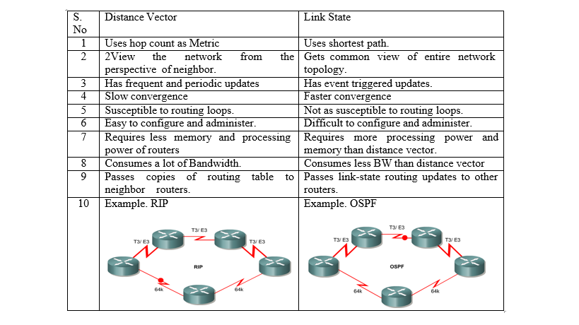
In both Link State Routing and Distance Vector Routing, routers exchange routing information with their neighbors to learn about the network topology and determine the best paths for packet forwarding. The key differences lie in the mechanisms used to exchange information, the representation of network state, and the algorithms employed for path calculation.
The selection of a routing algorithm depends on factors such as network size, complexity, scalability requirements, and network administrator preferences. Each algorithm has its strengths and weaknesses, and the choice should be made based on the specific needs and characteristics of the network.

