Health Monitoring System

What is a Remote Health Monitoring System?

A Remote health monitoring system is an extension of a hospital medical system where a patient’s vital body state can be monitored remotely. Traditionally the detection systems were only found in hospitals and were characterized by huge and complex circuitry which required high power consumption. Continuous advances in the semiconductor technology industry have led to sensors and microcontrollers that are smaller in size, faster in operation, low in power consumption and affordable in cost.
This has further seen development in the remote monitoring of vital life signs of patients especially the elderly. The remote health monitoring system can be applied in the following scenarios:
- A patient is known to have a medical condition with unstable regulatory body system. This is in cases where a new drug is being introduced to a patient.
- A patient is prone to heart attacks or may have suffered one before. The vitals may be monitored to predict and alert in advance any indication of the body status.
- Critical body organ situation

- The situation leading to the development of a risky life-threatening condition. This is for people at an advanced age and maybe having failing health conditions.
- Athletes during training. To know which training regimes will produce better results.

In recent times, several systems have come up to address the issue of remote health monitoring. The systems have a wireless detection system that sends the sensor information wirelessly to a remote server. Some even adopted a service model that requires one to pay a subscription fee. In developing countries, this is a hindrance as some people cannot use them due

to cost issue involved. There is also the issue of internet connectivity where some systems to operate, good quality internet for a real-time remote connection is required. Internet penetration is still a problem in developing countries.
Many of the systems were introduced in the developed countries where the infrastructure is working perfectly. In most cases, the systems are adapted to work in developing countries. To reduce some of these problems there is need to approach the remote detection from a ground-up approach to suit the basic minimal conditions presently available in developing countries.
A simple patient monitoring system design can be approached by the number of parameters it can detect. In some instances, by detecting one parameter several readings can be calculated. For simplicity considerations parameter detection are:
- Single parameter monitoring system:

In this instance, a single parameter is monitored e.g. Electrocardiogram (ECG) reading. From the ECG or heartbeat detection, several readings can be got depending on the algorithm used. An ECG reading can give the heart rate and oxygen saturation.
- Multi-parameter monitoring system:

This has multiple parameters being monitored at the same time. An example of such a system can be found in High Dependency Units (HDU), Intensive Care Units (ICU), during the surgery at a hospital theatre or Post surgery recovery units in Hospitals. Several parameters that are monitored include the ECG, blood pressure, respiration rate. The Multiparameter monitoring system basically proof that a patient is alive or recovering. In developing countries, just after retiring from their daily career routine majority of the elderly age group, move to the rural areas. In developed countries, they may move to assisted living group homes. This is where a remote health monitoring system can come in handy.

Statement of the problem

REMOTE HEALTH MONITORING

Remote health monitoring can provide useful physiological information in the home. This monitoring is useful for elderly or chronically ill patients who would like to avoid a long hospital stay. Wireless sensors are used to collect and transmit signals of interest and a processor is programmed to receive and automatically analyze the sensor signals. In this project, you are to choose appropriate sensors according to what you would like to detect and design algorithms to realize your detection. Examples are the detection of a fall, monitoring cardiac signals.
Using a single parameter monitoring system an approach to a remote health monitoring system was designed that extends healthcare from the traditional clinic or hospital setting to the patient's home. The system was to collect a heartbeat detection system data, fall detection system data, temperature data and few other parameters. The data from the single parameter monitoring systems was then availed for remote detection.
During design the following characteristics of the future medical applications adhered:

- Integration with current trends in medical practices and technology,

- Real-time, long-term, remote monitoring, miniature, wearable sensors and long battery life of a designed device.
- Assistance to the elderly and chronic patients. The device should be easy to use with minimal buttons.

Purpose of the study
Design a Remote Patient Health Monitoring System (RPHMS) which has heartbeat detection system, a fall detection system, temperature detection system, a humidity detection system, a toxic gas and air quality detection system and SPO2 detection system. A doctor or health specialist can use the system to monitor remotely of all vital health parameters of the patient or person of interest.
An attempt at designing a remote healthcare system made with locally available components.

- The fall detector, temperature, humidity, pressure, toxic gas, air quality control, SPO2 modules comprise of an accelerometer, wireless transmitter and microcontroller. The data collected was transmitted wirelessly to a receiver module.
- ECG consists of a non-invasive infrared finger detector, Liquid Crystal Display (LCD), a designed circuit for cardiac signal detection and microcontroller. The detected analog signal was then digitized to give a digital value that was read on the LCD.
- A simple cloud server where hosted with a database for all the vital data to be accessed remotely whenever required.

Objective of the study
Here the main objective is to design a Remote Patient Health Monitoring System to diagnose the health condition of the patients. Giving care and health assistance to the bedridden patients at critical stages with advanced medical facilities have become one of the major problems in the modern hectic world. In hospitals where many patients whose physical conditions must be monitored frequently as a part of a diagnostic procedure, the need for a cost-effective and fast responding alert mechanism is inevitable. Proper implementation of such systems can provide timely warnings to the medical staffs and doctors and their service can be activated in case of medical emergencies. Present-day systems use sensors that are hardwired to a PC next to the bed.

The use of sensors detects the conditions of the patient and the data is collected and transferred using a microcontroller. Doctors and nurses need to visit the patient frequently to examine his/her current condition. In addition to this, use of multiple microcontroller based intelligent system provides high-level applicability in hospitals where many patients must be frequently monitored. For this, here we use the idea of network technology with wireless applicability, providing each patient a unique ID by which the doctor can easily identify the patient and his/her status of health parameters. Using the proposed system, data can be sent wirelessly to the Patient Monitoring System, allowing continuous monitoring of the patient. Contributing accuracy in measurements and providing security in proper alert mechanism give this system a higher level of customer satisfaction and low-cost implementation in hospitals. Thus, the patient can engage in his daily activities in a comfortable atmosphere where distractions of hardwired sensors are not present. Physiological monitoring hardware can be easily implemented using simple interfaces of the sensors with a Microcontroller and can effectively be used for healthcare monitoring. This will allow development of such low-cost devices based on natural human-computer interfaces. The system we proposed here is efficient in monitoring the different physical parameters of many number bedridden patients and then in alerting the concerned medical authorities if these parameters bounce above its predefined critical values. Thus, remote monitoring and control refer to a field of industrial automation that is entering a new era with the development of wireless sensing devices.

The Internet of Things (IoT) platform offers a promising technology to achieve the healthcare services, and can further improve the medical service systems. IoT wearable platforms can be used to collect the needed information of the user and its ambient environment and communicate such information wirelessly, where it is processed or stored for tracking the history of the user. Such a connectivity with external devices and services will allow for taking preventive measure (e.g., upon foreseeing an upcoming heart stroke) or provide immediate care (e.g., when a user falls and needs help).

Limitation of the study
The scope of the project was limited to ECG, fall, temperature, humidity, pressure, toxic gas, air quality and SPO2 detection and remote viewing of the collected data for a single patient. Here, the most important specification considered was that they should be safe to use and accurate. This is because the physiological information being detected determines the severity of a critical life-threatening situation.

Development and Clinical Evaluation of a Home Healthcare System Measuring in Toilet, Bathtub and Bed without Attachment of Any Biological Sensors
Daily monitoring of health condition at home is important for an effective scheme for early diagnosis, treatment, and prevention of lifestyle-related diseases such as adiposis, diabetes and cardiovascular diseases. While many commercially available devices for home health care monitoring are widely used, those are cumbersome in terms of self-attachment of biological sensors and self-operation of them. From this viewpoint, we have been developing a non-conscious physiological monitoring system without attachment of any sensors to the human body as well as any operations for the measurement. We developed some devices installed in a toilet, a bath, and a bed and showed their high measurement precision by comparison with simultaneous recordings of ordinary biological sensors directly attached to the body. To investigate that applicability to the health condition monitoring, we developed a monitoring system in combination with all the monitoring devices at hospital rooms and previously carried out the measurements of patients' health condition. Further, in this study, the health conditions were measured in 10 patients with cardiovascular disease or sleep disorder. From these results, the patients’ health conditions such as the body and excretion weight in the toilet, the ECG during taking the bath and the pulse and respiration rate during sleeping were successfully monitored in the hospital room, demonstrating its usefulness for monitoring the health condition of the subjects with cardiovascular disease or sleep disorder.

Intelligent wireless mobile patient monitoring system
Nowadays, Heart-related diseases are on the rise. Cardiac arrest is quoted as the major contributor to the sudden and unexpected death rate in the modern stress filled lifestyle around the globe. A system that warns the person about the onset of the disease earlier automatically will be a boon to the society. This is achievable by deploying advances in wireless technology to the existing patient monitoring system. This paper proposes the development of a module that provides mobility to the doctor and the patient, by adopting a simple and popular technique, detecting the abnormalities in the bio signal of the patient in advance and sending an SMS alert to the doctor through Global System for Mobile(GSM) thereby taking suitable precautionary measures thus reducing the critical level of the patient. Worldwide surveys conducted by World Health Organization (WHO) have confirmed that the heart-related diseases are on the rise. Many of the cardiac-related problems are attributed to the modern lifestyles, food habits, obesity, smoking, tobacco chewing and lack of physical exercises etc. The post-operative patients can develop complications once they are discharged from the hospital. In some patients, the cardiac problems may reoccur, when they start doing their routine work. Hence the ECG of such patients needs to be monitored for some time after their treatment. This helps in diagnosing the improper functioning of the heart and take precautions. Some of these lives can often be saved if acute care and cardiac surgery is provided within the so-called golden hour. So, the need for advice on first-hand medical attention and promotion of good health by patient monitoring and follow-up becomes inevitable. Hence, patients who are at risk require that their cardiac health to be monitored frequently whether they are indoors or outdoors so that emergency treatment is possible. Telemedicine is widely considered to be part of the inevitable future of the modern practice of medicine.

The real-time monitoring system for in-patient based on ZigBee
The system is made up of two sub-systems: patient physical states data acquisition and communication system based on ZigBee technology, and hospital monitoring and control center. The patient physical states data acquisition and communication system monitors the main physical parameters and movement status continuously. The information from data acquisition system is sent to hospital monitoring center by ZigBee wireless communication module. The monitoring center receives the information from each patient and save them to the database, and then judges the states of the patient by fuzzy reasoning. The data from the patient can be displayed as a graph or numeric on the monitor if it is necessary, and then the doctor can diagnose the patient according to the recorded continuous data. Wireless sensor network is made up of a lot of wireless sensors based on ZigBee technology. The ZigBee technology provides a resolution for transmitting sensors’ data by wireless communication. ZigBee technology can transmit data with a rate of 250kbps, and then it is enough for the physical parameters of the patient. The communication distance of ZigBee node can be over 200 meters and can be spread by add route node, and then ZigBee technology is suited to a short distance wireless sensors network. ZigBee technology owns many virtues, such as low power consumption, low cost, small size, free frequency, etc. To know the physical states of in-patient, the physical parameters need to be monitored real-time. The traditional medical test instrument is a large size and connected by wire often, and the patient is required to be quiet during the test. In most of the hospital, the medical instruments need to be read by doctor or nurse, and the physical parameters are tested and recorded one or two times each day, the real-time monitoring is expensive for most of the patients, and can be only acquirable for ICU by a nurse. For this reason, the worsening of patient can’t be found in time, and then the patient can’t be helped in time. For most of the patients can be monitored real-time in hospital, we should

find a new method. Consider that the movement of the patient is limited in hospital, we adopted the ZigBee and wireless sensors network to acquire the physical parameters of the patient.

3.1 Existing System
In the existing system, we use active network technology to network various sensors to a single PMS. Patients’ various critical parameters are continuously monitored via single PMS and reported to the Doctors or Nurses in attendance for timely response in case of critical situations. The sensors are attached to the body of the patients without causing any discomfort to them. In this PMS we monitor the important physical parameters like body temperature, ECG, heart beat rate and blood pressure using the sensors which are readily available. Thus, the analog values that are sensed by the different sensors are then given to a microcontroller attached to it. The microcontroller processes these analog signal values of health parameters separately and converts it to digital values using ADC converter.
Now, the digitalized values from more than one microcontroller are sent to the Central PMS. Each of the sensors attached microcontroller with a transceiver will act as a module which has its own unique ID. Each module transmits the data wirelessly to the gateway attached to the PC of the Central PMS. The gateway is attached to the PC i.e. Central PMS which is situated in the medical center, is capable for selecting different patient IDs and allowing the gateway to receive different physical parameter values the patient specified by the ID.
The software designed using Graphical User Interface (GUI) can operate on different physical parameters of each patient, consecutively with a specified time interval for each patient.

At any time, any of the doctors or nurses can log on the Central PMS and check the history of the observed critical parameters of any of the patient attached to the network.

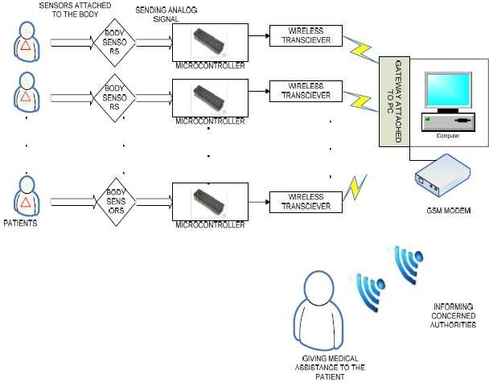

Figure 1: Existing System

In case of a critical situation which requires the immediate attention of the doctors or nurses for any of the patients, the custom software will instruct the Central PMS to enable the GSM modem to send an SMS with the patient ID. A voice call is also made to the doctors and the staffs of the hospital. The SMS also consists of a status of the patient’s physical condition. With the help of the patient ID, the doctor can easily identify and attend to the patient situation.

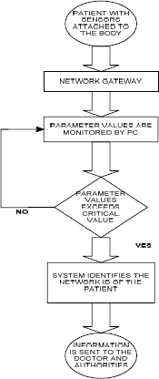

Figure 2: Flow chart of Existing System

Chapter 4 - Proposed System

The main objective is to design a Patient Monitoring System with two-way communication

i.e. not only the patient’s data will be sent to the doctor through SMS and email on emergencies, but also the doctor can send required suggestions to the patient or guardians through SMS or Call or Emails. And Patient or guardian can able to track patient’s location at any point in time through Google Maps which would enable to send medical services in case of an emergency for non-bed ridden patients.

Block Diagram

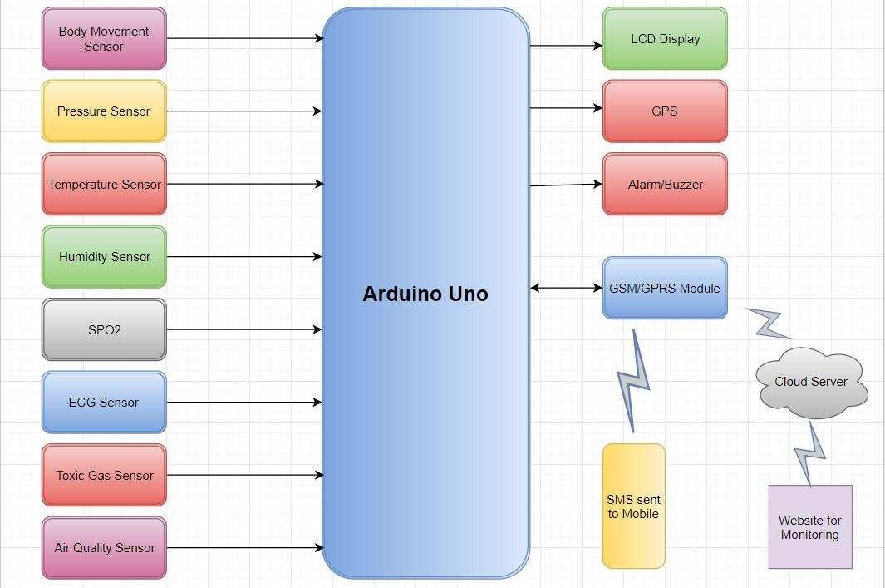

Figure 3: Block Diagram of the proposed system

Chapter 5 - Sensors and Modules

Proposed system consists of following sensors and modules

    - Arduino Micro Controller

    - ECG

    - GSM/GPRS Module

    - Temperature sensor

    - Pressure sensor

    - Body Movement Sensor

    - Humidity Sensor

    - Toxic Gas sensor

    - Air Quality sensor

Arduino Micro controller
Arduino Uno is a microcontroller board based on the ATmega328P. It has 14 digital input/output pins (of which 6 can be used as PWM outputs), 6 analog inputs, a 16 MHz quartz crystal, a USB connection, a power jack, an ICSP header and a reset button. It contains everything needed to support the microcontroller; simply connect it to a computer with a USB cable or power it with a AC-to-DC adapter or battery to get started.

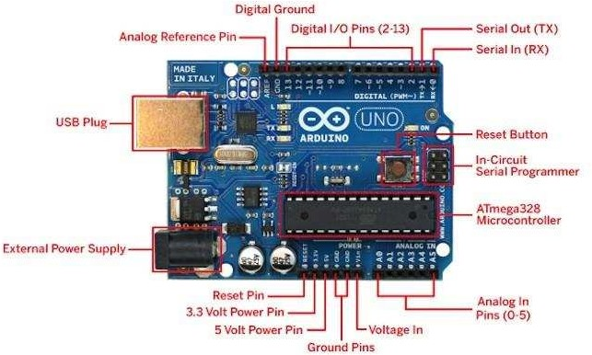

Figure 4: Arduino Board

Starting clockwise from the top center:

    - Analog Reference pin

    - Digital Ground

    - Digital Pins 2-13

    - Digital Pins 0-1/Serial In/Out - TX/RX (dark green) - These pins cannot be used for digital i/o (digitalRead and digitalWrite) if you are also using serial communication (e.g. Serial.begin).
    - Reset Button - S1

    - In-circuit Serial Programmer

    - Analog In Pins 0-5

    - Power and Ground Pins

    - External Power Supply In (9-12VDC) - X1

    - Toggles External Power and USB Power (place jumper on two pins closest to desired supply) - SV1
    - USB (used for uploading sketches to the board and for serial communication between the board and the computer; can be used to power the board)

ECG
ECG records the electrical activity generated by heart muscle depolarizations, which propagate in pulsating electrical waves towards the skin. Although the electricity amount is in fact very small, it can be picked up reliably with ECG electrodes attached to the skin. The full ECG setup comprises at least four electrodes which are placed on the chest or at the four extremities according to standard nomenclature (RA = right arm; LA = left arm; RL = right leg; LL = left leg). Of course, variations of this setup exist to allow more flexible and less intrusive recordings, for example, by attaching the electrodes to the forearms and legs. ECG electrodes are typically wet sensors, requiring the use of a conductive gel to increase conductivity between skin and electrodes.
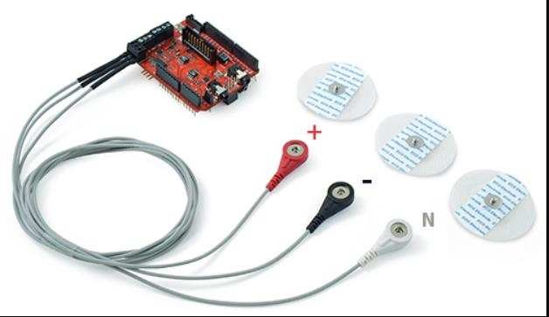

(Ref: https://www.cooking-hacks.com/documentation/tutorials/ehealth-biometric-sensor-platform-arduino-
raspberry-pi-medical)

Figure 5: ECG Sensor

GSM/GPRS
GSM/GPRS module is used to establish communication between a computer and a GSM- GPRS system. Global System for Mobile communication (GSM) is an architecture used for mobile communication in most of the countries. Global Packet Radio Service (GPRS) is an extension of GSM that enables higher data transmission rate. GSM/GPRS module consists of a GSM/GPRS modem assembled together with power supply circuit and communication interfaces (like RS-232, USB etc.) for a computer. GSM/GPRS MODEM is a class of wireless MODEM devices that are designed for communication of a computer with the GSM and GPRS network. It requires a SIM (Subscriber Identity Module) card just like mobile phones to activate communication with the network. Also, they have IMEI (International Mobile Equipment Identity) number similar to mobile phones for their identification. A GSM/GPRS MODEM can perform the following operations:
- Receive, send or delete SMS messages in a SIM.
- Read, add, search phonebook entries of the SIM.
- Make, Receive, or reject a voice call.

The MODEM needs AT commands, for interacting with processor or controller, which are communicated through serial communication. These commands are sent by the controller/processor. Different AT commands supported by the MODEM can be sent by the processor/controller/computer to interact with the GSM and GPRS cellular network.

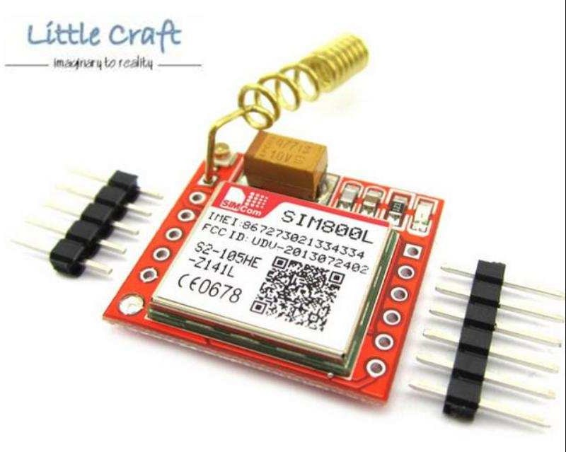

(Ref: https://www.lelong.com.my/sim800l-gprs-gsm-module-arduino-raspberry-littlecraft-175954380-2019-04-Sale- P.htm)
Figure 6: GSM/GPRS Module

Temperature Sensor
Temperature sensor is a device which is designed specifically to measure the hotness or coldness of an object. LM35 is a precision IC temperature sensor with its output proportional to the temperature (in °C). With LM35, the temperature can be measured more accurately than with a thermistor. It also possesses low self-heating and does not cause more than 0.1 °C temperature rise in still air. The operating temperature range is from -55°C to 150°C.The LM35’s low output impedance, linear output, and precise inherent calibration make interfacing to readout or control circuitry especially easy.
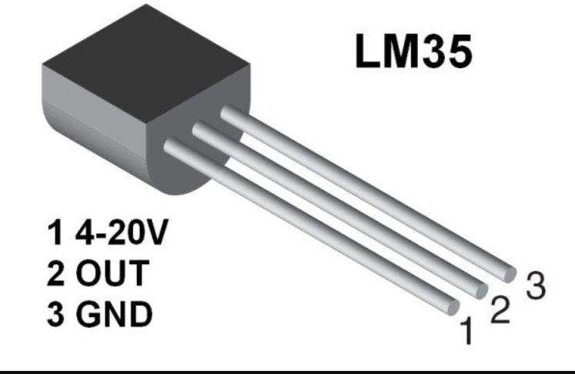

(Ref: http://www.instructables.com/id/LM35-Temperature-Sensor/)

Figure 7: Temperature Sensor

Pressure Sensor
A pressure sensor, as the name suggests, is a device that senses and measures pressure (usually of gases or liquids). The pressure sensor in electronic circuits is in the form of an integrated circuit that acts as a transducer, that is, it replicates (in the form of an electrical signal) the signal it receives as a function of imposed pressure.
A pressure sensor is also known as a pressure transducer, pressure transmitter, pressure sender, pressure indicator, piezometer and manometer.

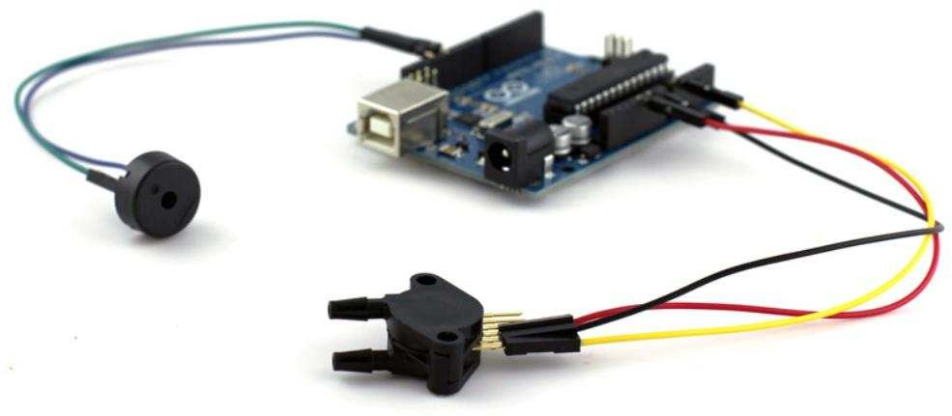

(Ref: http://www.tomorrow-lab.com/images/lab/lab_16/15.jpg)

Figure 8: Pressure Sensor

Body Movement Sensor
Unintentional falls are a common cause of severe injury in the elderly population. By introducing small, non-invasive sensor in conjunction with a wireless network, this project aims to provide a path towards more independent living for the elderly or bed ridden patients. Using a small device worn on the waist and a network of fixed in the home environment, we can detect the occurrence of a fall and the location of the victim. Low-cost and low-power MEMS accelerometers are used to detect the fall while RF signal strength is used to locate the person.
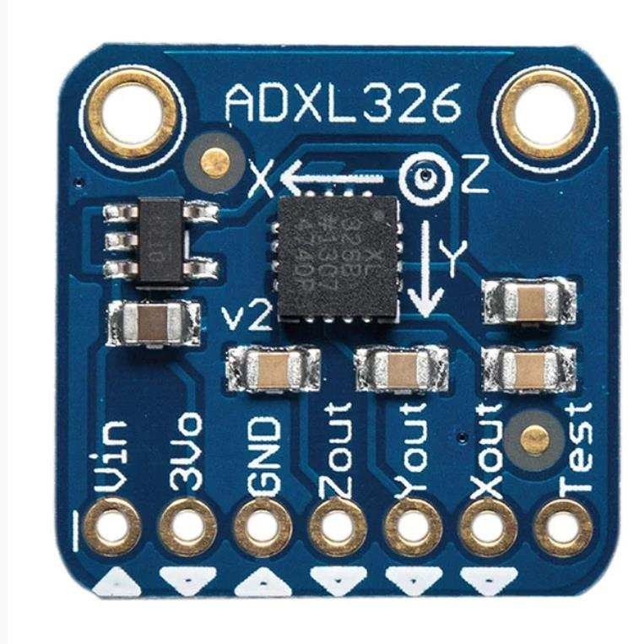

(Ref: https://www.adafruit.com/product/1018)

Figure 9: Body Movement Sensor

Humidity Sensor
A humidity sensor (or hygrometer) senses, measures and reports the relative humidity in the air. It therefore measures both moisture and air temperature. Relative humidity is the ratio of actual moisture in the air to the highest amount of moisture that can be held at that air temperature. The warmer the air temperature is, the more moisture it can hold. Humidity / dew sensors use capacitive measurement, which relies on electrical capacitance. Electrical capacity is the ability of two nearby electrical conductors to create an electrical field between them. The sensor is composed of two metal plates and contains a non-conductive polymer film between them. This film collects moisture from the air, which causes the voltage between the two plates to change. These voltage changes are converted into digital readings showing the level of moisture in the air.
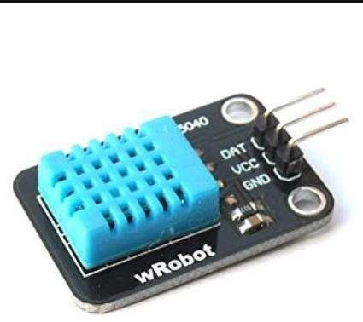

(Ref: http://erltech.com/product/shop/dht11-temperature-and-humidity-sensor-module/)

Figure 10: Humidity Sensor

Toxic Gas Sensor
Gas Sensor(MQ9) module is useful for gas leakage detection (in home and industry). It is suitable for detecting LPG, CO, CH4. Due to its high sensitivity and fast response time, measurements can be taken as soon as possible. The sensitivity of the sensor can be adjusted by using the potentiometer.
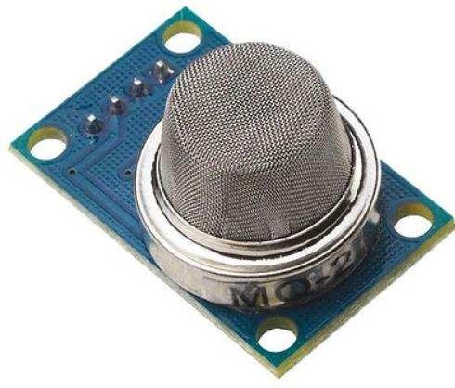

(Ref: https://iot-playground.com/blog/2-uncategorised/53-esp8266-wifi-gas-sensor-arduino-ide)

Figure 11: Toxic Gas Sensor

Air Quality Sensor
This sensor is designed for comprehensive monitor over indoor air condition. It’s responsive to a wide scope of harmful gases, as carbon monoxide, alcohol, acetone, thinner, formaldehyde and so on. Due to the measuring mechanism, this sensor can’t output specific data to describe target gases’ concentrations quantitatively. But it’s still competent enough to be used in applications that require only qualitative results, like auto refresher sprayers and auto air cycling systems.

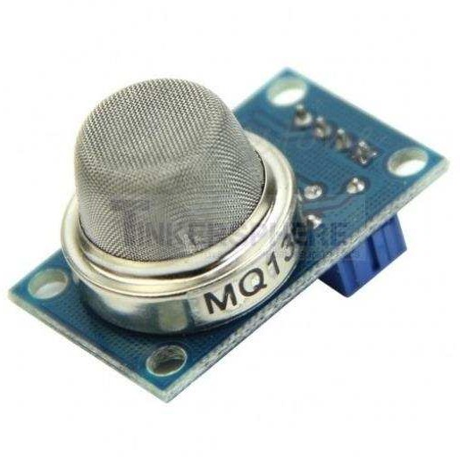

(Ref: http://tinkersphere.com/sensors/1374-mq135-air-quality-sensor-arduino-pi-compatible.html)

Figure 12: Air Quality Sensor

Heartbeat Sensor
Heartbeat sensor provides a simple way to study the function of the heart which can be measured based on the principle of psycho-physiological signal used as a stimulus for the virtual- reality system. The amount of the blood in the finger changes with respect to time. The sensor shines a light lobe (a small very bright LED) through the ear and measures the light that gets transmitted to the Light Dependent Resistor. The amplified signal gets inverted and filtered, in the Circuit. In order to calculate the heart rate based on the blood flow to the fingertip, a heart- rate sensor is assembled with the help of LM358 OP-AMP for monitoring the heartbeat pulses.
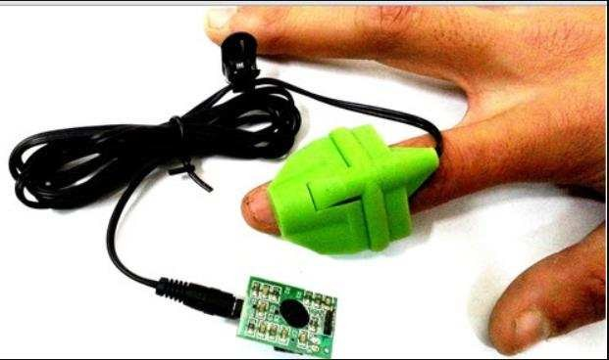

(Ref: https://www.elprocus.com/heartbeat-sensor-circuit-daigram-working-with-8051/)

Figure 13: Heartbeat Sensor

Chapter 6 - Requirement Analysis

Requirement Analysis is the first and important phase of the software developing activity in developing any kind of project effectively. I started to list out all the functionalities that my application should provide. There have been some minor changes with respect to the functionalities over the course of development. After a meeting with my Professor Dr. Daniel Andresen, following are the requirements that have been implemented in this project.

Functional Requirements
    - Application must have a module for login using unique credentials of a patient for the

doctor to monitor patient’s vital data.

    - Application must have a module for login using unique credentials of a patient for

Guardian/Caretaker to monitor patient’s vital data.

    - Location Tracking: Application must have track location option with which doctor or guardian can track location of the patient.
    - Location sender: Hardware must have a GPRS module to fetch location coordinates which can be used to track location of patient.
    - Messaging Service: Hardware must have GSM module which send’s SMS alert messages to doctor and guardians upon any emergencies. And application must send email alerts upon any emergencies.

Non-Functional Requirements
Non-functional requirements are not directly related to the functional behavior of the system.

    - Web application must be user friendly, simple and interactive.

    - The user interface is designed in such way that novice users with little knowledge of web, should be able to access this application.
    - Users are required to have some knowledge regarding google maps.

Software Specifications
    - Operating System: Windows 7 or higher

    - Platform: IoT Cloud

    - IDE: Arduino 1.8.4

    - Database: MySQL

    - Technologies used: C, SQL, PHP

Hardware Specifications
    - Microcontroller: Arduino Uno Board

    - Sensors: Temperature(LM35), Toxic gas(MQ9), GSM Module, GPRS Module, ECG, Humidity, Air Quality, Pressure
    - Processor: Pentium IV or higher

    - Processor speed: 1.6GHz

    - RAM: 512 MB

    - Disk Space: 250 MB or higher

Chapter 7 - System Design

Systems design is the process of defining the architecture, components, modules, interfaces, and data for a system to satisfy specified requirements. Overall product architecture, the subsystems that compose the product, and the way subsystems are allocated to processors are depicted using the System Design. UML is used to model system designs. Unified Modelling Language is a standard object-oriented analysis and design language. Use Case diagram and Sequence diagram, which are types of UML diagrams, of the application are shown below.

Use Case Diagram
A Use Case Diagram consists of set of elements and the relationships between them. It depicts all the scenarios, regarding how our application interacts with users and other external systems to achieve the goals of application. The main components of a use case diagram include actors, use cases and their relationships. The use case is an external view of the system that represents some actions that the user performs to get a job done. Actors are the users who interact with the application.

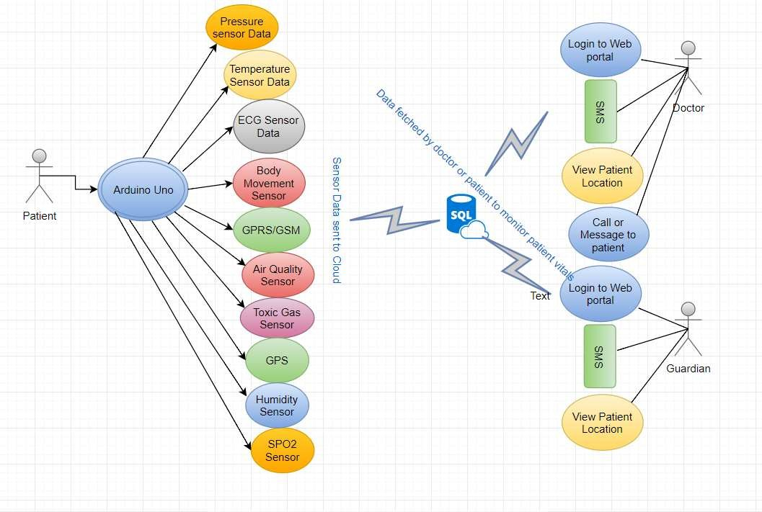

Figure 14: Use Case Diagram

Actors:

The Actors of the system are Patient, Guardian and Doctor

Use cases:

I have identified a set of use cases based on the functionalities and goals of the application.

- Login- This use case denotes a set of actions required for Subject to login into the application.
- Call Service- This use case denotes a set of actions required by doctor to call a guardian or patient in case medical emergencies.
- View Location- This use case denotes a set of actions required by Guardian or Doctor to locate subject on map after receiving his location details.

- Messaging Service- This use case denotes a set of actions required by Doctor to send a

message to subject’s guardian in case of emergencies.

Sequence Diagram
Sequence diagrams model the flow of logic within your system in a visual manner, enabling you both to document and validate your logic, and are commonly used for both analysis and design purposes.
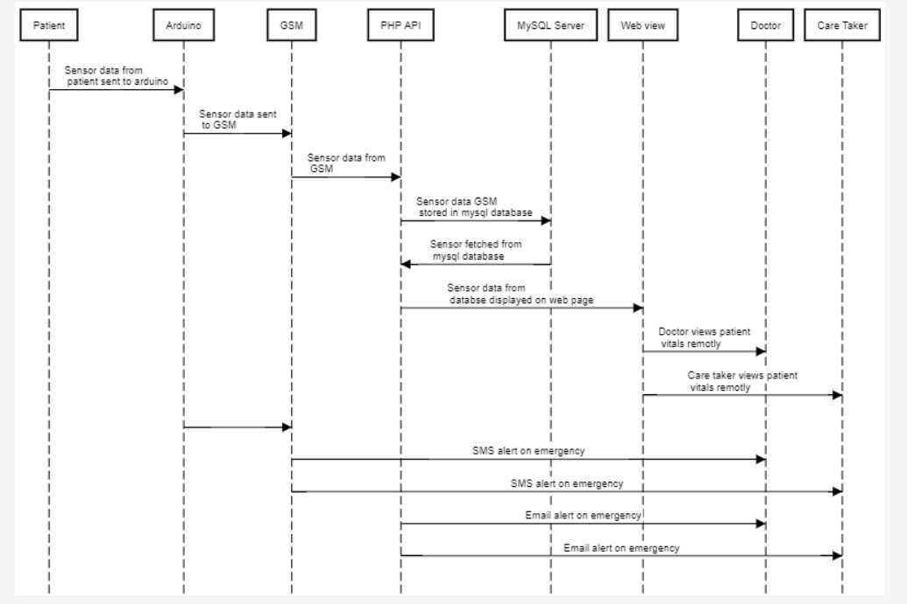

Figure 15: Sequence Diagram

Chapter 8 - Database Design

MySQL is the most popular Open Source Relational SQL Database Management System. MySQL is one of the best RDBMS being used for developing various web-based software applications. MySQL is developed, marketed and supported by MySQL AB, which is a Swedish company. Oracle MySQL Cloud Service delivers a secure, cost-effective and enterprise-grade MySQL database service. Built on MySQL Enterprise Edition and powered by the Oracle Cloud, it provides a simple, automated, integrated and enterprise ready MySQL cloud service, enabling organizations to increase business agility and reduce costs.
In this project, we have used a MySQL database which two tables. One table stores all the

patient’s sensor data and other table stores longitude and latitude of patient’s location.

Table Schema:

Patient’s table

CREATE TABLE `Patienthealth` (

`id` bigint(30) NOT NULL,

`temp` varchar(30) NOT NULL,

`hbt` varchar(30) NOT NULL,

`ecg` varchar(30) NOT NULL,

`hum` varchar(30) NOT NULL,

`pre` varchar(30) NOT NULL,

`tox` varchar(30) NOT NULL,

`air` varchar(30) NOT NULL,

`fal` varchar(30) NOT NULL,

`createdat` timestamp NOT NULL DEFAULT CURRENT_TIMESTAMP ON UPDATE CURRENT_TIMESTAMP
) ENGINE=MyISAM DEFAULT CHARSET=latin1;

Location Table

CREATE TABLE `patientlocation` (

`id` bigint(30) NOT NULL,

`lat` varchar(128) NOT NULL,

`lon` varchar(128) NOT NULL,

`pid` varchar(30) NOT NULL,

`current` timestamp NOT NULL DEFAULT CURRENT_TIMESTAMP ON UPDATE CURRENT_TIMESTAMP
) ENGINE=MyISAM DEFAULT CHARSET=latin1;

Chapter 9 - Implementation

This project has been developed with Arduino microcontroller connected with sensors which are attached to the patient. All the sensors and location data sent from microcontroller to MySQL database into the cloud. A doctor or guardian can log in to web portal to monitor patient’s data at any point in time. In case of emergencies, like temperature spike or heartbeat spike or detection of toxic gas etc. an SMS and email alert sent to doctor and guardian’s mobile and email

respectively. And at any point of time either a doctor or guardian can log into web portal with patient unique credentials and can track patient’s location which would help medical services to send appropriate help in case of emergencies.

Arduino Micro controller Init
    - Gsm_init(): With this event, Arduino board checks out network connectivity before fetching sensor data and relay it to cloud. Below Algorithm in Arduino board executes series of AT commands which would check network connectivity and enables internet.

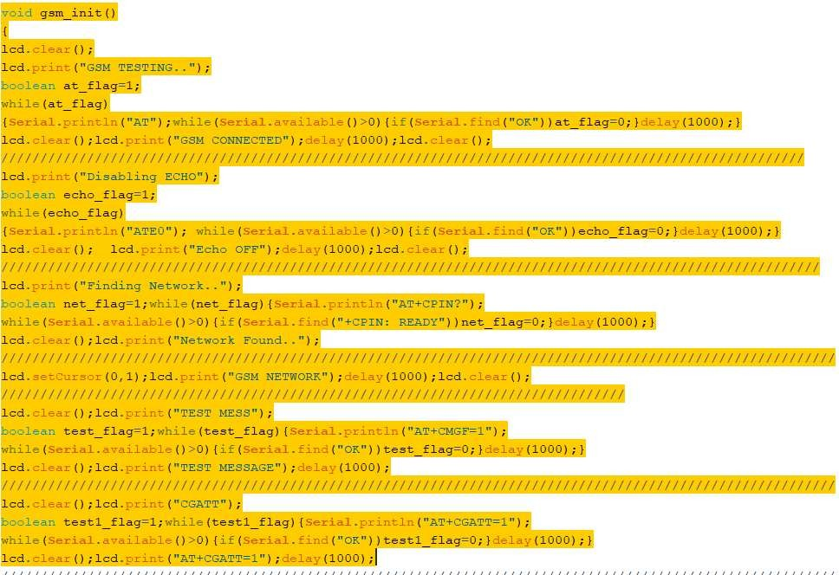

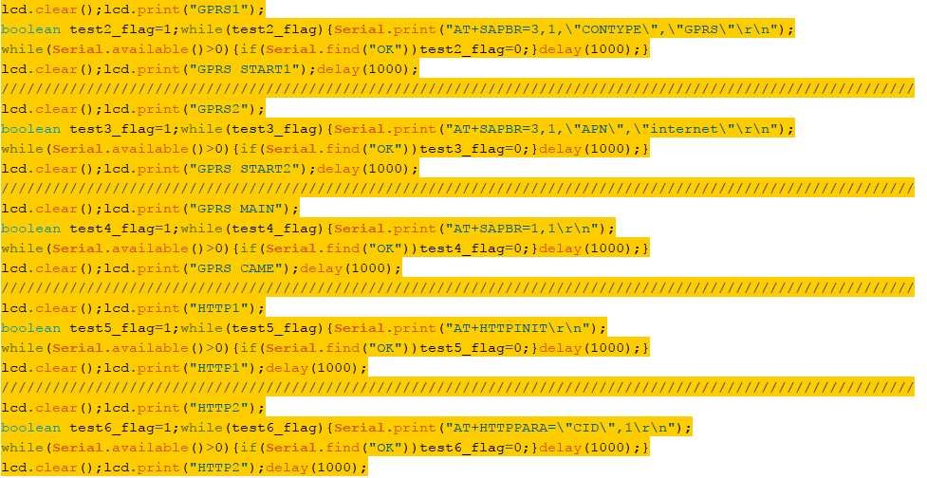

Location Tracking
    - GpsEvent(): With this event, GPRS module in board fetch’s current location coordinates.

In this algorithm below, gpsEvent fetch’s data from GPRS module and parse it to get exact

location coordinates.
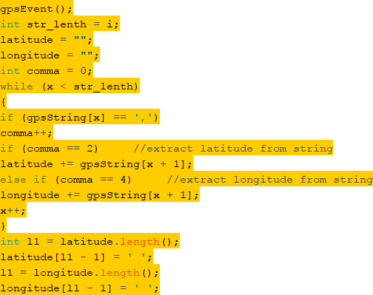

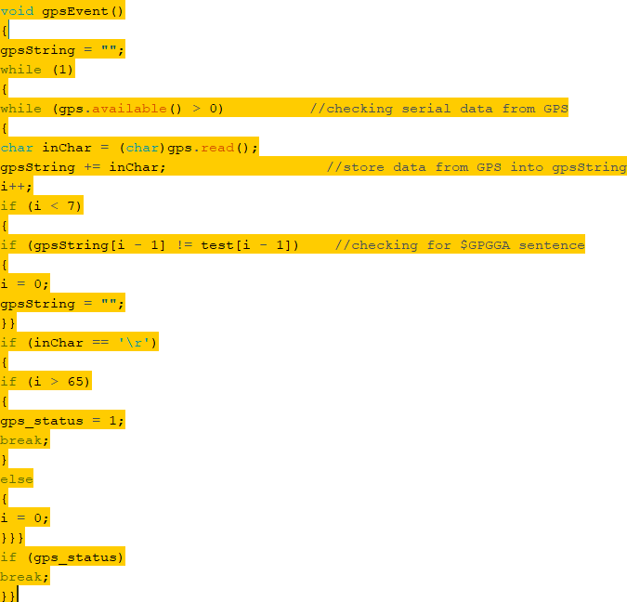

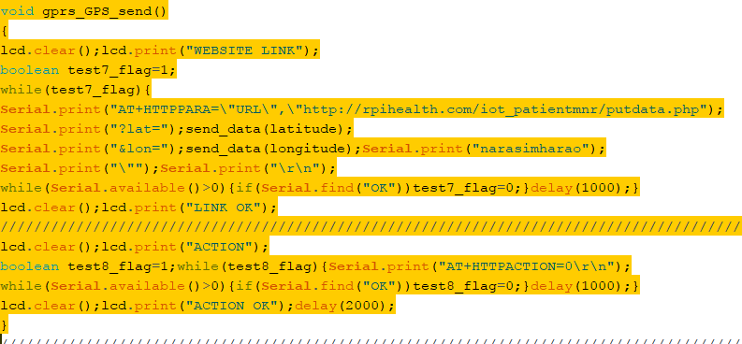
    - Gprs_gsm_send(): This event sends the location coordinates using GSM module to cloud through AT+HTTPPARA command. Here once gpsEvent parse the location information into coordinates, gprs_GPS_send event immediately sends coordinates to MySQL database server. PHP API fetch location coordinates from server and using Google maps API, pin points the location of the patient.

  - Sending data to MySQL database server
    - Gprs_send(): This event sends the sensor data using GSM module to cloud through AT+HTTPPARA command i.e. this event sends all the sensor data to MySQL database server which later PHP API fetch’s data from server and relays information on web page.
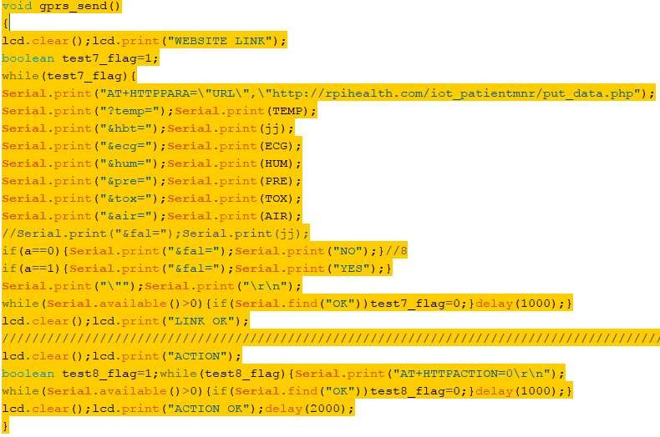

  - Sending SMS alert
    - AT+CMGS command: Arduino board sends SMS alert using GSM module
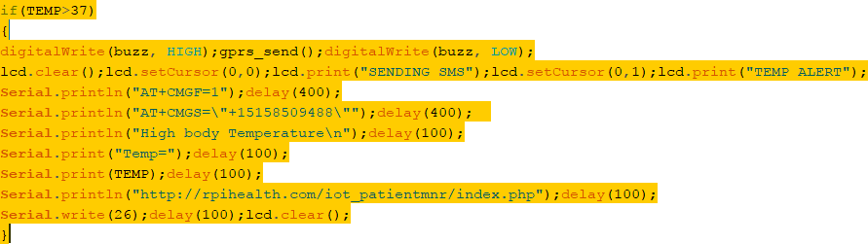

  - Sending Email alert
    - Mail(): PHP code analyses the data from server and sends email alert on emergencies while relaying patient data to server. Email alert consists of message about condition which failed like temperature spikes, fall detection, heartbeat failure etc. along with link to patient web page. On click link will be redirected to patient web page where doctor and care taker can view patient vitals and current location of patient.

Chapter 10 - Graphical User Interface

This Project is designed to make sure that user interface pages are easily understandable and the navigation between pages is obvious. Below are list of web pages that user can navigate between and are shown in details.

Web Page Login
Here doctor or care taker enter patient’s unique credentials. Once the credentials are verified, login page will be navigated to Patient vital monitoring page where doctor or caretaker can view current vital readings of the patient. Here patient’s unique credentials must be kept confidential by the doctor and caretaker to protect privacy of the patient data.
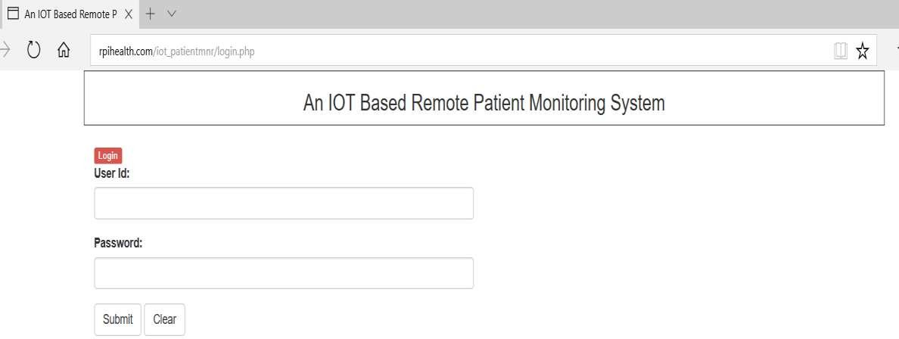

Figure 16: Webpage Login

Patient’s Vital Monitoring Page
After doctor or care taker login successfully, either can able to view live patient’s vital information which includes temperature, humidity, heartbeat, ECG etc. In order to protect privacy of the patient’s data, data is encrypted while sending it to MySQL database server and is decrypted while relaying same data on web page.
In below images, it is shown in detail about that the current readings of the patient are displayed on patient vital monitoring page with out any error. In case device is not connected or any of the sensor is not attached to patient, then all the readings or respective reading would be shown as zero in case of digital values. In case device is switched off then this page would display only last known readings that were stored in database.

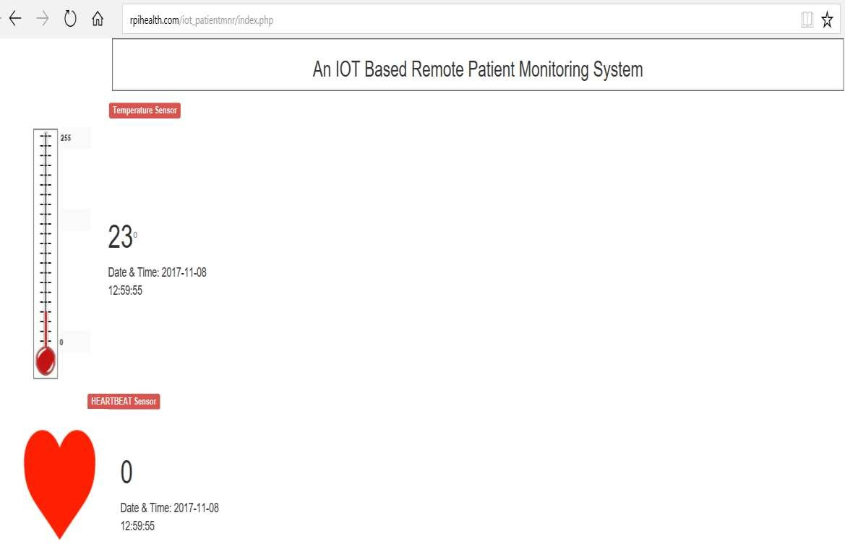

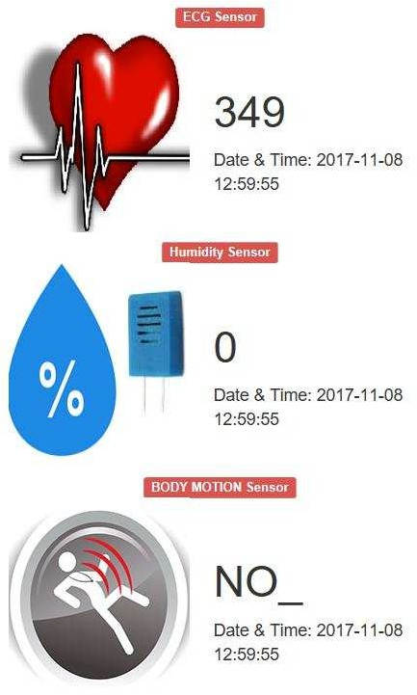
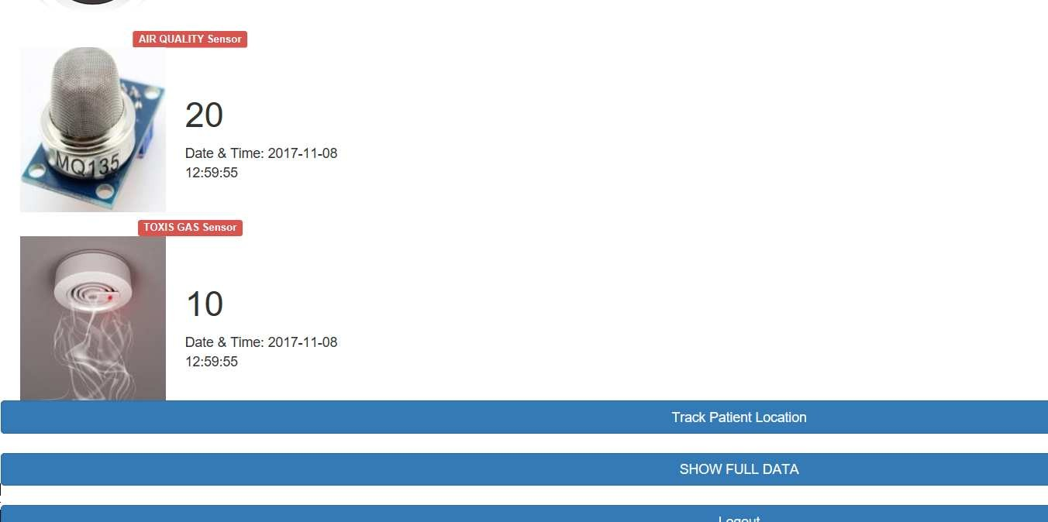

Figure 17: Patient’s Vital Monitoring Page

Track Patient Location
When doctor or care taker would need to know patient’s, location can click on track patient location link on index page. On clicking page is redirected to google maps page with current patient location details. In case of GPRS module failure to locate current coordinates in the device, then only last know location of the patient would be shown on this page.
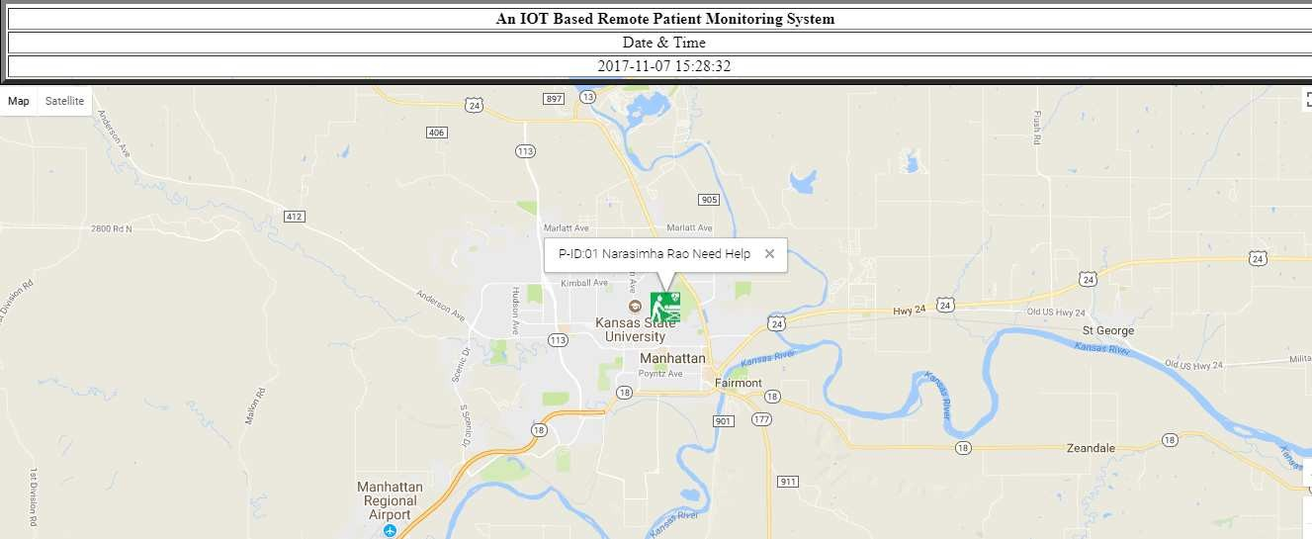

Figure 18: Patient location tracking maps page

Show History of Patient data
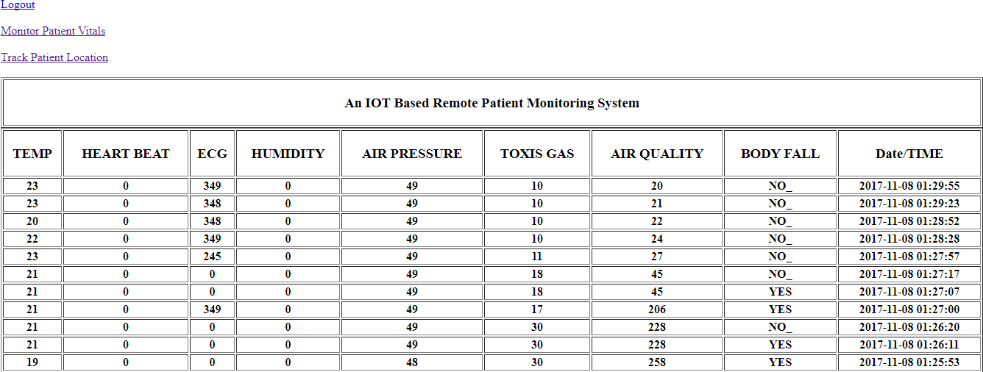
Here doctor can see history of patient vitals that has been recorded and stored in server in tabular form. This data can specifically be used by doctor to perform analysis on patient health condition to predict any irregularities in health conditions, to recommend change in medication or treatments etc. and can be used to recommend patient regular visits.

Figure 19: Patient vitals history page

System Setup
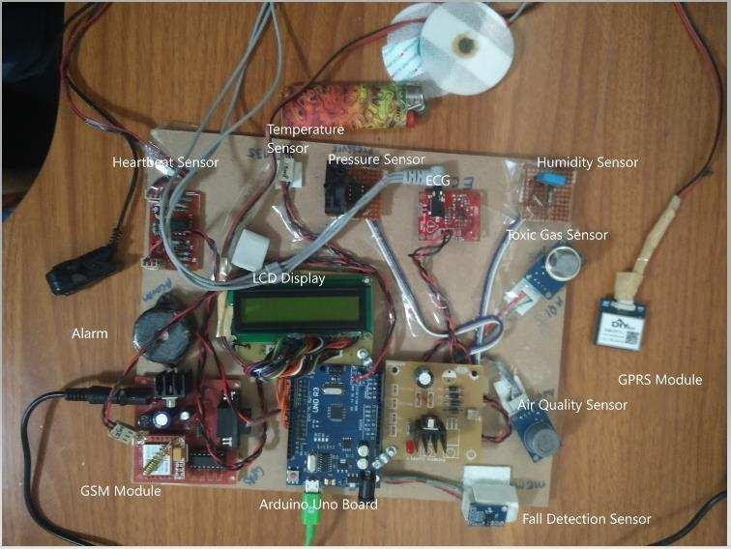

Figure 20: System setup

In the above image, it is shown complete device setup which includes Arduino micro controller board with power supply attached to it. Micro controller is connected with all the sensors which includes from right bottom Fall detection sensor (Body Movement sensor), Air quality sensor, Toxic gas sensor, Humidity sensor, ECG sensor, Pressure sensor, Temperature sensor, Heartbeat sensor. Micro controller also connected with alarm which will be used in case any of sensor data conditions are not met like temperature spikes, toxic gases etc. And GSM and GPRS modules are connected which are used to send sensor data into server and fetch location coordinates of the patient respectively. LCD is connected to micro controller which displays series

of information as soon as device is turned on which includes location coordinates and HTTP protocols which shows the network connect procedure. In case device unable to connect to network, we could see the command at which device currently halted and can be used to diagnose the issue. And finally, once device is connected to network, it displays all the patient information on it along with any irregularities of patient vitals.

Results
Email alert: Here email alert has been sent to registered email with the information about patient vitals and link to patient monitoring page.

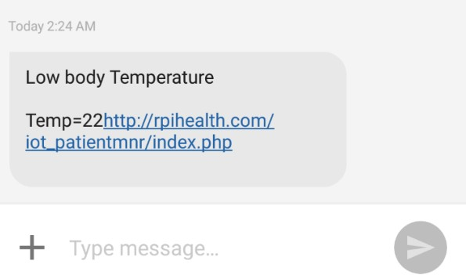
SMS alert: Here SMS alert has been sent to registered email with the information about patient vitals and link to patient monitoring page.

Chapter 11 - Testing

Software Testing is a process of executing the application with an intent to find any software bugs. It is used to check whether the application met its expectations and all the functionalities of the application is working. The final goal of testing is to check whether the application is behaving in the way it is supposed to under specified conditions. All aspects of the code are examined to check the quality of application. The primary purpose of testing is to detect software failures so that defects may be uncovered and corrected. The test cases are designed in such way that scope of finding the bugs is maximum.

Testing Levels
There are various testing levels based on the specificity of test.

    - Unit testing: Unit testing refers to tests conducted on a section of code in order to verify the functionality of that piece of code. This is done at the function level.
    - Integration Testing: Integration testing is any type of software testing that seeks to verify the interfaces between components against a software design. Its primary purpose is to expose the defects associated with the interfacing of modules.
    - System Testing: System testing tests a completely integrated system to verify that the system meets its requirements.
    - Acceptance testing: Acceptance testing tests the readiness of application, satisfying all requirements.
    - Performance testing: Performance testing is the process of determining the speed or effectiveness of a computer, network, software program or device such as response time or millions of instructions per second etc.

System Test Cases
A test case is a set of test data, preconditions, expected results and post conditions, developed for a test scenario to verify compliance against a specific requirement. I have designed and executed a few test cases to check if the project meets the functional requirements.

Test Objectives: Navigation from Login page to Monitoring page

TEST  CONDITION | INPUT  SPECIFICATION | OUTPUT  SPECIFICATION | PASS/FAIL
The user is currently on the  login page | User enters credentials and clicks  on login button | Directs to monitoring page | PASS
Table 1: Test case for navigation from Login page

Test Objectives: Navigation from Monitoring page to Google Maps page

TEST  CONDITION | INPUT  SPECIFICATION | OUTPUT  SPECIFICATION | PASS/FAIL
The user is  currently on the Monitoring page | User clicks on Track  location link on monitoring page. | Directs to google maps page | PASS
Table 2: Test case for navigation from Monitoring page to Google maps page

Test Objectives: Navigation from Google maps page to Monitoring page

TEST  CONDITION | INPUT  SPECIFICATION | OUTPUT  SPECIFICATION | PASS/FAIL
The user is  currently on the Google Maps page | User clicks on Monitoring page link | Directs to Monitoring page | PASS
Table 3: Test case for navigation from Google maps page to Monitoring page

Test Objectives: Microcontroller sends SMS alert

TEST  CONDITION | INPUT  SPECIFICATION | OUTPUT  SPECIFICATION | PASS/FAIL
Any of the patient’s vital exceeds above or below required  condition | Vitals values | System sends SMS alert immediately to doctor and guardian | PASS
Table 4: Test case for system sending SMS alert

Test Objectives: System sends emails alert

TEST  CONDITION | INPUT  SPECIFICATION | OUTPUT  SPECIFICATION | PASS/FAIL
Any of the patient’s vital exceeds above or below required  condition | Vitals values | System sends email alert immediately to doctor and guardian | PASS
Table 5: Test case for system sending email alert

Chapter 12 - Performance Testing

Performance of the system can be determined based on the system/application responsiveness under all kinds of load. Performance testing in IoT framework is little different than traditional performance testing. IoT devices generates a lot of data which is saved in server and analyzed for immediate decisions. Hence IoT system must be built for high performance and scalability. And to measure these two key attributes, it is important to understand the business value for which it is build i.e. in our case patient health data. Hence it is necessary to simulate real world models, network conditions etc.

Performance Testing Challenges in IoT
    - IoT does not have a standard protocol set to establish a connection between IoT application and devices. IoT protocols used range from HTTP, MQTT, AMQP and more. These protocols are still in early phases of development and different IoT vendors come up specific protocol standards. Since these are new protocols, current performance testing tools may or may not support them.

    - IoT devices or sensors spread across different places and use different network to connect to servers to send and receive data. As a part of PT, we can simulate devices from different locations using different networks such as 2G, 3G, 4G, Bluetooth, WIFI etc.
    - Sometimes IoT implementations require the data from device that needs to be processed at runtime and based on data received, corresponding decision to be made. These decisions are generally notifications or alerts. As a part of PT, these notifications are to be monitored i.e. time taken to generate the notification.

Performance testing approach on IoT Framework
Section | IoT PT
Simulation | On devices or sensors
Scale | Few devices to thousands of devices
Protocols | IoT uses non-standard and new protocols to communicate
Requests/Response | IoT devices create the requests and receive response as well as request and provide response
Amount of data | Sends and receives minimal data per request but data is shared continuously with time interval

Table 6: Performance test on IoT framework

Performance Test Cases
Following are the scenarios where performance testing can be performed on IoT framework.

    - Device to device communication

    - Device to server communication

    - Server to server communication

    - Network bandwidth, latency and packet loss

Based on above scenarios and focusing the scope of this project, below are the performance test cases that are tested on this project.

Test Objectives: Time taken to send data to cloud

TEST  CONDITION | OUTPUT SPECIFICATION | OPTIMAL
Time taken to send sensor data to MySQL database in cloud. | Micro controller sends data every 15 seconds to cloud. Here network plays important role and time taken to send each record is <200ms including response time. But if there is issue with network bandwidth then performance will be deteriorated as system takes additional to check network connectivity and send  data to cloud. | TRUE
Table 7: Test case checking time taken to send data to cloud

Test Objectives: Time taken to initialize GSM Module

TEST  CONDITION | OUTPUT SPECIFICATION | OPTIMAL
Time taken to | Micro controller executes set of commands on GSM | TRUE
initialize GSM | module which takes 2min to 5min once the system
module to identify | powered on. And once network is found and
network and enable | connected, system would be able to send data in a real
internet | time.
Table 8: Test case for checking time taken to initialize GSM

Test Objectives: Time taken to initialize GPRS Module

TEST  CONDITION | OUTPUT SPECIFICATION | OPTIMAL
Time taken to | Micro controller GPRS module takes 5min to 15min | TRUE
initialize GPRS | to identify coordinates once system powered on. Once
module to identify | GPRS module fetch coordinates, data is sent in real
location coordinates | time.
Table 9: Test case for checking time taken to initialize GPRS

Test Objectives: Time taken to relay patient data on web page

TEST  CONDITION | OUTPUT SPECIFICATION | OPTIMAL
Time taken to fetch  data from cloud and view it on web | Time taken to run query and relay information on web page is <500ms | TRUE
Table 10: Test case for checking time taken to fetch data from cloud and relay on web

Test Objectives: Time taken to relay patient data to Micro controller

TEST  CONDITION | OUTPUT SPECIFICATION | OPTIMAL
Time taken to fetch data from sensors to  Micro controller | Time taken to fetch data from sensor and relay information to Micro controller is <50ms | TRUE
Table 11: Test case for checking time taken to fetch data from sensor to Micro controller

Test Objectives: Time taken to send SMS alert by GSM Module

TEST  CONDITION | OUTPUT SPECIFICATION | OPTIMAL
Time taken to send SMS alert. | GSM Module sends SMS alert to doctor and caretaker in real time. | TRUE

Table 12: Test case for checking time taken to send SMS alert

Test Objectives: Time taken to send Email alert by GSM Module

TEST  CONDITION | OUTPUT SPECIFICATION | OPTIMAL
Time taken to send Email alert. | PHP API sends email alert to doctor and caretaker in real time. | TRUE

Table 13: Test case for checking time taken to send email alert

Test Objectives: Time taken to display patient history data on web page

TEST  CONDITION | OUTPUT SPECIFICATION | OPTIMAL
Time taken to | PHP API displays history of patient’s data in real | TRUE
display patient | time. This scenario has been tested with mock data
vitals history data. | dump of >100000 records and system is able to relay
 | data on web page in one second.
Table 14: Test case for checking time taken to display patient history

Fault Tolerance

There is chance that any of the above test cases fails in this architecture. Sometimes sensors may get damaged, run out of power, communication between GSM module and server may be interrupted due to unavailability of network, GPRS module may not fetch location coordinates or relaying information from board to server may delayed due to network unavailability. Fault tolerance is an ability to sustain sensor network functionalities without any interruptions due to failures in sensors, network etc.

In case sensor failures, data fetched from other sensors would be sent to server along with notification of failure in any of sensor. And if there is any GSM network failures, WIFI module can be installed along with GSM module which would effectively send the data to server without any failures in delaying and sends an email alerts in case of emergencies but not SMS alerts. In case of GPRS module failure, only last known location will be shown on web page, and SOS feature can be implemented in the device which would be used to find location of the patient.

Chapter 13 - Summary of the Study, Conclusion and Recommendations

Summary of the Study
The remote patient monitoring system was researched, designed and presented the concept of the Internet of things. Personal physiological data from the patient is collected that simulates fall detection, heartbeat, temperature, humidity, toxic gas, air quality control, pressure. The readings are collected in a simple cloud database and can be viewed remotely by a doctor or Healthcare giver. The data can also be used in research on medical issues affecting the elderly or chronically ill. On the security of the data, the database system is protected with Advanced Encryption Standard (AES). This generates the secret key which can be used to decrypt the patients’ records ensuring that only authorized personnel access the data. This safeguards the patients’ records from unauthorized users and hackers who may want to intercept.

Conclusion

The main objective of the experiment was successfully achieved. All the individual modules like Heartbeat detection module, fall detection module etc. and remote viewing module gave out the intended results.

The designed system modules can further be optimized and produced to a final single circuit. More important fact that came up during project design is that all the circuit components used in the remote health detection system are available easily.
With the development in the integrated circuit industry, Micro Electro Mechanical Systems (MEMs) and microcontrollers have become affordable, have increased processing speeds, miniaturized and power efficient. This has led to increased development of embedded systems that the healthcare specialists are adopting. These embedded systems have also been adopted in the Smartphone technology. And with increased internet penetration in most developing countries through mobile phones, and with use of Internet of things (IoT) will become adopted at a faster rate. The Remote Health Care system utilizes these concepts to come up with a system for better quality of life for people in society.
From an engineering perspective, the project has seen concepts acquired through the computer science and embedded study period being practically applied. The Electric circuit analysis knowledge was used during design and fabrication of the individual modules. Electromagnetic fields analysis used in the wireless transmission between microcontrollers and Software programming used during programming of the microcontrollers to come up with a final finished circuit system.

Recommendations on Future Work

- Physiological data collection

  - Home Ultrasound

  - Brain signal monitoring

- Remote viewing of data

  - Problems associated with having data online. Tackle Distributed denial of service. DDOS, and Data privacy/security especially of medical systems.
- IoT based Remote Patient Monitoring System can be enhanced to detect and collect data of several anomalies for monitoring purpose such as home ultrasound, Brain signal monitoring, Tumor detection etc.
- More research on problems associated with having data online, data privacy as IoT is managed and run by multiple technologies and multiple vendors are involved in it. Security algorithms and certain precautions by the users will help avoid any security related threats in IoT network.
- The interface can be designed to control which sensors can be used by consumers according to their needs.
- Web UI can be enhanced to perform several activities which include controlling the hardware, real-time graphs, history and analysis graphs to observe anomalies etc.

References

- “Arduino Architecture”
https://www.engineersgarage.com/what-is-gsm-gprs-module [Oct. 1, 2017]
- “Systems design”
https://en.wikipedia.org/wiki/Systems_design [Oct. 15, 2017]
- “UML - Standard Diagrams”
https://www.tutorialspoint.com/uml/uml_standard_diagrams.htm [Oct. 18, 2017]
- “The Internet of Things in healthcare: an overview”
https://scholar.google.com/citations?user=Y4opLB8AAAAJ&hl=en [Sept. 7, 2017]
- “Envisioning inclusive futures: technology-based assistive sensory and action substitution”
https://www.infona.pl/resource/bwmeta1.element.elsevier-3d45bfdd-fe55-359f-84e4- 674a21cae024 [Sept 4, 2017]
- “A multiple communication standards compatible IoT system for medical usage” http://ieeexplore.ieee.org/document/6577775/?reload=true [Sept 5, 2017]
- “Ubiquitous data accessing method in IoT-based information system for emergency medical
services”
https://www.deepdyve.com/lp/institute-of-electrical-and-electronics-engineers/ubiquitous- data-accessing-method-in-iot-based-information-system-for-YCZzyY5W9g [Sept 6, 2017]
- “Implementation of a medical support system considering P2P and IoT technologies”
https://www.computer.org/csdl/proceedings/cisis/2014/4325/00/4325a101-abs.html [Sept 7,
2017]
- “Acquisition and management of biomedical data using Internet of Things concepts” http://ieeexplore.ieee.org/document/7050625/ [Sept 10, 2017]
- “Real time internet application with distributed flow environment for medical IoT”
https://csdl.computer.org/csdl/proceedings/icgciot/2015/7910/00/07380578-abs.html [Sept 11,
2017]
- “Secure end-to-end communication for constrained devices in IoT-enabled ambient assisted living systems”
https://www.computer.org/csdl/proceedings/wf-iot/2015/0366/00/07389141-abs.html [Sept 11, 2017]

- “Software Testing”
https://en.wikipedia.org/wiki/Software_testing [Oct 20, 2017]
- “Sensors”
https://tkkrlab.nl/wiki/Arduino_37_sensors [Oct 20, 2017]

