MODBUS AND PROFIBUS

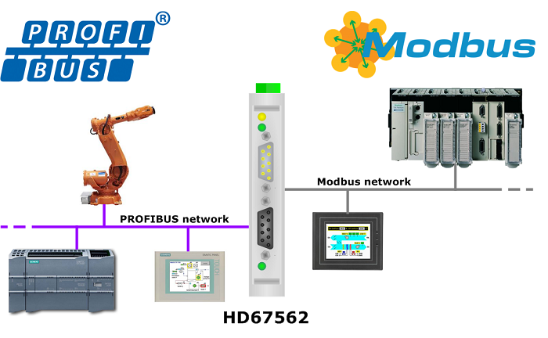

Modbus and PROFIBUS are both widely used industrial communication protocols that facilitate data exchange between various devices in industrial automation and control systems. While they serve similar purposes, there are differences between them in terms of their specifications, features, and applications.
Modbus:
Modbus is an open serial communication protocol that was developed by Modicon (now Schneider Electric) in 1979. It is a simple and widely supported protocol used for communication between devices connected over serial lines or Ethernet networks. Modbus has become a de facto standard in many industries and is often used for connecting programmable logic controllers (PLCs), human-machine interfaces (HMIs), and other automation devices.
Key features of Modbus:
Two primary variants: Modbus RTU (binary format) and Modbus ASCII (ASCII text format).
Communication can be established over various physical layers, including RS-232, RS-485, and Ethernet.
Master-slave architecture, where a master device initiates communication with one or more slave devices.
Supports multiple data types and function codes for reading and writing data, controlling devices, and gathering diagnostic information.
Limited data size per message (typically 1-256 bytes) and relatively low transmission speeds.
Modbus is a master-slave protocol, where a master device initiates communication and the slave devices respond to the requests.
It uses a simple and straightforward message structure, consisting of function codes, data, and error checking fields.
Modbus supports both point-to-point and multi-drop communication architectures. In point-to-point, there is one master and one slave, whereas in multi-drop, multiple slaves can be connected to the same network.
It is a widely adopted protocol in various industries, including manufacturing, energy, building automation, and more.
Modbus TCP/IP is an extension of Modbus that enables communication over Ethernet networks, providing higher speeds and broader connectivity options.

PROFIBUS:

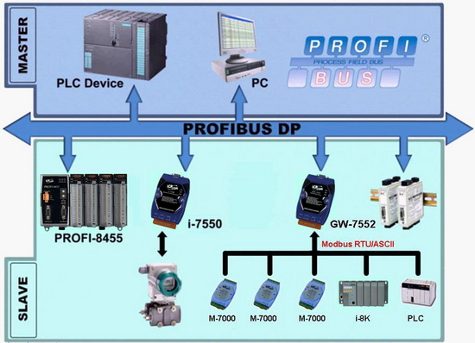
PROFIBUS (Process Field Bus) is a fieldbus communication standard developed by Siemens in the late 1980s. It is widely used in industrial automation systems, particularly in manufacturing and process control applications. PROFIBUS enables communication between various devices, such as PLCs, distributed control systems (DCS), motor drives, and sensors, over a single bus network.

Key features of PROFIBUS:
Two main variants: PROFIBUS DP (Decentralized Periphery) for fast, high-speed communication and PROFIBUS PA (Process Automation) for process automation applications.
Supports multiple physical layers, including RS-485 for DP and a two-wire bus system for PA.
Master-slave architecture, where a master device controls the communication with one or more slave devices.
Supports cyclic data exchange, alarm handling, and diagnostics.
Provides flexible data types and extensive diagnostic capabilities.
Higher transmission speeds compared to Modbus, allowing larger data payloads.
PROFIBUS is a versatile protocol that supports both process automation (PROFIBUS PA) and factory automation (PROFIBUS DP) applications.
It offers a wide range of data transmission speeds, from 9.6 kbit/s to 12 Mbit/s, depending on the variant and physical layer used.
PROFIBUS DP uses a master-slave configuration, while PROFIBUS PA employs a multi-master architecture, allowing multiple devices to communicate on the bus simultaneously.
PROFIBUS provides extensive diagnostic capabilities, enabling efficient troubleshooting and maintenance of devices on the network.
It offers advanced features such as cyclic data exchange, which enables real-time control and monitoring of devices, and acyclic communication for event-driven data transmission.
Both Modbus and PROFIBUS have their strengths and are widely used in different industrial sectors. The choice between them depends on factors such as the specific application requirements, the existing infrastructure, and the compatibility with the devices and systems being used.
Examples of Modbus:
1.In a manufacturing plant, Modbus is used to connect the PLCs to the human-machine interfaces (HMIs) for monitoring and controlling processes.
2. In the oil and gas industry, Modbus is used to connect remote terminal units (RTUs) and supervisory control and data acquisition (SCADA) systems for real-time monitoring and control of remote equipment.
3. Modbus is used in power generation plants to connect the control systems of different equipment, such as generators and turbine controllers.
4. In building automation systems, Modbus is used to connect various devices like sensors, actuators, and controllers to the central management system for efficient control and monitoring.

Examples of PROFIBUS
PROFIBUS is widely used in various industries for communication between devices. Here are some examples of how PROFIBUS is used:
1. In the automotive industry, PROFIBUS is used to connect devices such as programmable logic controllers (PLCs) and human-machine interfaces (HMIs) for controlling and monitoring assembly lines.
2. In the water and wastewater industry, PROFIBUS is used to connect controllers, sensors, and actuators in distributed control systems for process automation and monitoring.
3. In the food and beverage industry, PROFIBUS is used to connect devices such as motor drives, temperature controllers, and flow meters for precise control and monitoring of production processes.
4. PROFIBUS is also used in the pharmaceutical industry for connecting various devices in manufacturing and packaging lines.

Differences between Modbus and PROFIBUS
Here are ten key differences between Modbus and PROFIBUS, categorized by difference area:
Difference Area | Modbus | PROFIBUS
Data Transmission | Modbus uses either RS-232 or RS-485 physical layer for data transmission. | PROFIBUS uses RS-485 physical layer for data transmission.
Speed | Modbus supports data rates up to 115.2 kbps. | PROFIBUS supports data rates up to 12 Mbps.
Network Topology | Modbus supports simple master-slave architecture. | PROFIBUS supports both master-slave and peer-to-peer communication.
Addressing | Modbus uses a 16-bit address space, allowing up to 65536 devices. | PROFIBUS uses an 8-bit address space, allowing up to 126 devices.
Protocol Type | Modbus is a simple, open, and widely adopted protocol. | PROFIBUS is a complex, standardized protocol.
Flexibility | Modbus allows easy integration with existing systems. | PROFIBUS provides a higher level of flexibility and configurability.
Diagnostic Capabilities | Modbus has limited diagnostic capabilities. | PROFIBUS provides advanced diagnostic capabilities for troubleshooting.
Application | Modbus is commonly used in small to medium-sized applications. | PROFIBUS is commonly used in large-scale industrial automation applications.
Interoperability | Modbus has good interoperability with various devices. | PROFIBUS has high interoperability due to its standardized protocol.
Cost | Modbus is generally more cost-effective compared to PROFIBUS. | PROFIBUS can be more expensive due

