Machine to Machine Interaction

Defination:
Machine-to-machine, or M2M, is a broad label that can be used to describe any technology that enables networked devices to exchange information and perform actions without the manual assistance of humans. Artificial intelligence (AI) and machine learning (ML) facilitate the communication between systems, allowing them to make their own autonomous choices.
M2M technology was first adopted in manufacturing and industrial settings, where other technologies, such as SCADA and remote monitoring, helped remotely manage and control data from equipment. M2M has since found applications in other sectors, such as healthcare, business and insurance. M2M is also the foundation for the internet of things (IoT).

How M2M works

The main purpose of machine-to-machine communication is to collect data and transmit it to a network. Another goal of M2M is to automatically perform actions that are triggered by sequences of events. Additionally, the art of machine learning can be used so that machines optimize their action sequences. This application for M2M technology is closely related to artificial intelligence and is the basis for the Internet of Things.
To understand the technology, it’s helpful to know its defining characteristics. All machine-to-machine systems consist of the three main components, which are shown below.

Data endpoint (DEP)
The data endpoint is the system containing the data to be transmitted or monitored. A DEP can be a vending machine that sends inventory information to a central office, an instrument that records weather data, or a medical device that transmits patient health data. Data endpoints are microcomputer systems, meaning transmitters that are linked to a receiver. An M2M communication network can consist of numerous data endpoints and connected devices. The data endpoints send the desired information to the network, where it is transmitted to the data integration point. Individual data endpoints also communicate with each other via the network.

Communication networks
There are different types of communication networks for transferring data from one machine to another. These include the cellular networks and wireless or wired Internet connections that we use every day. However, there are also a variety of other technologies for transferring data that are primarily used in Internet of Things applications:
- RFID technology (Radio Frequency Identification) uses electromagnetic waves to enable contactless data exchanges and is mainly used in logistics. RFID is also used for payment cards and animal ID tags.
- The short-range radio standard NFC is also based on RFID. NFC is used extensively for contactless payment, paperless access control, two-factor authentication, and much more. There are even some smartphone apps and games that use NFC signals to communicate with users.
- Bluetooth is also used in the Internet of Things. This technology allows you to quickly transfer data in a piconet. Bluetooth is not only used for sending photos and videos, but also in audio systems in smart homes or hands-free systems in cars. In addition, Bluetooth plays an important role in medical equipment such as hearing aids, prostheses, or devices for monitoring blood sugar.

Data integration point (DIP)
The machine that receives the information is called the data integration point. While there can be many data endpoints, there is only one data integration point in a network. The DIP can be a server, a control center that monitors meter readings, or a web crawler that collects data on a large number of websites.

M2M applications and examples
Machine-to-machine communication is often used for remote monitoring. In product restocking, for example, a vending machine can message the distributor's network, or machine, when a particular item is running low to send a refill. An enabler of asset tracking and monitoring, M2M is vital in warehouse management systems (WMS) and supply chain management (SCM).
Utilities companies often rely on M2M devices and applications to not only harvest energy, such as oil and gas, but also to bill customers -- through the use of Smart meters -- and to detect worksite factors, such as pressure, temperature and equipment status.
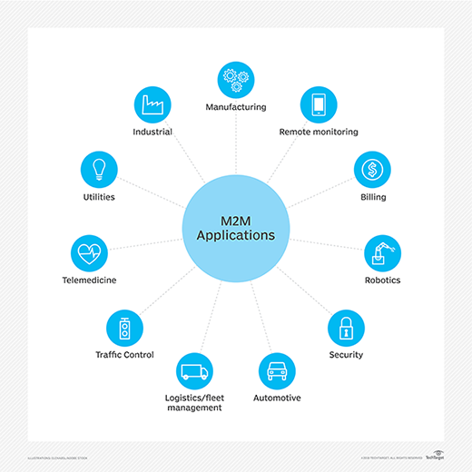
In telemedicine, M2M devices can enable the real time monitoring of patients' vital statistics, dispensing medicine when required or tracking healthcare assets.
The combination of the IoT, AI and ML is transforming and improving mobile payment processes and creating new opportunities for different purchasing behaviors. Digital wallets, such as Google Wallet and Apple Pay, will most likely contribute to the widespread adoption of M2M financial activities.
Smart home systems have also incorporated M2M technology. The use of M2M in this embedded system enables home appliances and other technologies to have real time control of operations as well as the ability to remotely communicate.
M2M is also an important aspect of remote-control software, robotics, traffic control, security, logistics and fleet management and automotive.

Key features of M2M
Key features of M2M technology include:
- Low power consumption, in an effort to improve the system's ability to effectively service M2M applications.
- A Network operator that provides packet-switched service
- Monitoring abilities that provide functionality to detect events.
- Time tolerance, meaning data transfers can be delayed.
- Time control, meaning data can only be sent or received at specific predetermined periods.
- Location specific triggers that alert or wake up devices when they enter particular areas.
- The ability to continually send and receive small amounts of data.

M2M requirements
According to the European Telecommunications Standards Institute (ETSI), requirements of an M2M system include:
- Scalability - The M2M system should be able to continue to function efficiently as more connected objects are added.
- Anonymity - The M2M system must be able to hide the identity of an M2M device when requested, subject to regulatory requirements.
- Logging - M2M systems must support the recording of important events, such as failed installation attempts, service not operating or the occurrence of faulty information. The logs should be available by request.
- M2M application communication principles - M2M systems should enable communication between M2M applications in the network and the M2M device or gateway using communication techniques, such as short message service (SMS) and IP Connected devices should also be able to communicate with each other in a peer-to-peer (P2P) manner.
- Delivery methods - The M2M system should support Unicast, anycast, multicast and broadcast communication modes, with broadcast being replaced by multicast or anycast whenever possible to minimize the load on the communication network.
- Message transmission scheduling - M2M systems must be able to control network access and messaging schedules and should be conscious of M2M applications' scheduling delay tolerance.
- Message communication path selection - Optimization of the message communication paths within an M2M system must be possible and based on policies like transmission failures, delays when other paths exist and network costs.

Advantages of M2M communication
Machine-to-machine communication has more advantages beyond faster transmission methods and the ability to schedule data transfers. These include remote control of devices, reduced need for maintenance, prevention of outages, and subsequent cost savings. Machine-to-machine also creates new business opportunities for IT services and enables companies to improve maintenance and customer services in existing lines of business.
This is the reference link of the Machine to Machine Interaction code using Arduino : https://youtu.be/fxcFNwDwZC0

