Introduction
An electric vehicle is one powered by an electric motor rather than a traditional petrol/diesel engine. This electric motor is powered by rechargeable batteries that can be charged by common household electricity.

History of electric vehicles

1900S
Electric cars are nothing new. Interest in motor vehicles increased greatly around the 1900s and at that time there were about twice as many electric cars on the road than petrol/diesel cars. It wasn’t until the 1920s that interest in electric cars dwindled. The reason was that electric cars were limited by their low top speeds and low range (just a few miles). In addition, in 1912 the electric starter motor was developed for petrol cars, eliminating the traditional drawback of petrol cars: having to use a hand crank to get the car moving!
It was Henry Ford who put the nail in the electric car coffin when his company began to mass-produce the Model T. This slashed the price of petrol cars to about half that of an electric car and so in the early 1900s almost all electric car manufacturers began to cease making them.
The limited maximum speed of electric cars (up to 30mph) limited their practicality. For most of the 20th century, British milk floats made up most of the world’s number of electric vehicles.
Interest in electric cars returned following the energy crises of the 1970s and 80s; with the availability and price of oil being shown to be increasingly volatile, people could see the potential benefits of battery-powered cars. A few big car companies brought out models and some were sold to environmentally-minded members of the public. However, in general electric vehicles were still losing out to the style and lower price of their petrol-fuelled cousins.

2000S
In the 2000s, the development of hybrid vehicles, plus another fuel crisis, saw the technology adopted by larger numbers than ever before. Tesla’s Roadster, which went on sale in 2008, was a game changer for the industry. The attractive design and extended range of the Roadster appealed to a larger market than ever before and encouraged competitors such as Nissan and Chevrolet to launch their own models.
As of September 2016, there are more than one million pure electric cars and vans owned globally.

Working Principle of Electric Vehicle and Hybrid Electric Vehicle
There are two types of EV technology: hybrid and pure electric.

FULLY ELECTRIC vehicle/car
The main parts in an electric car are a rechargeable battery, controller and electric motor. First, the battery is powered. Then the controller converts the current from DC-AC so that it can be used by the motor. The motor converts electrical energy to mechanical energy.

HYBRID vehicle/CAR
The same technology exists in hybrid cars, alongside a small gasoline engine running a generator. This powers the car at cruising speed, and batteries provide extra power when accelerating. Batteries can recharge themselves when the car is decelerating or standing still. Hybrid technology means that your petrol goes much further, saving you money and reducing environmental impact.

What are the benefits of electric cars?
- They produce no tailpipe emissions, so are better for the planet.
- They are exempt from road tax and from the London Congestion Charge.
- They often have a smoother drive than petrol cars.
- They are cheaper to run.
- Do not need much maintenance, as they have fewer moving parts.
Electric Vehicle Promotion in world
- The scenario analysis highlights the fact that it is quite possible to reach the EU 2020 targets without EVs. Meeting the longer term targets however, i.e. in 2050 (and likely intermediary targets from 2030-2050), would prove to be very difficult without EVs, and given the massive biofuel requirements, perhaps even impossible. Hydrogen based personal vehicles could form part of the solution, but at this point in time it would appear that EVs and PHEVs will be a more cost-effective solution. In addition, the production and on-board conversion of hydrogen also involves additional processes that increase the overall energy use for hydrogen vehicles relative to EVs.
- The scenarios demonstrate the likely future importance of EVs and PHEVs in the EU passenger vehicle segment. Given the lifetime of a personal vehicle, a transition to such a large segment of electrical drivetrains will take time, and equally important, will require technology advancement and cost reductions. To spur this technology advancement and cost reduction it is important that EV production and utilisation rates are increased in the upcoming years. The primary objective of the remainder of this report is therefore to identify and provide recommendations regarding EU level measures and incentives that can promote EV diffusion.
Electric Vehicle Promotion in India
- Electric Vehicles in India are still relatively new. They account for just 1 % of the total vehicle density. India unveiled the ‘National Electric Mobility Mission Plan (NEMMP) 2020’ in 2013 to address the issues of national energy security, vehicular pollution, and growth of domestic manufacturing capabilities.
- While you might see a lot of e-rickshaws zipping across the narrow lanes of Karol Bagh in Delhi, a major shift has yet to arrive towards Electric Vehicles. Only a handful of electric cars are available in the market, and the small-vehicle market is still dominated by conventional vehicles.
- “We are going to introduce electric vehicles in a very big way. We are going to make electric vehicles self-sufficient like UJALA. The idea is that by 2030, not a single petrol or diesel car should be sold in the country,” Power Minister Piyush Goyal said while addressing the CII Annual Session, 2017.
Reasons for EV development
As modern culture and technology continue to develop, the growing presence of global warming and irreversible climate change draws increasing amounts of concern from the world's population. It has only been recently, when modern society has actually taken notice of these changes and decided that something needs to change if the global warming process is to be stopped.
Countries around the world are working to drastically reduce CO₂ emissions as well as other harmful environmental pollutants. Amongst the most notable producers of these pollutants are automobiles, which are almost exclusively powered by internal combustion engines and spew out unhealthy emissions.
According to various reports, cars and trucks are responsible for almost 25% of CO₂ emission and other major transportation methods account for another 12%. With immense quantities of cars on the road today, pure combustion engines are quickly becoming a target of global warming blame. One potential alternative to the world's dependence on standard combustion engine vehicles are hybrid cars. Cost-effectiveness is also an important factor contributing to the development of an environment friendly transportation sector.

Introduction to Hybrid electric vehicle (HEV)
Consistent with the definition of hybrid above, the hybrid electric vehicle combines a gasoline engine with an electric motor. An alternate arrangement is a diesel engine and an electric motor (figure 1).
- 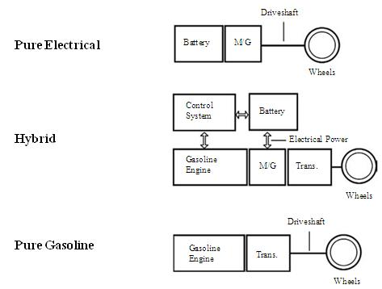

- Figure 1: Components of a hybrid Vehicle that combines a pure gasoline with a pure EV.

As shown in Figure 1, a HEV is formed by merging components from a pure electrical vehicle and a pure gasoline vehicle. The Electric Vehicle (EV) has an M/G which allows regenerative braking for an EV; the M/G installed in the HEV enables regenerative braking. For the HEV, the M/G is tucked directly behind the engine. In Honda hybrids, the M/G is connected directly to the engine. The transmission appears next in line. This arrangement has two torque producers; the M/G in motor mode, M-mode, and the gasoline engine. The battery and M/G are connected electrically.

Functions of different parts of Electric Vehicle
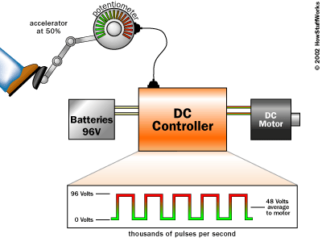
Controller
An electric vehicle motor controller is a machine that is employed to regulate the torque generated by the motors of electric vehicles by means of modifying the energy flow from the power sources to the motor.
Brushless DC motor
A brushless DC motor (known as BLDC) is a permanent magnet synchronous electric motor which is driven by direct current (DC) electricity.
Potentiometer
The signal from the potentiometers tells the controller how much power to deliver to the electric car's motor.
Battery:
A rechargeable battery is made up of secondary cells. The most familiar rechargeable battery is the leadacid battery that is commonly used as a car battery.

DC-to-DC converter
Therefore, an electric car has a normal 12-volt lead-acid battery to power all of the accessories. To keep the battery charged, an electric car needs a DC-to-DC converter. This converter takes in the DC power from the main battery array (at, for example, 300 volts DC) and converts it down to 12 volts to recharge the accessory battery. When the car is on, the accessories get their power from the DC-to-DC converter.
Vehicle Performance and transmission characteristics
Introduction
The topics covered in this chapter are as follows:
• The drive train configuration
• Various types of vehicle power plants
• The need of gearbox in a vehicle
• The mathematical model of vehicle performance
Drive train Configuration
An automotive drive train is shown in Figure 1 . It consists of:
• a power plant
• a clutch in a manual transmission or a torque converter in automatic transmission
• a gear box
• final drive
• differential shaft
• driven wheels
The torque and rotating speed from the output shaft of the power plant are transmitted to the driven wheels through the clutch or torque converter, gearbox, final drive, differential and drive shaft.
The clutch is used in manual transmission to couple or decouple the gearbox to the power plant. The torque converter in an automatic transmission is hydrodynamic device, functioning as the clutch in manual transmission with a continuously variable gear ratio.
The gearbox supplies a few gear ratios from its input shaft to its output shaft for the power plant torque-speed profile to match the requirements of the load. The final drive is usually a pair of gears that supply a further speed reduction and distribute the torque to each wheel through the differential.
- 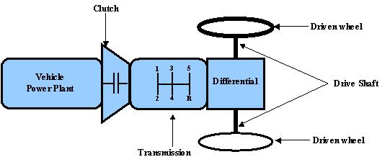
- Figure 1: An automobile power train
Vehicle power plant
There are two limiting factors to the maximum tractive effort of the vehicle:
- • Maximum tractive effort that the tire-ground contact can support
• Tractive effort that the maximum torque of the power plant can produce with the given driveline gear ratios.
The smaller of these factors will determine the performance potential of the vehicle. Usually it is the second factor that limits the vehicles performance.
The classification of various types of power plants used in a vehicle is shown in Figure 2 .
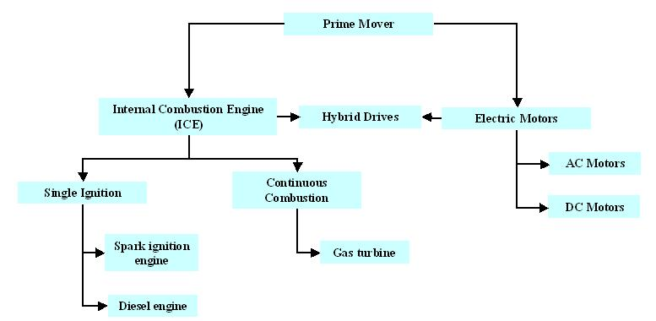
Figure 2: Classification of vehicle power plat
In selecting a suitable power plant, the following factors are considered:
- • Operating performance
• Economy
• Environment friendliness
For vehicular applications, the ideal performance characteristic of a power plant is constant power output over the full speed range. Consequently, the torque varies hyperbolically with respect to speed as shown in Figure 3 . This ideal performance characteristic of the power plant will ensure that the maximum power is available at any vehicle speed, thus resulting in optimal vehicle performance. In practice however, the torque is constrained to be constant a low speeds. This is done so as not to be over the maxima limited by the adhesion between the tyre-ground contact areas. The internal combustion (IC) engines are the most commonly used power plants for the land vehicles. In hybrid and electric vehicle technology, the electric motor is used.
- 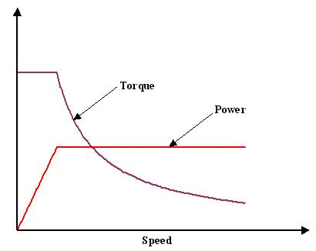
- Figure 3: Ideal performance characteristics for a vehicle power plant

Internal combustion engine
The internal combustion engines used in the vehicles are based on two principles:
• spark ignition ( petrol engines ) principle
• Diesel principle.
The key features of the ICs based spark ignition principle are:
• high power/weight ratio
• good performance
• low combustion noise.
The disadvantages of are the ICs based spark ignition principle are:
• quality of fuel required
• higher fuel consumption.
The advantages of the diesel engines are:
• low fuel consumption
• low maintenance requirement due to absence of ignition system
• low fuel quality required
The disadvantages of the diesel engine are
• high level of particulate emission
• greater weight and higher price
• higher levels of noise
The two typical characteristic curves used to describe the engine characteristic are:
• torque vs. engine speed curve at full load (100% acceleration pedal position)
• power vs. engine speed curve at full load (100% acceleration pedal position)
These two characteristic curves are shown in Figure 4. In Figure 4 the following nomenclature is used:
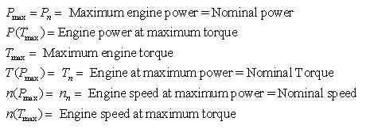
Various indices are used to facilitate comparison between different types of engine. The two most important indices are:
• torque increase (torque elasticity) defined as
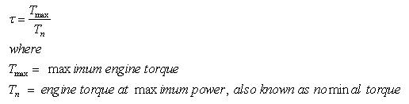 (1)
• engine speed ratio defined as
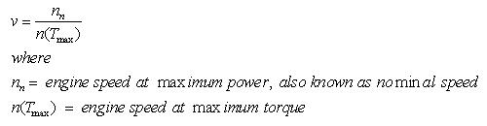 (2)

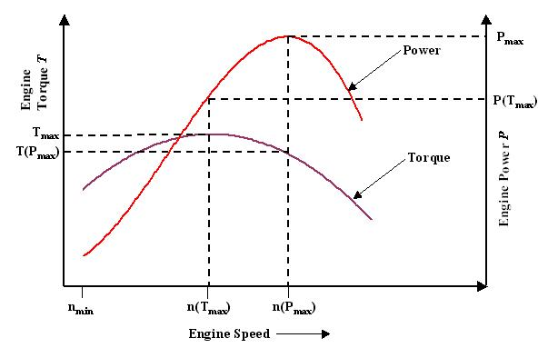
- Figure 4: Characteristic curves of an internal combustion engine
The higher value of the product τv better engine power at low and medium engine speeds. This in turn means less frequent gear changing.
Electric Motor
The electric motors have are ideal for vehicle application because of the torque speed characteristics of the motors (Figure 5). Electric motors are capable of delivering a high starting torque. It is very important to select proper type of motor with a suitable rating. For example, it is not accurate to simply refer to a 10 h.p. motor or a 15 h.p. motor, because horsepower varies with volts and amps, and peak horsepower is much higher than the continuous rating.

- 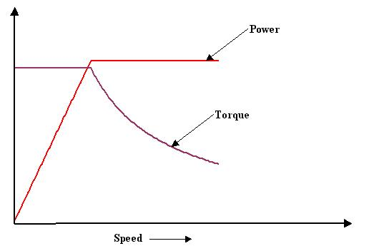
Figure 5: Torque vs. speed and power vs. speed characteristics of electric motor

Electric Powertrains

An electric vehicle (EV) is a vehicle that is powered, at least in part, by electricity. EV configurations include battery electric vehicles (BEVs) which are powered by 100% electric energy, various hybrid- electric vehicles (HEVs), and plug-in hybrid electric vehicles (PHEVs). This summary presents the differences between these basic EV configurations.

Battery Electric Vehicles

A battery electric vehicle (BEV) is a vehicle that is powered entirely on electric energy, typically a large electric motor and a large battery pack. Based on the type of transmission; the use of a clutch, gearbox, differential, and fixed gearing; and the number of battery packs and motors there are many variations on the BEV design. However, a basic BEV system is shown in Figure 1.
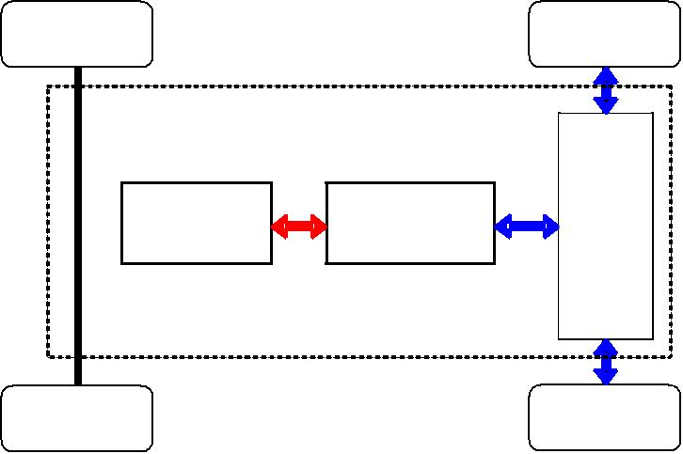

Battery | Motor/ | Transmission
Battery | Generator | Transmission

Figure 1: Schematic of a battery electric vehicle (BEV) powertrain

Mild Hybrid Electric Vehicles

Unlike a BEV, a hybrid electric vehicle (HEV) relies on two energy sources, usually an internal combustion engine and an electric battery and motor/generator. A Mild Hybrid is the least electrified type of HEV. A Mild Hybrid is a conventional internal combustion engine (ICE) vehicle with an oversized starter motor that can also be used as a generator, usually called an integrated starter-generator (ISG) or a belted alternator starter (BAS), and an oversized battery that powers and is recharged by the motor. A simple Mild Hybrid system is shown in Figure 2. In a Mild Hybrid, the engine must always be on while the vehicle is moving. However, the motor/generator can be used to enable idle stop in which the engine is turned off while the vehicle is at idle. The motor/generator can be used at high loads to assist the engine and increase vehicle performance. At low loads, it increases load on the engine and recharges the electric battery.

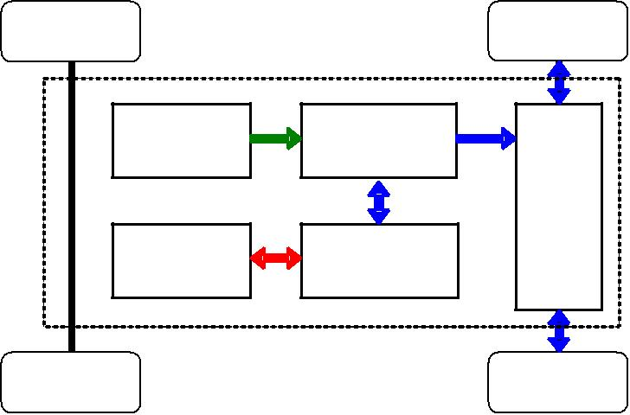

Liquid | Engine | Transmission
Fuel | Engine | Transmission
Battery | Motor/ | Transmission
Battery | Generator | Transmission

Figure 2: Schematic of a Mild Hybrid powertrain

Series Hybrid Electric Vehicles

In a Series Hybrid there is a single path to power the wheels of the vehicle, but two energy sources. As shown in figure 3, the fuel tank feeds an engine which is coupled to a generator to charge the battery which provides electrical energy to a motor/generator to power the wheels through a transmission although a direct coupling can also be used. The motor/generator is also used to recharge the battery during deceleration and braking.
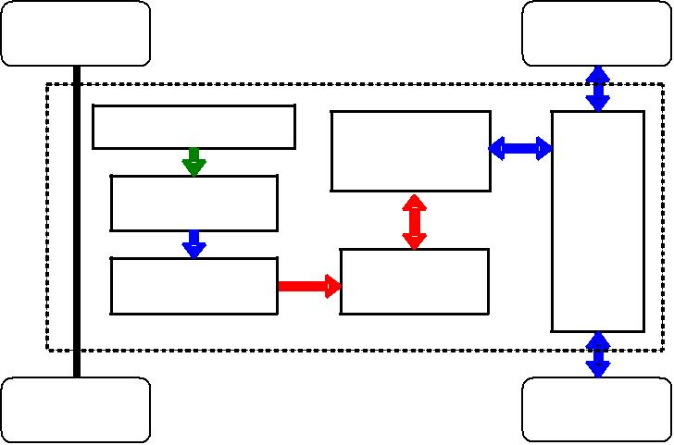

Liquid Fuel | Motor/ | Transmission
Engine | Generator | Transmission
Generator | Battery | Transmission

Figure 3: Schematic of a Series Hybrid powertrain

Although most Series Hybrids use an ICE, it is also possible to design a Series Hybrid using a Fuel Cell powered by hydrogen, creating a Fuel Cell Electric Vehicle (FCEV).

Parallel Hybrid Electric Vehicles

In a Parallel Hybrid, there are two parallel paths to power the wheels of the vehicle: an engine path and an electrical path, as shown in figure 4. The transmission couples the motor/generator and the engine, allowing either, or both, to power the wheels. Control of a Parallel Hybrid is much more complex that for a Series Hybrid because of the need to efficiently couple the motor/generator and engine in a way that maintains driveability and performance.
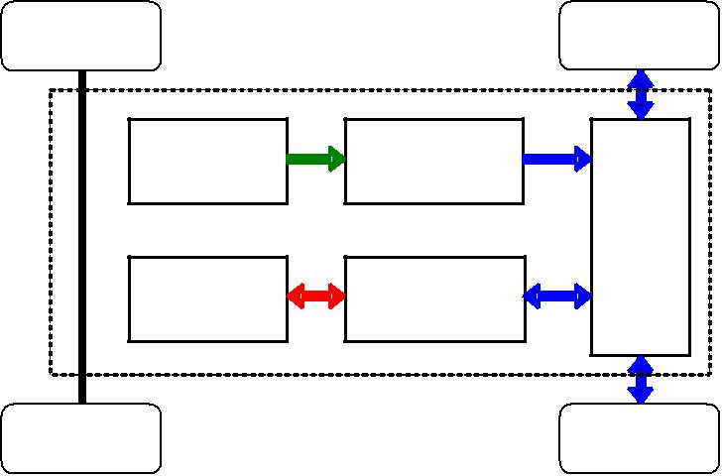

Liquid | Engine | Transmission
Fuel | Engine | Transmission
Battery | Motor/ | Transmission
Battery | Generator | Transmission

Figure 4: Schematic of a parallel hybrid powertrain

Series-Parallel Hybrid Electric Vehicles

A Series-Parallel HEV has both Series and Parallel energy paths. As shown in figure 5, a system of motors and/or generators that sometimes includes a gearing or power split device couples allows the engine to recharge the battery. Variations on this configuration can be very complex or simple, depending on the number of motors/generators and how they are used. These configurations can be classified as Complex hybrids (such as the Toyota Prius and Ford Escape Hybrids), Split-Parallel hybrids, or Power-Split hybrids.

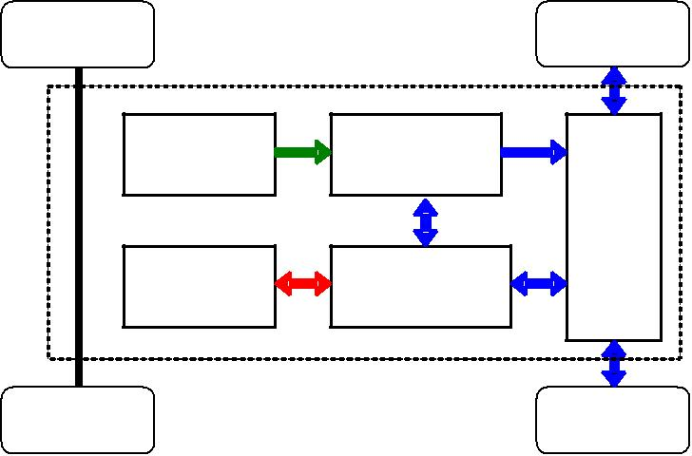

Liquid | Engine | Transmission
Fuel | Engine | Transmission
Battery | Motors/ | Transmission
Battery | Generators | Transmission

Figure 5: Schematic of a series-parallel hybrid powertrain

Plug-in Hybrid Electric Vehicles

A plug-in hybrid electric vehicle (PHEV) is an HEV that can be plugged-in or recharged from wall electricity. PHEVs are distinguished by much larger battery packs when compared to other HEVs. The size of the battery defines the vehicle’s All Electric Range (AER), which is generally in the range of 30 to 50 miles. PHEVs can be of any hybrid configuration. Although no PHEVs are available on the market today, a number of companies have begun to sell conversion kits and services to convert a standard HEV into a PHEV by adding additional battery capacity and modifying the vehicle controller and energy management system.

Module 2

Basic Architecture of Electric Drive Trains

Introduction

The topics covered in this chapter are as follows:

- Electric Vehicle (EV) Configuration

- EV alternatives based on drivetrains

- EV alternatives based on power source configuration

- Single and Multi-motor drives

- In wheel drives

Electric Vehicle (EV) Configurations

Compared to HEV, the configuration of EV is flexible. The reasons for this flexibility are:

- The energy flow in EV is mainly via flexible electrical wires rather than bolted flanges or rigid shafts. Hence, distributed subsystems in the EV are really achievable.

- The EVs allow different propulsion arrangements such as independent four

wheels and in wheel drives.

In Figure 1 the general configuration of the EV is shown. The EV has three major subsystems:

- Electric propulsion

- Energy source

- Auxiliary system

The electric propulsion subsystem comprises of:

- The electronic controller

- Power converter

- Electric Motor (EM)

- Mechanical transmission

- Driving wheels

The energy source subsystem consists of

- The energy source (battery, fuel cell, ultracapacitor)

- Energy management unit

- Energy refueling unit

The auxiliary subsystem consists of

- Power steering unit

- Temperature control unit

- Auxiliary power supply

In Figure 1 the black line represents the mechanical link, the green line represents the electrical link and the blue line represents the control information communication. Based on the control inputs from the brake and accelerator pedals, the electronic controller provides proper control signals to switch on or off the power converter which in turn regulates the power flow between the electric motor and the energy source. The backward power flow is due to regenerative braking of the EV and this regenerative energy can be stored provided the energy source is receptive.

The energy management unit cooperates with the electronic controller to control regenerative braking and its energy recovery. It also works with the energy-refueling unit to control refueling and to monitor usability of the energy source.

The auxiliary power supply provides the necessary power with different voltage levels for all EV auxiliaries, especially the temperature control and power steering units.
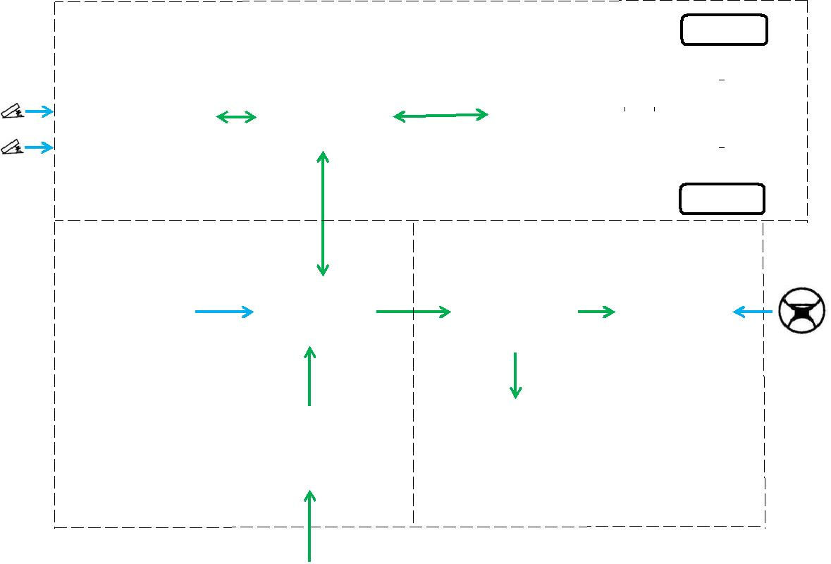
 | Electric propulsion subsystem |  |  |  |  |  |  |  |  |  |  |  |  |  | Wheel
Brake
Brake | Electronic |  |  | Power |  |  |  |  |  | Electric |  |  |  |  | Mechanical
 | controller |  |  | converter |  |  |  |  |  | motor |  |  |  |  | transmission
Accelerator
 |  |  |  |  |  |  |  |  |  |  |  |  |  |  | Wheel
 | Energy |  |  | Energy |  |  |  |  | Auxiliary |  |  |  |  | Power
 | management |  |  |  |  |  |  |  |  | Power |  |  |  | steering
 | management |  |  | source |  |  |  |  |  | Power
 | unit |  |  |  |  |  |  |  |  | Supply |  |  |  |  | unit
 | unit |  |  |  |  |  |  |  |  | Supply |  |  |  |  |  |  |  | Steering
 |  |  |  |  |  |  |  |  |  |  |  |  |  |  |  |  |  | wheel
 |  |  |  | Energy |  |  |  |  | Temperature
 |  |  |  | Energy |  |  |  |  |  | control
 |  |  |  | refueling
 | Energy source |  |  | unit |  |  |  |  |  | unit
 | subsystem |  |  |  |  |  |  |  |  | Auxiliary subsystem

Energy source

Figure 1:General Configuration of a Electric Vehicle [1]

In modern EV’s configuration:

- Three phase motors are generally used to provide the traction force

- The power converter is a three-phase PWM inverter

- Mechanical transmission is based on fixed gearing and a differential

- Li-ion battery is typically selected as the energy source

The typical setup of the EV is shown in Figure 2.
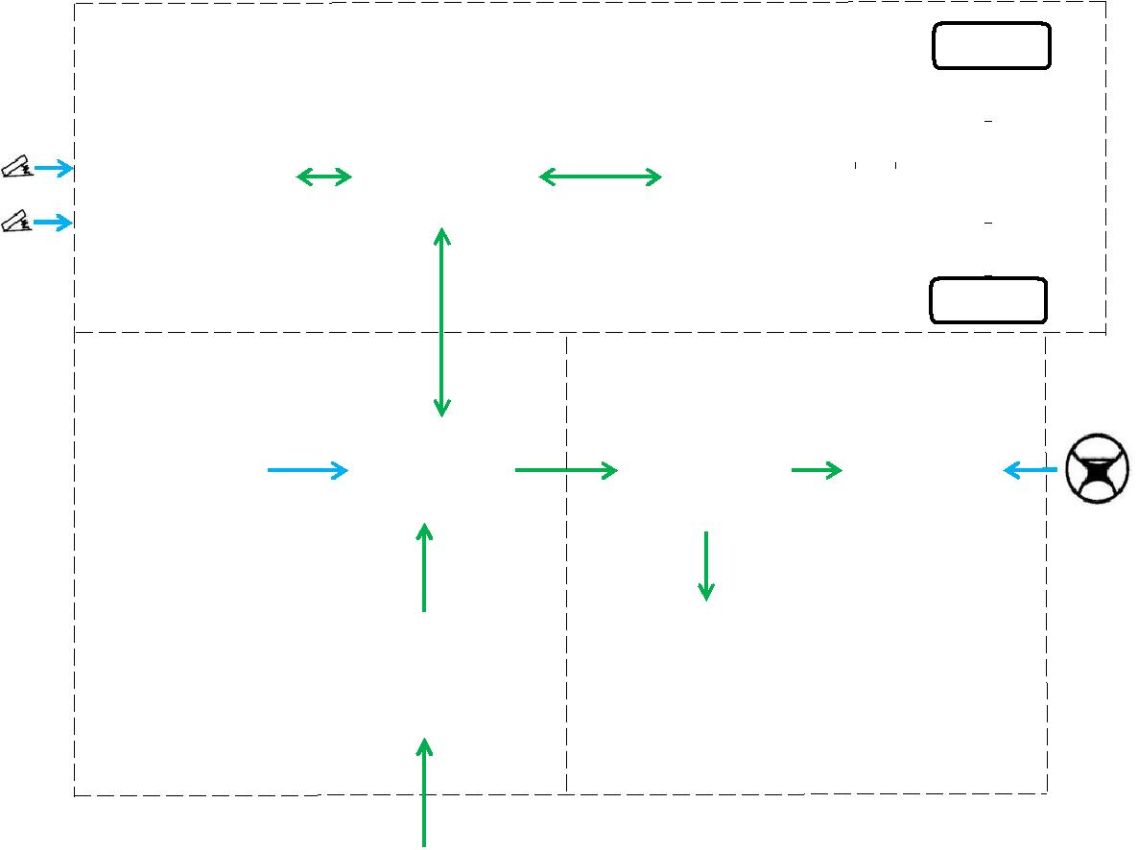
 | Electric propulsion subsystem |  |  |  |  |  |  |  | Wheel
Brake
Brake |  | Electronic |  |  | 3-phase |  | 3-phase |  | Mechanical
 |  | Electronic |  |  | PWM |  | 3-phase
 |  | controller |  |  | PWM |  | 3-phase |  | transmission
 |  | controller |  |  | PWM |  | AC motor
 |  | controller |  |  | inverter |  | AC motor
Accelerator
 |  |  |  |  |  |  |  |  | Wheel

Energy |  |  |  |  |  |  | Auxiliary |  |  |  | Power
management |  |  | Battery Pack |  |  |  | Power |  |  |  | steering
unit |  |  |  |  |  |  | Supply |  |  |  | unit | Steering
 |  |  |  |  |  |  |  |  |  |  |  | wheel
 |  |  | Energy |  |  |  | Temperature
 |  |  | refueling |  |  |  | control
Energy source |  |  | unit |  |  |  | unit
subsystem |  |  |  |  |  |  |  | Auxiliary subsystem

Figure 2:Typical Configuration of a Electric Vehicle [1]

Electric Vehicle (EV) Drivetrain Alternatives Based on Drivetrain Configuration

There are many possible EV configurations due the variations in electric propulsion and energy sources. Based on these variations, six alternatives are possible as shown in Figure 3. These six alternatives are

- In Figure 3a a single EM configuration with gearbox (GB) and a clutch is shown. It consists of an EM, a clutch (C), a gearbox, and a differential (D). The clutch enables the connection or disconnection of power flow from EM to the wheels. The gear consists of a set of gears with different gear ratios. With the use of clutch and gearbox, the driver can shift the gear ratios and hence the torque going to the wheels can be changed. The wheels have high torque low speed in the lower gears and high-speed low torque in the higher gears.

- In Figure 3b a single EM configuration without the gearbox and the clutch is shown. The advantage of this configuration is that the weight of the transmission is reduced. However, this configuration demands a more complex control of the EM to provide the necessary torque to the wheels.

- Figure 3c shows a configuration of EV using one EM. It is a transverse front EM front wheel drive configuration. It has a fixed gearing and differential and they are integrated into a single assembly.

- In Figure 3d a dual motor configuration is shown. In this configuration the differential action of an EV when cornering can be electronically provided by two electric motors.

- In order to shorten the mechanical transmission path from the EM to the driving wheel, the EM can be placed inside a wheel. This configuration is called in-wheel drive. Figure 3e shows this configuration in which fixed planetary gearing is employed to reduce the motor speed to the desired wheel speed.

- In Figure 3f an EV configuration without any mechanical gearing is shown. By fully abandoning any mechanical gearing, the in-wheel drive can be realized by installing a low speed outer-rotor electric motor inside a wheel.
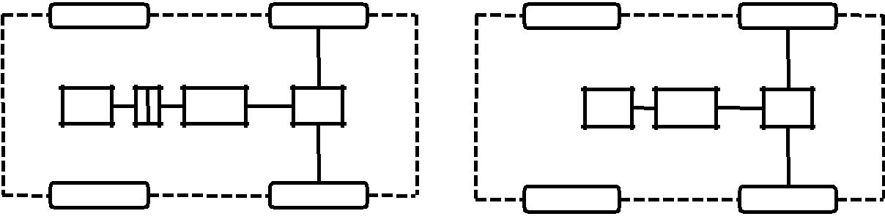

 | C
M | GB | D | MFG | D

Figure 3a: EV configuration with clutch, gearbox and | Figure 3b: EV configuration without clutch and gearbox
differential [1] | [1]
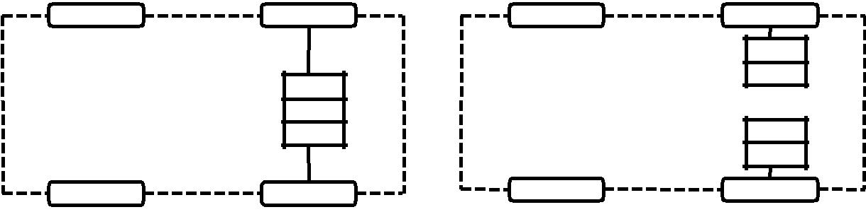

M
FG
D

Figure 3c:EV configuration with clutch, gearbox and differential [1]

FG
M

M
FG

Figure 3d:EV configuration with two EM [1]

Electric Vehicle (EV) Drivetrain Alternatives Based on Power Source

Configuration

Besides the variations in electric propulsion, there are other EV configurations due to

variations in energy sources. There are five configurations possible and they are:

- Configuration 1: It is a simple battery powered configuration, Figure 4a. The battery may be distributed around the vehicle, packed together at the vehicle back or located beneath the vehicle chassis. The battery in this case should have reasonable specific energy and specific power and should be able to accept regenerative energy during braking. In case of EVs, the battery should have both high specific energy and specific power because high specific power governs the driving range while the high power density governs the acceleration rate and hill climbing capability.

- Configuration 2: Instead of two batteries, this design uses two different batteries, Figure 4b. One battery is optimized for high specific energy and the other for high specific power.

- Configuration 3: In this arrangement fuel cell is used, Figure 4c. The battery is an energy storage device, whereas the fuel cell is an energy generation device. The operation principle of fuel cells is a reverse process of electrolysis. In reverse and electrolysis, hydrogen and oxygen gases combine to form electricity and water. The hydrogen gas used by the fuel cell can be stored in an on-board tank whereas oxygen gas is extracted from air. Since fuel cell can offer high specific energy but cannot accept regenerative energy, it is preferable to combine it with battery with high specific power and high-energy receptivity.

- Configuration 4: Rather than storing it as a compressed gas, a liquid or a metal hydride, hydrogen can be can be generated on-board using liquid fuels such as methanol, Figure 4d. In this case a mini reformer is installed in the EV to produce necessary hydrogen gas for the fuel cell.

- Configuration 5: In fuel cell and battery combination, the battery is selected to provide high specific power and high-energy receptivity. In this configuration a battery and supercapacitor combination is used as an energy source, Figure 4e. The battery used in this configuration is a high energy density device whereas the supercapacitor provides high specific power and energy receptivity. Usually, the supercapacitors are of relatively low voltage levels, an additional dc-dc power converter is needed to interface between the battery and capacitor terminals.
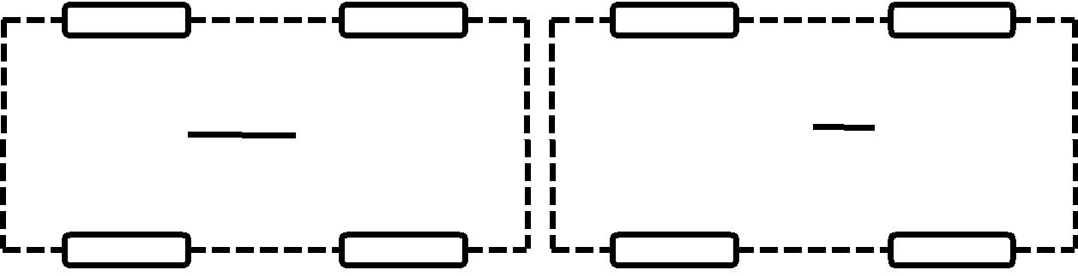

 |  |  |  | B
B |  | P |  |  |  |  | P
B |  | P |  | B |  |  | P

Figure 4a: EV configuration with battery source [1] Figure 4b: EV configuration with two battery sources [1]
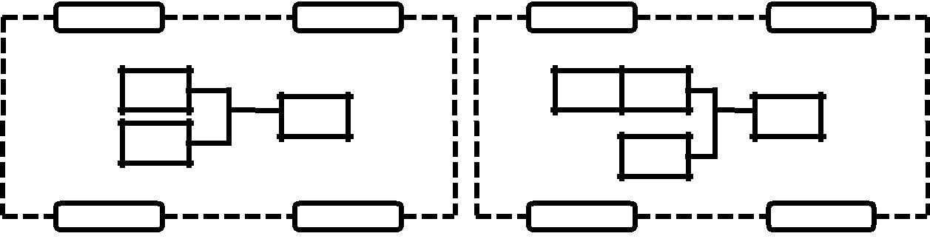

FC | R | FC
P |  | P
B |  | B
Figure 4c: EV configuration with battery and fuel cell | Figure 4d: EV configuration with multiple energy sources
sources [1] |  | [1]
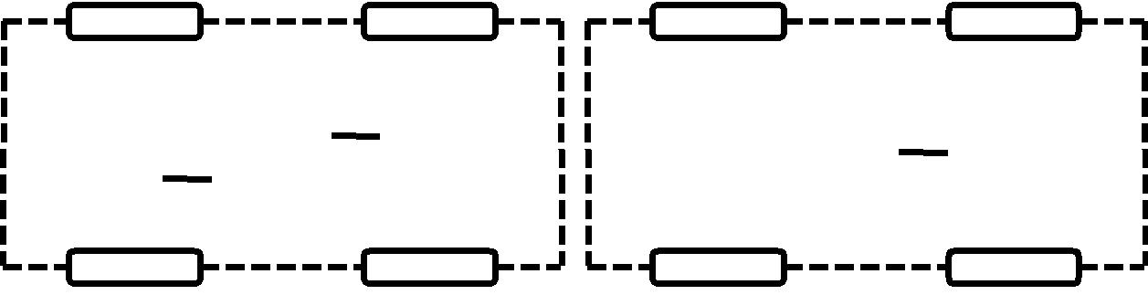

 |  | B
 |  |  |  |  |  |  |  | P |  | B |  |  |  |  | P
 | C |  |  |  | P |  |  | P |  |  |  |  |  |  | P
 |  |  |  |  |  |  |  |  |  | FW |  | P

Figure 4e: EV configuration with battery and capacitors sources [1]

Figure 4f: EV configuration with battery and flywheel sources

Single and Multi-motor Drives

A differential is a standard component for conventional vehicles. When a vehicle is rounding a curved road, the outer wheel needs to travel on a larger radius than the inner wheel. Thus, the differential adjusts the relative speeds of the wheels. If relative speeds of the wheels are not adjusted, then the wheels will slip and result in tire wear, steering difficulties and poor road holding. In case of EVs, it is possible to dispense the mechanical differential by using two or even four EMs. With the use of multiple EMs, each wheel can be coupled to an EM and this will enable independent control of speed of each wheel in such a way that the differential action can be electronically achieved. In Figure 5, a typical dual motor drive with an electronic differential is shown.
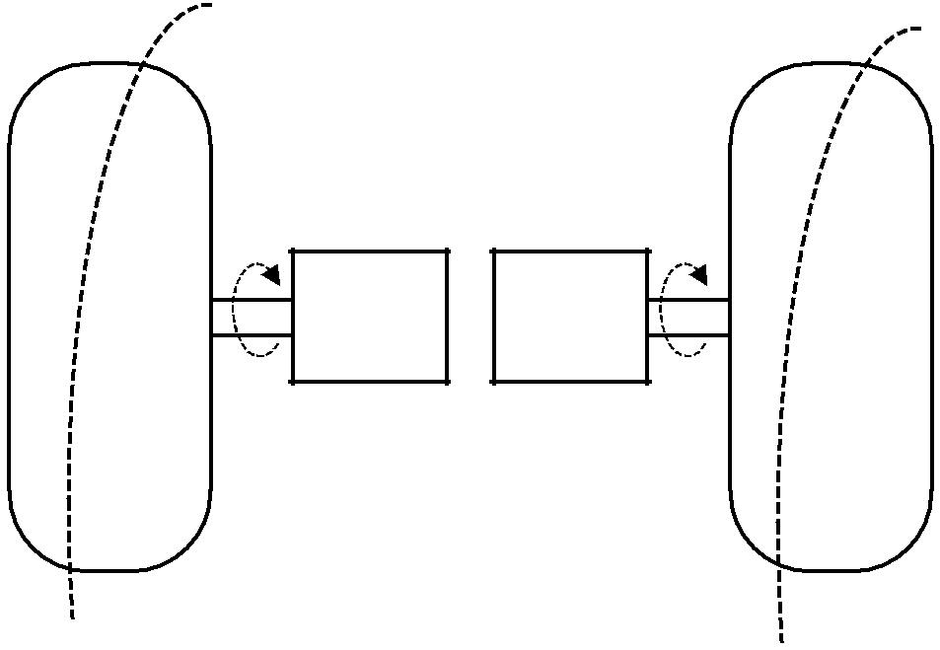
Wheel | Wheel
ω > ω
out | in
ω | ω
ω | in
out
EM 1 | EM 2
with fixed | with fixed
gearing | gearing

Figure 5: Differential action [1]

In Wheel Drives

By placing an electric motor inside the wheel, the in wheel motor has the advantage that the mechanical transmission path between the electric motor and the wheel can be minimized. Two possible configurations for in wheel drives are:

- When a high-speed inner-rotor motor is used (Figure 6a) then a fixed speed-reduction gear becomes necessary to attain a realistic wheel speed. In general, speed reduction is achieved using a planetary gear set. This planetary gear is mounted between the motor shaft and the wheel rim. Usually this motor is designed to operate up to 1000 rpm so as to give high power density.

- In case outer rotor motor is used (Figure 6b), then the transmission can be

totally removed and the outer rotor acts as the wheel rim and the motor speed is equivalent to the wheel speed and no gears are required.

The tradeoffs of the high-speed inner rotor motor are:

- It has the advantage of smaller size, lighter weight and lower cost

- Needs additional planetary gearset

The tradeoffs of outer-rotor motor are

- Low speed and hence does not need additional gears

- The drawbacks are larger size, weight and cost because of the low speed design.

Inner-rotor |  | Outer-rotor
 | Tire |  | Tire
 |  |  | Rim
 | Rim |  | PM
Brake |  |  | PM
Brake |  |  | Motor Winding
 | Wheel | Brake | Motor Winding
Motor Winding |  |  | Wheel
 | Bearing |  | Encoder
PM | Planetary gear set | Bearing | Encoder
PM | Encoder | Bearing | Wheel
 | Bearing
Motor Winding |  |  | Motor Winding
Brake |  | Brake
Brake | Wheel
 | Wheel |  | PM
 | Rim |  | Rim
 | Tire |  | Tire
Figure 6a: Inner rotor In Wheel drive [1] |  |  | Figure 6b: Outer rotor In Wheel drive [1]
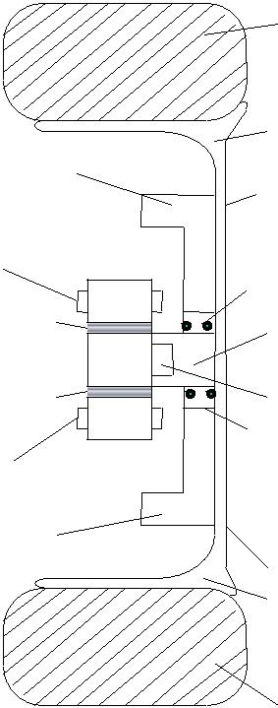
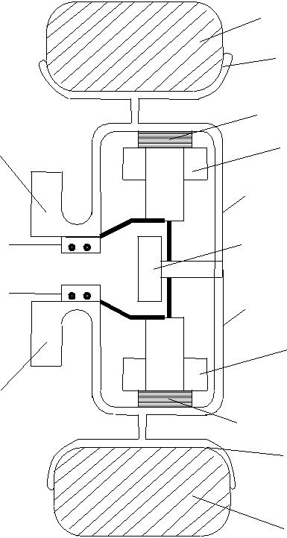

Considerations of EMs used in EVs

The requirements of EMs used in EVs are:

- Frequent start/stop

- High rate of acceleration and deceleration

- High torque low speed hill climbing

- Low torque cruising

- Very wide speed range of operation

The EMs for EVs are unique and their major differences with respect to industrial motors in load requirement, performance specification and operating environment are as follows:

- EV motors need to produce the maximum torque that is four to five times of the rated torque for acceleration and hill climbing, while industrial motors generally offer the maximum torque that is twice of the rated torque for overload operation

- EV motors need to achieve four to five times the base speed for highway cruising, while industrial motors generally achieve up to twice the base speed for constant power operation

- EV motors require high power density as well as good efficiency map (high efficiency over wide speed and torque ranges), while industrial motors are generally optimized to give high efficiency at a rated point.

- EV motors need to be installed in mobile vehicles with harsh operating conditions such as high temperature, bad weather and frequent vibration, while industrial motors are generally located in fixed places.

Energy Storage

Batteries

Introduction

A battery consists of two or more electric cells joined together. The cells convert chemical energy to electrical energy. The cells consist of positive and negative electrodes joined by an electrolyte. It is the chemical reaction between the electrodes and the electrolyte which generates DC electricity. In the case of secondary or rechargeable batteries, the chemical reaction can be reversed by reversing the current and the battery returned to a charged state.

The ‘lead acid’ battery is the most well-known battery.

The first electric vehicle using rechargeable batteries preceded the invention of the rechargeable lead acid by quarter of a century, and there are a very large number of materials and electrolytes that can be combined to form a battery. However, only a relatively small number of combinations have been developed as commercial rechargeable electric batteries suitable for use in vehicles. At present these include lead acid, nickel iron, nickel cadmium, nickel metal hydride, lithium polymer and lithium iron, sodium sulphur and sodium metal chloride.

In this lecture the different types of the energy storage devices are presented. The following topics are covered in this lecture:

- Overview of Batteries

- Battery Parameters

- Lead acid batteries

- Lithium ion batteries

- Metal air batteries

- Battery Charging

Overview of Batteries

From the electric vehicle designer’s‘blackpoint box’ which has a range of performance criter

- specific energy

- energy density

- specific power

- typical voltages

- amp hour efficiency

- energy efficiency

- commercial availability

- cost, operating temperatures

- self-discharge rates

- number of life cycles

- recharge rates

The designer also needs to understand how energy availability varies with regard to:

- ambient temperature

- charge and discharge rates

- battery geometry

- optimum temperature

- charging methods

- cooling needs.

However, at least a basic understanding of the battery chemistry is very important, otherwise the performance and maintenance requirements of the different types, and most of the disappointments connected with battery use, such as their limited life, self-discharge, reduced efficiency at higher currents.

Battery Parameters

• Cell and battery voltages

All electric cells have nominal voltages which gives the approximate voltage when the cell is delivering electrical power. The cells can be connected in series to give the overall voltage required. The ‘internalbatteryresistance’shown in Figure 1. The battery is represented as having a fixed voltage E, but the voltage at the terminals is a different voltage V , because of the voltage across the internal resistance R. Assuming that a current I is flowing out of the battery, as in Fig. 1, then by basic circuit theory we can say that:

V =E −IR | (1)

 |  |  | I
 | R | V
 |  | V | External
E |  |  | Load
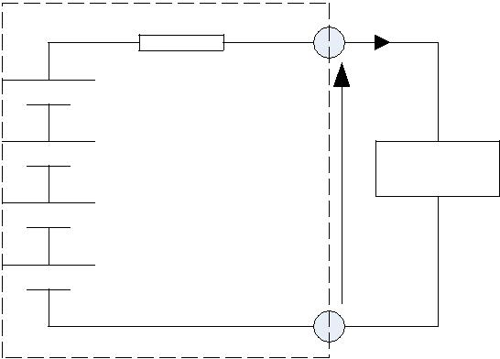

Fig. 1 Simple equivalent circuit model of a battery. This battery is composed of six cells

• Charge (or Ahr) capacity

The electric charge that a battery can supply is clearly a most crucial parameter. The SI unit for this is the Coulomb, the charge when one Amp flows for one second. The capacity of a battery might be, say, 10Amphours. This means it can provide 1Amp for 10 hours.

• Energy stored

The energy stored in a battery depends on its voltage, and the charge stored. The SI unit is the Joule, but this is an inconveniently small unit, and so we use the Whr instead.

Energy in Whr =V ×Ahr | (2)

• Specific energy

Specific energy is the amount of electrical energy stored for every kilogram of battery mass. It has units of Wh.kg⁻¹.

• Energy density

Energy density is the amount of electrical energy stored per cubic metre of battery volume. It normally has units of Wh.m⁻³.

• Specific power

Specific power is the amount of power obtained per kilogram of battery. It is a highly variable and rather anomalous quantity, since the power given out by the battery depends far more upon the load connected to it than the battery itself.

• Ahr (or charge) efficiency

In an ideal world a battery would return the entire charge put into it, in which case the amp hour efficiency is 100%. However, no battery does; its charging efficiency is less than 100%. The precise value will vary with different types of battery, temperature and rate of charge. It will also vary with the state of charge.

• Energy efficiency

This is another very important parameter and it is defined as the ratio of electrical energy supplied by a battery to the amount of electrical energy required to return it to the state before discharge.

• Self-discharge rates

Most batteries discharge when left unused, and this is known as self-discharge. This is important as it means some batteries cannot be left for long periods without recharging. The rate varies with battery type, and with other factors such as temperature; higher temperatures greatly increase self-discharge.

• Battery temperature, heating and cooling needs

Although most batteries run at ambient temperature, some run at higher temperatures and need heating to start with and then cooling when in use. In others, battery performance drops off at low temperatures, which is undesirable, but this problem could be overcome by heating the battery. When choosing a battery the designer needs to be aware of battery temperature, heating and cooling needs, and has to take these into consideration during the vehicle design process.

• Battery life and number of deep cycles

Most rechargeable batteries will only undergo a few hundred deep cycles to 20% of the battery charge. However, the exact number depends on the battery type, and also on the details of the battery design, and on how the battery is used. This is a very important figure in a battery specification, as it reflects in the lifetime of the battery, which in turn reflects in electric vehicle running costs.

Lead Acid Batteries

• Introduction

The best known and most widely used battery for electric vehicles is the lead acid battery. Lead acid batteries are widely used in IC engine vehicles and as such are well known. However for electric vehicles, more robust lead acid batteries that withstand deep cycling and use a gel rather than a liquid electrolyte are used. These batteries are more expensive to produce.

In the lead acid cells the negative plates have a spongy lead as their active material, whilst the positive plates have an active material of lead dioxide. The plates are immersed in an electrolyte of dilute sulphuric acid. The sulphuric acid combines with the lead and the lead oxide to produce lead sulphate and water, electrical energy being released during the process. The overall reaction is:

Pb +PbO₂ +2H ₂ SO₄ ↔2PbSO₄ 2+H ₂O | (3)

The reactions on each electrode of the battery are shown in Fig. 2. In the upper part of the diagram the battery is discharging. Both electrode reactions result in the formation of lead sulphate. The electrolyte gradually loses the sulphuric acid, and becomes more dilute.

When being charged, as in the lower half of Figure 2, the electrodes revert to lead and lead dioxide. The electrolyte also recovers its sulphuric acid, and the concentration rises. The lead acid battery is the most commonly used rechargeable battery in anything but the smallest of systems. The main reasons for this are that the main constituents (lead, sulphuric acid, a plastic container) are not expensive, that it performs reliably, and that it has a comparatively high voltage of about 2V per cell. The overall characteristics of the battery are given in Table I.

The figure given in Table I of 0.per022cell is Ωarule of thumb figure taken from a range of good quality traction batteries. A good estimate of the internal resistance of a lead acid battery is thus:

0.022
R =No. of Cells × Ohms (4)

^{C}10

Table I Nominal battery parameters for lead acid batteries

Specific energy |  | 20–35 Wh.kg−1 depe
Energy density |  | 54–95Wh.L−1
Specific power |  | ∼250 | W.kg−1 | befo
 |  | very greatly
Nominal | cell | 2V
voltage
Amphour |  | ∼80%, varies with rate of discharge &
efficiency |  | temp.
Internal resistance |  | Extremely low, ∼0.022_ per cell for 1
 |  | Amphour cell
Commercially |  | Readily | availablefrom | several
available |  | manufacturers
Operating |  | Ambient, poor performance in extreme
temperature |  | cold
Self-discharge |  | ∼2% per day, but see text below
Number of | life | Up to 800 to 80% capacity
cycles
Recharge time |  | 8 h (but 90% recharge in 1 h possible)

Positive electrode changes from lead to lead sulphate
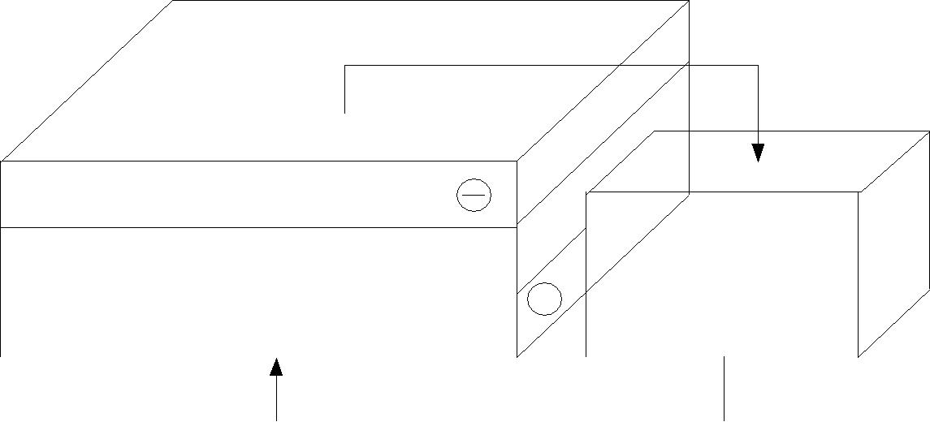

Pb +SO ²⁻ →PbSO +2e
4 | 4

 | 2 H | SO → 4 H ⁺+2SO²
2 |  |  | 4 |  | 4 |  |  |  |  |  | Load
 | PbO +4 H ⁺ |  | +SO ² ⁻ 2+e ⁻ |  |  |  |  |  |  |  | eg Electric Motor
 |  |  |  |  | PbSO→ | 2H+O
2 |  |  | 4 |  | 4 | 2
Negative electrode changes from lead peroxide to lead sulphate |  |  |  |  |  |  |  |  |  |  | Electrons flow round
 |  |  |  |  |  |  |  |  |  |  | the external circuit

Reactions during the discharge of the lead acid battery.

Note that the electrolyte loses suphuric acid and gains water.

Positive electrode changes back from lead sulphate to lead.

 | PbSO +2e ⁻ →Pb +SO²
 |  |  | 4 |  |  | 4
2 H | ₂ O → 4 H | + | +2O | 2 − | + |  | 2− | →2H ₂ SO₄
2 H | ₂ O → 4 H |  | +2O | ; 4 H | +2SO |  | 4 |  |  |  | External DC Power
 |  |  |  |  |  |  |  |  |  |  |  |  | Supply
 | PbSO +2O ² ⁻ →PbO |  |  |  |  | +SO ² ⁻ |  | 2+e
 | 4 |  |  |  | 2 |  | 4
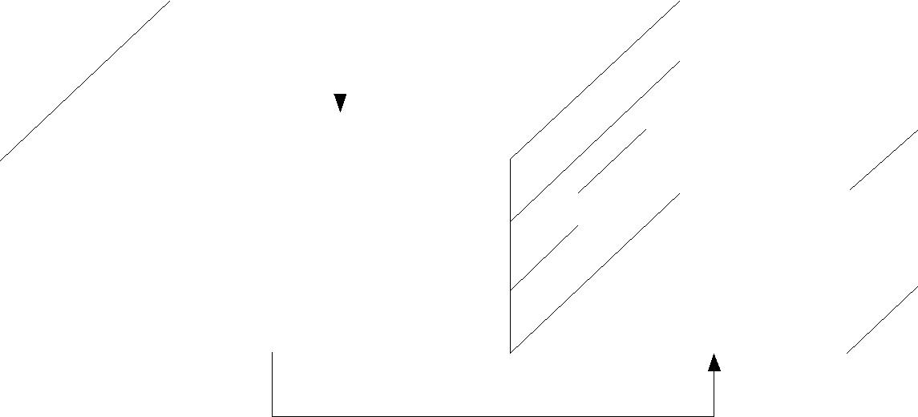
Negative electrode changes back from lead sulphate to lead peroxide

Reaction during the charging of the lead acid battery. Note that the electrolyte suphuric acid concentration

increases.

Fig. 2 The reactions during the charge and discharge of the lead acid battery

• Battery charging

Charging a lead acid battery is a complex procedure and, as with any battery, if carried out incorrectly it will quickly ruin the battery and decrease its life. As we have seen, the charging must not be carried out at too high a voltage, or water loss results.

There are differing views on the best way of charging lead acid batteries and it is essential that, once a battery is chosen, th

The most commonly used technique for lead acid batteries is called multiple steps charging. In this method the battery is charged until the cell voltage is raised to a predetermined level. The current is then switched off and the cell voltage is allowed to decay to another predetermined level and the current is then switched on again.

Lithium Batteries

Since the late 1980s rechargeable lithium cells have come onto the market. They offer greatly increased energy density in comparison with other rechargeable batteries, though at greatly increased cost. It is a well-established feature of the most expensive laptop computers and mobile phones that lithium rechargeable batteries are specified, rather than the lower cost NiCad or NiHM cells that we have been considering earlier.

The lithium batteries are of following types:

- Lithium polymer batteries

- Lithium ion batteries

In the following subsections each of the above two battery types are described.

The lithium polymer battery

The lithium polymer battery uses lithium metal for the negative electrode and a transition metal intercalation oxide for the positive. In the resulting chemical reaction the lithium combines with the metal oxide to form a lithium metal oxide and release energy. When the battery is recharged the chemical reaction is reversed. The lithium is thus both a reactant and the mobile ion that moves through the electrolyte. The overall chemical reaction is:

xLi +M _{y} O_{z} ↔Li_{x} M _{y} O_{z} | (5)

The lithium ion battery

The lithium ion battery was introduced in the early 1990s and it uses a lithiated transition metal intercalation oxide for the positive electrode and lithiated carbon for the negative electrode. The electrolyte is either a liquid organic solution or a solid polymer. Electrical energy is obtained from the combination of the lithium carbon and the lithium metal oxide to form carbon and lithium metal oxide. The overall chemical reaction for the battery is:

C₆ Li_{x} +M _{y} O_{z} ↔6C +Li_{x} M _{y} O_{z} | (6)

The essential features of the battery are shown in Table II. An important point about lithium ion batteries is that accurate control of voltage is needed when charging lithium cells. If it is slightly too high it can damage the battery, and if too low the battery will be insufficiently charged. Suitable commercial chargers are being developed along with the battery.

Table II Nominal battery parameters for lithium ion batteries.

Specific energy |  | 90 Wh.kg−1
Energy density |  | 153 Wh.L−1
Specific power |  | 300 W.kg−1
Nominal | cell | 3.5V
voltage
Amphour |  | Very good
efficiency
Internal resistance |  | Very low
Commercially |  | Only in very small cells not suitable for
available |  | electric vehicles
Operating |  | Ambient
temperature
Self-discharge |  | Very low, ∼10% per month
Number of | life | >1000
cycles
Recharge time |  | 2–3 h

Metal Air Batteries

The metal air batteries represent an entirely different development, in the sense that the batteries cannot be recharged simply by reversing the current. Instead the spent metal electrodes must be replaced by new ones. The metal electrodes can thus be considered as a kind of fuel.

The aluminium air battery

The basic chemical reaction of the aluminium air battery is essentially simple. Aluminium is combined with oxygen from the air and water to form aluminium hydroxide, releasing electrical energy in the process. The reaction is irreversible. The overall chemical reaction is:

4AI +3O₂ +6H ₂ O →4AI (OH )₃ | (7)

The aluminium forms the negative electrode of the cell, and it typically starts as a plate about 1cm thick. As the reaction proceeds the electrode becomes smaller and smaller. The positive electrode is typically a porous structure, consisting of a metal mesh onto which is pressed a layer of catalysed carbon. A thin layer of PTFE gives it the necessary porosity to let the oxygen in, but prevent the liquid electrolyte getting out. The electrolyte is an alkaline solution, usually potassium hydroxide.

The battery is recharged by replacing the used negative electrodes. The electrolyte will normally also be replenished, as it will be contaminated with the aluminium hydroxide. The essential characteristics of the aluminium air battery are shown in Table III. The big drawback of the aluminium air battery is its extremely low specific power.

Table III Nominal battery parameters for aluminium air batteries

Specific energy | 225 Wh.kg−1
Energy density | 195 Wh.L−1
Specific power | 10 W.kg−1
Nominal cell voltage | 1.4V
Amphour efficiency | N/A
Internal resistance | Rather high, hence low power
Commercially available | Stationary systems only available
Operating temperature | Ambient
Self-discharge | Very high (>10% per day) normally, but the
 | electrolyte can
 | be pumped out, which makes it very low
Number of life cycles | 1000 or more
Recharge time | 10min, while the fuel is replaced

The zinc air battery

The zinc air battery is similar in many ways to the aluminium air battery but it has a much better overall performance, particularly with regard to specific power which is nearly ten times that of the aluminium air battery, making it suitable for use in road vehicles. The structure is similar, with a porous positive electrode at which oxygen reacts with the electrolyte. The electrolyte is a liquid alkaline solution. The negative electrode is solid zinc.

The energy from the battery is obtained by combining zinc with the oxygen in the air and forming zinc oxide. Alternatively, depending on the state of the electrodes and electrolyte, zinc hydroxide may be formed, as for the aluminium-air cell. The process is normally irreversible. The general characteristics of the battery are shown in Table IV. A few manufacturers have claimed to produce electrically rechargeable zinc-air batteries, but the number of cycles is usually quite small. The more normal way of recharging is as for the aluminium air cell, which is by replacing the negative electrodes.

NPTEL –Electrical Engineering – Introduction to Hybrid and Electric Vehicles

Table IV Nominal battery parameters for zinc air batteries

Specific energy |  | 230 Wh.kg−1
Energy density |  | 270 Wh.L−1
Specific power |  | 105 W.kg−1
Nominal | cell | 1.2V
voltage
Amphour |  | Not applicable
efficiency
Internal resistance |  | Medium
Commercially |  | A very few suppliers
available
Operating |  | Ambient
temperature
Self-discharge |  | High, as electrolyte is left
 |  | in cell
Number of | life | >2000
cycles
Recharge time |  | 10min, while the fuel is
 |  | replaced

Fuel Cell

In this lecture the energy storage (fuel cell) is presented. The following topics are covered in this lecture:

- Fuel cell

- Issues in fuel cell

- Hydrogen fuel cell

- Fuel cell thermodynamics

- Main reasons for loss in voltage

Fuel Cell

Introduction

Fuel cells are hardly a new idea. They were invented in about 1840, but they are yet to really make their mark as a power source for electric vehicles. However, this might be set to change over the next 20 or 30 years. Certainly most of the major motor companies are spending very large sums of money developing fuel cell powered vehicles. The basic principle of the fuel cell is that it uses hydrogen fuel to produce electricity in a battery-like device to be explained in the next section. The basic chemical reaction is:

2H ₂ +O₂ →2H ₂ O | (1)

The product is thus water, and energy. Because the types of fuel cell likely to be used
∼ ◦

in vehicles work at quite modest temperatures ( 85 C) there is no nitrous oxide produced by reactions between the components of the air used in the cell. A fuel cell vehicle could thus be described as zero-emission. Furthermore, because they run off a fairly normal chemical fuel (hydrogen), very reasonable energies can be stored, and the range of fuel cell vehicles is potentially quite satisfactory. They thus offer the only real prospect of a silent zero-emission vehicle with a range and performance broadly comparable with IC engine vehicles. It is not surprising then that there have, for many years, been those who have seen fuel cells as a technology that shows great promise, and could even make serious inroads into the domination of the internal combustion engine.

Main issues in the fuel cell

There are many problems and challenges for fuel cells to overcome before they become a commercial reality as a vehicle power source. The main problems centre on the following issues.

- Cost: Fuel cells are currently far more expensive than IC engines, and even hybrid IC/electric systems.

  - Water management: It is not at all self-evident why water management should be such an important and difficult issue with automotive fuel cells.

  - Cooling: The thermal management of fuel cells is actually rather more difficult than for IC engines.

  - Hydrogen supply: Hydrogen is the preferred fuel for fuel cells, but hydrogen is

very difficult to store and transport. does the hydrogen come from’ these issu

so many rival solutions.

However, there is great hope that these problems can be overcome, and fuel cells can be the basis of less environmentally damaging transport.

Hydrogen Fuel Cells: Basic Principles

Electrode reactions

We have seen that the basic principle of the fuel cell is the release of energy following a chemical reaction between hydrogen and oxygen. The key difference between this and simply burning the gas is that the energy is released as an electric current, rather that heat. How is this electric current produced?

To understand this we need to consider the separate reactions taking place at each electrode. These important details vary for different types of fuel cell, but if we start with a cell based on an acid electrolyte, we shall consider the simplest and the most common type.

At the anode of an acid electrolyte fuel cell the hydrogen gas ionizes, releasing electrons and creating H⁺ ions (or protons).
+ | +4e | − | (2)
2 H ₂ → 4 H | +4e |  | (2)

This reaction releases energy. At the cathode, oxygen reacts with electrons taken from the electrode, and H+ ions from the electrolyte, to form water.

O₂ +4e | − | +4H | + | →2H ₂O | (3)

Clearly, for both these reactions to proceed continuously, electrons produced at the anode must pass through an electrical circuit to the cathode. Also, H⁺ ions must pass through the electrolyte. An acid is a fluid with free H⁺ ions, and so serves this purpose very well. Certain polymers can also be made to contain mobile H⁺ ions.

Different electrolytes

The reactions given above may seem simple enough, but they do not proceed rapidly in normal circumstances. Also, the fact that hydrogen has to be used as a fuel is a disadvantage. To solve these and other problems many different fuel cell types have been tried. The different types are usually distinguished by the electrolyte that is used, though there are always other important differences as well.

 |  | 2H 2 → |  |  |  |  | 4H | + |  | + 4e
H | + | Ions through electrolyte
H |  |  |  |  |  |  |  |  |  |  |  |  |  |  |  |  | Load
 |  |  |  |  |  |  |  |  |  |  |  |  |  |  | ex: electric motor
 |  |  | O₂ +4e |  |  | − | +4H |  |  | + | →2H₂O
Oxygen, usually from |  |  |  |  |  |  |  |  |  |  |  |  | Electrons flow round
 |  | the air |  |  |  |  |  |  |  |  |  |  | the external circuit
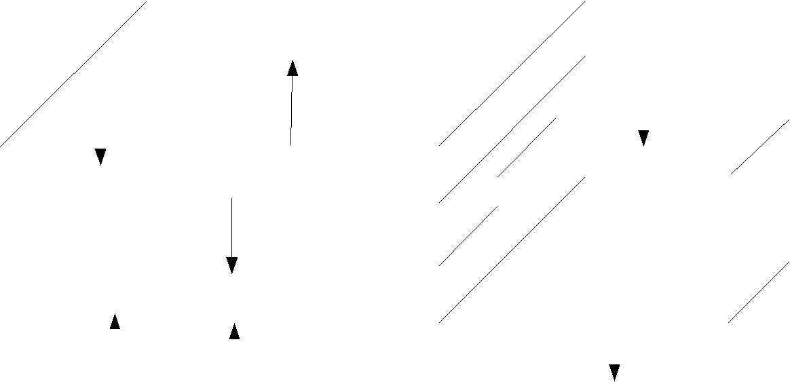
Fig. 1 The reactions at the electrodes, and the electron movement, in a fuel cell with an acid Electrolyte

Table I: Data for different types of fuel cell

Fuel cell type | Mobile | Operating | Applications and notes
 | ion | temp.
Alkaline (AFC) | OH⁻ | 50–200°C | Used in space vehicles, e.g.
 |  |  | Apollo, Shuttle.
Proton exchange | H⁺ | 30-100°C | Vehicles and mobile applications,
membrane |  |  | and for lower power CHP systems
(PEMFC)
Direct | H⁺ | 20-90°C | Suitable for portable electronic
methanol(DMFC) |  |  | systems of low power, running for
 |  |  | long times
Phosphoric acid | H⁺ | 220°C | Large numbers of 200kW CHP
(PAFC) |  |  | systems in use
Molten carbonate | CO₃²⁻ | 650°C | Suitable for medium to large scale
(MCFC) |  |  | CHP systems, up to MW capacity
Solid oxide (SOFC) | _{O}2- | 500-1000°C | Suitable for all sizes of CHP
 |  |  | systems, 2 kW to multi MW

Module-3
Controller:
The controller takes power from the batteries and delivers it to the motor. The accelerator pedal hooks to a pair of potentiometers (variable resistors), and these potentiometers provide the signal that tells the controller how much power it is supposed to deliver. The controller can deliver zero power (when the car is stopped), full power (when the driver floors the accelerator pedal), or any power level in between.
The controller normally dominates the scene when you open the hood, as you can see here:
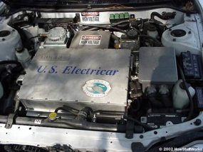
The 300-volt, 50-kilowatt controller for this electric car is the box marked "U.S. Electricar."
In this car, the controller takes in 300 volts DC from the battery pack. It converts it into a maximum of 240 volts AC, three-phase, to send to the motor. It does this using very large transistors that rapidly turn the batteries' voltage on and off to create a sine wave.
When you push on the gas pedal, a cable from the pedal connects to these two potentiometers:
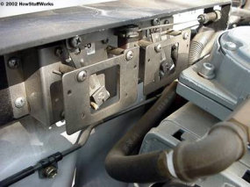
The potentiometers hook to the gas pedal and send a signal to the controller.
The signal from the potentiometers tells the controller how much power to deliver to the electric car's motor. There are two potentiometers for safety's sake. The controller reads both potentiometers and makes sure that their signals are equal. If they are not, then the controller does not operate. This arrangement guards against a situation where a potentiometer fails in the full-on position.

Eleectric Vehicle Motors:
The commonly used motors in EVs are:
• AC motors
• Permanent magnet (PM) motors
• Series wound DC motors
• Shunt wound DC motors
The DC series motors were used in a number of prototype Electric Vehicle (EVs) and prior to that mainly due to the ease of control. However, the size and maintenance requirements of DC motors are making their use obsolete. The recent EVs and Hybrid Electric Vehicles (HEVs) use AC, PM and Switched Reluctance motors. A classification of motors used in EVs is shown in Figure.

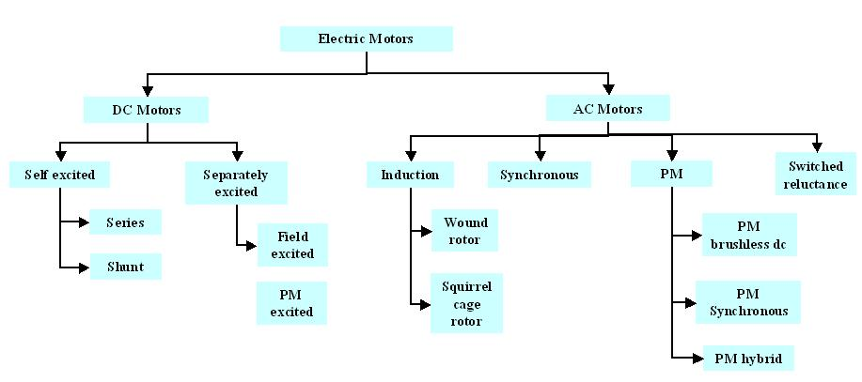
Classification of electric motors used in EVs
The AC Induction Motor (IM) technology is very mature and significant research and development activities have taken place in the area of induction motor drives. The control of IM is more complex than DC motors, but the availability of fast digital processors, computational complexity can easily be managed. The competitor to the induction motor is the permanent magnet (PM) motor. The permanent magnet motors have magnets on the rotor, while the stator construction is same as that of induction motor. The PM motors can be surface mounted type or the magnets can be inset within the rotor. The PM motors can also be classified as sinusoidal type or trapezoidal type depending on the flux density distribution in the air gap. Permanent magnet motors with sinusoidal air gap flux distribution are called Permanent Magnet synchronous Motors (PMSM) and the with trapezoidal air gap flux distribution are called Brushless DC (BLDC) motors.
Permanent Magnet (PM) Machines
By using high energy magnets such as rare earth based magnets, a PM machine drive can be designed with high power density, high speed and high operation efficiency. These advantages are attractive for their application in EVs and HEVs. The major advantages of PM machines are:
- High efficiency : The PM machines have a very high efficiency due to the use of PMs for excitation which consume no power. Moreover, the absence of mechanical commutators and brushes results in low mechanical friction losses.
- High Power density : The use of high energy density magnets has allowed achieving very high flux densities in the PM machines. As a result of high flux densities, high torque can be produced from a given volume of motor compared to other motors of same volume.
- Ease of Control : THE PM motors can be controlled as easily as DC motors because the control variables are easily accessible and constant throughout the operation of the motor.
However, the PM machines also suffer from some disadvantages such as:
- Cost : Rare-earth magnets commonly used in PM machines are very expensive.
- Magnet Demagnetization : The magnets can be demagnetized by large opposing magnetomotive force and high temperatures.
- Inverter Failure : Due to magnets on the rotor, PM motors present major risks in the case of short circuit failures of the inverters. The rotor is always energized and constantly induces EMF in the short circuited windings. A very large current circulates in those windings and an accordingly large torque tends to block the rotor. The dangers of blocking one or several wheels of a vehicle are non-negligible.
Based on the shape of the back e.m.f induced in the stator windings, the PM motors can be classified into two types:
- Permanent Magnet Synchronous Machine with sinusoidal back e.m.f ( Figure 1a )
- Brushless Permanent Magnet DC Machines (BLDC) with trapezoidal back e.m.f ( Figure 1b )
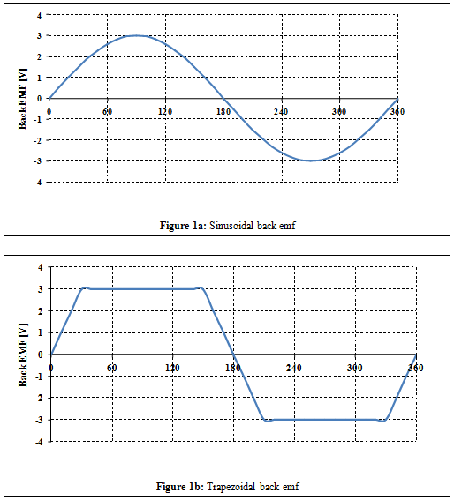

Based on the construction of the rotor, the PM machines can be broadly classified into three categories:
- Inner rotor machine (Figure 2a)
- Outer rotor machine (Figure 2b)
- Interior magnet rotor (Figure 2c)
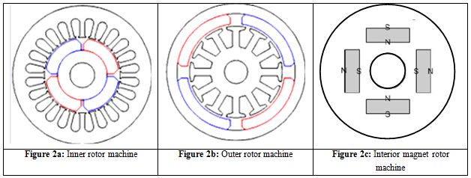
Principle of Operation of PM Machine
In PM machines, the necessary rotor flux is present due to rotor PMs. Currents in the stator windings generate the stator mmf. The zero relative speed between the stator mmf and the rotor flux is achieved if the stator mmf is revolving at the same speed as the rotor flux , that is, rotor speed and also in the same direction. The revolving stator mmf is the result of injecting a set of polyphase currents phase shifted from each other by the same amount of phase shift between the polyphase windings. For example, a three phase machine with three windings shifted in space by electrical 120° between them produces a rotating magnetic field constant in magnitude and travelling at an angular frequency of the currents (just as in case of Induction machines). The rotor has permanent magnets on it, hence the flux produced by the rotor magnets start to chase the stator mmf and as a result torque is produced. Since the relative speed between the stator mmf and rotor flux has to be zero, the rotor moves at the same speed as the speed of the stator mmf. Hence, the PM machines are inherently synchronous machines.
As the coils in the stator experience a change of flux linkages caused by the moving magnets, there is an induced emf in the windings. The shape of the induced emf is very dependent on the shape of the flux linkage. If the rotational electrical speed of the machine ω_{r} and the air gap flux is sinusoidal then it can be expressed as (Figure 3)
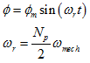  where  Φ_{m} is the peak flux produced  ω_{r} electrical speed of rotation of the rotor  ω_{mech} is the mechanical speed of the rotor  N_{p} is the number of poles of the motor | (1)
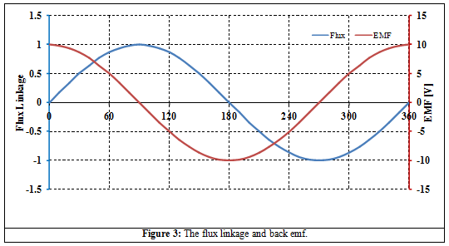

Permanent magnet DC motor
A PM motor does not have a field winding on the stator frame, instead relying on PMs to provide the magnetic field against which the rotor field interacts to produce torque. Compensating windings in series with the armature may be used on large motors to improve commutation under load. Because this field is fixed, it cannot be adjusted for speed control. PM fields (stators) are convenient in miniature motors to eliminate the power consumption of the field winding. Most larger DC motors are of the "dynamo" type, which have stator windings. Historically, PMs could not be made to retain high flux if they were disassembled; field windings were more practical to obtain the needed amount of flux. However, large PMs are costly, as well as dangerous and difficult to assemble; this favors wound fields for large machines.
To minimize overall weight and size, miniature PM motors may use high energy magnets made with neodymium or other strategic elements; most such are neodymium-iron-boron alloy. With their higher flux density, electric machines with high-energy PMs are at least competitive with all optimally designed singly-fed synchronous and induction electric machines. Miniature motors resemble the structure in the illustration, except that they have at least three rotor poles (to ensure starting, regardless of rotor position) and their outer housing is a steel tube that magnetically links the exteriors of the curved field magnets.

Brushless DC motor
Some of the problems of the brushed DC motor are eliminated in the BLDC design. In this motor, the mechanical "rotating switch" or commutator is replaced by an external electronic switch synchronised to the rotor's position. BLDC motors are typically 85–90% efficient or more. Efficiency for a BLDC motor of up to 96.5% have been reported,^{[70]} whereas DC motors with brushgear are typically 75–80% efficient.
The BLDC motor's characteristic trapezoidal back-emf waveform is derived partly from the stator windings being evenly distributed, and partly from the placement of the rotor's PMs. Also known as electronically commutated DC or inside out DC motors, the stator windings of trapezoidal BLDC motors can be with single-phase, two-phase or three-phase and use Hall effect sensors mounted on their windings for rotor position sensing and low cost closed-loop control of the electronic commutator.
BLDC motors are commonly used where precise speed control is necessary, as in computer disk drives or in video cassette recorders, the spindles within CD, CD-ROM (etc.) drives, and mechanisms within office products, such as fans, laser printers and photocopiers. They have several advantages over conventional motors:
- Compared to AC fans using shaded-pole motors, they are very efficient, running much cooler than the equivalent AC motors. This cool operation leads to much-improved life of the fan's bearings.
- Without a commutator to wear out, the life of a BLDC motor can be significantly longer compared to a DC motor using brushes and a commutator. Commutation also tends to cause a great deal of electrical and RF noise; without a commutator or brushes, a BLDC motor may be used in electrically sensitive devices like audio equipment or computers.
- The same Hall effect sensors that provide the commutation can also provide a convenient tachometer signal for closed-loop control (servo-controlled) applications. In fans, the tachometer signal can be used to derive a "fan OK" signal as well as provide running speed feedback.
- The motor can be easily synchronized to an internal or external clock, leading to precise speed control.
- BLDC motors have no chance of sparking, unlike brushed motors, making them better suited to environments with volatile chemicals and fuels. Also, sparking generates ozone, which can accumulate in poorly ventilated buildings risking harm to occupants' health.
- BLDC motors are usually used in small equipment such as computers and are generally used in fans to get rid of unwanted heat.
- They are also acoustically very quiet motors, which is an advantage if being used in equipment that is affected by vibrations.
Modern BLDC motors range in power from a fraction of a watt to many kilowatts. Larger BLDC motors up to about 100 kW rating are used in electric vehicles. They also find significant use in high-performance electric model aircraft.

Switched reluctance motor

6/4 pole switched reluctance motor
Main article: Switched reluctance motor
The SRM has no brushes or PMs, and the rotor has no electric currents. Instead, torque comes from a slight misalignment of poles on the rotor with poles on the stator. The rotor aligns itself with the magnetic field of the stator, while the stator field windings are sequentially energized to rotate the stator field.
The magnetic flux created by the field windings follows the path of least magnetic reluctance, meaning the flux will flow through poles of the rotor that are closest to the energized poles of the stator, thereby magnetizing those poles of the rotor and creating torque. As the rotor turns, different windings will be energized, keeping the rotor turning.
SRMs are now being used in some appliances.

Synchronous motor
A synchronous electric motor is an AC motor distinguished by a rotor spinning with coils passing magnets at the same rate as the AC and resulting in a magnetic field that drives it. Another way of saying this is that it has zero slip under usual operating conditions. Contrast this with an induction motor, which must slip to produce torque. One type of synchronous motor is like an induction motor except the rotor is excited by a DC field. Slip rings and brushes are used to conduct current to the rotor. The rotor poles connect to each other and move at the same speed hence the name synchronous motor. Another type, for low load torque, has flats ground onto a conventional squirrel-cage rotor to create discrete poles. Yet another, such as made by Hammond for its pre-World War II clocks, and in the older Hammond organs, has no rotor windings and discrete poles. It is not self-starting. The clock requires manual starting by a small knob on the back, while the older Hammond organs had an auxiliary starting motor connected by a spring-loaded manually operated switch.
Finally, hysteresis synchronous motors typically are (essentially) two-phase motors with a phase-shifting capacitor for one phase. They start like induction motors, but when slip rate decreases sufficiently, the rotor (a smooth cylinder) becomes temporarily magnetized. Its distributed poles make it act like a PMSM. The rotor material, like that of a common nail, will stay magnetized, but can also be demagnetized with little difficulty. Once running, the rotor poles stay in place; they do not drift.
Low-power synchronous timing motors (such as those for traditional electric clocks) may have multi-pole PM external cup rotors, and use shading coils to provide starting torque. Telechron clock motors have shaded poles for starting torque, and a two-spoke ring rotor that performs like a discrete two-pole rotor.

Regenerative Braking
Introduction:
In a battery-powered electric vehicle, regenerative braking (also called regen) is the conversion of the vehicle’s kinetic energy into chemical energy stored in the battery, where it can be used later to drive the vehicle. It is braking because it also serves to slow the vehicle. It is regenerative because the energy is recaptured in the battery where it can be used again.
The kinetic energy stored in a moving vehicle is related to the mass and speed of the vehicle by the equation E = ½mv². All else being equal, if your car is twice as heavy it has twice the kinetic energy and if it is moving twice as fast it has four times the kinetic energy. Any time your car slows down the kinetic energy stored in the vehicle has to go somewhere. Let’s take a look at where this energy goes. There is always some kinetic energy consumed by the rolling resistance, mechanical friction, and aerodynamics of your car. These bits of energy go into heating the road, the surrounding air, and various spinning parts in your car. But the vast majority of the kinetic energy is converted into heat by your brake pads when you stomp on the brakes. In the Tesla Roadster, regenerative braking recovers some energy that would otherwise have been wasted in the brakes.

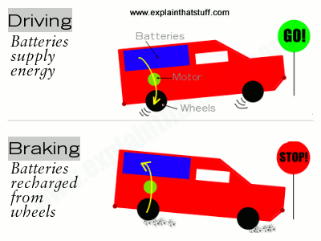
Regenerative braking in a nutshell: Top: When you drive an electric vehicle, energy flows from the batteries to the wheels via the electric motor. Bottom: When you brake, energy flows from the wheels to the batteries via the motor, which works as an electric generator. Next time you switch on the power, you can reuse the energy you stored during braking.

Working:
Electric trains, cars, and other electric vehicles are powered by electric motors connected to batteries. When you're driving along, energy flows from the batteries to the motors, turning the wheels and providing you with the kinetic energy you need to move. When you stop and hit the brakes, the whole process goes into reverse: electronic circuits cut the power to the motors. Now, your kinetic energy and momentum makes the wheels turn the motors, so the motors work like generators and start producing electricity instead of consuming it. Power flows back from these motor-generators to the batteries, charging them up. So a good proportion of the energy you lose by braking is returned to the batteries and can be reused when you start off again. In practice, regenerative brakes take time to slow things down, so most vehicles that use them also have ordinary (friction) brakes working alongside (that's also a good idea in case the regenerative brakes fail). That's one reason why regenerative brakes don't save 100 percent of your braking energy.

High Voltage Safety Rules:
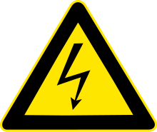

The term high voltage usually means electrical energy at voltages high enough to inflict harm on living organisms.
Two factors considered in classifying a voltage as "high voltage" are the possibility of causing a spark in air, and the danger of electric shock by contact or proximity.
The International Electro technical Commission define high voltage as above 1000 V for alternating current, and at least 1500 V for direct current—and distinguish it from low voltage (50 to 1000 VAC or 120–1500 VDC) and extra low voltage (<50 VAC or <120 VDC) circuits.
Voltages over approximately 50 volts can usually cause dangerous amounts of current to flow through a human being who touches two points of a circuit—so safety standards, in general, are more restrictive around such circuits
Voltages greater than 50 V applied across dry unbroken human skin can cause heart fibrillation if they produce currents in body tissues that happen to pass through the chest area.
The voltage at which there is the danger of electrocution depends on the electrical conductivity of dry human skin. Living human tissue can be protected from damage by the insulating characteristics of dry skin up to around 50 volts. If the same skin becomes wet, if there are wounds, or if the voltage is applied to electrodes that penetrate the skin, then even voltage sources below 40 V can be lethal.
Accidental contact with high voltage supplying sufficient energy may result in severe injury or death. This can occur as a person's body provides a path for current flow, causing tissue damage and heart failure
Other injuries can include burns from the arc generated by the accidental contact. These burns can be especially dangerous if the victim's airways are affected. Injuries may also be suffered as a result of the physical forces experienced by people who fall from a great height or are thrown a considerable distance.
Low-energy exposure to high voltage may be harmless, such as the spark produced in a dry climate when touching a doorknob after walking across a carpeted floor. The voltage can be in the thousand-volt range, but the current (the rate of charge transfer) is low.
Safety equipment used by electrical workers includes insulated rubber gloves and mats. These protect the user from electric shock. Safety equipment is tested regularly to ensure it is still protecting the user. Test regulations vary according to country. Testing companies can test at up 300,000 volts and offer services from glove testing to Elevated Working Platform (or EWP) testing.

