OPC UA
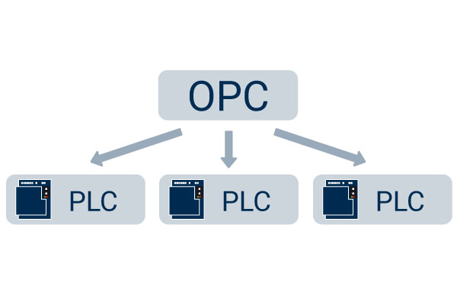

OPC UA (Unified Architecture) is a modern and widely adopted industrial communication protocol and framework designed for secure and reliable data exchange in industrial automation and control systems. It is a successor to the older OPC (OLE for Process Control) protocol and addresses its limitations while providing advanced features and enhanced interoperability.
Key features of OPC UA:
Platform Independence: OPC UA is designed to be platform-independent, allowing communication between different operating systems, programming languages, and hardware architectures. This enables seamless integration across diverse industrial devices and systems.

Secure Communication: OPC UA incorporates robust security measures to ensure secure data exchange. It supports encryption, authentication, and authorization mechanisms, protecting the integrity and confidentiality of the communicated information.

Scalability: OPC UA supports both small-scale and large-scale systems. It can handle a wide range of data types, including structured data, events, alarms, and historical data, making it suitable for complex industrial applications.

Object-Oriented Model: OPC UA utilizes an object-oriented information model, where data is organized into a hierarchy of objects representing real-world entities and their properties. This model provides a flexible and extensible framework for representing and accessing industrial data.

Services and Methods: OPC UA defines a set of services and methods that allow clients to read, write, subscribe to data changes, invoke methods, and interact with the server. These services provide a standardized way for clients to communicate with OPC UA servers.

Discovery and Redundancy: OPC UA supports discovery mechanisms that allow clients to locate OPC UA servers on the network dynamically. It also provides redundancy features for fault-tolerant systems, ensuring continuous operation even in the event of server failures.

Time Synchronization: OPC UA includes mechanisms for synchronizing time across devices in a distributed system. This is crucial for applications that require coordinated actions or historical data analysis.

OPC UA has gained significant popularity in the industrial automation domain due to its advanced features, security, interoperability, and support from major industrial automation vendors. It enables seamless integration between devices, systems, and software applications, facilitating data exchange, interoperability, and interoperability in various industries, including manufacturing, energy, transportation, and more.

OPC Server
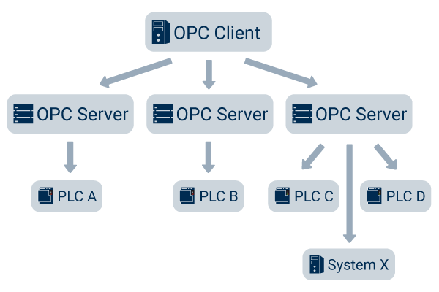
The OPC Server is the basis of OPC communication. It is a software that implements the OPC standard and thus provides the standardized OPC interfaces to the outside world. Inside, the proprietary communication protocol for controlling the manufacturer is implemented. OPC Servers are provided by different parties.

2.OPC Client

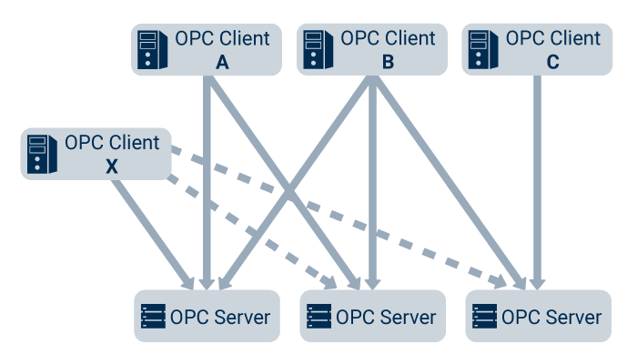

The OPC Client is the logical counterpart to the OPC Server. The OPC Server can be connected to the OPC Client and read out the data provided by the Server. Since the OPC Servers implement the predefined interfaces of the OPC standard, each client can access any OPC Server and exchange data with the server in the same way.
3. OPC Classic vs. OPC UA
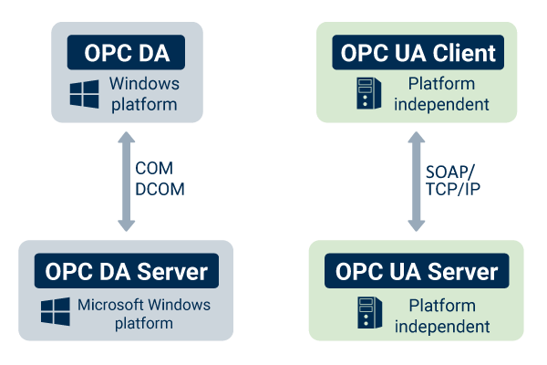
The current standard of the OPC specification is OPC UA (OPC Unified Architecture). It is the successor of the old OPC standard, which is called OPC Classic. Many installations of OPC servers are Classic OPC Servers until today. The old standard already very successfully solved the task of realizing data exchange in automation independent of the manufacturer and defined the basic interfaces. The disadvantage of OPC Classic was the lack of platform independence. OPC Classic is based on the Microsoft technologies COM and DCOM and therefore OPC Server and OPC Client installations were limited to Microsoft Windows operating systems and networks. With the increasing success of other platforms (Linux, Web architectures, Cloud, IoT Devices, CPS, …) the distribution of OPC was limited

OPC Classic vs. OPC UA

The current standard of the OPC specification is OPC UA (OPC Unified Architecture). It is the successor of the old OPC standard, which is called OPC Classic. Many installations of OPC servers are Classic OPC Servers until today. The old standard already very successfully solved the task of realizing data exchange in automation independent of the manufacturer and defined the basic interfaces. The disadvantage of OPC Classic was the lack of platform independence. OPC Classic is based on the Microsoft technologies COM and DCOM and therefore OPC Server and OPC Client installations were limited to Microsoft Windows operating systems and networks. With the increasing success of other platforms (Linux, Web architectures, Cloud, IoT Devices, CPS, …) the distribution of OPC was limited.
OPC UA consists of these specifications:
1. Concepts
2. Security Model
3. Address Space Model
4. Services
5. Information Model
6. Mappings
7. Profiles
8. Data Access
9. Alarms and Conditions
10. Programs
11. Historical Access
12. Discovery
13. Aggregates
14. PubSub

FOR FURTHER INFORMATION WATCH BELOW VIDEOS:
https://youtu.be/vRk42W_4R0o

