2.15. Origin of lateral roots
The lateral roots are endogenous in origin (from a deeper layer). They develop from mature cells, some distance away from the apical meristem (Fig. 609) usually behind the root hair zone. The seat of its origin is cells of pericycle, usually opposite a protoxylem group, become meristematic and go on dividing periclinally and anticlinally. Lateral roots are produced in a definite pattern. The youngest roots are closing (proximal) to the apex. The number of lateral roots corresponds to the number of xylem bundles.

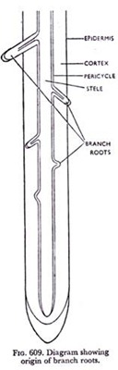

In higher plants, angiosperms and gymnosperms, the development of lateral root is commonly initiated in the pericycle—an intrastelar ground tissue of the parent root, and the lateral root ultimately makes its way by piercing the cortex and epidermis. In lower vascular plants the branch roots originate in the endodermis.
The method of formation of a lateral root in a higher plant is as follows (Fig. 610). A few mature cells of pericycle, usually opposite a protoxylem group, become meristematic and go on dividing periclinally and anticlinally. Thus a number of cells are produced, which form something like a protrusion. This is really the primordium of the lateral root. It soon takes the shape of a growing point with its initial cells, the cap and other histogens. With gradual development of the primordium other tissues surrounding it get stretched and ultimately ruptured. That is how it eventually comes out piercing all the tissues. As regards the mechanism of growth of the lateral root some workers have suggested that it partially digests the cortical tissue during its advance; whereas others are of opinion that it is entirely a matter of mechanical penetration.
It has been reported in some cases that the endodermis also undergoes anticlinal division and forms a layer surrounding the lateral root primordium; and by further periclinal division it may be even more than one layer in thickness. But at any rate those cells die and are shed when the lateral root comes out.
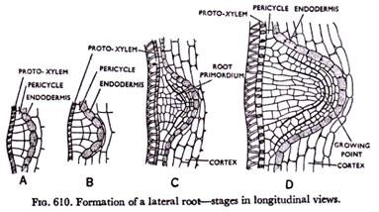

The lateral roots develop from the mature tissues in acropetal order, though there is no regularity in the order of development with reference to each other. In roots having more than two xylem strands the lateral roots commonly originate against the protoxylem groups, or less commonly opposite the phloem groups.
Thus they come out in vertical rows, the number being equal to that of the xylem strands present. But in diarch roots having two xylem strands, the primordia develop at each side of the phloem group, so that the number of lateral roots formed is double that of xylem strands.
They exhibit all the characters of the primary root, having four distinct regions. Thus an extensive root system is formed which ramifies through the soil particles. All the lateral roots do not grow equally vigorously. In fact, many of them continue normal growth and form the root system, whereas some remain undeveloped, or may even be lost. In some fleshy roots like those of carrot additional lateral roots may arise at the bases of original ones when the latter perish.

