INTRODUCTION

Robots are being used in variety of industrial applications for various activities like pick and place, painting, assembling of subsystems and in hazardous places for material handling etc. A robot is a machine which is designed to perform a particular task based on the programming done by the user. The robot is controlled through webpage and the commands from the LINUX platform via RASPBERRY PI[1] .As the internet of things is the concept, newly introduced in the field of electronics. The concept is about handling the things with the use of internet and the best model for these applications is raspberry pi. When the surveillance is considered, home automation or the weather monitoring ,the raspberry pi has proved its importance for application in the field as the paper deals with this it can be seen further. A robot can perform the particular risky tasks which cannot be done by the user. The robots are used in its specific fields of applications such as office, military, hospital, school and agricultural places. The positioning controller is used to observe not only on image capturing process algorithm, due to this controller has been operated independently from speed and fast running using microprocessor based optical sensors which is mounted on the robotic vehicle. This paper contains the information for controlling a robotic vehicle movement through the use of internet. The videos sent by the robotic vehicle to the user. This determines whether the size of the video is small or large depending upon the speed of the Raspberry pi. The webcam will capture live data in the surroundings and then send it to a desired device through internet. The user will be observing this data on the monitor at the user end. According to the movement, the user will control the wheel through the webpage by using Raspberry pi. The instruction given to the webpage is sent through the internet and desired movement occurs at the robot.

PROPOSED SYSTEM

The first part is construction of the robotic vehicle. With the help of programs an internet connection is established between the robotic vehicle and the user. Then robot captures the images using a webcam and stores them into the memory. The next task is to capture and send live images using internet at a rate sufficient to make them seem like a live video to the human eye. This was initially implemented using LAN before moving to internet. The desired result was achieved by sending compressed low resolution images so that transmission would not be affected in case high upload speeds were not available.

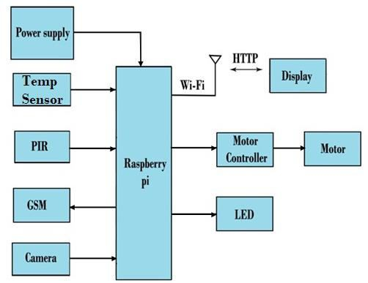

- SYSTEM DESIGN

Software Details
It required number of Programming Tools & Languages to build a project. Eclipse Kepler, HTML/CSS, SERVLET/JSP, Java Script, Tomcat Web Serverand Putty.

Eclipse Kepler
Eclipse is an integrated development environment (IDE) used in computer programming. It contains a base workspace and an extensible plug- in system for customizing the environment. I used Eclipse Kepler and version 4.3.2.

HTML/CSS
Hypertext Mark-up Language, commonly abbreviated as HTML, is the standard mark-up language used to create web pages. Along with CSS, and JavaScript, HTML is a cornerstone technology used to create web pages, as well as to create user interfaces for mobile and web applications. Cascading Style Sheets (CSS) is a style sheet language used for describing the presentation of a document written in a language. Although most often used to set the visual style of web pages and user interfaces written in HTML. We used HTML and CSS both for the design of website and web page to control the Robot.

JSP/Servlet
Java Server Pages (JSP) technology enables Web developers and designers to rapidly develop and easily maintain, information-rich, dynamic Web pages that leverage existing business systems. Servlets are most often used to process or store a Java class in Java EE that conforms to the Java Servlet API, a standard for implementing Java classes which respond to requests.

Java Script
JavaScript is a high-level, dynamic, untipped, and interpreted programming language. JavaScript's typing is dynamic. JavaScript is loaded as human-readable source code. JavaScript's are prototype-based.

Debian Raspberry PI Language
Debian is a Unix-like computer operating system that is composed entirely of free software, most of which is under the GNU General Public License, and packaged by a group of individuals known as the Debian Project. Raspbian Jessi Lite version 4.1 is installed in Raspberry Pi 2.

Apache Tomcat
Tomcat implements several Java EE specifications including Java Servlet, Java Server Pages (JSP), Java EL, and Web Socket, and provides a "pure Java" HTTP web server environment in which Java code can run. User have to install Apache in Eclipse and Raspberry Pi to run the java code. If the version is different and it will cause error to run different version Java code.
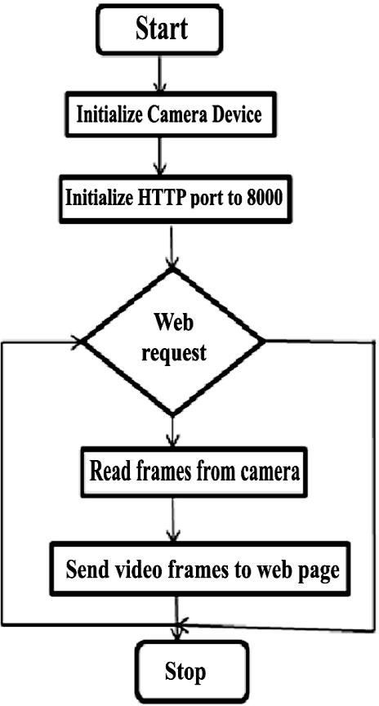

- Hardware Details

Raspberry Pi
Raspberry Pi is used for making robot wireless and web based. Webcam is interfaced to the Raspberry Pi and then the videos are transmitted wirelessly from the robot to the user’s monitor, from where the user can conveniently control the robotic vehicle’s movement and also the robotic arm movement. Raspberry pi is connected with the dongle which enables raspberry pi to transmit over the web network.[3]
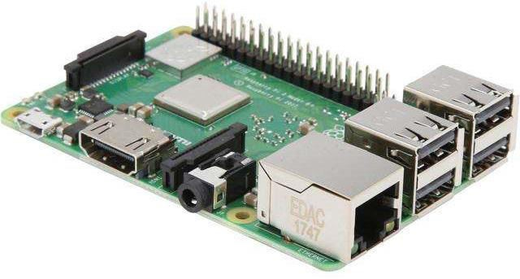

Raspberry Pi uses an SD card for booting and for memory as it doesn’t have an inbuilt hard disk for storage. Raspberry Pi requires 5 volt supply with minimum of 700-1000 mA current and it is powered through micro USB cable. ARM11 only requires 3.3 volt of supply which it takes with the help of linear regulator. 5 volt is required for the USB ports. It operates at 700 MHz We use python or embedded C to write the code into the raspberry pi. It has a strong processing capability due to the ARM11 architecture and Linux-based system. In terms of interface and control, it has 1 SPI, 1 UART, 1 I2C and 8 GPIO[4], which basically meet the control requirement. There are easy to use open source peripheral driver libraries.

Raspberry Pi camera module
Raspberry Pi camera module module has a five megapixel fixed-focus camera that supports 1080p30, 720p60 and VGA90 video modes, as well as stills capture[5].
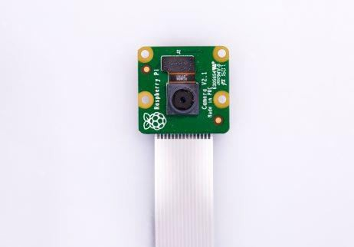
Features

Figure .4. Raspberry-Pi camera
  - 5MP sensor
  - Wider image, capable of 2592x1944 stills, 1080p30 video
  - 1080p video supported
  - CSI
  - Size: 25 x 20 x 9 mm

Motor Driver
L293D is a dual H-bridge motor driver integrated circuit (IC). Motor drivers act as current amplifiers since they take a low- current control signal and provide a higher-current signal. This higher current signal is used to drive the motors. L293D contains two inbuilt H-bridge driver circuits[6].
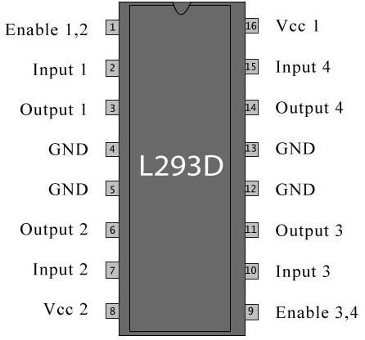

Figure.5.Motor Driver L293D

PIR Sensor
The term PIR is the short form of the Passive Infra Red. The term “passive” indicates that the sensor does not actively take part in the process, which means, it does not emit the referred IR signals itself, rather passively detects the infrared radiations coming from the human body in the surrounding area.

7. Temperature Sensor
The DS18B20 is a three terminal temperature sensor available in the TO-92 (transistor type) package. It is very easy to use and requires only one external component to start working. Also it requires only one GPIO pin from the MCU/MPU to communicate with it. A typical DS18B20 temperature sensor with its pin name is shown below.

- IMPLEMENTATION DETAILS

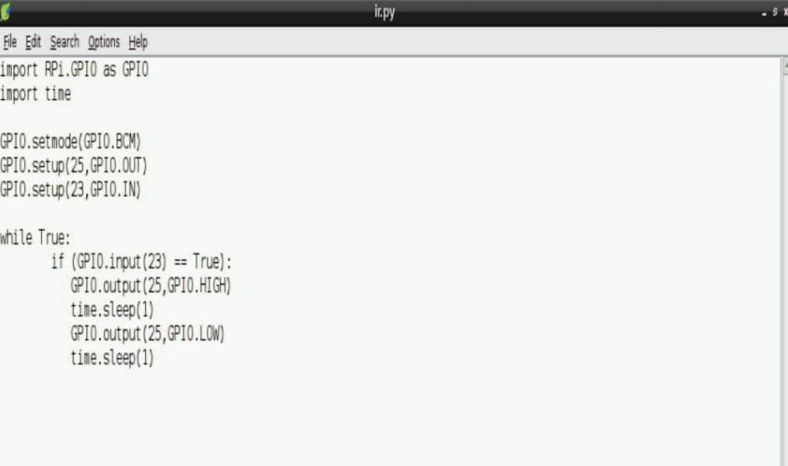
The implementation of this work starts with selecting the operating system that we prefer. In this project we have selected raspbian operating system [7]. Now, we have to boot the operating system that we have selected with the necessary configurations. The various configurations which can be done are such as changing the password for default user, choosing whether to boot into a desktop environment, scratch, or the command line, enabling camera etc. The configuration settings are done according to the users need.

Figure.7. Leaf Pad

After the configuration settings are done, the python program is to be typed in the leaf pad. Leaf pad is created by file manager->right click->create->blank file->enter a file name.py- > click ok. The leaf pad is shown in the Fig. 5. Next the program is saved [8] and it is executed by means of the LX terminal. Then using python language we interface all sensors and the camera with raspberry pi and we can operate the system via webpage. We have to make a webpage to give navigation control to robot and to get real time data(video) to the operator we can see the webpage in fig where we can control robot as well as view real time data.
