Analytical, synthetic and other evidence in structure of benzene
Determination of molecular weight percentage component derived of molecular formula C6H6.
If it is an acyclic compound, it can have one triple bond and two double bonds.
I it is a ring compound, one ring with one triple and one double etc.
Chemical properties indicate neither of the above possible as the above indicate highly unsaturated which benzene is not.
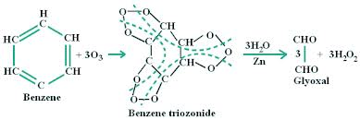
Ozonolysis under strong condition gave glyoxalin CHO-CHO and no other products with -CH2 or CH2CHO or CH3– or CH3CO- etc. Indicating benzene has =CH-CH= i.e., three such that too in a ring which is possible if it is a six membered ring similar to the hypothetical cyclohexatriene.
I R and U V spectra indicates that benzene has all the six C-C bond of almost equal length, the length being in between C=C and C-C. The six-membered ring in benzene is a perfect hexagon (all carbon-carbon bonds have an identical length of 1.40 Å). The cyclohexatriene contributors would be expected to show alternating bond lengths, the double bonds being shorter (1.34 Å) than the single bonds (1.54 Å).
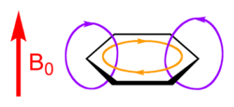
The molecule being planar, all the C, H atoms lie in a single plane. H-NMR spectral indicates that all the H atoms appear highly deshielded, becauses induced current creates a local magnetic field that has the same direction as the external field outside the aromatic ring where the attached protons are, leading to the deshielding of the nuclei
 | 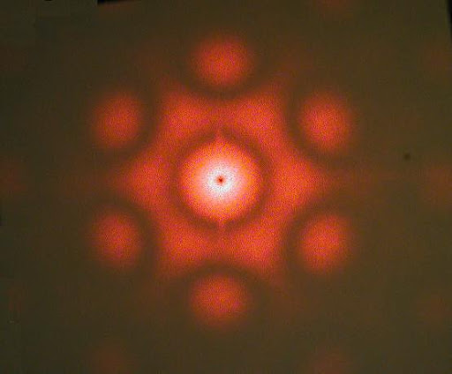 | 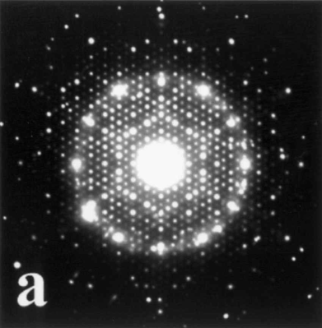
x-Ray Crystallography | Laser Diffraction | Electron Diffraction pattern
Chemical reactions indicates, Benzene undergoes electrophilic substance more easily than addition reactions and more stable than that expected of compounds with double bonds. Because addition reaction would break the π-bond leading to destruction of delocalization and stability.
Difference in enthalpy of hydrogenation between Hypothetical cyclohexatriene and Benzene.
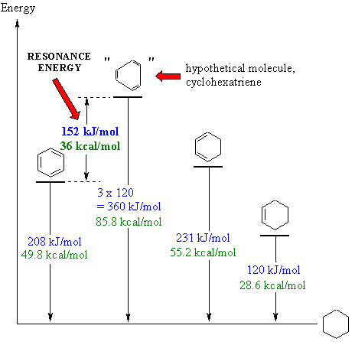
All these results along with theoretical studies indicate that benzene cannot be explained by a single structure but a hybrid of two Kekule and three Dewar structures.

