TYPES OF IOT INTERACTIONS: 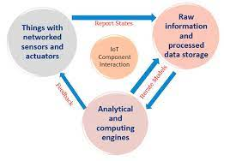
- IoT (Internet of Things) interactions can be categorized into several types based on the nature of communication and the involved entities. Here are some common types of IoT interactions:
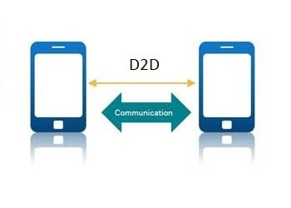
- Device-to-Device (D2D) Interaction: This refers to direct communication between IoT devices without the involvement of a central hub or cloud server. For example, two smart thermostats communicating with each other to synchronize temperature settings.
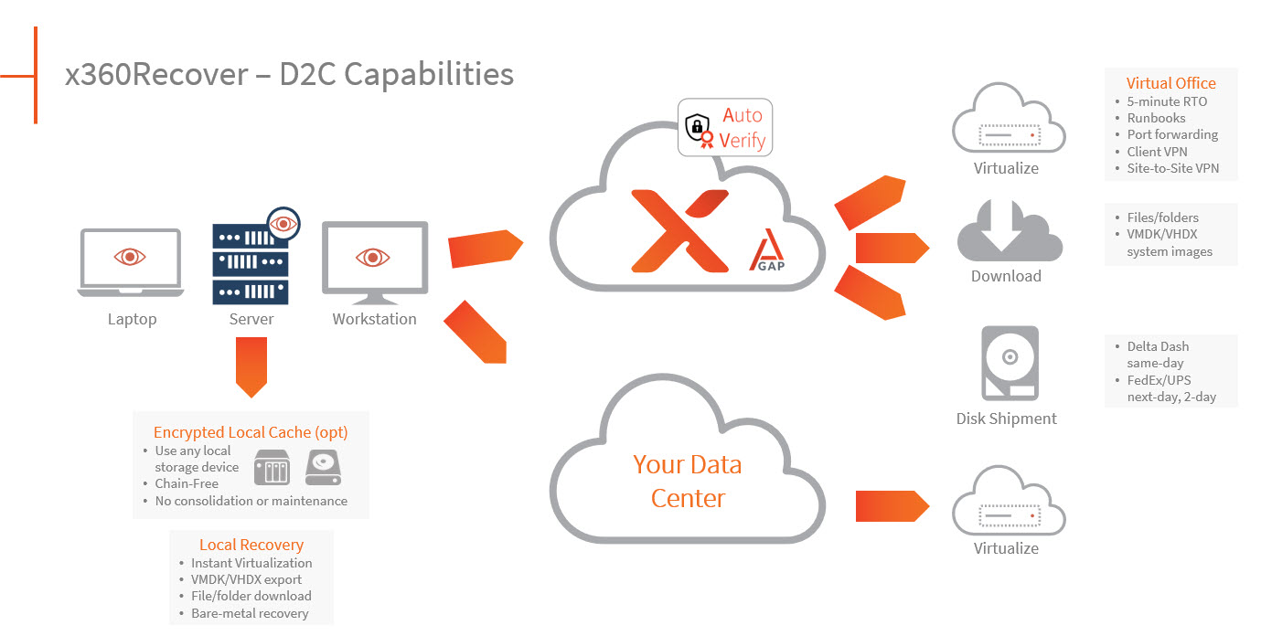z
- Device-to-Cloud (D2C) Interaction: In this type of interaction, IoT devices communicate with a central cloud-based server or platform. The devices send data to the cloud for processing, storage, and analysis. This enables remote monitoring, control, and data management. For instance, a smart home security camera sending video footage to the cloud for storage and remote viewing.
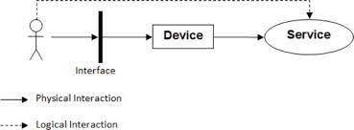

- Device-to-User (D2U) Interaction: This involves the communication between IoT devices and end-users or consumers. The devices provide real-time updates, notifications, and alerts to users through mobile apps, websites, or other interfaces. For example, a fitness tracker sending daily activity summaries and health recommendations to a user's smartphone.

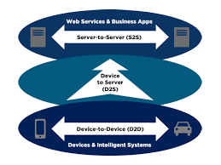

- Device-to-Service (D2S) Interaction: IoT devices can interact with various online services to access additional functionality or data. For instance, a smart refrigerator ordering groceries automatically from an online supermarket based on the inventory levels detected by its sensor.
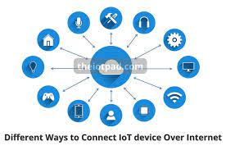

- Device-to-Network (D2N) Interaction: This type of interaction involves IoT devices communicating with the underlying network infrastructure. It includes actions like device authentication, network configuration, and data transmission over various network protocols.
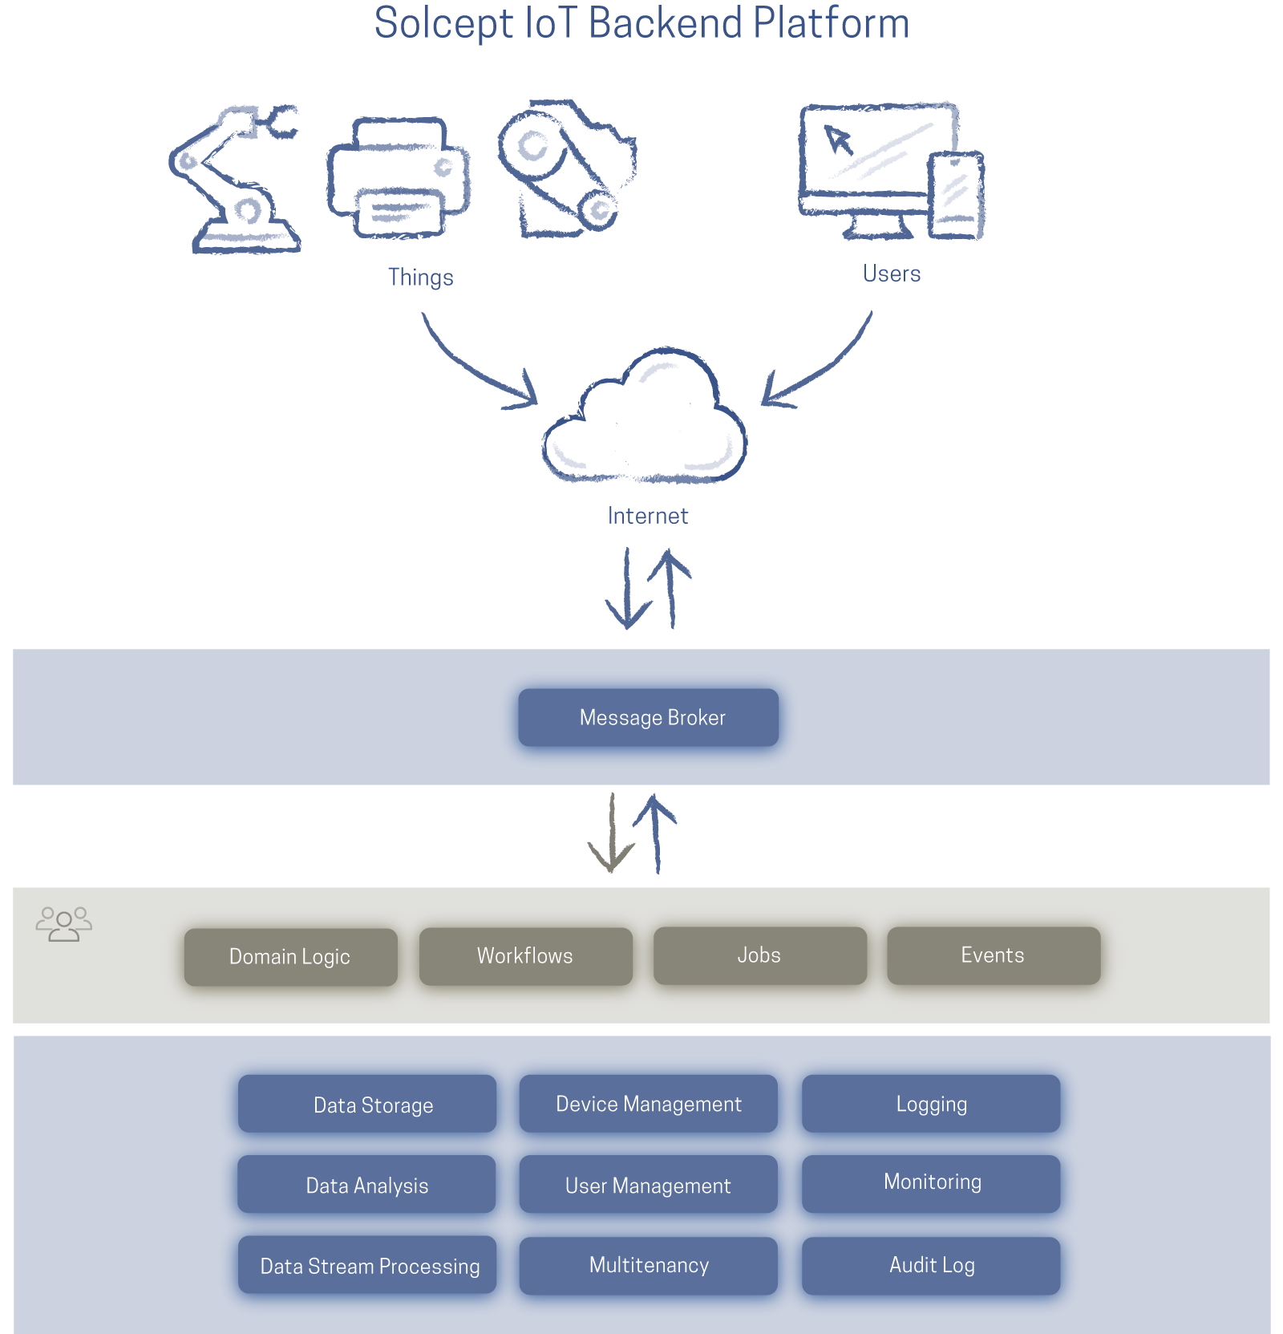

- Device-to-Backend (D2B) Interaction: IoT devices interact with backend systems and databases for data storage, processing, and analysis. This enables complex data analytics, machine learning, and decision-making. For example, a fleet of connected vehicles sending telemetry data to a backend system for predictive maintenance analysis.
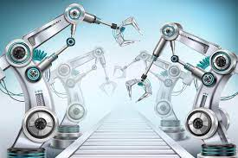
- Device-to-Application (D2A) Interaction: IoT devices can interact with specific applications or software platforms designed to control and manage them. These applications provide user interfaces, rules engines, and automation capabilities. For instance, a smart lighting system interacting with a mobile app that allows users to control the intensity and color of the lights.
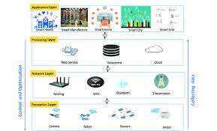

- Device-to-Infrastructure (D2I) Interaction: IoT devices can interact with physical infrastructure such as smart grids, smart buildings, or smart cities. These interactions enable optimized resource allocation, energy management, and infrastructure maintenance.

- These are some of the common types of IoT interactions, but it's important to note that the nature and scope of interactions can vary depending on the specific IoT system and its use case.

Types of Communications in IOT

IoT Communication: IoT is the connection of devices over the internet, where these smart devices communicate with each other , exchange data , perform some tasks without any human involvement. These devices are embedded with electronics, software, network and sensors which help in communication. Communication between smart devices is very important in IOT as it enables these devices to gather, exchange data which contribute in success of that IOT product/project.
1. Human to Machine (H2M):
In this human gives input to IOT device i.e as speech/text/image etc. IOT device (Machine) like sensors and actuators then understands input, analyses it and responds back to human by means of text or Visual Display. This is very useful as these machines assist humans in every everyday tasks. It is a combo of software and hardware that includes human interaction with a machine to perform a task.
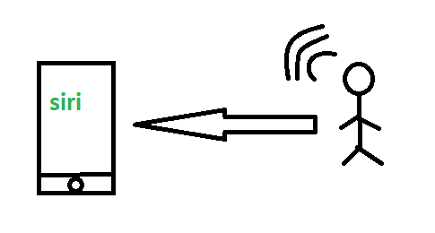
Merits: This H2M has a user-friendly interface that can be quickly accessed by following the instructions. It responds more quickly to any fault or failure. Its features and functions can be customized.
Examples:
- Facial recognition.
- Bio-metric Attendance system.
- Speech or voice recognition.

2. Machine to Machine (M2M):
The process of exchanging information or messages between two or more machines or devices is known as Machine to Machine (M2M) communication.
It is the communication among the physical things which do not need human intervention.
M2M communication is also named as Machine Type communication in 3GPP(3rd Generation Partnership Project).
In this the interaction or communication takes place between machines by automating data/programs. In this machine level instructions are required for communication. Here communication takes place without human interaction. The machines may be either connected through wires or by wireless connection. An M2M connection is a point-to-point connection between two network devices that helps in transmitting information using public networking technologies like Ethernet and cellular networks. IoT uses the basic concepts of M2M and expands by creating large “cloud” networks of devices that communicate with one another through cloud networking platforms.
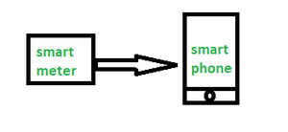
Advantages –
This M2M can operate over cellular networks and is simple to manage. It can be used both indoors and outdoors and aids in the communication of smart objects without the need for human interaction. The M2M contact facility is used to address security and privacy problems in IoT networks. Large-scale data collection, processing, and security are all feasible.
Disadvantages –
However, in M2M, use of cloud computing restricts versatility and creativity. Data security and ownership are major concerns here. The challenge of achieving interoperability between cloud/M2M IoT systems is daunting. M2M connectivity necessitates the existence of a reliable internet connection.
Examples:
- Smart Washing machine sends alerts to the owners’ smart devices after completion of washing or drying of clothes.
- Smart meters tracks amount of energy used in household or in companies and automatically alert the owner.

3. Machine to Human (M2H) :
In this machine interacts with Humans. Machine triggers information(text messages/images/voice/signals) respective / irrespective of any human presence. This type of communication is most commonly used where machines guide humans in their daily life. It is way of interaction in which humans co-work with smart systems and other machines by using tools or devices to finish a task.
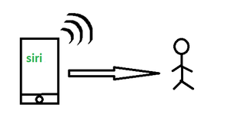
M2H communication
Examples:
- Fire Alarms
- Traffic Light
- Fitness bands
- Health monitoring devices

