Trends in Cyber Crimes across the world-
some prevalent trends in cybercrimes based on information available up until my knowledge cutoff in September 2021. Please note that the cybercrime landscape is constantly evolving, and new trends may have emerged since then. Here are some notable trends:

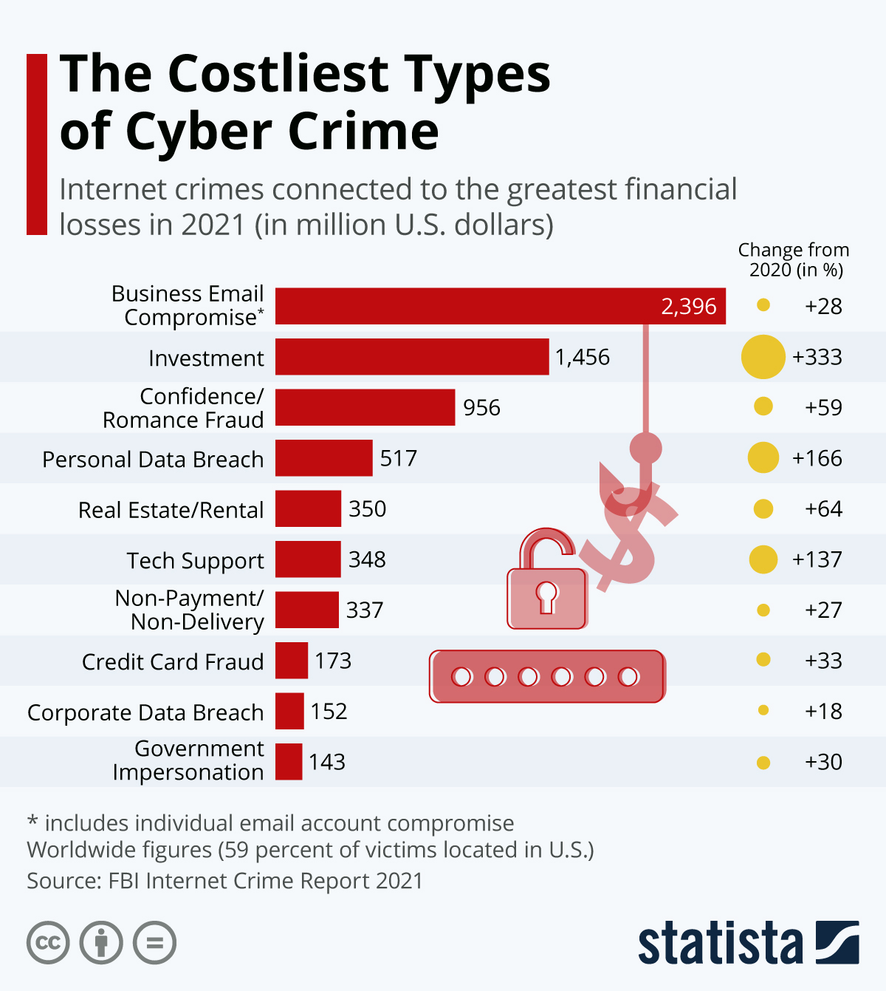
- Ransomware Attacks: Ransomware attacks have been on the rise globally. Cybercriminals employ sophisticated techniques to infiltrate systems, encrypt valuable data, and demand ransom payments in exchange for decryption keys. High-profile attacks on organizations, including healthcare providers, government agencies, and critical infrastructure, have garnered significant attention.
- Remote Work Exploitation: The COVID-19 pandemic led to a surge in remote work, creating new opportunities for cybercriminals. Attackers targeted vulnerabilities in remote access tools, virtual private networks (VPNs), and collaboration platforms to gain unauthorized access to corporate networks and steal sensitive data.
- Supply Chain Attacks: Cybercriminals increasingly focus on compromising the supply chains of organizations. By targeting software vendors, cloud service providers, or third-party suppliers, attackers can gain unauthorized access to numerous organizations connected to the compromised supply chain, potentially causing widespread damage.
- Social Engineering Attacks: Social engineering remains a prominent technique used by cybercriminals to manipulate individuals into divulging sensitive information or performing actions that compromise security. Phishing, spear phishing, and business email compromise (BEC) attacks are prevalent, often leveraging psychological manipulation and impersonation tactics.
- Cryptocurrency-related Crimes: The growing popularity of cryptocurrencies has attracted cybercriminals. Cryptocurrency-related crimes include ransomware attacks demanding ransom payments in cryptocurrency, cryptojacking (illegitimate use of computing resources to mine cryptocurrencies), and investment scams targeting individuals seeking to invest in digital assets.
- Internet of Things (IoT) Vulnerabilities: The proliferation of IoT devices has introduced new security challenges. Vulnerable IoT devices are attractive targets for cybercriminals who exploit security weaknesses to gain unauthorized access, launch DDoS attacks, or compromise personal data.
- Cyber Espionage and Nation-State Threats: Nation-state-sponsored cyber espionage activities continue to pose significant threats globally. State-sponsored actors engage in targeted attacks to gain access to sensitive information, disrupt critical infrastructure, or conduct influence operations.
- Dark Web Activities: The dark web facilitates various illicit activities, including the sale of stolen data, hacking tools, drugs, weapons, and other illegal goods and services. Cybercriminals leverage the anonymity provided by the dark web to carry out their operations.
- Artificial Intelligence (AI) Exploitation: As AI technologies advance, cybercriminals are exploring ways to exploit AI for malicious purposes. This includes the use of AI algorithms to automate phishing attacks, generate convincing deepfake content, or bypass security measures.
- Data Privacy and Regulations: The enforcement of data protection regulations, such as the European Union's General Data Protection Regulation (GDPR) and the California Consumer Privacy Act (CCPA), has prompted increased scrutiny on data privacy practices. Cybercriminals may target organizations to steal or exploit personal data, leading to significant legal and financial consequences for non-compliance.
It is essential for individuals, organizations, and governments to stay vigilant, adopt robust cybersecurity measures, and regularly update their knowledge to effectively counter evolving cybercrime trends.

