cyber pornography,defamation, computer vandalism, crimes through social networking sites,malware-
- Cyber Pornography: Cyber pornography, also known as online pornography, refers to the distribution, creation, or consumption of explicit or sexually explicit material using digital platforms, such as websites, social media, or file-sharing networks. It involves the dissemination of sexually explicit images, videos, or other content through digital channels. Cyber pornography can include non-consensual distribution of intimate images (revenge porn), child pornography, or the involvement of minors in explicit activities. 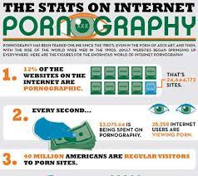
Engaging in or promoting cyber pornography is illegal in many jurisdictions due to the harm it can cause to individuals involved, including exploitation, violation of privacy, and potential psychological and emotional damage. It is important to report instances of cyber pornography to the appropriate authorities.
- Defamation: Defamation in the context of cybercrime refers to the act of making false statements or spreading harmful information about someone that damages their reputation. With the widespread use of the internet and social media, defamation can occur online through various means, including false posts, comments, or articles that harm an individual's character or professional standing. Defamation can have significant consequences for victims, affecting their personal and professional lives.
Legal systems provide remedies for defamation, and individuals who believe they have been defamed online can pursue legal action against the perpetrators. It's important to exercise responsible online behavior, refrain from spreading false information, and be mindful of the potential impact of our digital actions on others.
- Computer Vandalism: Computer vandalism, also referred to as cyber vandalism, involves the intentional destruction, alteration, or impairment of computer systems, networks, or data without authorization. Cyber vandals may use various methods, such as introducing malicious code, deleting or modifying files, disrupting services, or defacing websites. Computer vandalism can cause financial losses, system downtime, data breaches, or reputational damage. 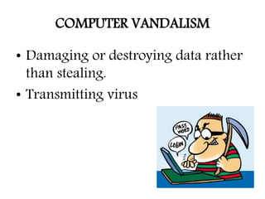
Computer vandalism can be motivated by various factors, including personal gain, revenge, political activism, or simply the desire to cause chaos and disruption. Perpetrators may target individuals, organizations, or even critical infrastructure systems. Engaging in computer vandalism is illegal and can result in severe legal consequences.
- Crimes through Social Networking Sites: Social networking sites provide platforms for communication and interaction, but they can also be used for criminal activities. Crimes through social networking sites can include various forms of cyberbullying, harassment, identity theft, online scams, grooming of minors, or the dissemination of illegal or harmful content.

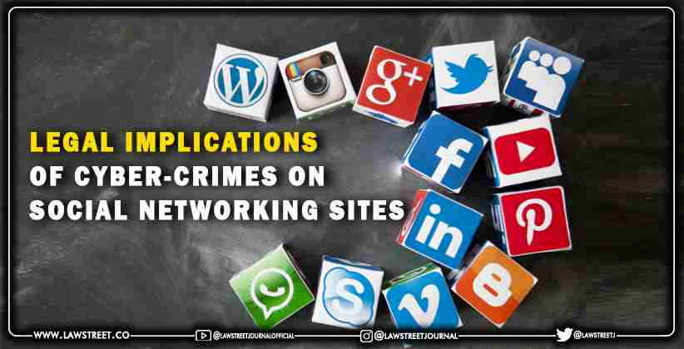

Perpetrators may exploit the features and vulnerabilities of social networking sites to deceive or harm others. It is crucial to exercise caution when using social networking platforms, maintain privacy settings, be cautious of sharing personal information, and report any suspicious or harmful activities to the platform administrators or appropriate authorities.

- Malware: Malware, short for malicious software, is any software or code designed to infiltrate or harm computer systems, networks, or devices without the consent of the owner. Malware includes a wide range of threats, such as viruses, worms, Trojans, ransomware, spyware, or adware. Malware can be distributed through various means, including email attachments, infected websites, malicious downloads, or removable storage devices. 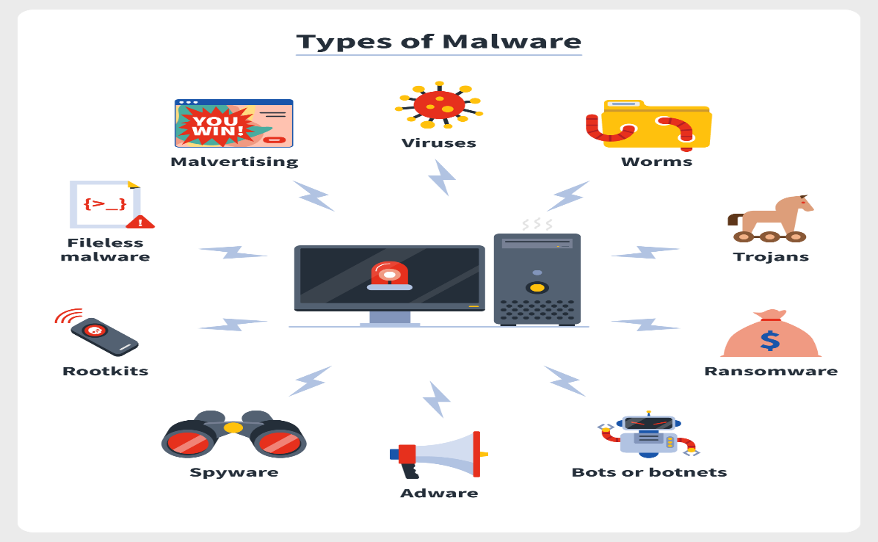

Once installed or executed on a system, malware can perform various malicious actions, such as stealing sensitive information, hijacking systems, disrupting operations, or providing unauthorized access to cybercriminals. Protecting against malware involves using up-to-date antivirus software, regularly updating software and operating systems, exercising caution when downloading or opening files, and avoiding suspicious websites or links.
Understanding these cybercrimes helps individuals and organizations take preventive measures, report illegal activities, and contribute to a safer online environment.

