steganography, cyberstalking, spoofing-
- Steganography: Steganography is the practice of concealing or hiding information within other seemingly innocent or unrelated data or media. It involves embedding secret messages, images, or files within digital content, such as images, audio files, videos, or even text documents. The hidden data can be encrypted to ensure its secrecy. Steganography aims to make the presence of the hidden information undetectable to unintended recipients. 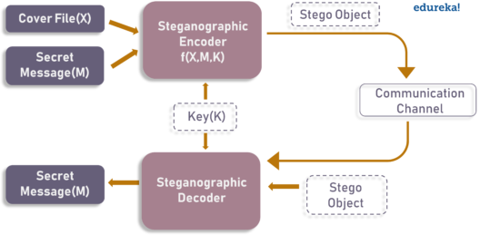
Steganography techniques vary, but they often rely on manipulating the least significant bits of the digital carrier to embed the hidden data. The resulting carrier appears visually or audibly unchanged, making it challenging for others to identify the presence of hidden information without using specific steganography detection tools or methods.
Steganography can be used for both legitimate purposes, such as digital watermarking or copyright protection, as well as illicit activities, including covert communication between criminals or the hiding of sensitive information for espionage purposes. It is important to note that the use of steganography for illegal activities is subject to legal consequences.
- Cyberstalking: Cyberstalking refers to the persistent and unwanted harassment or stalking of individuals using digital technologies. Cyberstalkers use online platforms, social media, email, instant messaging, or other digital channels to engage in behaviors that cause fear, distress, or harm to their victims. This can include sending threatening messages, spreading false rumors, monitoring the victim's online activities, or disseminating personal information without consent. 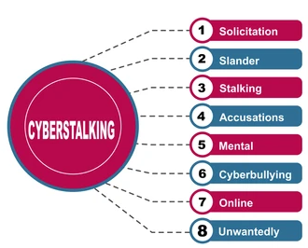
Unlike physical stalking, cyberstalking can happen 24/7, and the anonymity provided by the internet makes it easier for perpetrators to conceal their identity. Cyberstalking can have severe psychological and emotional effects on victims, leading to anxiety, depression, and a sense of helplessness.
Laws and regulations around cyberstalking vary by jurisdiction, but many countries have enacted legislation to address this issue and provide legal remedies for victims. It's important for individuals to be cautious with their online presence, to report instances of cyberstalking to authorities, and to take necessary steps to protect their personal information and online privacy.
- Spoofing: Spoofing refers to the act of falsifying or masquerading one's identity or information to deceive others or gain unauthorized access to systems or data. There are different types of spoofing techniques: 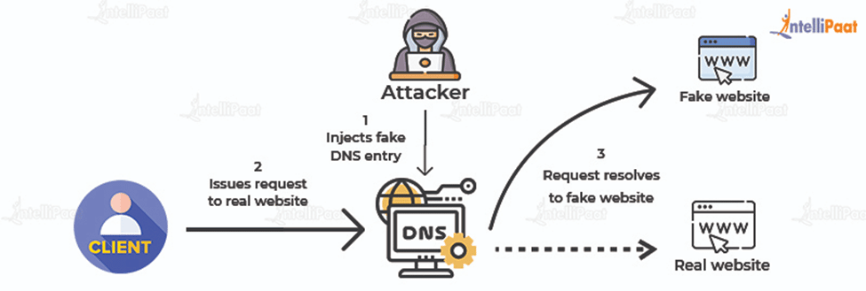
- IP Spoofing: IP spoofing involves altering the source IP address in network packets to impersonate another computer or network device. This can be used to bypass security measures, launch denial-of-service attacks, or hide the origin of an attack.
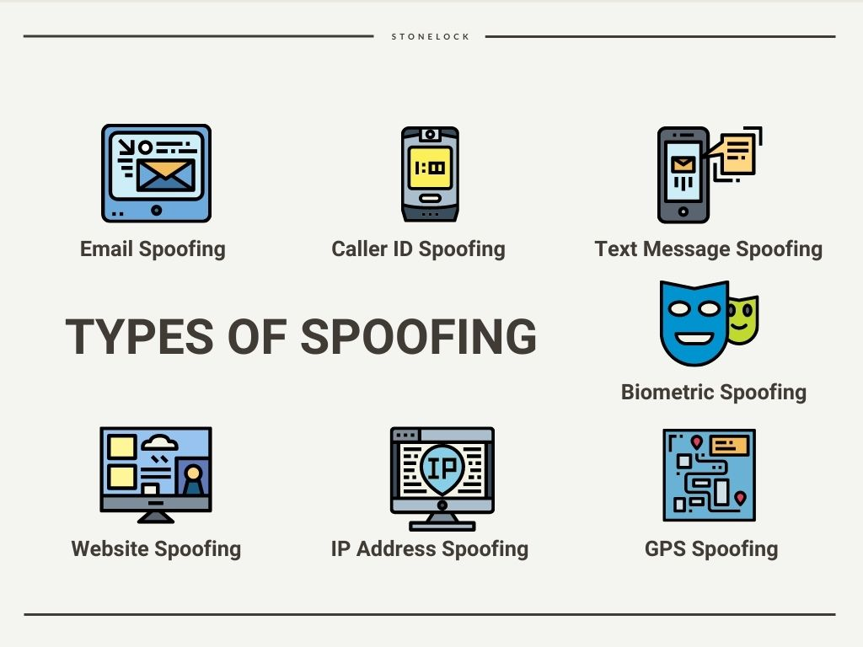
- Email Spoofing: Email spoofing involves forging the sender's email address to make it appear as if the email is coming from a different source. Email spoofing is often used in phishing attacks or to send malicious emails that appear to be from trusted entities.
- Caller ID Spoofing: Caller ID spoofing involves manipulating the information displayed on the recipient's caller ID to make it appear as if the call is coming from a different number. This technique is commonly used in phone scams or fraudulent activities.
- Website Spoofing: Website spoofing involves creating fake websites that mimic the appearance and functionality of legitimate websites. The intention is to deceive users into providing sensitive information, such as login credentials or financial details.
Spoofing can be employed for malicious purposes, including identity theft, phishing, fraud, or launching attacks. It is important for individuals and organizations to be cautious, verify the authenticity of communication channels, and use security measures, such as email authentication protocols or network filtering, to mitigate the risks associated with spoofing.
Understanding these concepts helps individuals navigate the digital landscape and protect themselves from potential threats and risks associated with steganography, cyberstalking, and spoofing.

