Industrial Automation: What is it?
Due to the rapid advances in technology, all industrial processing systems, factories, machinery, test facilities, etc. turned from mechanization to automation. A mechanization system needs human intervention to operate the manual operated machinery. As new and efficient control technologies evolved, computerized automation control is being driven by the need for high accuracy, quality, precision and performance of industrial processes.
Industrial automation is the use of control devices such as PC/PLCs/PACs etc. to control industrial processes and machinery by removing as much labor intervention as possible, and replacing dangerous assembly operations with automated ones. Industrial automation is closely linked to control engineering.
Automation is a broad term applied to any mechanism that moves by itself or is self dictated. The word ‘automation’ is derived from ancient Greek words of Auto (means ‘self’) Matos (means ‘moving’). As compared with manual systems, automation systems provide superior performance in terms of precision, power, and speed of operation.
In industrial automation control, a wide number of process variables such as temperature, flow, pressure, distance, and liquid levels can be sensed simultaneously. All these variables are acquired, processed and controlled by complex microprocessor systems or PC based data processing controllers.

Types of Industrial Automation
Industrial automation is the use of computer and machinery aided systems to operate the various industrial operations in a well-controlled manner. Depends on the operations involved, the industrial automation systems are majorly classified into two types, namely process plant automation and manufacturing automation.
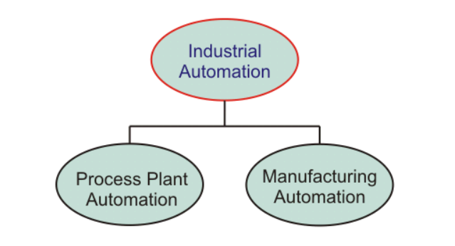

Process Plant Automation
In process industries, the product results from many chemical processes based on some raw materials. Some of the industries are pharmaceuticals, petrochemical, cement industry, paper industry, etc. Thus the overall process plant is automated to produce the high quality, more productive, high reliable control of the physical process variables.
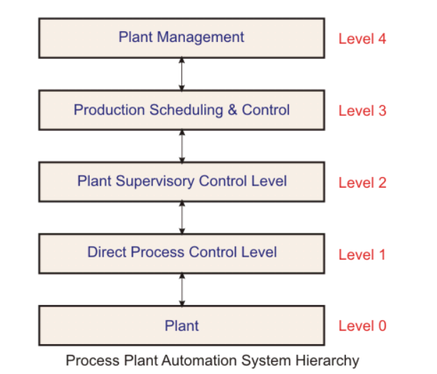
The above figure shows the process automation system hierarchy. It consists of various layers representing widespread components in a process plant.
Level 0 or Plant: This level consists of machines which are closest to processes. In this, sensors and actuators are used to translate the signals from the machines and physical variables for the purpose of analysis and to produce the control signals.
Direct Process Control: In this level, automatic controllers and monitoring systems acquire the process information from sensors and correspondingly drives the actuator systems. Some of the tasks of this level are-
- Data acquisition
- Plant monitoring
- Dara checking
- Open and closed loop control
- Reporting
Plant Supervisory Control: This level commands the automatic controllers by setting the targets or set points. It looks after the control equipment for optimal process control. Some of the tasks of this level are:
- Plant monitoring performance
- Optimal process control
- Plant coordination
- Failure detection, etc.
Production Scheduling and Control: This level solves the decision-making problems like resource allocation, production target, maintenance management, and so on. Tasks of this level include:
- Production dispatch
- Inventory control
- Production supervision, production reporting, etc.
Plant Management: This is the higher level of the process plant automation. It deals more with commercial activities than technical activities. Tasks of this level include-
- Market and Customer analysis
- Orders and sale statistics
- Production planning
- Capacity and order balance, etc.

