import cv2

# Create an object to read
# from camera
video = cv2.VideoCapture(0)

# We need to check if camera
# is opened previously or not
if (video.isOpened() == False):
print("Error reading video file")

# We need to set resolutions.
# so, convert them from float to integer.
frame_width = int(video.get(3))
frame_height = int(video.get(4))

size = (frame_width, frame_height)

# Below VideoWriter object will create
# a frame of above defined The output
# is stored in 'filename.avi' file.
result = cv2.VideoWriter('grayimage.avi',
cv2.VideoWriter_fourcc(*'MJPG'),
10, size)
Result:
Vedio Input
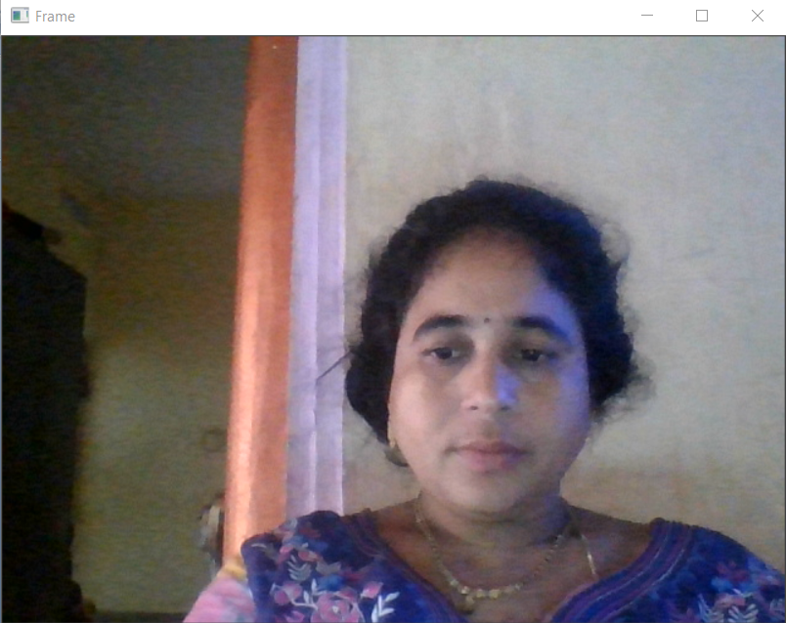
Canny output
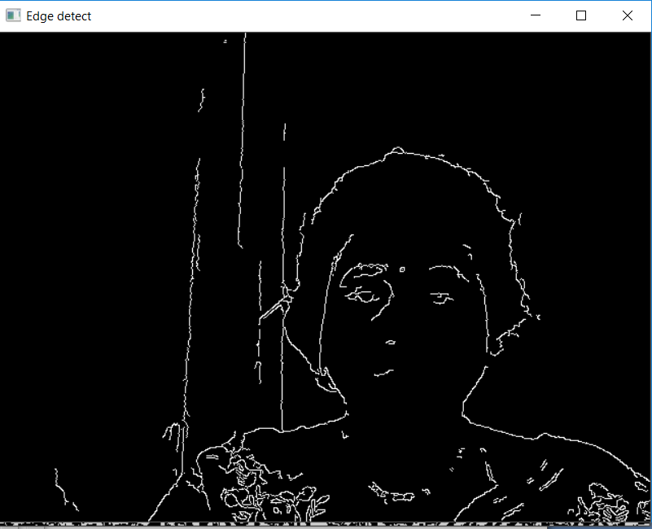

while(True):
ret, frame = video.read()

if ret == True:

# Write the frame into the
# file 'filename.avi'
result.write(frame)

# Display the frame
# saved in the file
cv2.imshow('Frame', frame)
gray = cv2.cvtColor(frame, cv2.COLOR_BGR2GRAY)
Thresh = cv2.adaptiveThreshold(gray, 255, cv2.ADAPTIVE_THRESH_MEAN_C,
cv2.THRESH_BINARY_INV, 11, 2)
cv2.imshow('Thresh', Thresh)
edge_detect = cv2.Canny(frame, 100, 200)
cv2.imshow('Edge detect', edge_detect)

# Press S on keyboard
# to stop the process
if cv2.waitKey(1) & 0xFF == ord('s'):
break

# Break the loop
else:
break

# When everything done, release
# the video capture and video
# write objects
video.release()
result.release()

# Closes all the frames
cv2.destroyAllWindows()

print("The video was successfully saved")

