AIM OF THE EXPERIMENT:
- Write C program For interface single led to 8051 controller using Keil µvision4 and design and simulate using Proteus
- Write C program For interface four leds to 8051 controller using Keil µvision4 and design and simulate using Proteus

COMPONENT REQUIRED:
HARDWARE:
- Personal Computer(with Window 10 Operating System)
SOFTWARE:
- Keil µvision4
- Proteus 8 professonal
Devices:
    - AT89C51
    - LED-BIBY
    - RES

Therory:
The LED is a PN-junction diode which emits light when an electric current passes through it in the forward direction. In the LED, the recombination of charge carrier takes place. The electron from the N-side and the hole from the P-side are combined and gives the energy in the form of heat and light. The LED is made of semiconductor material which is colourless, and the light is radiated through the junction of the diode.
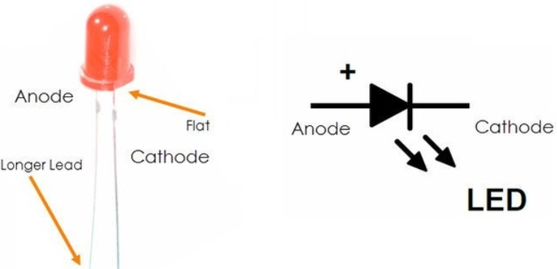
Procedure:
- Write Keil c program .Compile and Build and create Hex file
    - Open Keil µvision4
    - Create a folder name it as LED
    - Create new project in LED folded name the project as LED with .uvproj extension
    - Create a new file
    - Write cc code and save the file with led.c extension
    - Add the led.c to source file
    - Compile the project till no error
    - Create Hex file
- Design using Proteus 8 Professional and then simulate the design.
- Open Proteus 8 Professional
- Create new project
- Create schematic
- Add all the required devices to the project
- Connect all the component according the circuit design.
- Add hex file
- run the design

- Check the output.
CODE
#include<reg51.h>
sbit LED = P1^0;
void delay(int a);
int main(void)
{4
while(1)
{
LED = 0;
delay(30000);
LED = 1;
delay(30000);
}
}

void delay(int a)
{
int i;
for(i=0;i<a;i++);
}

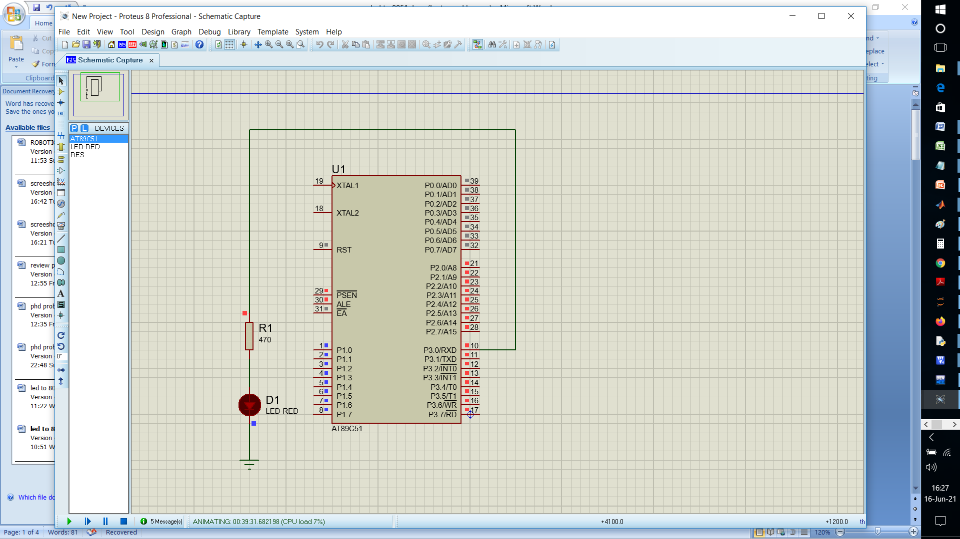

FOUR LED CODE
#include<reg51.h>
sbit led1=P2^0;
sbit led2=P2^1;
sbit led3=P2^2;
sbit led4=P2^3;
void delay(int a);
void main()
{
while(1)
{
led1=0;
led2=1;
led3=0;
led4=1;
delay(1000);
led1=1;
led2=0;
led3=1;
led4=0;
delay(1000);
}
}
void delay(int a)
{
int i;
for(i=0;i<a;i++);

}
