EXPERIMENT-3
AIM OF THE EXPERIMENT:
Write a program for interface Temperature sensor (LM35) to Atmega 328P controller and find the atmospheric temperature and display the Temperature in Serial Monitor.
COMPONENT REQUIRED:
Hardware Required:
- Aurduino Uno---1 Numbers
- LM35---------------2 Numbers
- Jumper wires
Software required:
1.Aurduino IDE-1.8.10
THEORY:
Aurduino:
LM35:
Jumper wire:
PROCEDURE:
- Open Arduino IDE (Interface Development Environment)
- Write program in IDE
- Save the file in a folder with .ino extension.
- Compile the code .
- Make circuit connection as per the circuit diagram.
- Upload the code in Arduino Board
- Check the result.
CODE:
int delip=A3;
void setup()
{
pinMode(delip, INPUT);
Serial.begin(9600);
}

void loop()
{
int value=analogRead(delip);
float mili=(value/1023.0)*5000;
float centigrade=mili/10;
Serial.print(centigrade);
Serial.println("C");
delay(1000);
}
CIRCUIT DIAGRAM:
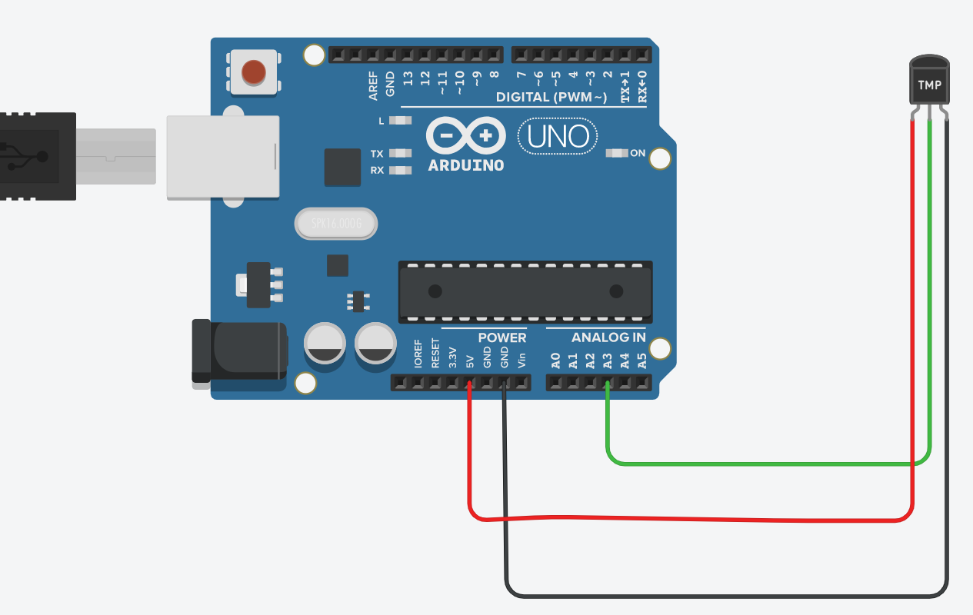
RESULT:
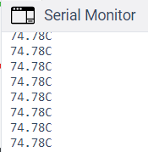
CONCLUSION:
We have successfully interfaced Temperature sensor (LM35) to Atmega 328P controller and also we observed the atmospheric temperature and displed the Temperature in Serial Monitor.

