CONCEPT OF 8951 CONTROLLER
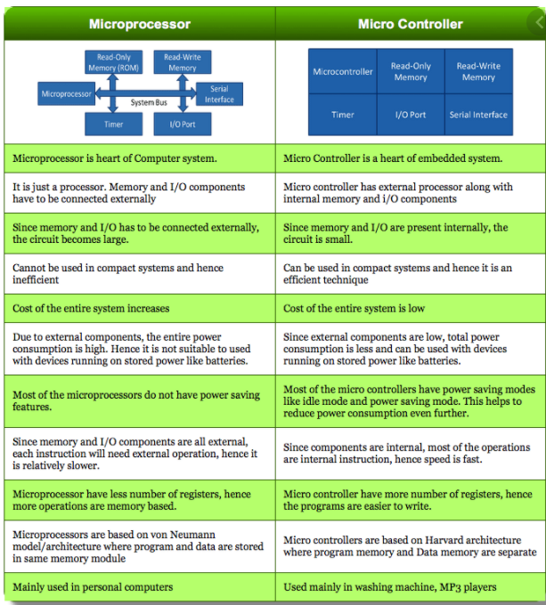

THE PIN DIAGRAM OF 8051 MICROCONTROLLER LOOKS AS FOLLOWS −8051/89c51/8052/89c52
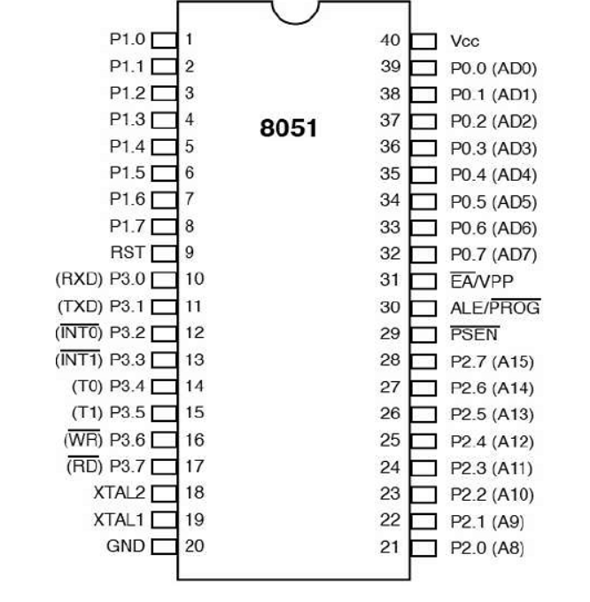

Pins 1 to 8 − These pins are known as Port 1. This port doesn’t serve any other functions. It is internally pulled up, bi-directional I/O port.
Pin 9 − It is a RESET pin, which is used to reset the microcontroller to its initial values.
Pins 10 to 17 − These pins are known as Port 3. This port serves some functions like interrupts, timer input, control signals, serial communication signals RxD and TxD, etc.
Pins 18 & 19 − These pins are used for interfacing an external crystal to get the system clock.
Pin 20 − This pin provides the power supply to the circuit.
Pins 21 to 28 − These pins are known as Port 2. It serves as I/O port. Higher order address bus signals are also multiplexed using this port.
Pin 29 − This is PSEN pin which stands for Program Store Enable. It is used to read a signal from the external program memory.
Pin 30 − This is EA pin which stands for External Access input. It is used to enable/disable the external memory interfacing.
Pin 31 − This is ALE pin which stands for Address Latch Enable. It is used to demultiplex the address-data signal of port.
Pins 32 to 39 − These pins are known as Port 0. It serves as I/O port. Lower order address and data bus signals are multiplexed using this port.
Pin 40 − This pin is used to provide power supply to the circuit.
8051 microcontrollers have 4 I/O ports each of 8-bit, which can be configured as input or output. Hence, total 32 input/output pins allow the microcontroller to be connected with the peripheral devices.

