8051 microcontroller is designed by Intel in 1981. It is an 8-bit microcontroller. It is built with 40 pins DIP (dual inline package), 4kb of ROM storage and 128 bytes of RAM storage, 2 16-bit timers. It consists of are four parallel 8-bit ports, which are programmable as well as addressable as per the requirement. An on-chip crystal oscillator is integrated in the microcontroller having crystal frequency of 12 MHz.
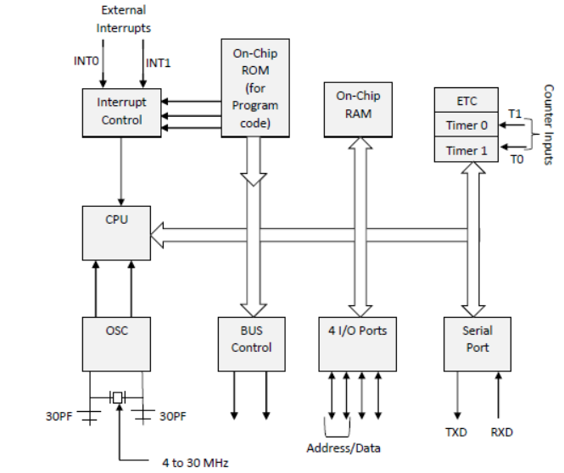
The pin diagram of 8051 microcontroller looks as follows –
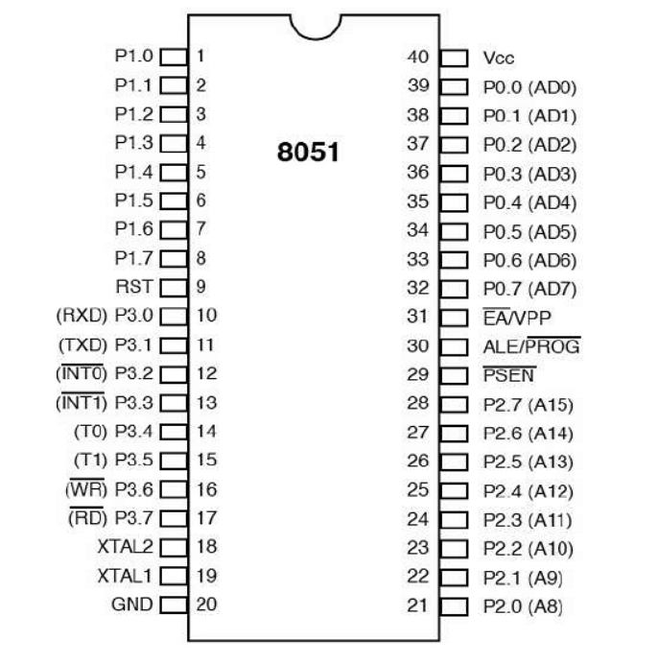
- Pins 1 to 8 − These pins are known as Port 1. This port doesn’t serve any other functions. It is internally pulled up, bi-directional I/O port.
- Pin 9 − It is a RESET pin, which is used to reset the microcontroller to its initial values.
- Pins 10 to 17 − These pins are known as Port 3. This port serves some functions like interrupts, timer input, control signals, serial communication signals RxD and TxD, etc.
- Pins 18 & 19 − These pins are used for interfacing an external crystal to get the system clock.
- Pin 20 − This pin provides the power supply to the circuit.
- Pins 21 to 28 − These pins are known as Port 2. It serves as I/O port. Higher order address bus signals are also multiplexed using this port.
- Pin 29 − This is PSEN pin which stands for Program Store Enable. It is used to read a signal from the external program memory.
- Pin 30 − This is EA pin which stands for External Access input. It is used to enable/disable the external memory interfacing.
- Pin 31 − This is ALE pin which stands for Address Latch Enable. It is used to demultiplex the address-data signal of port.
- Pins 32 to 39 − These pins are known as Port 0. It serves as I/O port. Lower order address and data bus signals are multiplexed using this port.
- Pin 40 − This pin is used to provide power supply to the circuit.
8051 microcontrollers have 4 I/O ports each of 8-bit, which can be configured as input or output. Hence, total 32 input/output pins allow the microcontroller to be connected with the peripheral devices.

