Code

int motion = 2;
int light =13;
void setup()
{
pinMode(motion, INPUT);
pinMode(light, OUTPUT);
Serial.begin(9600);
}

void loop()
{
int sensor = digitalRead(motion);
Serial.println(sensor);
if(sensor==LOW){
digitalWrite(light, HIGH);
delay(500);
digitalWrite(light, LOW);
delay(500);
}
}

CIRCUIT DIAGRAM
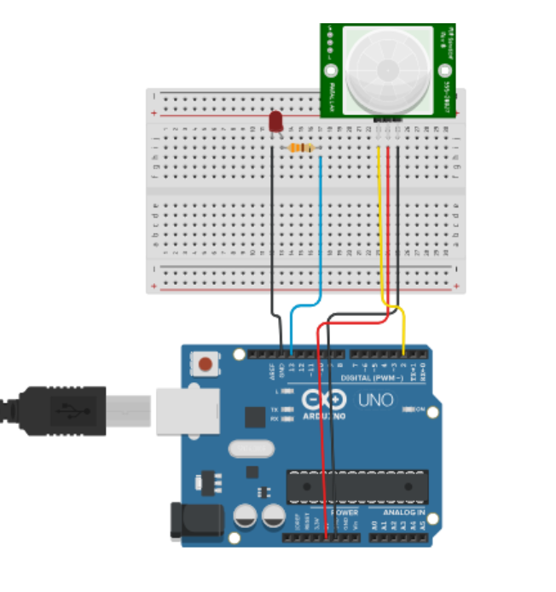
OUTPUT
