Experiments:1

Instullation of softwares

1:-Aurduino IDE(interfacing of sensors)

2-Cappeleri Sim(design and simulate robot)

3-vertual environment for ubuntu

(linux commands, installations of ROS)

Output devices like :

LED:2 pin Anode and Cathode:

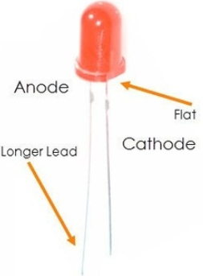

Motor:

DC motor

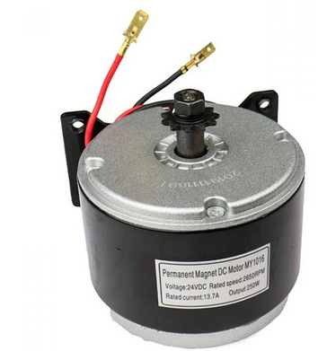

Servo motor

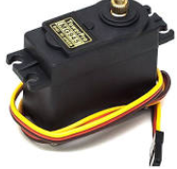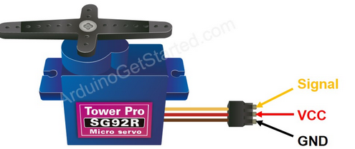

Gear motor

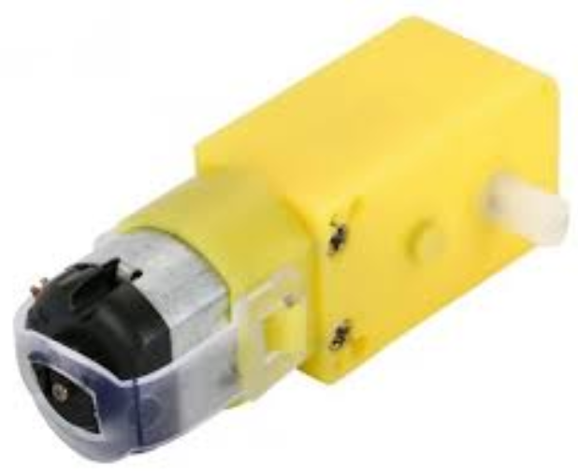

BLDC motor:

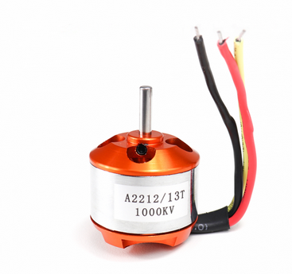

ESC

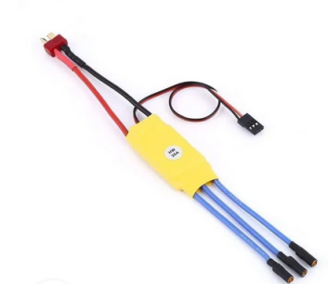

Buzzer

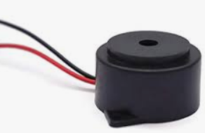

Input devices like:

Sensors

DHT11(tepm and Humidity):

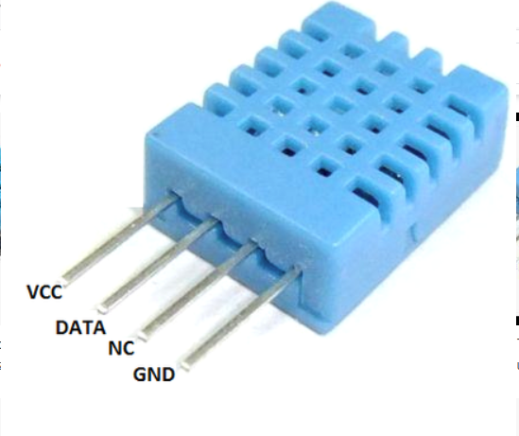

Ultrasonic sensor: SR-04

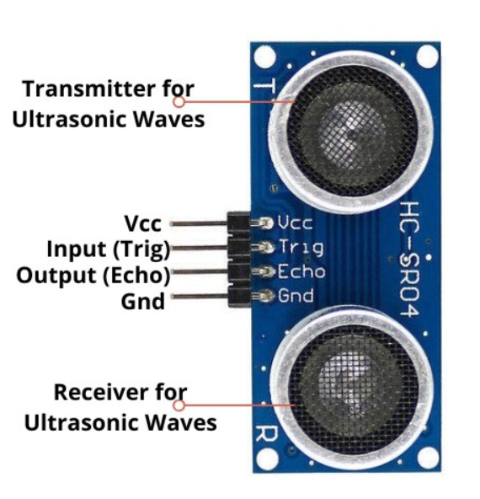

Ir sensor:

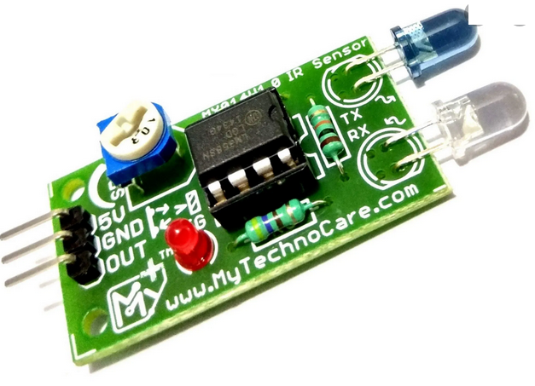

Pir sensor:

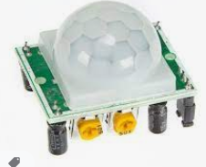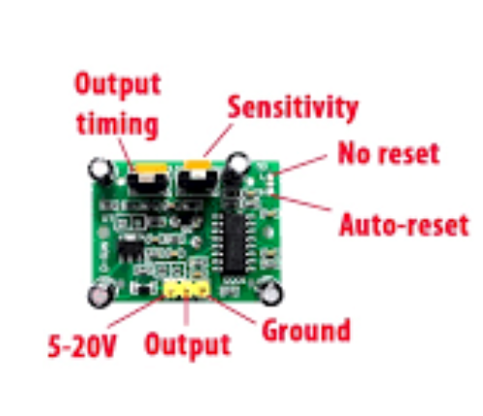

Soil moisture sensor:

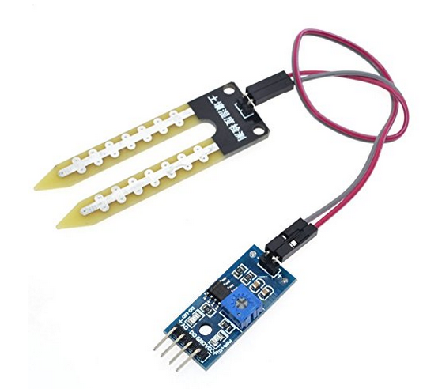

Ph sensor:

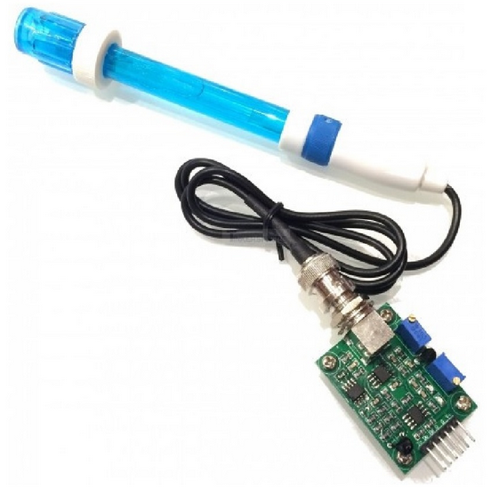

gas sensor(ch3) or mq2 sensor:

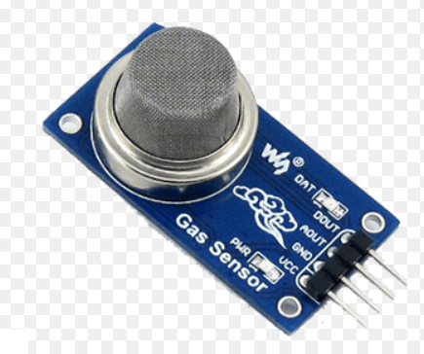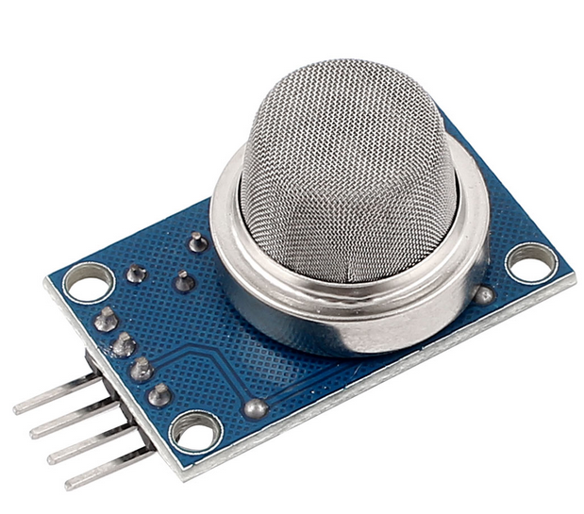

adxl335 accelerometer sensor:

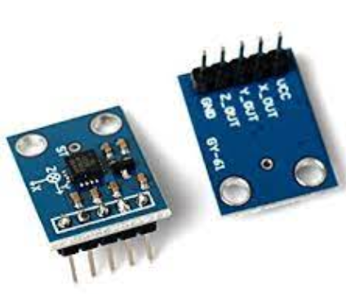

ldr sensor:

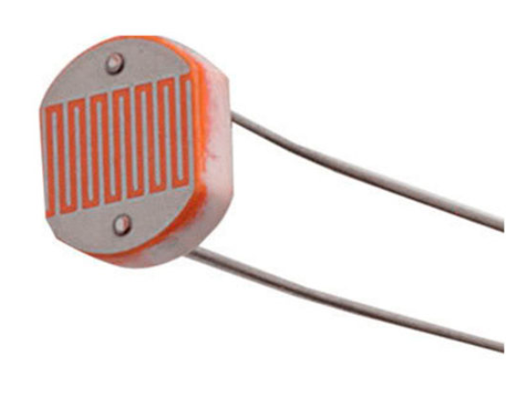

lm35 temperature:

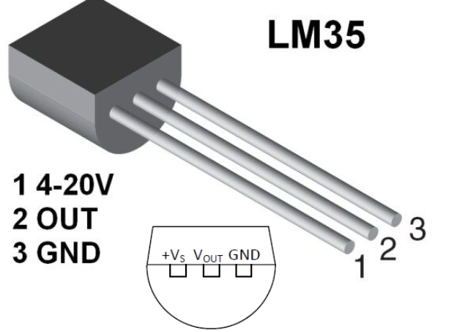

rfid module:

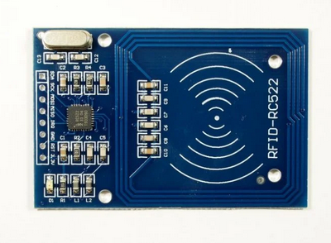

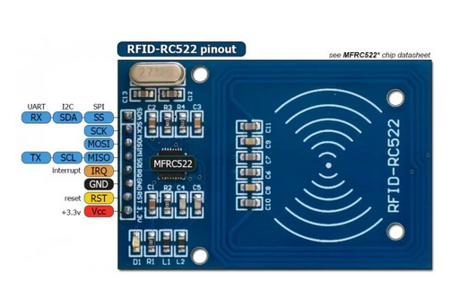

Thermistor:

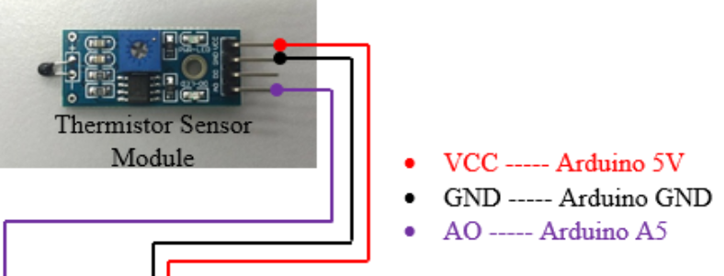

Zigbee Module:

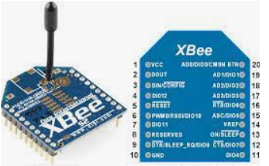

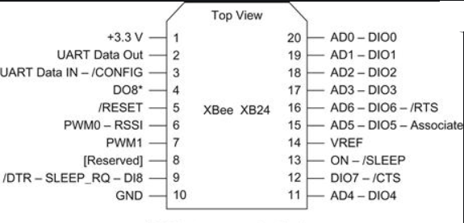

HC05 Bluetooth Module:

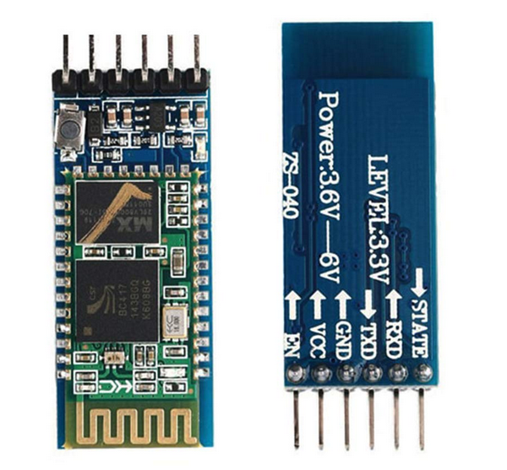

relay dual channel module:

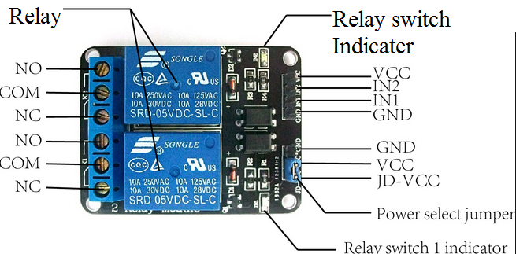

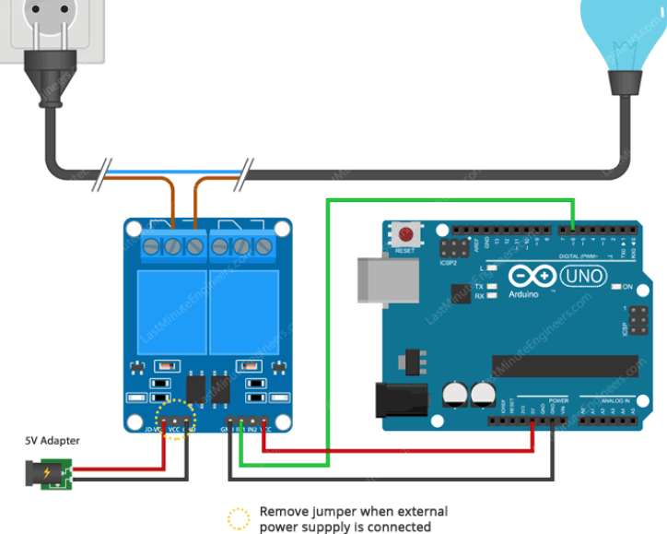

motor driver l293d

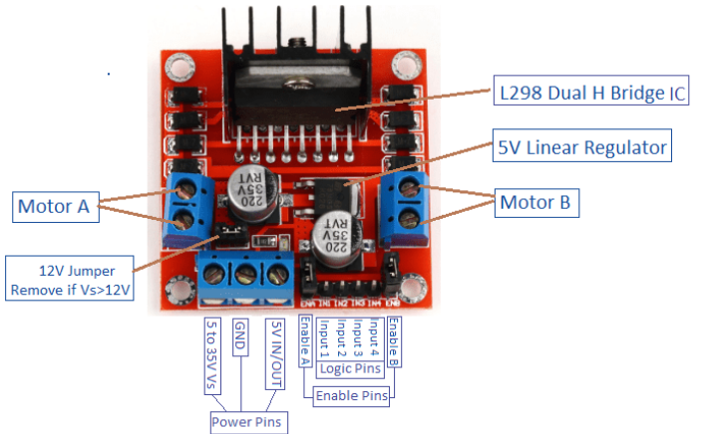

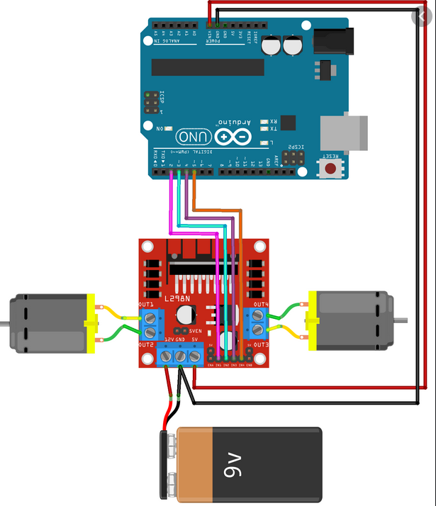

OV7076 camera module

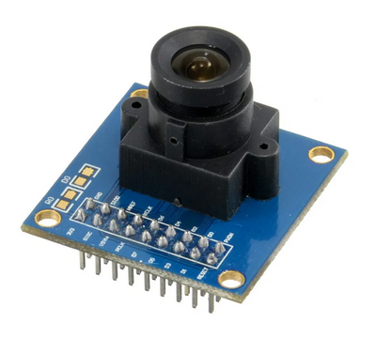

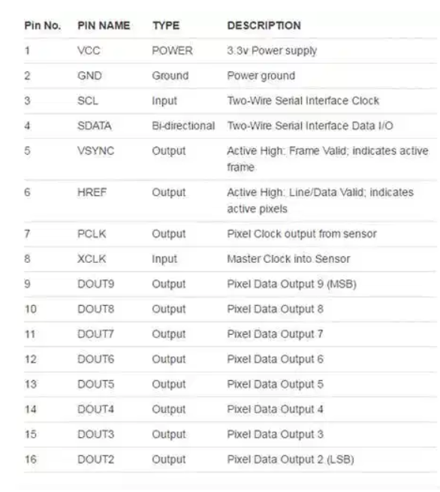

oled display module:

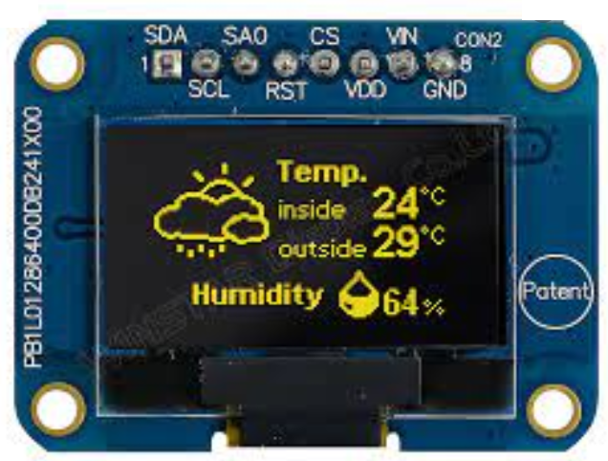

Switches:

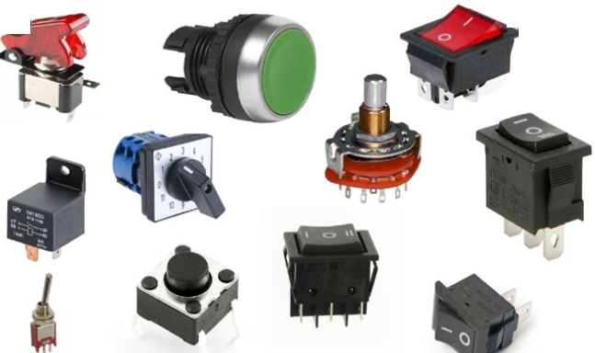

Keyboard:

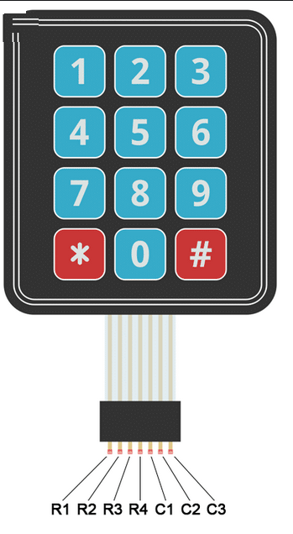

Aurduino pins: use for temporary connection of any electronic components

14 pin(GPIO:General perpose Input and Output pin)

Analog pins:6

Power pins:vcc:5v

Gnd

Bread board:

Question: code for interface an Buzzer to D2 or GPIO 4 pin of NodeMCU

Projects List:

Introduction

Abstract Or Obstracve

Components used

Description of each and every component with diagram

Circuit diagram_own block diagram

Code explain

Outputs

reference

1.self balancing Robot

2.Abstracle avoidance robot

3.robotic arm

4.fire fighting robot

5.Foor cleaning robot using ultrasonic sensor.

6.Real time face detection and tracking robot

7.Bluetooth based walking and tracking robot.

8.Mobile phone controlled Robot car

9.Smart Vacume cleaning robot

10.Wifi controlled robot.

11.Accelerometer based hand gesture controlled robot

12. PC Controlled Human Detection Robot

13. Design of Rescue Robot and Pipeline Inspection Using Zigbee

14. Mobile Robot Navigation System with RFID and Ultrasonic Sensors.

15. Design of an Unmanned Vehicle using a GSM Network with Microcontrollers.

16. Bluetooth Controlled Robot Using Android Smart Phone:

