Grid connection of solar modules in Microgrid
Challenges in Renewable Integration:-
- Intermittent generation dependent on season, weather and other parameters-Power balancing .
- Voltage and frequency control; most of these sources do not have reactive power generation.
- The sudden generation loss can lead to transient angle and voltage instability.
- Stability issue more challenging due to inertia less generation, e.g. solar.
- Power Quality issues-Harmonics, flicker, under voltage ride through capability
- Power management and Maximum power point tracking.
CEA – Technical Standards for Connectivity to Grid
- Existing:-
  - The generating unit should be capable of operating in the frequency range of 47.5 to 52 Hz and shall be able to deliver rated output in the frequency range of 49.5 Hz to 50.5 Hz.
- Proposed:-
  - Wind/solar generating units connected to the grid shall remain connected to the grid when voltage at the interconnection point on any or all phases dips up to the levels depicted by the thick lines in the following curve. Provided that during the voltage dip the world and solar generating units shall generate active power in proportion to the rated voltage. Provided further that during voltage dip the generating units shall maximize supply of reactive current till the time voltage starts recovering or for 300 ns, whichever is lower.
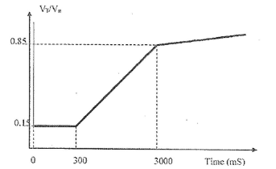

- Introduction of Frequency range with provision to include frequency response by wind & solar power stations.
- Introduce applicability of LVRT to solar generating stations.
- Change applicability of LVRT to wind generating units at all voltage levels in place of 66kV level & above.
- Introduction of HVRT facility to solar & wind generating units.
- Specify ramp up & ramp down rates for solar & wind generating units.
- Introduction of voltage regulation services for solar & wind generating stations.
- Introduction of short circuit ratio for renewable generating units.
- Review of reactive power control capability of renewable generating units.
- Review of limits of Harmonics.
- Power to relax in case of introduction of a new technology.
- Compliance monitoring of CEA regulations.

