Testing of Microgrid
Think small
Cities, utilities, businesses, universities, and the U.S. military are turning to microgrids for supplemental and backup power. It isn’t hard to see why. Microgrids offer the flexibility, quick response and control, and security that the larger grid can’t. They also respond to customers’ desire for more local control of their energy and a greater percentage of renewables powering their homes and businesses.
Microgrid testing at the ESIF
Research at the Energy Systems Integration Facility (ESIF) focuses on getting microgrids and microgrid technologies from the factory into the field. The ESIF allows manufacturers and integrators to test out their technology or configuration at actual power before implementation—something only possible at a handful of facilities in the world. In addition, the ESIF is able to add an important communications layer that connects a real-time simulated network and network devices to the power devices and systems under test. This cyber-physical test platform makes it possible to test not only factors like microgrid power quality and transitions between modes, but also communications protocols and latency and bandwidth requirements for the microgrid controller.
The main elements of the ESIF’s microgrid test platform
Network simulator-in-the-loop
• OMNeT++: simulates a network and links with real computers and virtual hosts.
Hardware
• 1-MW, high-bandwidth grid simulator: a completely programmable AC power source is decoupled from the utility.
• High-resolution load banks: independent phase control, programmable load profiles, and a full range of power factors make it possible to test a wide variety of load scenarios.
• Diesel generators: because diesel generators are traditional microgrid components, three different gensets with various control options are available for microgrid integration efforts.
• DC power supplies: the ESIF’s full suite of DC simulation capability includes a 1.5-MW PV simulator, three bi-directional DC supplies for battery simulation up to 700 kW, and a 10-kW rooftop PV array.
• Lithium-ion batteries: 100-kW and 80-kWh packs for use in both controls and power electronics development as well as microgrid integration work.
• Advanced inverters: an array of advanced grid-interactive PV and hybrid inverters is available, ranging from 3-kW residential to 20-50 kW commercial and 500-kW central station.
Power hardware-in-the-loop
- OPAL-RT and RTDS real-time simulation platforms for running power system models concurrently with actual hardware at power, in real time.
• Emulation of utility grid, energy storage, distribution feeder, and load.
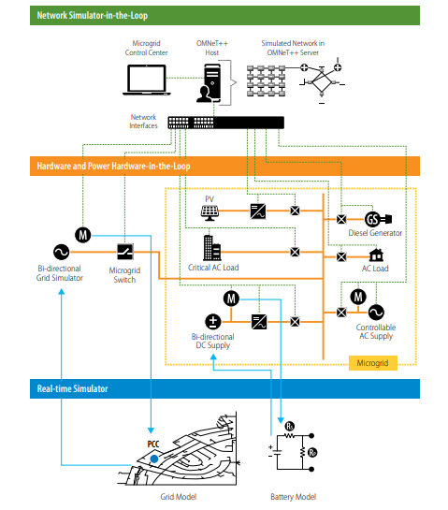
Benefits of testing
There is no substitute for testing microgrid technology at full power and actual load levels before implementation. The ESIF’s cyber-physical test platform for microgrids reduces the risks of deployment and helps to optimize the performance of microgrid hardware, communications, and security.
About NREL’s Energy Systems Integration Facility
The ESIF offers utilities, industry, manufacturers, universities, and other government laboratories access to an awardwinning, state-of-the-art lab space and a team of specialized scientists and engineers to help move new technologies forward. Bring us your biggest energy system challenges and let’s solve them together.

