https://www.youtube.com/watch?v=4R6qdBgm_JQ
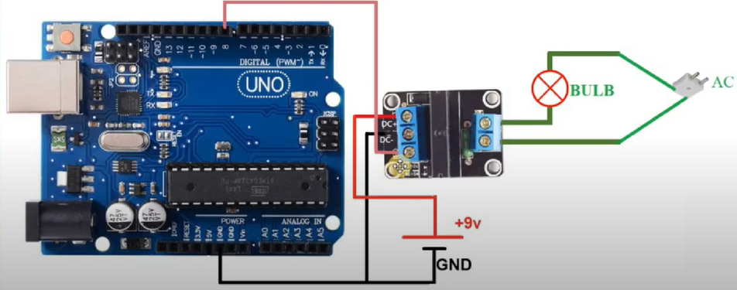
CODE
int relayPin=8;
void setup() {
pinMode(relayPin,OUTPUT);
digitalWrite(relayPin,LOW);// put your setup code here, to run once:

}

void loop() {
digitalWrite(relayPin,HIGH);// put your main code here, to run repeatedly:
delay(2000);
digitalWrite(relayPin, LOW);
delay(2000);
}

