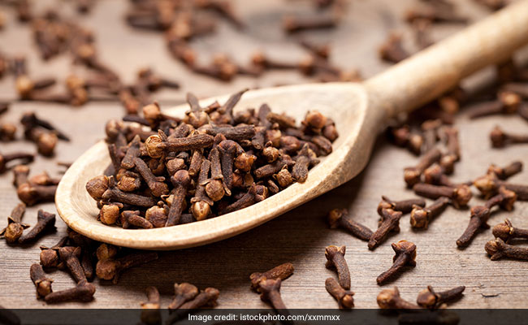

Pungent and peppery, cloves are used in a variety of curries and pulao for its distinct flavour. Cloves can be found both in whole and ground forms, and both of them are pretty popular in Indian kitchens. The warming spice is a winter favourite too and has many potent medicinal properties that helps keep cold, cough, nausea, digestive disorders and flu at bay. Ayurveda has many healing concoctions or kadhas that uses clove as one of its main ingredients. As per Ayurveda, cloves are said to be kaphahar which means that they have the ability to balance the kapha dosha. Kapha governs the structure and fluid in the body. Its primary function is protection. Being carminative in nature, it helps in improving digestion. Therefore, it is suggested you add cloves while cooking foods like kidney beans or black gram that tend to cause flatulence. Ayurvedic medicine used cloves for tooth decay, halitosis, and bad breath. Ground cloves are traditionally applied to minor cuts for healing purposes. Moreover, its tea is a popular warm beverage to relieve congestion. Using clove oil helps relieve headaches, flatulence, as well as reduce stretch marks
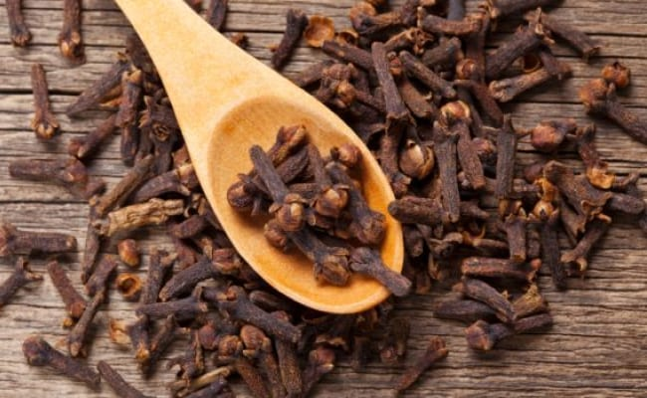

Cloves (Laung) For Diabetes: Here's How The Pungent Herb Is Effective In Managing Diabetes
Alongside it's antiseptic properties, cloves also offer anti-inflammatory, analgesic and digestive health benefits for diabetes. Cloves also help keep your blood sugar levels in check and are known to promote insulin production, further controlling diabetes. A recent study, published in Journal Natural Medicine, examined the hypoglycaemic effects of clove on genetically diabetic mice and found that the extract helps increase the secretion of insulin and improve the function of cells that produce insulin.
Insulin is a hormone that helps keep your blood sugar levels in control. Among diabetics, the insulin hormone is often impaired, which is why it gets difficult for the system to process how much sugar is needed and how much is extra. Clove oil also helps in maintaining the insulin levels. The postprandial insulin and glucose response mechanism is improved significantly on consuming clove oil.

