Binary multiplication-

Binary Multiplication Rules
Binary multiplication is similar to the multiplication of decimal numbers. We have a multiplier and a multiplicand. The result of multiplication results in a product. Since only binary digits are involved in binary multiplication, we get to multiply only 0s and 1s. The rules for binary multiplication are as follows.
Multiplicand | Multiplier | Product
0 | 0 | 0 × 0 = 0
0 | 1 | 0 × 1 = 0
1 | 0 | 1 × 0 = 0
1 | 1 | 1 × 1 = 1

How to Multiply Binary Numbers?
The process of multiplying binary numbers is similar and easier to do than decimal multiplication as binary numbers consist of only two digits which are 0 and 1. The method of multiplying binary numbers is given below. The same set of rules also apply to binary numbers with a decimal point. Let us take the example of multiplying (11101)2 and (1001)2. The decimal equivalent of (11101)2 is 29 and the decimal equivalent of (1001)2 is 9. Now let us multiply these numbers.
Step 1: Write down the multiplicand (11101)2 and the multiplier (1001)2 one below the other in proper positions.
Step 2: Multiply the rightmost digit or the least significant bit (LSB) of the multiplier (1) with all the digits of the multiplicand (11101)2.
Step 3: Add a place holder of '0' or 'X' before multiplying the next higher order digit of the multiplier& with the multiplicand.
Step 4: Repeat the same process for all the next higher-order digits until we reach the most significant bit (MSB) which is the left-most digit of the multiplicand with the multiplier.
Step 5: The product obtained in each row is called the partial product. Finally, add all the partial products. To add all the binary numbers use the rules of binary addition.
(The rules for binary addition are listed as follows: 0 + 0 = 0, 0 + 1 = 1, and 1 + 1 = 0, with a carryover of 1. So, 1 + 1 = 10 and 1 + 1 + 1 = 11 in the binary number system)
Let us look at the following process of binary multiplication as described above.
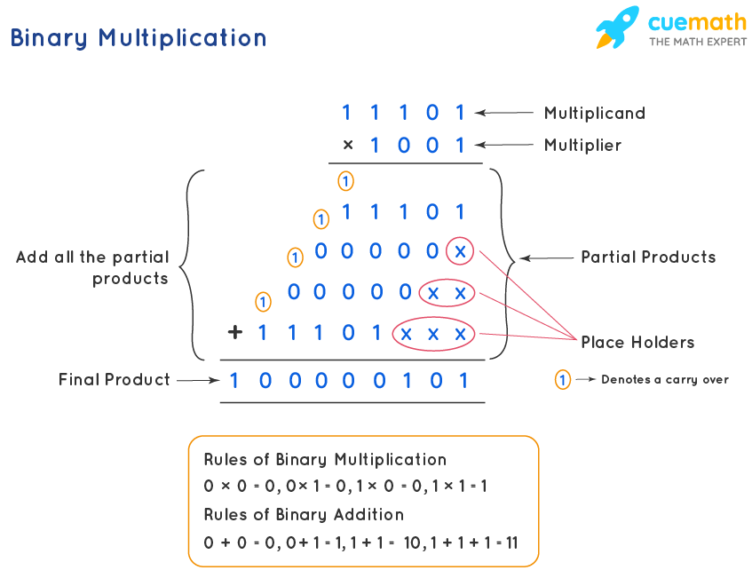

Binary Division Rules
We can perform all arithmetic operations such as addition, subtraction, multiplication, and division on binary numbers, in the same way as we perform arithmetic operations on the decimal number system. Binary subtraction, binary multiplication, binary addition, and binary division are the four types of arithmetic operations that are performed here. We just need to follow some rules while dividing two binary numbers. There are four rules to be followed while performing binary division. Similar to the decimal system (or in any other number system), division by 0 is meaningless in Binary division. The binary division rules are as follows:
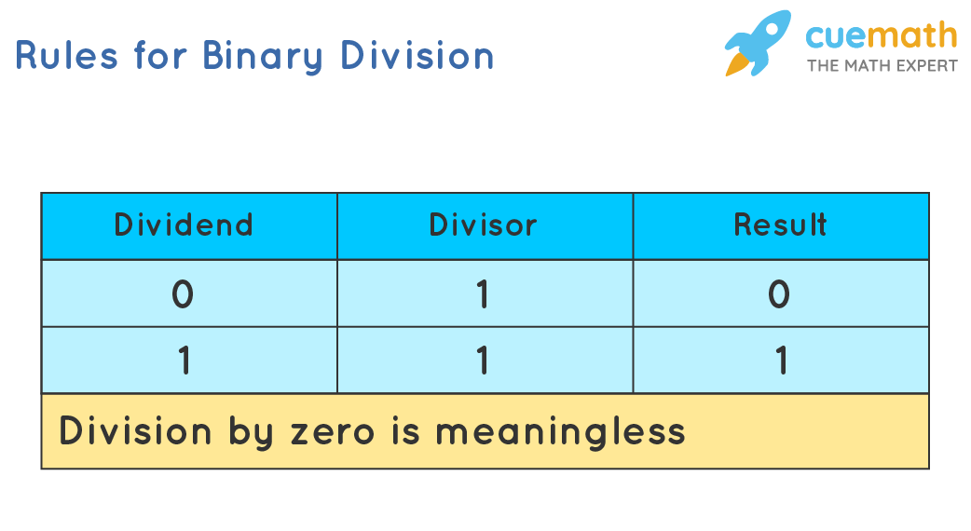
The four rules given above are all the possible conditions for the division of binary numbers as binary numbers include only two digits 0 and 1.

How To Do Binary Division?
Binary division problems can be solved by using the long division method, which is one of the most efficient and easiest ways to divide binary numbers. These are the steps to be followed in a binary division operation:
- Step 1: Compare the divisor with the dividend. If the divisor is larger, place 0 as the quotient, then bring the second bit of the dividend down. If the divisor is smaller, multiply it with 1 and the result becomes the subtrahend. Then, subtract the subtrahend from the minuend to get the remainder.
- Step 2: Then bring down the next number bit from the dividend portion and perform step 1 again.
- Step 3: Repeat the same process until the remainder becomes zero or the whole dividend is divided.
Let us understand binary division operation better using the following example:
Example: Consider two binary numbers, B = 0110102 and C = 01012 where we want to divide B by C.
Given: Dividend, 0110102 and the divisor, C = 01012.
Step1: Since the zero in the most significant bit position doesn't change the value of the number, let's remove it from both the dividend and divisor. So the dividend becomes 110102, and the divisor becomes 1012.
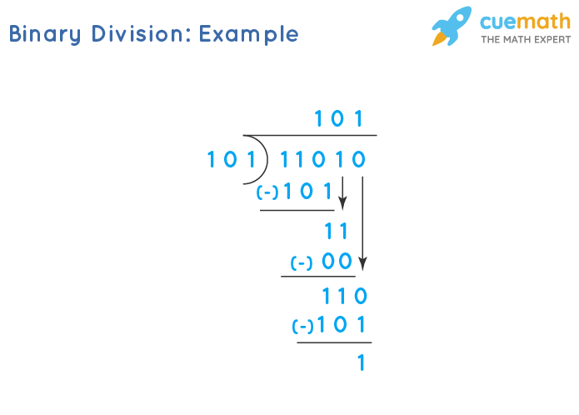
Step 2: Let us use the long-division method. In this step, compare the divisor 1012 with the first digit in the dividend 110102, since the divisor is smaller, it will be multiplied with 1 and the result will be the subtrahend.
As per the binary multiplication rules:
- 1 × 1 = 1
- 1 × 0 = 0
- 0 × 1 = 0
- 0 × 0 = 0
So, 101 × 1 = 1012, and this result is written below.
Step 3: Subtract the subtrahend 1012 from the minuend 1102.
As per the binary subtraction rules,
- 0 - 1 = 1, we need to borrow 1 from the next more significant bit.
- 0 - 0 = 0
- 1 - 1 = 0
- 1 - 0 = 0
When we apply the above rules, this is how the calculation is done:
- For the first digit on the right, we have to subtract (0 - 1). So, we borrow a 1 from the digit on the left or the next higher order digit. Therefore, the result is 1.
- Then, (0 - 0 = 0) since the number in the next higher order digit becomes 0 after borrowing.
- 1 - 1 = 0 in the second next higher order digit.
- So, 1102- 1012= 0012, and this result is written below.
Step 4: As per the rules of division, the next least significant bit comes down, and the divisor is multiplied by 1. Since the result, 1012 is bigger than the minuend 00112, this step cannot be completed. Then, we have to go to the next step
Step 5: We write 0 as the next bit of the quotient and then, the least significant bit 0 comes down.
Step 6: Again the divisor is multiplied by 1 and the result is written as 101 × 1 = 1012.
Step 7: Now we are at the final step. As per the binary subtraction, we subtract 1012 from 1102. We get, 1102 - 1012 = 0012. The remainder is similar to Step 3, as all the numbers are the same.
The binary division operation is completed now and we get the following result.
- Quotient = 1012
- Remainder = 001 = 1

