Introductory Agro meteorology and climate change

COURSE NO. – ASAG1202
CREDIT- 2(1+1)
STUDY MATERIAL

Prepared by:
Ms. Jnana Bharati Palai
Department of Agronomy
MS SWAMINATHAN SCHOOL OF AGRICULTURE
CENTURION UNIVERSITY OF TECHNOLOGY & MANAGEMENT
Paralakhemundi, Odisha-761211,
INDIA

Lecture No. | Content
1 | Earth atmosphere- its composition, extent and structure
2 | Atmospheric weather variables; Atmospheric pressure, its variation with height; Wind, types of wind, daily and seasonal variation of wind speed, cyclone, anticyclone, land breeze and sea breeze;
3 | Nature and properties of solar radiation, solar constant, depletion of solar radiation, short wave, longwave and thermal radiation, net radiation, albedo
4 | Atmospheric temperature, temperature inversion, lapse rate, daily and seasonal variations of temperature, vertical profile of temperature, Energy balance of earth
5 | Atmospheric humidity, concept of saturation, vapor pressure, process of condensation, formation of dew, fog, mist, frost, cloud; Precipitation, process of precipitation, types of precipitation such as rain, snow, sleet, and hail, cloud formation and classification
6 | Artificial rainmaking. Monsoon- mechanism and importance in Indian agriculture
7 | Weather hazards - drought, floods, frost, tropical cyclones and extreme weather conditions such as heat-wave and cold-wave.Agriculture and weather relations
8 | Modifications of crop microclimate, climatic normals for crop and livestock production
9 | Weather forecasting- types of weather forecast and their uses
10 | Climate change, climatic variability, global warming, causes of climate change and its impact on regional and national Agriculture
SYLLABUS
References
1. Radha Krishna Murthy, V. 2016. Principles and Practices of agricultural disaster management, B.S. Publications, Koti, Hyderabad.
2. Reddy, S.R. 2014. Introduction to Agriculture and Agrometeorology. Kalyani Publishers, Ludhiana, Punjab.
3. Radha Krishna Murthy, V. 2002. Basic Principles of Agricultural meteorology, B.S. Publications, Koti, Hyderabad.

Lecture No. 1
ATMOSPHERE
- Atmosphere is a colourless, tasteless and odourless mixture of gases that surround the earth. Total mass of atmosphere has been calculated at about 56x10¹⁴ t.
Composition of atmosphere
Constituent Per cent by volume
Nitrogen 78.08 %
Oxygen 20.94 %
Argon 0.93 %
Carbon-dioxide 0.03 %
- There is no definite upper boundary layer to the atmosphere.
- The decrease of air(density) with altitude.
- However, 99% of the total mass of the atmosphere is within 40 km.
- The atmosphere is a mixture of many gases. In addition it contains large quantities of solid and liquid particles, collectively called aerosols.
- The lower part of the atmosphere contains water vapour from 0-4% by volume.
- Nitrogen and oxygen make up approximately to 99% and remaining 1% by other gases.
- The lower atmosphere also contains impurities like dust particles, salt crystals, bacteria, pollen etc.
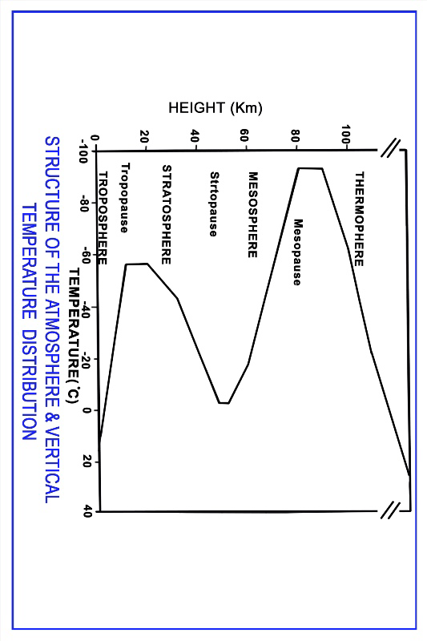(i) Troposphere
- The word “Tropo” means mixing or turbulence and “Sphere” means region.
- The average height of this lower most layer of the atmosphere is about 8-18 km.
- All weather phenomena like clouds, fogs, dew, rain etc. occur in this layer. So this layer is called “Seat of weather phenomena”.
- The wind velocity increases with height and attain the maximum at the top of this layer.
- Another striking feature of troposphere is that there is a decrease of temperature with increasing elevation and the temperature at the boundary is -60⁰C.
- Most of the radiation received from the sun is absorbed by the earth’s surface. So the troposphere is heated below.
- It is the densest part of the atmosphere and contains about 85% of total atmosphere’s mass.
- At the top of the troposphere there is a shallow layer separating it from stratosphere which is known as tropopause.
(ii) Stratosphere
- This layer exists above the tropopause (around 20 km onwards) and extends to altitudes of about 50-55 kilometers.
- This layer is called as "Seat of photochemical reactions".
- It is dust free and cloudless.
- The temperature of this layer increases with height. It contains around 15% of total atmosphere’s mass.
- In the upper parts of the stratosphere the temperatures are almost as higher as those near the earth's surface, which is due to the fact that the ultra violet radiation from the sun is absorbed by ozone in this region.
- It is also called as chemosphere or ozonosphere.
- The upper boundary of stratosphere is stratopause.
(iii) Mesosphere
- The layer between 50 and 85 km is called mesosphere.
- It is the layer where most of the meteors burn up during entering the atmosphere.
- In this layer the temperature decrease to -100⁰C with height. It is the coldest layer.
- The upper boundary of this layer is called mesosphere.
(iv) Thermosphere
- The thermosphere starts just above the mesosphere and extends to 600 kilometers.
- Temperature increases with altitude in the thermosphere
- Aurora and satellites occur in this layer
(v) Ionosphere: The ionosphere is an abundant layer of electrons and ionized atoms and molecules that stretches from about 48 kilometers above the surface to the edge of space at about 965 km, overlapping into the mesosphere and thermosphere. Long distance radio communication is made possible through this ionized layer.
(vi)Exosphere
- The outer most layer of the earth's atmosphere is named as exosphere. It extends from the top of thermosphere upto 10,000 kilometres.
- At such a greater height the density of atoms in the atmosphere is extremely low. The density of the atmosphere becomes so low that collisions between neutral particles become extremely rare.
- Hydrogen and Helium gases predominate in this outer most region.

Lecture No. 2
Weather variables: six major weather variables are air temperature, air pressure, humidity of the air, amount and kind of cloud cover, amount and kind of precipitation and speed and direction of the wind.
ATMOSPHERIC PRESSURE
Pressure
Technically pressure is defined as “Force per unit area”.
Atmospheric pressure : Atmospheric pressure is defined as “the pressure exerted by a column of air with a cross sectional area of a given unit i.e., a square inch or a square centimeter extending from the earth surface to the upper most boundary of the atmosphere”.
Standard atmospheric pressure : The atmospheric pressure varies continuously over a relatively small range and the average of these fluctuations is very close to a value adopted for certain standard conditions defined as “Standard atmosphere”. At a temperature of 15⁰C and at 45⁰ latitude the standard normal pressure is *1013.2 millibars which is equivalent to 29.92 inches (or) 760 mm of mircury at the sea level, which is considered as standard atmospheric pressure.
- Basic atmospheric pressure patterns
These are various smaller pressure systems closely identified with daily weather changes. These are seen on daily weather maps.
1. Low pressure systems or cyclones
♦ When the isobars are circular or elliptical in shape, and the pressure is lowest at the centre, such a pressure system is called “low” or “depression” or “cyclone”.
♦ A line of low pressure is called a “Trough” when the isobars are not joined at the ends.
♦ The word “cyclone” is derived from a Greek word “cyclos” meaning the coils of a snake.
♦ In India cyclones occur during the monsoon seasons especially in north-east monsoon.
♦ The gales accompanying a cyclone give rise to confused seas, torrential rains and usually approach the coast at 300 to 500 kilometers per hour. A single severe cyclone can perish hundreds of human lives, animal populations, and submerge thousands of hectares of standing crop.
♦ The diameter of a cyclone ranges from a few hundreds to 2000 kilometers.
♦ Floods are the results of the cyclones.
♦ The devastation could be attributed to the absence of – Timely warning – Lack of awareness among the people – Inadequate preparedness – Poor response and participation.
♦ Cyclones are recurring feature in India.
2. High pressure systems or anticyclones
- When isobars are circular, elliptical in shape and the pressure is highest at the centre such a pressure system is called “High” or “Anticyclone”. When the isobars are elliptical rather than circular the system is called as a “Ridge” or “Wedge”.
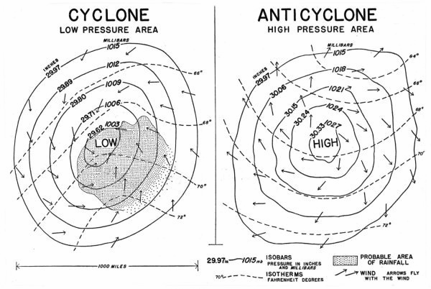

Cyclones | Anticyclones
Lowest pressure at the centre and it  increases towards the outer rim  gradually. | Highest pressure at the centre and it  decreases towards the outer rim  gradually.
Relative humidity increases towards  centre and bring cloudy weather. | Relative humidity decreases and  clouds are dissipated giving fair  weather.
Variety of clouds lies at different  heights. | Little clouds with cool dry air are  usually associated.
Highest rainfall occurs at the front side. | Rainfall is almost negligible.
Wind velocity increases from outer rim  to the centre. | Wind spirally rushes outward from the centre to periphere.
Move in anticlock wise in northern  hemisphere and clock wise in southern  hemisphere | Move in clock wise in northern  hemisphere and anti clock wise in  southern hemisphere.

WIND : Air in horizontal motion is known as “Wind”. Winds are named by the direction they come from. Windward refers to the direction a wind comes from and leeward is the direction towards which it flows. The wind which flows more frequently from one direction than any other is called as “Prevailing wind”.

Importance of wind on plants
- Transports heat in either sensible or latent form, from lower to higher latitudes,
- Provides the moisture (to the land masses) which is necessary for precipitation
- Moderate turbulence promotes the consumption of carbon – dioxide by photosynthesis.
- Wind prevents frost by disrupting a temperature inversion
- Wind dispersal of pollen and seeds is natural and necessary for certain agricultural crops, natural vegetation, etc.
Land and sea breezes
- These winds are defined as “The complete cycle of diurnal local winds occurring on sea coasts due to differences in surface temperature of land and sea”.
- There is a complete diurnal reversal of wind direction of these coastal winds.
- That is why they are also referred to as diurnal monsoon, since these wind systems are caused by unequal heating of land and water surfaces.
- Land and sea breezes are caused by diurnal variation of pressure (monsoon by seasonal variation).
- During the day time, more so in summer land is heated more than the adjacent body of water.
- As a result, warmed air over the land expands producing an area of low pressure.
- The cooler air over the water starts moving across the coast line from sea to land. This is the “Sea breeze” or “On shore breeze”.
- However, at night because of nocturnal radiation, land is colder than adjacent sea and the pressure gradient is directed from land to sea. There is a gentle flow from land to sea. This “Off-shore” wind is called “Land breeze”.

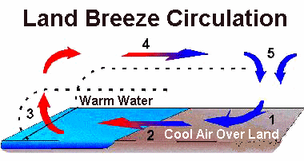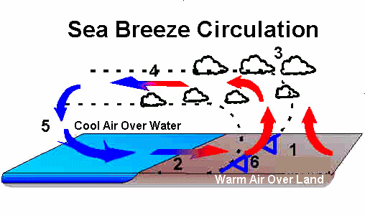
Land breeze | Sea breeze
Occurs in night time. | Occurs in day time.
Flows from land. | Flows from sea.
Do not have more moisture than sea breeze. | Have more moisture than land breeze.
Produces cooler winters and warmer summers. | Modifies weather on hot summer afternoons.
Weaker than the sea breeze. | Stronger than land breeze.
Mountain winds | Valley winds
Blows from mountain up slope to base. | Blows from valley base to up slope.
Occur during night time. | Occur during day time.
Cooling of air close to slope takes place. | Over heating of air adjacent to slope  takes place.
Also known as “Katabalic winds”. | Also known as “Anabatic winds”.

Lecture No. 3
SOLAR RADIATION
Solar radiation
- The flux of radiant energy from the sun is solar radiation.
- Heavenly bodies emit – short wave radiation
- Near surfaces including earth emit - long wave radiation
Radiation flux
- The amount of radiant energy emitted, received, transmitted across a particular area is known as radiant flux.
Radiant flux density
- The radiant flux divided by the area across which the radiation is transmitted is called radiant flux density.
Emissive power
- The radiant flux density emitted by a source is called its emissive power.
Spectrum of Radiation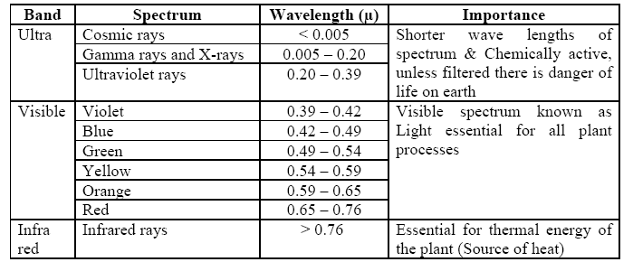

The functions of light are:
1. All the plant parts are directly or indirectly influenced by light
2. Light of correct intensity, quality and duration is essential to normal plant development
3. Poor light availability causes abnormalities and disorders in plants
4. Light is indispensable to photosynthesis
5. Light governs the distribution of photosynthates among different organs of plants
6. Affects tiller production
7. Affects stability, strength and length of culms
8. Affects dry matter production
9. Affects the size of the leaves
10. Affects the root development
11. Affects the flowering and fruiting
12. Affects the dormancy of the seed
Solar constant: It is the energy falling in one minute on a surface of 1 cm2 at the outer boundary layer of the atmosphere, held normal to the sunlight at the mean distance of the earth from the sun. The units are cal/cm2/min. "cal/cm2 “is also known as "Langley". The estimated value of this constant is from 1.94 to 2.0 langely/min. The average value is 2 LY/mn.

The insolation received at the surface of Earth depends upon the solar constant (the rate at which solar radiation is received outside Earth’s atmosphere), the distance from the Sun, inclination of the Sun’s rays, and the amount of insolation depleted while passing through the atmosphere. The last two are the important variable factors.
Depletion of Solar Radiation If the Sun’s radiation was not filtered or depleted insome manner, our planet would soon be too hot for life to exist. We must now consider how the Sun’s heat energy is both dispersed and depleted. This is accomplished through dispersion, scattering, reflection, and absorption.
DISPERSION: Earlier it was learned that Earth’s axis is inclined at an angle of 23 1/2°. This inclination causes the Sun’s rays to be received on the surface of Earth at varying angles of incidence, depending on the position of Earth. When the Sun’srays are not perpendicular to the surface of Earth, the energy becomes dispersed or spread out over a greater area. If the available energy reaching the atmosphere is constant and is dispersed over a greater area, the amount of energy at any given point within the area decreases, and therefore the temperature is lower. Dispersion of insolation in the atmosphere is caused by the rotation of Earth. Dispersion of insolation also takes place with the seasons in all latitudes, but especially in the latitudes of the polar areas.
SCATTERING: About 25 percent of the incoming solar radiation is scattered or diffused by the atmosphere. Scattering is a phenomenon that occurs when solar radiation passes through the air and some of the wavelengths are deflected in all directions by molecules of gases, suspended particles, and water vapor. These suspended particles then act like a prism and produce a variety of colors. Various wavelengths and particle sizes result in complex scattering affects that produce the blue sky. Scattering is also responsible for the red Sun at sunset, varying cloud colors at sunrise and sunset, and a variety of optical phenomena. Scattering always occurs in the atmosphere, but does not always produce dramatic settings. Under certain radiation wavelength and particle size conditions all that can be seen are white clouds and a whitish haze. This occurs when there is a high moisture content (large particle size) in the air and is called diffuse reflection. About two-thirds of the normally scattered radiation reaches earth as diffuse sky radiation. Diffuse sky radiation may account for almost 100 percent of the radiation received by polar stations during winter.
REFLECTION: Reflection is the process whereby a surface turns a portion of the incident back into the medium through which the radiation came. A substance reflects some insolation. This means that the electromagnetic waves simply bounce back into space. Earth reflects an average of 36 percent of the insolation. The percent of reflectivity of all wavelengths on a surface is known as its albedo. Earth’s average albedo is from 36 to 43 percent. That is, Earth reflects 36 to 43 percent of insolation back into space. In calculating the albedo of Earth, the assumption is made that the average cloudiness over Earth is 52 percent. All surfaces do not have the same degree of reflectivity; consequently, they do not have the same albedo. Some examples are as follows: 1. Upper surfaces of clouds reflect from 40 to 80 percent, with an average of about 55 percent. 2. Snow surfaces reflect over 80 percent of incoming sunlight for cold, fresh snow and as low as 50 percent for old, dirty snow. 3. Land surfaces reflect from 5 percent of incoming sunlight for dark forests to 30 percent for dry land. 4. Water surfaces (smooth) reflect from 2 percent, when the Sun is directly overhead, to 100 percent when, the Sun is very low on the horizon. This increase is not linear. When the Sun is more than 25°above the horizon, the albedo is less than 10 percent. In general, the albedo of water is quite low. When Earth as a whole is considered, clouds are most important in determining albedo.
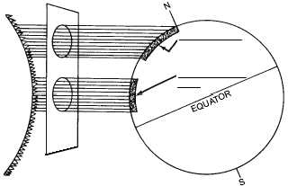
Oblique rayes disoersed over a large area
Perpendicular rays
Dispersion of insolation
Short and longwave radiation:
The energy for various purposes in the earth atmospheric system comes from the sun having surface temperature of 6000K. The radiation emitted from the sun is known as shortwave radiation, generally called solar radiation. It ranges from 0.15 to 4.0 µ with a peak at 0.483µ. the terrestrial radiation is the radiation emitted by the earth. The range of terrestrial radiation (longwave radiation) spectrum ranges from 4 to 80 µ with a peak of 9.66 µ.
Thermal radiation:
Net radiation
- The difference between the incoming radiation from the sun and the out going radiation from the earth is known as net radiation. The net radiation values become –ve after late evening hours to early morning hours. It is a conservative term and plays an importance role in the energy processes of the crops.

- Albedo
It is the percentage of reflected radiation to the incident radiation. (Varies with colour and composition of the earth’s surface, season, angle of the sun rays). Value is Highest in winter and at sunrise and sunset. Pure water – 5-20%, Vegetation 10-40%, Soils 15-50%, Earth 34-43% and clouds 55%. High albedo indicates that much of the incident solar radiation is reflected rather than absorbed.
- Depends up on
1. Angle of incidence of radiation. Albedo increase with decreasing elevation of sun with minimum during noon.
2. Physical characteristics of surface
3. Season
4. Time of the day
For plant community albedo depends upon
1. Age of the crop
2. Percentage of ground cover
3. Colour and reflectivity of the foliage

Lecture No. 4
AIR TEMPERATURE
Temperature is defined as, “The measure of speed per molecule of all the molecules of a body”. Whereas heat is, “the energy arising from random motion of all the molecules of a body’. (Degree of molecular activity). It is the intensity aspect of heat energy.
Conduction
Heat transfer when two bodies of unequal temperatures come into contact. Heat passes from point to point by means of adjacent molecules.
Convection
Transfer through movement of particles (part of mass) in fluids and gasses. These ar able to circulate internally and distribute heated part of the mass.
Radiation
It is the process of transmission of energy by electromagnetic waves between two bodies without the necessary aid of an intervening material medium
Factors affecting air temperature
1. Latitude
The time of occurrence of maximum monthly mean temperature and minimum monthly mean temperature also depends on latitude of a place. (eg.) The coldest month is January in northern regions of India while December in the south. Similarly, the warmest month is May in the south while June in the north across the country.
2. Altitude
The surface air temperature decreases with increasing altitude from the mean sea level as the density of air decreases. Since the density of air is less at higher altitudes, the absorbing capacity of air is relatively less with reference to earth’s longwave radiation.
3. Distribution of land and water
Land and water surfaces react differently to the insolation. Because of the great contrasts between land and water surfaces their capacity for heating the atmosphere varies. Variations in air temperature are much greater over the land than over the water. The differential heating process between land and sea surfaces are due to their properties. It is one of the reasons for Indian monsoon.
4. Ocean currents
The energy received over the ocean surface carried away by the ocean currents from the warm areas to cool areas. This results in temperature contrast between the equator and poles. The occurrence of El-Nino is due to change in sea surface temperature between two oceanic regions over the globe.
5. Prevailing winds
Winds can moderate the surface temperature of the continents and oceans. In the absence of winds, we feel warm in hot climates. At the same time, the weather is pleasant if wind blows.
6. Cloudiness
The amount of cloudiness affects the temperature of the earth’s surface and the atmosphere. A thick cloud reduces the amount of insolation received at a particular place and thus the day time temperature is low. At the same time, the lower layers in the
atmosphere absorb earth’s radiation. This results in increasing atmospheric temperature during night. That is why, cloudy nights are warmer. This is common in the humid tropical climates.
7. Mountain barriers
Air at the top of the mountain makes little contact with the ground and is therefore cold while in the valley at the foothills makes a great deal of contact and is therefore warm. That is, the lower region of the earth’s atmosphere is relatively warmer when compared to hillocks.
Diurnal and seasonal variations:
It is a common knowledge that day temperature is higher than night temperature. The temperature variation between day and night is called diurnal variation of temperature. Diurnal variation is less in coastal areas while it is considerable in inlands. It is very well known that temperature varies with season : higher temperature prevailing during summer and lower temperature during winter. The seasonal variation in temperature is less near the equator and is more at higher altitude.
Diurnal and seasonal variation of air temperature
- The minimum air temperature occurs at about sunrise, after which there is a constant rise till it reaches to maximum.
- The maximum air temperature is recorded between 1300 hrs and 1400 hrs although the maximum solar radiation is reaches at the noon.
- A steady fall in temperature till sunrise is noticed after is attains maximum. Thus the daily March displays one maximum and one minimum. The difference between the two is called the diurnal range of air temperature.
- The diurnal range of air temperature is more on clear days while cloudy weather sharply reduces daily amplitudes.
- The diurnal range of temperature is also influenced by soils and their coverage in addition to seasons.
Horizontal air temperature distribution
- The lines connecting points of equal temperature is called as isotherm
- It is largely depends latitude. A general decrease in temperature from equator towards poles is one of the most fundamental factors of climatology.
- Irregular distribution of land and water on earth’s surface breaks the latitudinal variation in temperature.
- Land areas warm and cool rapidly than water bodies
- Mountain barriers influence horizontal distribution of temperature by restricting movement of air masses.
- On local scale topographic relief exerts an influence on temperature distribution.
Temperature inversion
- Occasionally at some altitude the temperature abruptly increases instead of decreasing. This condition in which this abrupt rise instead of fall in temperature occurs in the air is known as the temperature inversion. This may occurs under the following conditions.
- When the air near the ground cools off faster than the overlying layer, because of heat loss during cooling nights.
- When an actual warm layer passing over a lower cold layer.
- Cold air from hill tops and slopes tend to flow downward and replaced by warm air.
Energy balance or heat balance
The net radiation is the difference between total incoming and outgoing radiations and is a measure of the energy available at the ground surface. It is the energy available at the earth’s surface to drive the processes of evaporation, air and soil heat fluxes as well as other smaller energy consuming processes such as photosynthesis and respiration. The net radiation over crop is as follows.
Rn = G + H + LE + PS + M
Rn is net radiation, G is surface soil heat flux, H is sensible heat flux, LE is laten heat flux, PS and M are energy fixed in plants by photosynthesis and energy involved in respiration, respectively. The PS and M are assumed negligible due to their minor contribution (about 1-2% of Rn). The net radiation is the basic source of energy for evapotranspiration (LE), heating the air (H) and soil (S) and other miscellaneous M including photosynthesis.

Lecture No. 5
Humidity
The amount of water vapour that is present in atmosphere is known as atmospheric moisture or humidity.
Absolute humidity
The actual mass of water vapour present in a given volume of moist air. It is expressed as grams of water vapour per cubic meter or cubic feet.
Specific humidity
Weight of water vapour per unit weight of moist air. It is expressed as grams of
water vapour per kilogram of air (g/kg).
Mixing ratio
The ratio of the mass of water vapour contained in a sample of moist air to the mass of dry air. It is expressed as gram of water vapour per kilogram dry air.
Relative Humidity
The ratio between the amount of water vapour present in a given volume of air and the amount of water vapour required for saturation under fixed temperature and pressure. There are no units and this is expressed as percentage. In other terms it is the ratio of the air’s water vapour content to its maximum water vapour capacity at a given temperature expressed in percentage. The relative humidity gives only the degree of saturation of air. The relative humidity of saturated air is 100 per cent
Dew Point temperature
The temperature to which a given parcel of air must be cooled in order to become saturation at constant pressure and water vapour content. In this case, the invisible water vapour begins to condense into visible form like water droplets.
Vapour Pressure deficit
The difference between the saturated vapour pressure (SVP) and actual vapour pressure (AVP) at a given temperature. This is an another measure of moisture in the atmosphere which is useful in crop growth studies. When air contains all the moisture that it can hold to its maximum limit, it is called as saturated air, otherwise it is unsaturated air, at that temperature. The vapour pressure created at this temperature under saturated conditions is vapour pressure or saturated vapour pressure (SVP).
Condensation
♦ Condensation is defined as “The process in which the water vapour is converted into its liquid".
♦ This process is inverse of evaporation process. In condensation 600 calories of heat is released by each gram of water which was taken in the evaporation process.
♦ Thus the evaporation of water produces cooling effect and condensation gives warming effect.
♦ The visible forms of condensed moisture in the atmosphere are known as “Hydrometeors”.
condensation occurrence of in the atmosphere.
a) Presence of sufficient water vapour
♦ An adequate amount of water vapour is necessary to bring about saturation of air.
♦ Dew point shall be reached through this water vapour to begin condensation.
b) Presence of condensation nuclei
♦ Sodium chloride injected into the atmosphere by sea-spray; Sulphur dioxide,
nitrous oxide etc., released from industries as combustion products; dust present in the atmosphere act as nuclei of condensation.
♦ Water vapour can only deposit and condense on them as these are hygroscopic in nature (affinity to water).
♦ As these particles are microscopic or sub-microscopic in size (0.1 to 1 micron) these are called either hygroscopic nuclei or condensation nuclei.
♦ In the absence of hygroscopic nuclei condensation can not trigger even if air is
supersaturated and its temperature being below freezing level.
c) Cooling of air
Cooling of air upto and below dew point is necessary for saturation of
atmospheric air with water vapour.
Forms of condensation
Condensation near the ground – dew, fog, haze or smog, frost
Condensation in higher altitude - clouds
Dew
The deposition of water vapour in the form of tiny droplets on the colder bodies
by condensation is known as dew. The temperature at which water vapour condenses is known as dew point temperature. When the objects on the surface of the earth get cooled in the night below dew temperature the water vapour is condensed on these surfaces. Dew forms when condensation takes place above freezing point. These surfaces should be good radiators and bad conductors of heat (Plant leaves; window glasses, pieces of paper etc. The conditions for the formation of dew are:
a. Clear sky
b. Absence of wind
With particularly favourable conditions, dew deposition may commence before sunset and continued till after sunrise. Deposition trends to be reduced under very calm conditions (wind speed range of 1-3 m/sec). Dew is an important secondary source of moisture for crops during the non-rainy season and plays vital role in plant growth. Dew occurrences benefit the plants in many ways.
3. Fog
“Low cloud” near the ground surface. Extremely small water droplets suspended in the atmosphere reducing the horizontal visibility is known as `Fog'. Fog reduces the visibility. The conditions for the formation of fag are
♦ Calm wind
♦ Atleast upto 75 % relative humidity
Fog is also called as “Cloud on and near the ground”. There is no particular form, shape or structure to fog. The following are types of fog.
• Radiation fog
This results from rapid loss of night time radiation either from the ground or lower air. This radiation produces cooling.
• Inversion fog: This is another type of radiation fog. This results from
condensation of water vapour in a mass of warm moist air lying over a layer of
cold air and near the ground.
These two fogs occur during night or cold morning. They disappear due to
desaturation of air with vapours after the rise of sun in the morning.
• Advection fog
This fog occurs when warm moist air rides in over a cold surface of either land or
water. These fogs occur at any time of the day.
4 Smog: The combined effect of smoke and fog droplets which reduce visibility is called “Smog”. Some solid particles like dust, smoke from fires and industry restricts the visibility further when these are added to smog which is known as `Haze'. On some occassions toxic materials present in fog, smog and haze and these are harmful. All these processes cause difficulty in rail, road, aviation and shipping traffics.
5 Rime: This is “Freezing fog” and is formed when wet fog has super cooled droplets immediately freeze on striking objects having temperatures below freezing point. White ice is formed on windward freezing point (telegraph post).
6 Mist: Mist is less dense fog. The suspended water droplets in the atmosphere in the
atmosphere restrict the visibility between 1100 to 2200 yards or number 4 on the coded scale (IMD). The relative humidity is 75 per cent when mist occurs. Mist disappears with rising sun.
Clouds
Definition: Cloud is defined as “An aggregation of minute drops of water suspended in the air at higher altitudes”. The rising air currents tend to keep the clouds from falling to the ground.
Cloud formation
1 When air rises due to increase in temperature the pressure being less it expands and cools until temperature is equalised. If the cooling proceeds further till the saturation point, the water vapour condenses and cloud is formed.
2 Clouds are also formed
• When a current of warm air strikes the one that is cooler.
• When moist air from sea blows over a cold land.
The World Meteorological Organisation (WMO) Classified the clouds according to their height and appearance into 10 categories. From the height, clouds are grouped into 4 categories (viz family A, B, C and D) as stated below and there are sub-categories in each of these main categories
Classification see the xerox
Types of rainfall
There are mainly 3 types of rainfall which are as follows:
1. Convectional rains
1. The air near the ground becomes hot and light due to heating. Then it starts upward movement. This process is known as convection .
2. As the air moves upward it cools at about 10oC per kilometer i.e., at dry adiabatic lapse rate.
3. As it becomes saturated, relative humidity reaches to 100 per cent and dew point is reached where the condensation begins. This level (height) is known as condensation level.
4. Above this level, air cools at about 4oC per kilometre slightly less than i.e., saturated adiabatic lapse rate. First, cloud is formed.
5. Then, the further condensation results into precipitation. These rains are known as convectional rains and mostly occurs in the tropics.
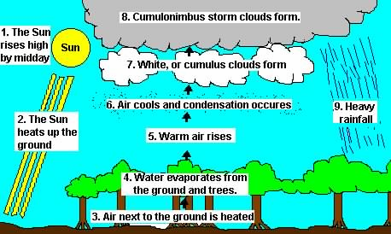Convectional Rain Fall
2. Orographic rains
1. When moist air coming from the sea or ocean strikes mountain it can not move horizontally. It has to over come the mountations.
2. When this air rises upward, cools down, cloud is formed and condensation starts giving precipitation.
3. These rains are known as orographic rains.
4. These are also known as `relief rains" as the rains also occurs when the air from sea or ocean strike or pass over relief barriers.
5. Due to these processes rains with high intensity are possible on the windward side of the mountain.
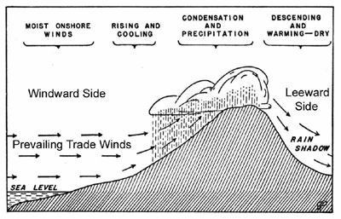
Orographic Rainfall
3. Cyclonic and frontal rains
1 The rains received from cyclones are known as `cyclonic rains'.
2 When two opposing air currents with different temperatures meet, vertical lifting takes place.
3 This convection gives rise to condensation and precipitation which is known as frontal precipitation.
Different forms and types of precipitation
I Liquid forms
1 Rain: It is defined as "Precipitation of drops of liquid water". The cloud consists of minute droplets of water and when these droplets combine and form large drops and can not remain suspended in the air they fall down as rain. These droplets are formed by rapid condensation. The size of rain drop is more than 0.5 mm in diameter. The imaginary lines drown on a map connecting the points of equal rainfall are known as “Isohytes”.
2 Drizzle: It is more or less uniform precipitation of very small and minute rain drops. These drops can be carried away even by light winds. The diameter of drizzle drop less than 0.5 mm. It falls from low lying nimbostratus cloud. Fog merges to form drizzle.
II Solid forms
1 Snow: It is defined as “Precipitation of water in solid form of small or large ice crystals”. It occurs only when the condensing medium has a temperature well below freezing (OoC) temperature. It is also seen in the form of flakes which are aggregates of many crystals, formed due to sublimation of water vapour at sub-freezing temperatures.
2 Hail: It is a precipitation of solid ice. A strong convective column on a warm sunny day may cause the formation of pellets of spherical shape with concentric layers of ice, which is known as hail. Hail falls from cumulo-nimbus clouds and is often associated with thunder and storm. The size of hail ranges from peanut to cricket ball. The rainfall associated with the hailstorms is called as "Hail Storm".
III Mixed
1 Sleet: It is the simultaneous precipitation of the mixture of rain and snow. Occasionally half frozen drops also fall, as sleet forms when rain drops are frozen as they fall through a layer of cold air.
2 Glaze: Freezing rain is known as glaze. This is formed at sub freezing temperatures when rain falls on objects or on ground. It looks like a sheet or coat.

Lecture No. 6
Monsoons
The term monsoon is derived from an Arabic word “Mausim” means “Season”.
There are different concepts to explain Indian monsoons. Of them the “Thermal concept” proposed by Halley in 1636. The two types of distinguished monsoons over India are
1. South-West monsoon (SW)
2. North-East monsoon (NE)
1. South-West monsoon (SW)
1. In summer the land mass of India heats quickly and develops a strong low pressure centre, particularly over north-west India during April and it exists upto September.
2. As the pressure over the adjacent oceans is high, a sea to land pressure gradient is established.
3 Therefore, the surface air flow is from the high pressure areas over the oceans towards the low pressure areas over the heated land.
4. Eventhough India should have North east monsoon winds throughout the year due to its position in NE trade wind zone the SW winds predominate because of the low pressure through lesing along Ganges and upper India.
5. The air that is attracted into the centres of low pressure from over the oceans is “Warm and moist”.
6. This monsoon is active from June to September.
7. The rainfall received is 75 per cent of the total annual rainfall of India covering all parts.
8. This monsoon enters Kerala around 1st June and by 15 July reaches the northern most parts of the country.
9. There are two branches of the South West Monsoon.
a. The Arabian Sea branch: This branch crosses Western ghats.
b. The Bay of Bengal branch: This branch crosses Gangetic plains.
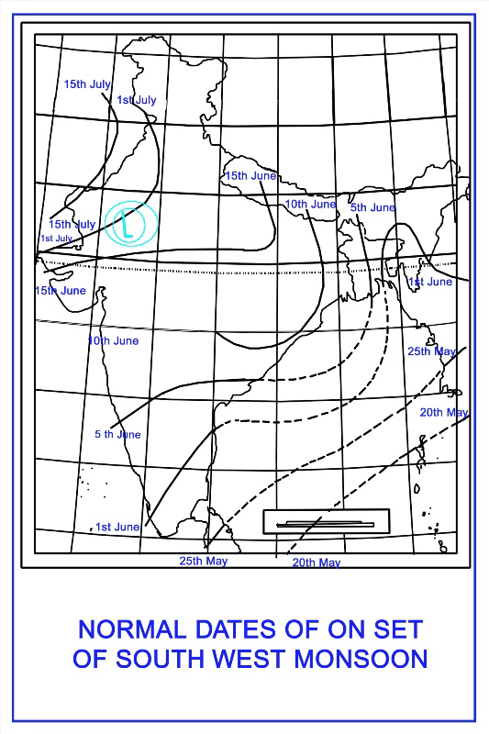
North-East monsoon
1. A complete reversal of the South west monsoon winds takes place during winter.
2. In this season the land mass over India cools more rapidly than the surrounding oceans.
3. So, a strong high pressure centre develops over the continent.
4. On the other hand, the pressure over the adjacent oceans is relatively lower.
5. As a consequence, the pressure gradient is directed from land to sea and winds flow in North-East direction.
6. Therefore, there is an outflow of air from the continental land mass to the adjacent oceans.
7. The air flow brings “Cold dry” air towards low latitudes.
8. This monsoon is active from October to mid December.
9. The rainfall received is 10 to 20 per cent of the total annual rainfall of India covering parts of Andhra Pradesh (Nellore, Chittoor) and Tamil Nadu.
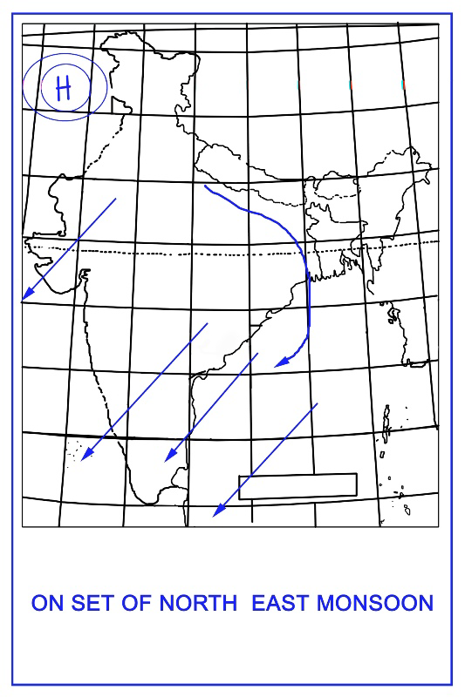

Withdrawn of monsoon
1. The monsoon withdraws from northern India around mid September.
2. The monsoon withdraws from extreme South of Indian Peninsula by December.
Break and Active in monsoon
1. A period of lean rainfall occurs when “Trough” shifts towards foot hills of Himalayas which is known as break in the monsoon over Indian sub-continent.
2. When the “Trough” shifts south of its normal position, monsoon becomes active over India.
Influence of monsoon rains on Indian agriculture
1. Nearly 54 per cent of population of the world depends on monsoon for their income.
2 .Monsoon rains are considered as life giving rains. Rice or paddy which is a major food crop depends on only rainfall for its yield. If rainfall is not uniformly distributed, it results in huge loss of rice crop in particular and all other crops in general.
3 .Heavy rain during harvesting causes lodging of crop and seed germination. If rainfall does not occur immediately after sowing, it results in germination failure.
4 . As in the case of other weather elements the amount and distribution of rainfall influence the crop yield considerably.
Example: Paddy and sugarcane require high amount of water as compared to groundnut and castor.
5. Timely and evenly distributed rainfall during the crop growth is more beneficial than heavy rainfall occurring at once.
6. Rainfall of 20 mm is necessary to wet the soil upto a depth of 15 cm which rainfall helps in decomposition of organic matter and also influences the fertility status of the soil by way of leaching of nutrients.
7. Many farm operations such as seed bed preparation, sowing, intercultivation etc. depend on rainfall.
Principle of artificial rain making: In the troposphere, the temperature of the atmosphere descends with altitude. Therefore the clouds in the troposphere are lower in temperature as they rise in altitude and vice versa. When the temperature of a cloud is above 0°C, the cloud is called a warm cloud; when it is below 0°C it is called a cold cloud. Inside a warm cloud, small water drops will become large ones through collision and coalescence, and will finally break the buoyancy of the cloud and fall out of its bottom to become rainfall to the ground. Likewise, inside a cold cloud, ice crystals can also grow to a size where they can break the buoyancy and fall out of the cloud's bottom, and when they pass through a temperature of 0 °C they will melt and become rain drops, also providing the ground with rain. When the water drops in a cloud are too small or there are not enough ice crystals to create rainfall, we can use artificial ways to create ice crystals or help small water drops grow, and thereby facilitate the formation of precipitation. This human influenced weather phenomenon is called artificial rain. There are many ways to make rain in a warm cloud, e.g. spraying water drops, hygroscopic powder or liquid (sodium chloride), etc, and letting the water drops grow though collision and coalescence to finally become rain. There are also many ways to make rain in a cold cloud, but the most common way is to use dry ice or silver iodide. This is mainly because the temperature of dry ice is -78 °C. Spreading dry ice in a cold cloud lacking ice crystals will rapidly reduce its temperature. Therefore we directly transform supercooled water into ice crystals, which will eventually become rain without the help of ice-crystal nuclei. Silver iodide, on the other hand, is a very effective ice-crystal nucleus. By adding it to a cloud, silver iodide acting as an ice-crystal nucleus can facilitate the solidification of water drops below -5 °C into ice crystals. Through the growing process the ice crystals under the coexistence of water drops, the rain will be formed.

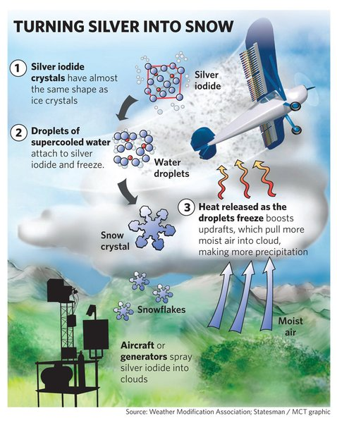

Weather Hazards:

Drought:
Drought occurs in those areas of the world, where the soil moisture is not sufficient to meet the demands of the potential evapotranspiration. Low relative humidity, wind and high temperatures are the contributory factors, which can create drought conditions by increasing the evapotranspiration.
It is a common phenomena in the desert areas, where evapotranspiration exceeds the rainfall. Under such conditions, agriculture is not possible without irrigation.
Drought is one of the worst disastrous of various natural hazards. Drought is generally considered to be a period of moisture deficiency. Drought occurs whenever the supply of moisture from rainfall or stored in the soil becomes insufficient to fulfil the optimum water needs of the plants.
Drought is such a phenomena, whose effect is felt after it has happened. Under prolonged drought conditions, it is not possible to raise agricultural crops. Therefore, drought conditions impose a great threat to the agricultural production.
The water requirements of the plants vary from season to season and from place to place. The water requirement of a crop depends upon the weather conditions prevailing during different stages of the crop.
At the same time, the stage of the crop is very important, therefore the water requirement increases from early stage to the reproductive stage of the crop. Inadequate soil moisture availability during reproductive stage has detrimental effects on the yield.
Drought creates adverse impact on the agriculture. There may be failure of crops under severe drought conditions. Thus, the prolonged drought conditions can shatter the economy of a region.
Drought can be divided into four types:
(a) Permanent droughts,
(b) Seasonal droughts,
(c) Contingent droughts, and
(d) Invisible droughts.
(a) Permanent Droughts:
Permanent droughts are found in the desert area, where rainfall is not equal to the water needs of the plants. In such cases, evaporation always exceeds total rainfall during the life cycle of the crops. Agriculture is not possible without irrigation.
(b) Seasonal Droughts:
Seasonal droughts occur in those areas, where there are well-defined rainy and dry seasons. These droughts are expected every year. Agriculture is possible during the rainy season and it is possible only with the use of irrigation in dry season.
(c) Contingent Droughts:
Contingent droughts occur when rainfall is erratic and variable. These droughts are found in sub-humid and humid areas. These droughts can occur in any season but these are more severe during the periods of greatest water need. They are serious because they cannot be predicted. The crops stand wilt under the influence of these three droughts.

(d) Invisible Droughts:
These droughts cannot be recognised very easily. Invisible drought can occur at any time. It may occur even during rainy season when the daily supply of moisture fails to meet the daily water requirements of the plants. Invisible droughts are very harmful for the crops. Yield of the crop is adversely affected under these conditions. High yield can be obtained by supplying irrigation to the crop.

Floods:
Floods are the major weather hazards, which are caused by heavy rainfall over a given area in a short period of time.In some of the areas, flood producing storms follow seasonal pattern, whereas in other areas flood producing storms occur irregularly.
These floods cause heavy damage to the crops and agricultural buildings. Northern and Eastern parts of India are prone to floods, where agricultural crops are adversely affected. The floods cause a greater loss of life and property than any other natural disaster.
There are three types of floods:
(a) First type of flood is caused due to intense local rainfall. In such cases, a very large amount of water is precipitated over a small area within a short time. Under these circumstances, the rate of arrival of water at the surface of the earth is much greater than the infiltration rate into the saturated soil. In such cases, flash floods can occur.
The flash floods are most common in those areas which experience heavy thunderstorms. Therefore, these may be regarded as a potential hazard whenever intense rainfall occurs. In the arid climates, the thunder showers resulting flash floods are erratic. This type of flash floods are common during monsoon season in the hilly areas.
(b) Second type of flood occurs, when snow begins to melt rapidly. This happens only when the rise of temperature is associated with rain. Warm rain melts snow more quickly than hot sunshine, most of which is reflected by the white surface. In mountainous areas of mid and high latitudes, snow melt results flooding with the onset of the warm season. Such floods have severe agricultural effects.
(c) Third type can be called autumn or winter flood, which is caused by rainfall lasting for many days. Although the rate of rainfall may be quite less but the total precipitation over a period of one or more days may be considerable. The fast moving water droplets can damage the delicate crop plants and seriously affect their growth and hence yield is reduced.
Frost:
Frost occurs when the air temperature near the ground surface falls below 0°C. Low temperatures generally retard the growth of the crop plants. Cold advection is more injurious during winter season because it creates a typical hazard when the field crops are in their seedling stage.
However, wheat crop can withstand freezing temperature but the plants are killed, if the roots are disturbed by frost heave. Frost occurrence is more common in middle and high latitudes. It occurs rarely in the tropical regions. However, it may occur on the high mountains in the tropical regions. The quality of the mature crops can be reduced by sub- freezing temperatures.
Frost is very injurious to the vegetable crops. Crops in north-west India experience frost of moderate to severe intensity. Therefore, every year potato and tomato crops are damaged worth crores of rupees due to low temperature injuries.
These crops are susceptible to frost injury right up to the maturity. The flowering stage is a critical period for most of the field crops and young fruit plants suffer serious damage due to low temperature injuries.
To protect the plants from the frost, there are many techniques in which the temperature is not allowed to fall below frost level:
(i) The temperature of the plant is increased by increasing the soil temperature. The soil temperature can be increased by giving irrigation to the crop.
(ii) By covering the plants with glass or plastic covers. In this way, the temperature of the plants rises.
(iii) Sprinkling irrigation also increases the temperature of the air.
Tropical cyclone:
A tropical cyclone is a rapidly rotating storm system characterized by a low-pressure center, a closed low-level atmospheric circulation, strong winds, and a spiral arrangement of thunderstorms that produce heavy rain.
Heat wave:
A heat wave is a period of excessively hot weather, which may be accompanied by high humidity, especially in oceanic climate countries. While definitions vary, a heat wave is usually measured relative to the usual weather in the area and relative to normal temperatures for the season.
Cold wave:
A cold wave is a weather phenomenon that is distinguished by a cooling of the air. Specifically, as used by the U.S. National Weather Service, a cold wave is a rapid fall in temperature within a 24-hour period requiring substantially increased protection to agriculture, industry, commerce, and social activities

Lecture No. 8
Modification of crop microclimate:
Micro climate is the climate of small area that results from the way the geometry or physical properties of those areas modify the general climate. It differs from macro climate, which prevails above the first few meters over the ground, primarily in the rate at which changes occur with elevation and with time. Whether the surface is bare or vegetated, the greatest diurnal range in temperature experienced at any level occurs there. Temperature changes drastically in the first few ten of millimeters from the surface in to the soil or into the air. Changes in humidity with elevation are greatest near the surface. Very large quantities of energy are exchanged at the surface in the processes of evaporation and condensation. Wind speed decreases markedly as the surface is approached and its momentum is transferred to it. Thus it is the greatest range in environmental conditions near the surface and the rate of these changes with time and elevation that make the microclimate so different from the climate just a few meters above, where atmospheric mixing processes are much more active and the climate is both moderate and more stable.
Artificial control of field environment to keep the optimum condition of plant growth and crop production - A practice of environmental control requires a complete knowledge of physiology of plants and physical environment. it is be done through:
- Controlling wind velocity
- Controlling heat load
- Controlling water balance

Climatic normals for crop production:
Climatic normal means the degree of temperature, amount of rainfall, humidity, etc., which distinguish optimal conditions from abnormal, both because of excess and insufficiency

Rice
Temperature and solar radiation influence rice yield by directly affecting the physiological processes involved in grain production and indirectly through the incidence of pest and diseases.
Temperature - The difference in yield is mainly due to temperature and solar radiation received during its growing season. It requires high temperature, ample water supply and high atmospheric humidity during growth period. Rice tolerates up to 40°C provided water is not limiting. A mean temperature of 22°C is required for entire growing period. If high temperature drops lower than 15°C during the growth phase, the rice yield is greatly reduced by formation of sterile spikelets. The period during which low temperature is most critical, is about 10–14 days before heading. Solar radiation - Low sunshine hours during the vegetative stage have slight ill effect on grain production, whereas the same situation during reproductive stage reduce the number and development of spikelets and thereby the yield. For getting grain yield of 5 t/ha, a solar radiation of 300 cal.cm₂/day is required. A combination of low daily mean temperature and high solar radiation during reproductive phase is good for getting higher yield. Rainfall - Rice requires high moisture and hence classified as hydrophytes. Rice requires a submerged condition from sprouting to milky stage. The water requirement is 125 cm. An average monthly rainfall of 200 mm is required to grow low land rice and 100 mm to grow upland rice successfully.

Wheat
Temperature - Optimum temperature for sowing is 15–20°C. At maturity, it requires 25°C. At harvest time, wheat requires high temperature of 30–35°C and bright sunny period of 9–10 hours. Moisture - One ha of wheat consumes about 2500–3000 tones of water. Water deficiency at the heading stage results in shriveled grains and low yield.

Maize
This crop is best suited for intermediate climates of the earth to which the bulk of its acreage is confined. Temperature - Maize requires a mean temperature of 24°C and a night temperature above 15°C. No maize cultivation is possible in areas where the mean summer temperature is below 19°C or where the average night temperature during the summer falls below 21°C. However, high night temperature also results in low yield. Moisture - Maize is adapted to humid climates and has high water requirements. It needs 75 cm of rainfall during its growth period. The average consumptive use of water by maize is estimated to range between 41 and 64 cm. From germination up to the earing stage, maize requires less water. However, at flowering, it requires more water and the requirement reduces towards maturity.

Cotton
It requires 4-5 months of uniformly high temperature (28–45oC) during its crop growth period. Mean air temperature of 21–29oC is required at vegetative period. The optimum air temperature for reproductive phase is 27–32oC; mean sunshine hours are 8-9 hrs/day; and mean RH is 70%. But at boll development and boll opening period (September to November), RH less than 70% and 8 hrs. of sunshine are ideal for good cotton production. The growth rate of cotton crop is increased at 25–30oC. Temperature below 15oC retards growth and reduces the square (bud) formation. Moisture - The minimum rainfall required for cotton is 500–650 mm. Heavy rainfall during early stage is undesirable. Dry autumn months are desirable for good quality produce. Excess rainfall at later stage may cause shedding of leaves, squares and bolls. It also stimulates top growth, delays maturity and changes colour of lint. High humidity favours many pests and diseases.

Sugarcane
Mean temperature for optimum germination is 30oC. Mean temperature for optimum growth is 35oC. At temperature less than 20oC, growth is reduced. Ideal climate is 4–5 months of hot period with temperature of 30–35oC followed by 6–8 weeks of cooler period for better maturity.

Potato
Potatoes produce a fibrous root system. As a result, potatoes are often unable to exploit nutrients and soil moisture at depth within a soil profile. While root growth occurs when soil temperatures are between 50 to 95˚F (10 to 35˚C), best, most active root development is at soil temperatures of between 59 and 68˚F (15 and 20˚C). Leaf (haulm) growth occurs at temperatures of between 44.6 to 86˚F (7 to 30˚C) , but optimal growth is at around 68 to 77˚F (20 to 25˚C). Optimum temperatures for stolon growth are similar. The potato tuber is an enlarged portion of the stolon. The initiation of this tuber is triggered by short day lengths (photoperiods), and involves growth hormones. The colder the soil temperature, the more rapid the initiation of tubers and the greater the number of tubers formed. The optimum soil temperature for tuber initiation is 59 to 68˚F (15 to 20˚C). Under these conditions, the potato plant will have short stolons and shoots. Longer day lengths delay tuber initiation and favor the growth of the stolon and shoot. High temperatures also reduce tuber formation. Late varieties seem to be more sensitive to long day lengths or high temperature conditions. Low nitrogen and high sucrose levels in the plant favour the formation of more tubers. Once formed, tubers grow rapidly, reaching a maximum rate of up to 1,249 lb/ac/day in temperate climates.

Soybean
Soybean is a tropical crop but its cultivation now extended to subtropical and temperate regions or climates. Climatic requirements of soybean are almost similar to that of maize. Minimum and maximum temperature for seed germination are 5 and 40°C respectively. Minimum temperature for growth is 10°C and maximum rate of development between planting and flowering occurs at 30°C. High night Temperature increases vegetative growth and no of branches. Low temperature delay flowering. Flowering is poor below 20°C and increases upto 32°C beyond which it increases flower abscission and pod setting. The yield reduces to half above 33°C. Soil temperature of about 30°C increases seed yield by more than 50% while 10°C decrease the yield by similar magnitude. Soybean is basically a short day plant. Day length influences the rate of development. In short day types , increased day length may result in the delay of flowering and taller plants with more nodes. Soyabean is often cultivated as kharif rainfed crop and as rabi crop on receding soil moisture after kharif crop. It can come up in areas with rainfall varying from 600 to 1000 mm. Soil moisture stress at flowering and pod development reduces the seed yield by about 50%. Excess soil moisture inhibits nitrogen fixation. Low atmospheric humidity significantly reduces the seed yield.

Lecture No. 9
Weather forecast
The prediction of weather for the next few days to follow.
NEED / IMPORTANCE OF FORECAST
• Basically weather has many social and economic impacts in a place.
• Among different factors that influence crop production, weather plays a decisive role as aberrations in it alone explains up to 50 per cent variations in crop production
• The rainfall is the most important among the required forecast, which decides the crop production in a region and ultimately the country’s economy.
• The planning for moisture conservation under weak monsoon condition and for flood relief under strong monsoon condition is important in a region.
• A reliable weather forecasting when disseminated appropriately will pave way for the effective sustainability.
• One can minimize the damage, which may be caused directly or indirectly by unfavourable weather.
• The recurring crop losses can be minimized if reliable forecast on incidence of pest and diseases is given timely based on weather variables.
• Help in holding the food grain prices in check through buffer stock operations. This means that in good monsoon years when prices fall, the government may step in and buy and in bad years when price tend to rise, it may unload a part of what it had purchased.
• Judicious use of water can be planned in a region depending up on the forecast.
Type of forecast | Validity  period | Main users | Predictions
Short range  a. Now casting  b. Very short range | Upto 72 hours  0-2 hours  0-12 hours | Farmers, marine  agencies, General public etc | Rainfall distribution, heavy rainfall, heat and cold wave conditions, thunder storms etc.
Medium range | Beyond 3 days  and upto two weeks | Farmers | Occurrence of rainfall, temperature intensity  etc.
Long range | More than 4 weeks to a  month; season | Planners | This forecast is provided for Indian monsoon rainfall. The out looks are usually expressed in the form of expected deviation from normal conditions.
Methods used in weather prediction
Three methods are used for accurate weather prediction.
1 Synoptic method
This is a subjective technique. In this method weather charts are analysed and the analogous situations happened in the past are matched with present situation. This method is useful for present situation. This method is useful also for short range forecast. The success of the forecast depends on the skill and experience of the forecaster.
2 Statistical methods
In this method correlations and regressions are calculated using weather elements.T his method is useful for long range weather forecast.
3 Numerical methods
This is basically an objective technique. Several equations are solved numerically using high speed and large memory computers. This method is useful for short and medium range forecasts.
Synoptic charts
An enormous volume of meteorological data is being collected from all over the world continuously round the clock through various telecommunication channels. To assess, assimilate and analyse the vast data, they have to be suitably presented. For this purpose, the observations are plotted on maps instandard weather codes. These maps are called ‘Synoptic maps or charts’. In synoptic charts different weather phenomena and atmospheric characters are marked with different symbols as mentioned below.

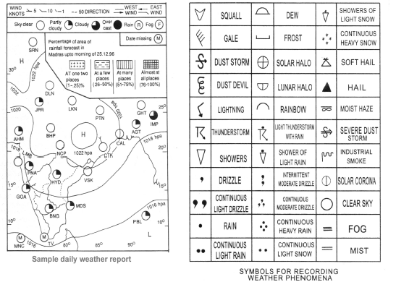

Symbols | Weather element/character/phenomenon
Narrow black lines | lsobars
Numbers at ends of isobars | Pressure values in kPa
Shading | Precipitation
Arrows | Wind direction
Feathers in the arrows | Wind velocity
Small circles with shading | Amount of clouds

Weather calendar
In order to provide the farmers with an efficient weather service, it is essential that the weather forecaster should be familiar with the crops that are grown in a particular agroclimatic zone. The type of forewarnings to be given depend on the stages of the crop. In case of farmers, they should become familiar with weather bulletins and learn how to interpret. To meet the above requirement, the detailed information collected from the agricultural departments has been condensed by the IMD and presented in a pictorial form known as crop weather calendar. This calendar has three parts as follows.
a) Bottom part
b) Middle part
c) Top part
a) Bottom part provides the activities related to crop or information related to phenological stages of the crop and the months.
b) Middle part gives information regarding normal weather condition required for active crop growth. It is divided into different sections according to rainfall, rainy days, minimum temperature, maximum temperature, pan evaporation and sunshine hours.
c) Top part gives information related to the weather abnormalities or to take precautionary measures. Top part is divided into different sections according to dry spell length, high wind, heavy rainfall and cloudy weather.
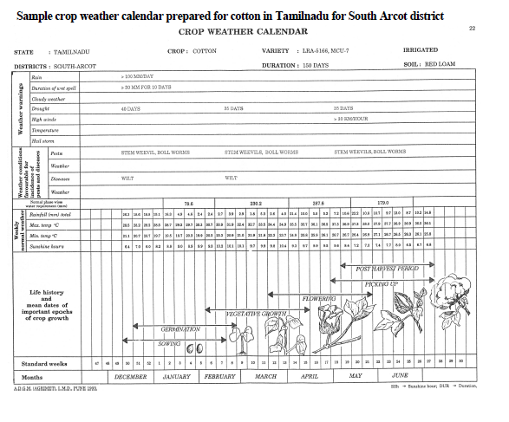

Lecture No. 10
- Climate change
- Any permanent change in weather phenomena from the normals of a long period average is referred as climate change. Eg. The global temperature has increased by 2 to 3 0C and increase in CO2 from 180ppm to 350ppm.
Climate variability
The temporal changes in weather phenomena which is part of general circulation of atmosphere and occurs on a yearly basis on a global scale. Climate change and climate variability are the concern of human kind in recent decades all over the world. The recurrent drought and desertification seriously threaten the livelihood of over 1-2 billion people who depend on the land for most of their needs. The weather related disasters viz. drought and floods, ice storms, dust storms, land slides, thunder clouds associated with lightening and forest fires are uncommon over one or other region of the world. The year 1998 was one of the recent weather related disaster years, which caused hurricane house in Central America and floods in China, India and Bangladesh. Canada and New England in the U.S. suffered heavily due to ice storm in January while Turkey, Argentina and Paraguay with floods in June 1998. Vast fires in Siberia burned over three million acres of forests. Human and crop losses are the worst phenomena in such weather disasters, affecting global economy to a considerable extent
The 1997-’98 El-Nino events, the strongest of the last century is estimated to have affected 110 million people and cost the global economy nearly US $ 100 billion. Statistics compiled from insurance companies for the period 1950-1999. Show that major natural catastrophes which are mainly weather and climate related caused estimated economic losses of US $ 960 billion. Most of the losses were recorded in recent decades. Increase in aerosols due to emission of green house gases including black carbon and chlorofluorocarbons (CFCS), ozone depletion, UV-B filtered radiation, cold and heat waves, global cooling and warming and “human hand” in the form of deforestation and loss of wetlands in the process of imbalanced development for betterment of human kind may be caused factors for climate variability and climate change.
Causes of climatic variability
A. External causes
i) Solar output: An increase in solar output by 0.3%when compared to 1650 -1700AD data.
ii) Orbital variation:
1. Earth orbit varies form almost a complete circle to marked ellipse (Eccentricity).
2. Wobble of earth’s axis (Precession of equinox) 3. Tilt of the earth’s axis of rotation relative to the plane of the orbit varies between 21.8º and 24.4 º.
B. Internal causes
i) Changes in the atmospheric composition. Change in the green house gases especially CO2
ii) Land surface changes particularly the afforestation and deforestation
iii) The internal dynamics of southern oscillation – changes in the sea surface temperature in western tropical Pacific (El-Nino/La-Nina) coupled with Southern Oscillation Index, the Tahiti minus Darwin normalized pressure index leading to the ENSO phenomena
iv) Anthropogenic causes of climate variation in green house gases and aerosols.
Effects of climate change
1. The increase concentration of CO2 and other green house gases are expected to increase the temperature of the earth.
2. Crop production is weather dependant and any change will have major effects on crop production and productivity.
3. Elevated CO2 and temperature affects the biological process like respiration, photosynthesis, plant growth, reproduction, water use etc. Depending on the latitude the CO2 may either offer beneficial effect or may behave otherwise also.
Global warming
The phenomenon of increasing average air temperatures near the surface of Earth over the past one to two centuries. Climate scientists have since the mid-20th century gathered detailed observations of various weather phenomena (such as temperatures, precipitation, and storms) and of related influences on climate (such as ocean currents and the atmosphere’s chemical composition). These data indicate that Earth’s climate has changed over almost every conceivable timescale since the beginning of geologic time and that the influence of human activities since at least the beginning of the Industrial Revolution has been deeply woven into the very fabric of climate change.
Many climate scientists agree that significant societal, economic, and ecological damage would result if global average temperatures rose by more than 2°C (3.6 °F) in such a short time. Such damage would include increased extinction of many plant and animal species, shifts in patterns of agriculture, and rising sea levels. The IPCC reported that the global average sea level rose by some 19–21 cm (7.5–8.3 inches) between 1901 and 2010 and that sea levels rose faster in the second half of the 20th century than in the first half. It also predicted, again depending on a wide range of scenarios, that by the end of the 21st century the global average sea level could rise by another 29–95 cm (11.4–37.4 inches) relative to the 1986–2005 average and that a rise of well over 1 metre (3 feet) could not be ruled out.
The scenarios referred to above depend mainly on future concentrations of certain trace gases, called greenhouse gases, that have been injected into the lower atmosphere in increasing amounts through the burning of fossil fuels for industry, transportation, and residential uses. Modern global warming is the result of an increase in magnitude of the so-called greenhouse effect, a warming of Earth’s surface and lower atmosphere caused by the presence of water vapour, carbon dioxide, methane, nitrous oxides, and other greenhouse gases. In 2014 the IPCC reported that concentrations of carbon dioxide, methane, and nitrous oxides in the atmosphere surpassed those found in ice cores dating back 800,000 years. Of all these gases, carbon dioxide is the most important, both for its role in the greenhouse effect and for its role in the human economy. It has been estimated that, at the beginning of the industrial age in the mid-18th century, carbon dioxide concentrations in the atmosphere were roughly 280 parts per million (ppm). By the middle of 2014, carbon dioxide concentrations had briefly reached 400 ppm, and, if fossil fuels continue to be burned at current rates, they are projected to reach 560 ppm by the mid-21st century—essentially, a doubling of carbon dioxide concentrations in 300 years.

