Chromatographic data analysis(CDS)-
Chromatographic Data Analysis (CDS) refers to the process of analyzing and interpreting data obtained from chromatographic techniques such as gas chromatography (GC), liquid chromatography (LC), or high-performance liquid chromatography (HPLC). CDS involves various techniques and tools to extract meaningful information from the chromatographic data generated during the analysis of samples.
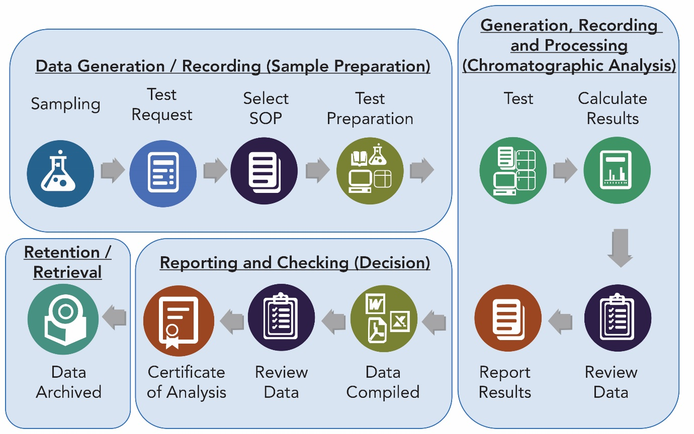

Here are some key aspects of Chromatographic Data Analysis:

1. Data Processing: CDS involves the preprocessing of chromatographic data to enhance its quality and remove any artifacts or noise. This step may include baseline correction, peak alignment, noise reduction, smoothing, and data normalization.

2. Peak Detection and Integration: Chromatographic peaks represent the individual components present in a sample. CDS involves the accurate detection and integration of these peaks to determine their retention times, peak areas, heights, and other parameters. Peak detection algorithms are used to automatically identify and quantify the peaks present in the chromatogram.

3. Quantification and Calibration: CDS enables the quantification of target compounds present in the sample. This involves the calibration of the chromatographic system using standard solutions of known concentrations. By comparing the peak areas or heights of the sample components with the calibration standards, the concentration of analytes can be determined.

4. Identification and Compound Confirmation: CDS may involve the identification and confirmation of the detected peaks based on their retention times, spectral data (such as UV/Vis or mass spectra), and comparison with reference standards or databases. This step is crucial for identifying unknown compounds or verifying the identity of known compounds.

5. Data Analysis and Interpretation: Once the chromatographic data is processed, peaks are detected and quantified, and compound identification is performed, various data analysis techniques can be applied. Statistical methods, pattern recognition, multivariate analysis, and other data mining techniques can be used to uncover trends, correlations, and patterns in the chromatographic data.

6. Report Generation: CDS software typically provides tools for generating comprehensive reports summarizing the analysis results. These reports may include chromatograms, peak tables, calibration curves, compound identifications, and any relevant calculations or statistical analysis performed during the data analysis.

Chromatographic Data Analysis is essential for understanding and interpreting the results obtained from chromatographic techniques. It helps researchers and analysts in a wide range of fields, such as pharmaceuticals, environmental analysis, food and beverage testing, forensics, and more, to extract valuable information from complex chromatographic data sets.

