GOOD WAREHOUSING PRACTICES

- Rules for warehousing
- Characters of good warehouse
- Warehouse staff
- Storage of material/products
- Stock management
- Quality assurance (sops)
2

CONTENTS:
- Introduction
- Purpose
- Various areas of ware housing
- Design
- General guidelines
- Good warehousing practice

Introduction:
- Maintaining proper storage condition for pharmaceutical products and paramedical is vital to ensure their quality, safety and efficacy.

- Factory stores will invariably be receiving duly approved raw materials and packaging materials from third party.

- A suitable space is provided to raw material , handling of raw & packaging materials required for manufacturing, including packaging of pharmaceuticals. This space is known as Warehouse.
- It is a part of pharmaceutical company.

3

- Storage of ordered products.
- Distribution of stocked products.
4

For what purpose ?:
- To enable the fastest and cheapest transport of drugs and medical equipment from suppliers to beneficiaries.

- There are mainly 3 stages:
1. Purchase of pharmaceutical products.

- VARIOUS AREAS OF WARE HOUSING :-

- RECEVING AREA:- includes initial inspection, cleaning & weight checking.
- SAMPLING AREA:- with adequate facilities to prevent cross contamination.
- STORAGE AREA:- including specific storage like air condition rooms, cold rooms, hazardous chemical storage room.
- REJECTED MATERIALS:-Destroye or retented unsuitable.
- DISPENSING AREA:-with adequate facilities to preclude cross contamination during dispensing.

5

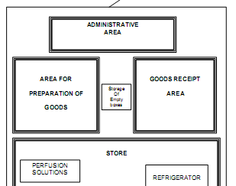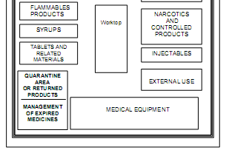

Design:
- Prinoiple : Premises must be located, designed, constructed, adapted,
and maintained to suit the operations to be carried out.

DIAGRAM FOR THE LAMOUT OF THE PHARMACEUTICAL WAREHOUSE
6

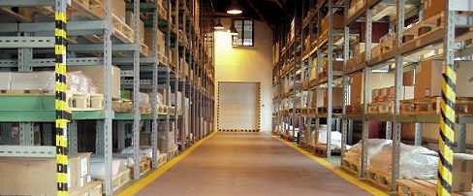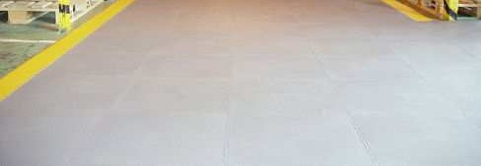

Pharmaceutical warehouse
7

- General :
- The layout and design of premises must aim to minimize the risk of
errors and permit effective cleaning and maintenance in order to avoid cross-contamination, build-up of dust or dirt, and, in general, any adverse effect on the quality of products..

- Where dust is generated (e.g. during sampling, weighing, mixing and processing operations, packaging of powder), measures should be taken to avoid cross-contamination and facilitate cleaning.

- Premises should be situated in an environment in which the minimum risk of any contamination of materials or products.

- Premises used for the manufacture of finished products should be suitably designed and constructed to facilitate good sanitation.

8

- Premises should be carefully maintained, and it should be ensured that repair and maintenance operations do not causes any hazard to the quality of products.

- Premises should be cleaned and, where applicable, disinfected according to detailed written procedures. Records should be maintained.

- Electrical supply, lighting, temperature, humidity and ventilation should be appropriate and such that they do not adversely affect, directly or indirectly, either the pharmaceutical products during their manufacture and storage, or the accurate functioning of equipment.

- Premises should be designed and equipped so as to afford maximum protection against the entry of insects, birds or other animals. There should be a standard procedure to prevent from rodent and pest control.
- Premises should be designed to ensure the logical flow of materials and personnel. 9

In co m in g go od s

R aw

Q C O ffices

C o rrid o r
C orridor

G o w n in g

C anteen

C o rrid o r Sh ip ping

M aterials & P ackaging Sto rage
W eighing P rocessing Fillin g
P ackaging
Finished Products S torage

Washing
M achine S hop
C orridor
U tilities and S ervices Waste Treatm ent

Zone: Clean Zone: Packaging Zone: Controlled

Arrival of goods, Entrance for visitors, Entrance for forkers, shipment of goods

Example of material and people flow

10

GENERAL GUIDE LINES :-

- Materials received against specific supply devices
- Each such consignment have written documents (delivery Chelan)
- All materials received by responsible persons
- materials to be checked for cleanliness & package integrity
- Damaged container separated & reporting immediately
- Check for proper container labeling
i.e status of materials —UNDER TEST,
—A Waiting for APPROVAL .

11

- GOOD WAREHOUSING PRACTICE :-

- Factory Stock which should be received with proper documents detailing the names of product ,the batch number ,the number of units of final packs of each batch ,the date of dispatch and the quality control status of the batches.

- The stock control system must be such that only passed batches of products are issued for distribution. Stocks should be stored, product wise to enable quick identification and control of stock movement
.Stocks should therefore be racked and stored in a manner that earlier stocks are more early accessible than the later ones.

- The picking and assembling areas should be so arranged as to minimize the distance travelled by warehouse operators. Picking stocks should be located on shelves at convenient heights and with proper labels which clearly identify the products.
12

- Assembled products should be checked for accuracy of quantities and identities of products ordered. Batch details should be recorded in relevant documents.
- Finished product should be packed in the containers and dispatched for the transportation.
- The unit product packs should be not contaminated by other products. Vehicles which carry the final packaged stocks of products should be so selected that-
- They are clear, dry and sufficiently protected from rain and other weather factors .
- They are free from infestation .
- They do not give off strong odours which may contaminate the products .
- They are suitable to withstand the weight of the load they carry .
13

RULES FOR WAREHOUSING :-
- Systematic storage of the delivered goods.
- Use air circulation & protection against rodents .
- Keeping a space at least 50cm between the rows of pellets walls .
- Providing each products have only one specific place.
- On shelves clear labeling of products should be there .
- Adequate space should be provided for each goods .
- Provide separate stoke card for each products.
- All boxes in stock should be closed .
- Flammable products should stored in separate place.

14

- Order the destruction of unsuitable products.
- Promote rational use of pharmaceutical products.
15

CHARACTERS OF GOOD WAREHOUSE :-
- Properly cleaned.
- Good preservation of drugs & equipments.
- Provide safety for staff & stocked goods.
- Control of air, light ,humidity & temperature.
- Products to be purchased according to needs.

- The warehouse staff:-
- The responsible pharmacist His duties
- Good management of the stock of the warehouse.
- Good preservation of drugs and equipments.
- Safety of stored goods.

- The warehouse keeper His duties
- Reception of supplies.
- Storage of stocks of goods.
- Recording of every IN and OUT movement of the products in the stock card.
- Issue of products during manufacturing. 16

- The warehouse worker His duties
- Handling operations includes the carrying and moving of goods which are intended for storage, shipment and sale.
- The warehouse staff helps in receives and issue goods and maintain inventory.

- The cleaner His duty
- Ensure cleanliness of premises and equipment.

- The security guard His duty
- He is responsible for ensuring supervision and security of the warehouse .

17

- STORAGE OF RAW & PACKAGING MATERIALS :-

- Storage oondition- special storage area with controlled temperature , humidity & stored off from the floor.

- 10. a) STORAGE OF PACKAGING MATERIAL :-
- bottles, vials, ampoules, tins, tubes should be stored in a manner that they do not contaminated by extraneous matter .
- printed packaging material also stored properly .
- Printed materials such as labels , printed films / foils /laminates, cartons should kept in storage cupboards.
- preventing mix up of printed & non printed materials .
- Physical segregation of printed & labeled containers should be made .
- Special precautions is needed for the storage of —packaging labeling controlled products.
- Appropriate storage condition to be provided ( air conditioning, aluminum foil)

18

- HANDLING & ISSUE – RAW MATERIALS :-

- Attention to be made for -prevent cross contamination ,health of personnel handling materials ,containers should be closed properly ,materials that support microbial growth are handled carefully. Eg.agar.
- materials issued only against authorized person .
- Personnel protective devices like gloves, facemasks etc. should be used to avoid health hazards. Adequate dust extraction system should be provided to suck away fine dust as to prevent cross-contamination.

19

- Unlike raw materials , exact quantity of packaging materials to
be issued.
- Unused packaging materials returned to the warehouse & will accompanied by authorized documents .
20

HANDLING & ISSUE: PACKAGING MATERIALS :-
- Packaging materials issued to production only against packaging materials order.
- Care should made to check for only right packaging materials to be issued.

- WARE HOUSING OF FINISHED PRODUCTS :-

- For avoiding deterioration, spoillage or breakage

- requirements:-
- safe , orderly & dispatch of all products -cold storage area have temperature monitoring & recording devices -racking & shelving system should have good mechanical strength .

- Prooedure:-stock received from factory with proper documentation (name, batch number, date of dispatch)
- Finished products which are —under test" must be quarantined & segregated from —passed stocks”
- Stock should be stored product wise to enable quick identification & controlled stock movement
- Store rotation should be on —first in ,first out basis.
21

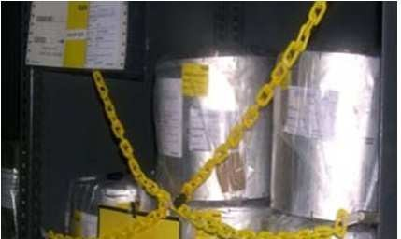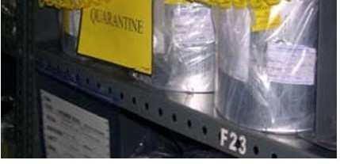

QUARANTINE MATERIALS

22

- Reprocessing of returned should be done according the
instruction of Qc manager.
23

- WARE HOUSING OF RETURNED GOODS :-
- Stocks should be carry out only consultation with quality controlled manager.
- Returned goods must be isolated on receipt ,clearly identified & records regarding reason for the return .
- Qc manager should examine whether these goods are reprocessed or destroyed.

- SANITATION:-
- Written sanitation programmes should be available. These should include validated cleaning procedures for premises and equipment, a quality standard for water, instructions for hygiene when manufacturing and handling goods, and instructions relating to the health, hygienic practices, and clothing of personnel and the disposal procedures for waste materials and unusable residues.
- Eating, smoking, and unhygienic practices should not be permitted in manufacturing areas.
- There shall be written procedures for use of suitable rodenticides, insecticides, fungicides, fumigating agents and cleaning and sanitizing agents.
- cleaning procedure to be followed, including equipment and materials . 24

MAINTANANCE :-
- Any building used in the manufacture, processing, packing, or holding of a drug product shall be maintained in a good state of repair.
- Deterioration of buildings not only presents a poor image of the facility, it can also impact on product quality.
- Cracks and holes in walls, floors, or ceilings can provide access for insects, rodents, birds, dirt, or microorganisms.
- They can also hinder cleaning and sanitation, thereby increasing the potential for cross contamination or microbial multiplication.
- Floor cracks can also become a safety hazard for people or even dislodge materials from trucks.
25

26

- The ingress of water from roof leaks can cause significant damage to materials and equipment, give rise to electrical failures and fires and result in damage to the basic structure of the building.
- Additionally, holes in the roof or near the tops of buildings provide ready access to birds, which may then be encouraged to nest within the building.

- STOCK MANAGEMENT:-

Objeotives:-
- To ensure continuity of supplies.
- To avoid over stocking.

Stock management will set out to;
- monitor stock levels
- monitor consumption
- anticipate delivery time for order activation.

Issuing of material:-

- store should issue raw and packaging materials on the basis of FIFO(first come first out) basis. Entry and exit of every consignment of materials should be entered on the stock card.
- Issuing of materials should do on the basis of raw and packaging materials required in manufacturing process. while issuing hazardous and explosive materials, the operation should be supervised to prevent any mistake.
27

- Quality Assurance (SOPs) :-
Each warehouses will have to establish operating procedures.
- They must be clearly defined for each stage activities.
- Direct purchase from raw materials manufactures.
- Purchase via Head quarters.
- Reception of local and imported orders.
- Unpacking, labeling and storage of products.
- Computerized stock managements.
- Preparations of an orders for delivery.
- Returns of drugs.
- Managements of Expired drugs.
- Safety and cleanliness of premises.
28

- Available on who.int (Surfing on 19-11-11).
- Also available in revised schedule-M (Surfing on 19-11-11).
29

- REFERENCES :-
- Sidney H. Willing ,Good manufacturing Practices For Pharmaceutics , 1st edition,, page no:173-76.

- DR.MGR , Ananth Vannemsetty , Tinu Thomas ,Consise text book of QC & Q.A , ,Page no: 222 – 231.

30

