Impact of Bioinformatics in Vaccine Discovery-
Bioinformatics plays a significant role in vaccine discovery by leveraging computational tools and techniques to analyze biological data, identify potential vaccine targets, and design effective vaccines. Here are some key impacts of bioinformatics in vaccine discovery:
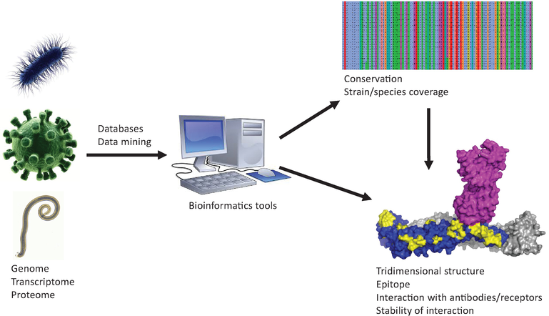

- Genomic Analysis: Bioinformatics enables the analysis of genomic data from pathogens to identify potential vaccine targets. It helps in the identification of conserved regions, virulence factors, surface proteins, and other essential components that can elicit an immune response. Comparative genomics allows the identification of shared features among different strains or species, aiding in the development of broad-spectrum vaccines.

- Antigen Prediction: Bioinformatics tools are used to predict potential antigens that can stimulate an immune response. Sequence-based methods, such as epitope prediction algorithms, can identify specific regions within antigens that are likely to bind to major histocompatibility complex (MHC) molecules and activate T-cells. This information guides the selection of antigens for vaccine development.

- Vaccine Design and Optimization: Bioinformatics aids in the rational design and optimization of vaccines. It helps in determining the most suitable vaccine formulation, such as selecting adjuvants, delivery systems, and optimizing antigen presentation. Computational models can simulate the interaction between antigens and immune receptors, facilitating the design of improved vaccine candidates.

- Immunoinformatics: Immunoinformatics integrates bioinformatics and immunology to study immune responses and predict vaccine efficacy. It involves analyzing immune system components, such as T-cell epitopes, B-cell epitopes, and antibody-antigen interactions, to identify potential vaccine targets. Computational methods can predict the immunogenicity and antigenicity of vaccine candidates, aiding in their prioritization.

- Vaccine Safety and Efficacy Assessment: Bioinformatics contributes to assessing the safety and efficacy of vaccines. It can analyze large-scale omics data, including transcriptomics, proteomics, and metabolomics, to evaluate the impact of vaccines on host immune responses. Bioinformatics tools can also predict potential adverse effects or off-target interactions, assisting in the evaluation of vaccine safety.

- Data Integration and Mining: Bioinformatics facilitates the integration and mining of diverse biological data, including genomics, proteomics, and clinical data. Integrated analysis of these datasets can reveal novel insights into host-pathogen interactions, immune responses, and vaccine effectiveness. Data mining approaches help in discovering patterns and relationships, guiding the identification of new vaccine targets and optimization strategies.

- Vaccine Surveillance and Epidemiology: Bioinformatics plays a crucial role in monitoring and analyzing pathogen evolution, transmission dynamics, and vaccine efficacy in real-time. It aids in tracking viral mutations, identifying emerging strains, and monitoring the effectiveness of existing vaccines. This information is invaluable for vaccine development and deployment strategies.

- Overall, bioinformatics enables researchers to leverage computational methods and data analysis techniques to expedite vaccine discovery. It enhances the efficiency and accuracy of target identification, vaccine design, and assessment processes, contributing to the development of safe and effective vaccines against various infectious diseases.

