Pharmacokinetics
is a branch of pharmacology that studies the movement of drugs within the body. It encompasses the processes of drug absorption, distribution, metabolism, and elimination, commonly referred to as ADME.
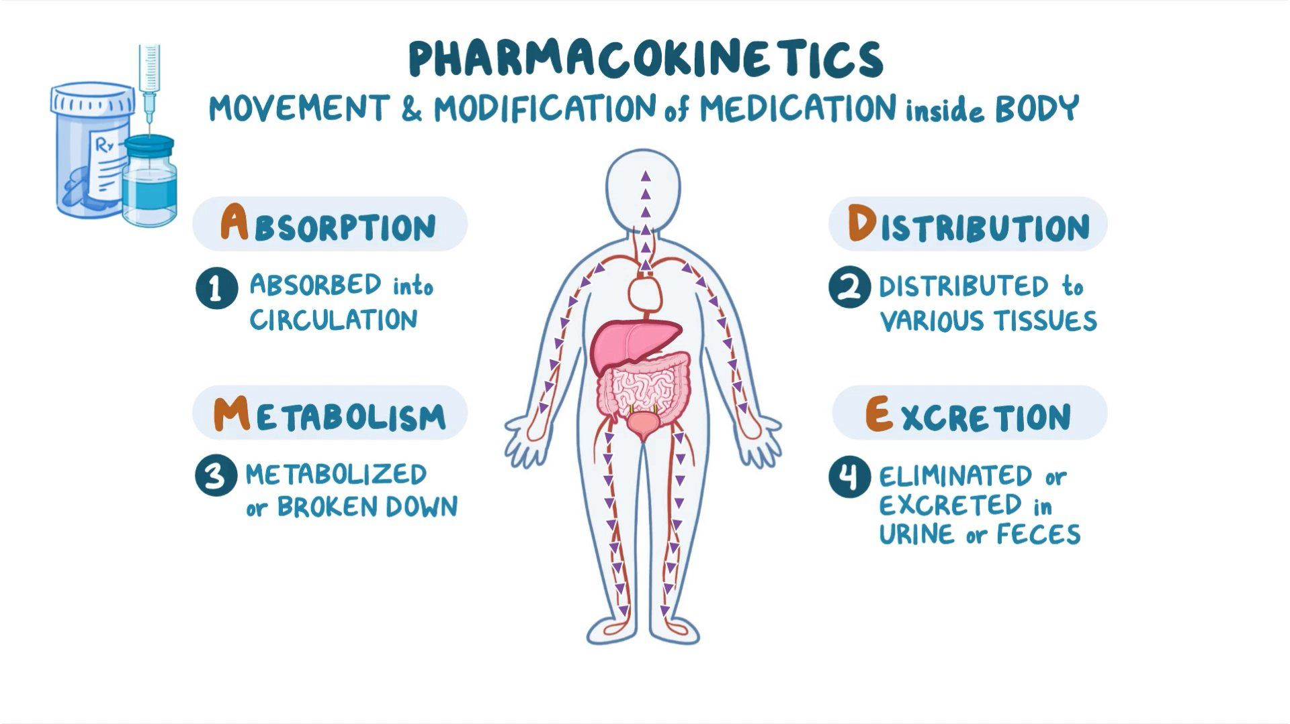

Here are the key aspects of pharmacokinetics:

- Absorption: Absorption refers to the process by which a drug enters the bloodstream from its site of administration (e.g., oral, intravenous, topical). Factors that affect drug absorption include the route of administration, drug formulation, and physiological factors such as blood flow and the presence of food or other drugs.

- Distribution: Once absorbed into the bloodstream, drugs are distributed throughout the body to their target sites. Factors influencing drug distribution include blood flow, tissue permeability, and protein binding. Some drugs may have specific affinity for certain tissues or organs.

- Metabolism (Biotransformation): Drug metabolism involves the enzymatic conversion of drugs into metabolites. The liver is the primary organ responsible for drug metabolism, although other organs and tissues also contribute. Metabolism helps inactivating drugs, converting them into more soluble forms for elimination, or transforming them into active or toxic metabolites.

- Elimination: Elimination refers to the removal of drugs and their metabolites from the body. The primary elimination routes are through the kidneys (urine) and the liver (bile). The rate of drug elimination is influenced by factors such as renal function, hepatic function, drug clearance mechanisms, and drug properties.

Pharmacokinetic Parameters: Various pharmacokinetic parameters help quantify the behavior of drugs in the body. Some important parameters include:

- Bioavailability: The fraction of an administered drug that reaches systemic circulation.
- Clearance: The rate at which a drug is eliminated from the body, often expressed as mL/min or L/h.
- Half-life: The time required for the concentration of a drug in the body to decrease by half.
- Volume of distribution: A theoretical volume that represents the extent of drug distribution in the body.
Understanding pharmacokinetics is crucial for optimizing drug therapy. It helps determine appropriate dosing regimens, predict drug concentrations over time, evaluate drug-drug interactions, and assess factors that may influence drug response in individuals (e.g., age, liver or kidney dysfunction).

Pharmacokinetic modeling and simulation techniques are employed to study and predict drug behavior in various patient populations, aiding in drug development and personalized medicine.

