Experiment 5: Preparation of Tolbutamide

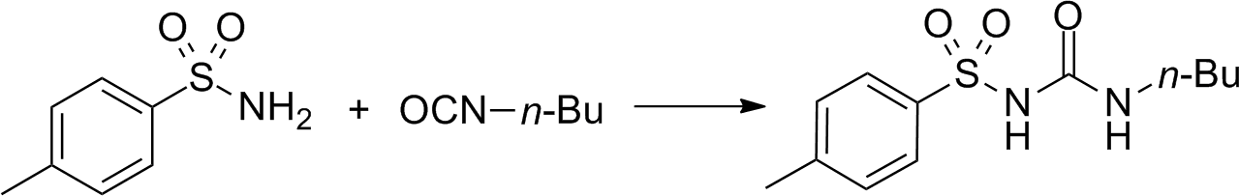
SYNTHESIS

4-Methylbenzenesulfonamide Tolbutamide

USAGE

The usual recommendation given by a doctor to patients is that tolbutamide is taken by mouth once daily in the morning. It sometimes can be divided into smaller portions specially if the patient experiences stomach upset when taking the medication. The dosage is closely tied to medical condition and response to treatment of the patient.
It is a common method to start off with a low dosage and start increasing it over time to see if the patient affected by any symptoms. Also, be aware that especially first-generation drugs have interactions with other drugs. [3]

EFFECT

Tolbutamide binds to the SUR1 – receptor, which is a sub potassium-channel. This ultimately leads to a depolarization of the membrane. Now Ca²⁺-ions flow into the β-cell. These ions initiate the merger of vesicles with the membrane. Inside those vesicles sits the insulin waiting to be released from the
cell. After the merger it is released into the patient’s metabolism, which leads to lowered blood sugar levels. [1][3]
The control of high blood sugar levels helps prevent kidney damage, blindness, nerve problems, loss of limbs, and sexual function problems. Proper medication against diabetes also may lessen the risk of a heart attack or stroke. [3]

SIDE EFFECTS

- Hypoglycaemia (various symptoms caused by low blood sugar levels, e.g. loss of consciousness)
- Weight gain
- Rare cases of liver damage
- Drug interactions (especially first-generation drugs): Increased hypoglycaemia with cimetidine, insulin, salicylates, and sulphonamides [3]

SOURCES

- https://de.wikipedia.org/wiki/Tolbutamid (15.06.18)

- https://commons.wikimedia.org/wiki/File:Tolbutamide_synthesis.png (15.06.18)

- https://www.webmd.com/drugs/2/drug-3948/tolbutamide-oral/details (15.06.18)

- https://roempp.thieme.de/roempp4.0/do/data/RD-20-02031 (15.06.18)

- https://pubchem.ncbi.nlm.nih.gov/compound/Carbutamide#section=Top (15.06.18)

- https://www.pharmawiki.ch/wiki/index.php?wiki=Glibenclamid (15.06.18)

