Experiment 4: Preparation of Triphenyl imidazole

STEP 1:
Synthesis of 2, 4, 5- triphenyl imidazole: It was synthesized by refluxing benzil, benzaldehyde with ammonium acetate in acetic acid medium at 100°C for 5-24 hrs.
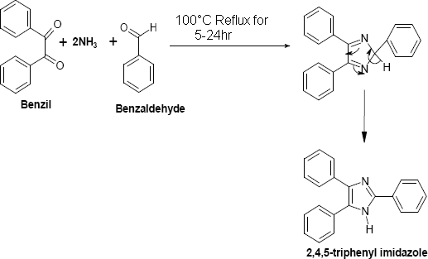
STEP 2:
Synthesis of acid chloride: It was synthesized by refluxing acid with excess of thionyl chloride at 80°C for 2-3 hrs. Excess thionyl chloride was removed by distillation.
STEP 3:
Synthesis of 1-substituted 2, 4, 5 triphenyl imidazoles: It was synthesized by refluxing 2,4,5- triphenyl imidazole and acid chloride by using benzene as solvent and pyridine as a catalyst for 4-5 hrs. The product was isolated, dried and recrystallized from ethanol.
