HOSPITAL AND CLINICAL

PHARMACY

Hospital Pharmacy
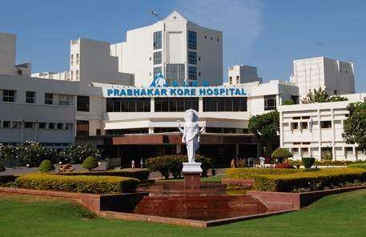
Hospital

- Definition,
- Function,
classifications based on various criteria,
- organization,
- Management
- health delivery system in India.

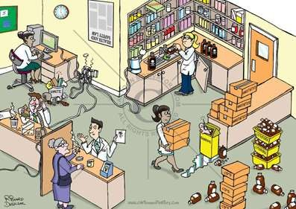
Hospital Pharmacy

- Definition
- Functions
- objectives of Hospital pharmaceutical services.
- Location,
- Layout,
- Flow chart of materials and men.
- Personnel and facilities requirements including equipment's based on individual and basic needs.
- Requirements and abilities required for Hospital pharmacists

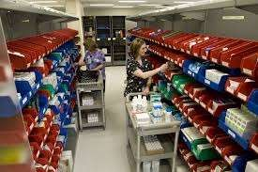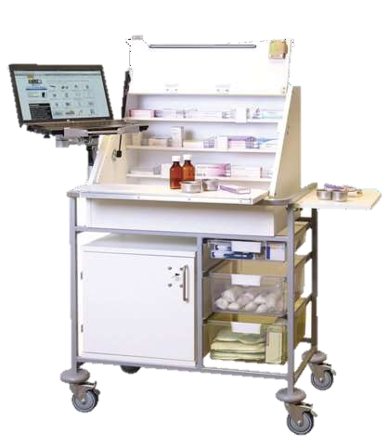

Drug Distribution system in Hospitals

- Out-patient service
- In-patient services
Types of services detailed discussion of :-
- unit Dose system
- Floor ward stock system
- satellite pharmacy services
- central sterile services
- Bed side pharmacy.

Manufacturing

  - Economical considerations
  - estimation of demand.

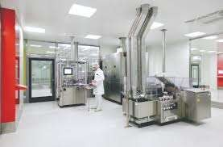
Sterile manufacture-

  - Large and small volume parenterals,
  - facilities,
  - requirements,
  - layout production planning
  - man-power requirements.

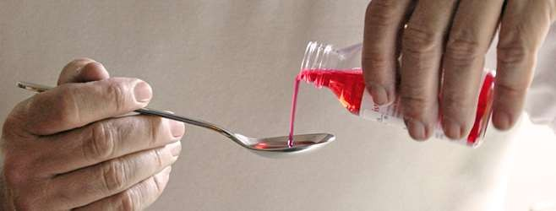
Non-sterile manufacture

  - Liquid orals
  - Externals
  - Bulk concentrates
  - Procurement of stores and testing of raw materials
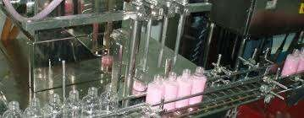

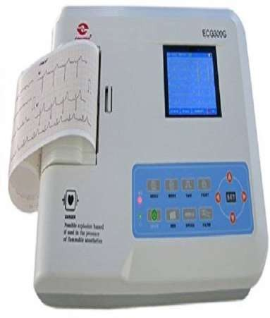
Nomenclature and uses of surgical instruments
and Hospital Equipments and health accessories.

P.T.C.(pharmacy Therapeutic Committee)

  - P.T.C.(pharmacy Therapeutic Committee)
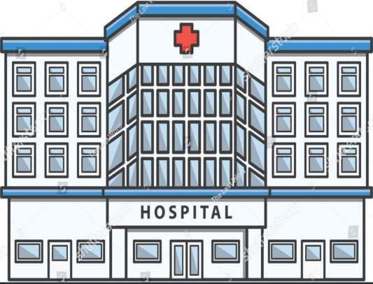

Hospital Formulary system and their
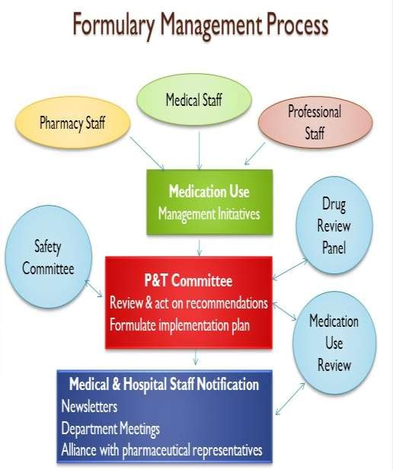
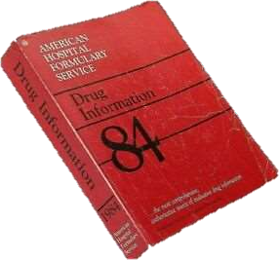
organization, functioning, composition

Drug Information service and Drug Information
Bulletin

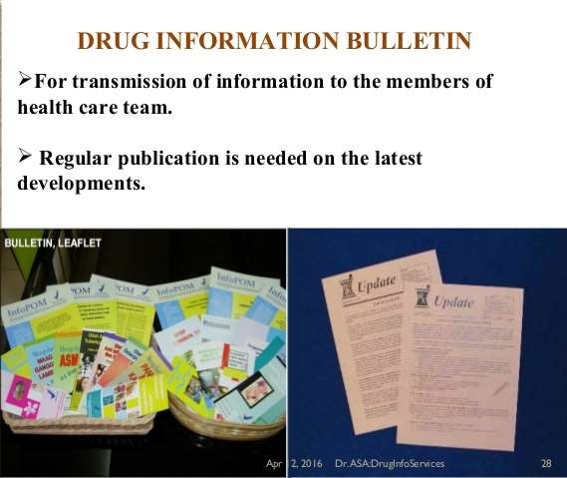
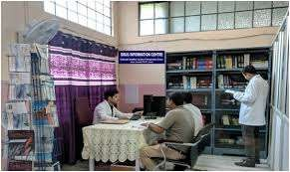

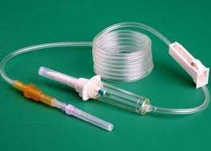
Surgical dressing

  - cotton,
  - gauze,
  - bandages
  - 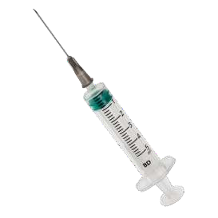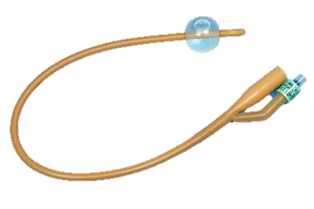adhesive tapes including their pharmacopoeial tests for quality. Other hospital supply eg. I.V.sets, B.G. sets, Ryals tubes, Catheters, Syringes etc

  - Application of computers in maintenance of records, inventory control, medication monitoring, drug information and data storage and retrieval in hospital retail pharmacy establishment.

Clinical Pharmacy:

  - Introduction to Clinical pharmacy practice- Definition, scope.
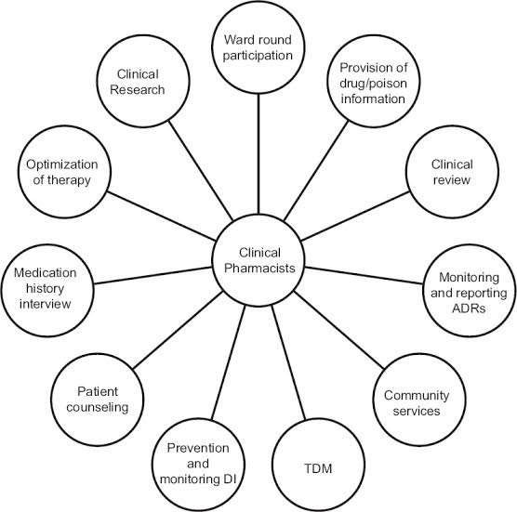
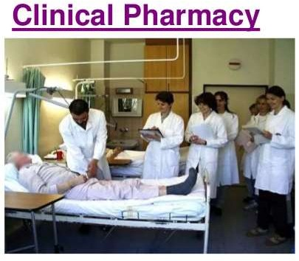

Modern dispensing aspects- Pharmacists and
patient counseling and advice for the use of common drugs, medication history.

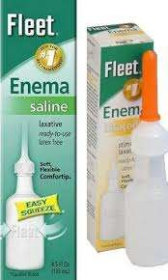
Common daily terminology used in the
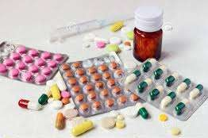
practice of Medicine.

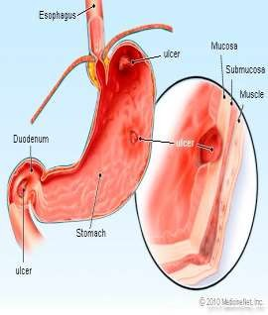
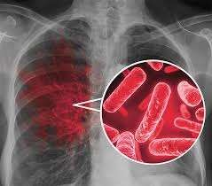
Disease, manifestation and patho-physiology including salient symptoms to understand the disease like
  - Tuberculosis,
  - Hepatitis,
  - Rheumatoid Arthritis,
  - Cardio-vascular diseases,
  - 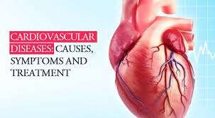Epilepsy,
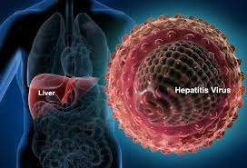
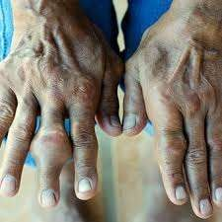
  - Diabetes,
  - Peptic Ulcer,
  - Hypertension

  - Physiological parameters with their significance.
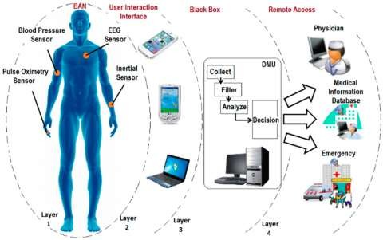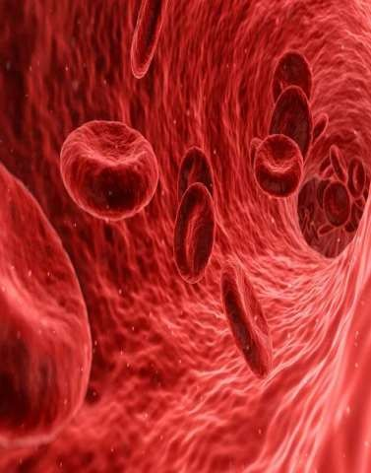

Drug Interactions

  - Definition of Drug Interactions
  - Mechanism of Drug Interaction.
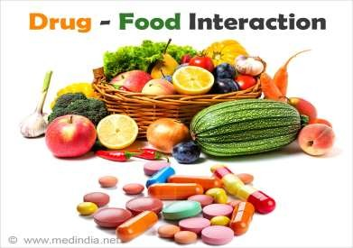
  - Drug-drug interaction with reference to analgesics, diuretics, cardiovascular drugs, Gastro-intestinal agents. Vitamins and Hypoglycaemic agents. Drug-food interaction.

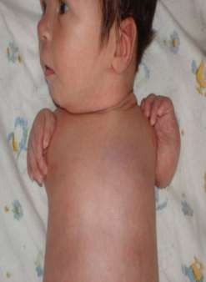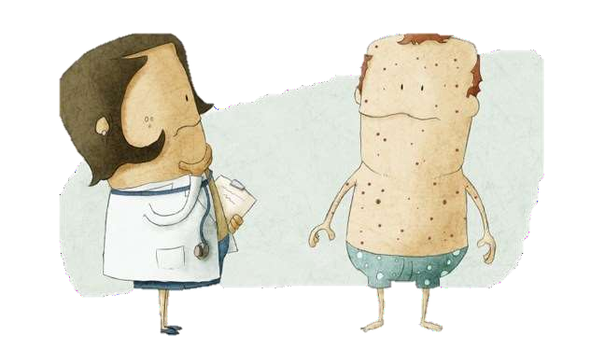

Adverse Drug Reaction

  - Definition
  - Significance.
  - Drug-Induced diseases
  - Teratogenicity.

Drugs in Clinical Toxicity

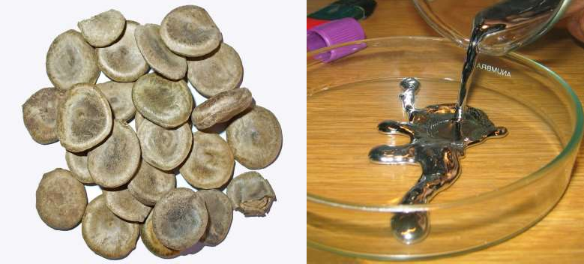
  - Introduction, general treatment of poisoning, systemic antidotes, Treatment of insecticide poisoning, heavy metal poison, Narcotic drugs, Barbiturate, Organo-phosphorus poisons.

DRUG DEPENDENCE

  - COMMONLY ABUSED DRUGS ,THEIR COMPLICATIONS AND TREATMENT
  - DRUG ABUSE
  - DRUG ADDICTION
  - DRUG HABITUATION

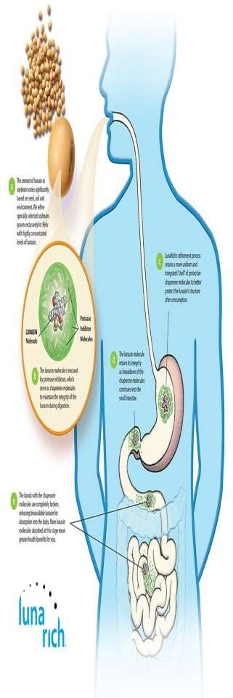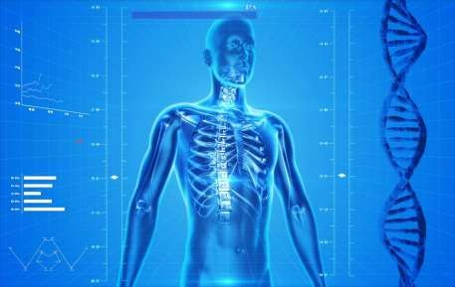

BIO-AVAILABILITY

What is mean by Bio-availability of drugs ?

What are the factors affecting Bio-availability of Drugs ?

