Mucoadhesive bilayer tablet formulation with inclusion complexation improved buccal permeation rate of ketoconazole: An in vitro and ex-vivo study

Abstract
This study focuses on the development and evaluation of mucoadhesive bilayer tablets of ketoconazole (KTZ) in hydroxyl propyl methyl cellulose (HPMC) matrix system containing β-cyclodextrin (BCD) /hydroxyl propyl β-cyclodextrin (HPBCD) as the drug layer and ethyl cellulose as the non swellable backing layer. Tablets were prepared by direct compression method and were evaluated for different physicochemical properties. In vitro drug release and ex vivo drug permeation studies (in sheep buccal mucosa) were also performed in phosphate buffer saline (pH 6.8). Fourier transform infrared spectroscopy and diffraction scanning calorimetry data confirmed absence of any significant incompatibility between the drug and excipients. However, minor shifting of some peaks could be assigned to the formation of KTZ-cyclodextrin complex. X-ray diffraction analysis though showed no major changes in crystalline behaviour, however, broadening of some peaks or change in peak heights could be attributed to the formation of weak bonds and inclusion of KTZ into the cyclodextrin cavity. Among the formulations, KHPBCD (KTZ with HPBCD) showed higher amount of drug release than free KTZ tablets and KTZ-BCD tablets as evidenced from in vitro as well as ex-vivo drug permeation study. Presence of cyclodextrin did not change the bioadhesion force and swelling behaviour of the formulation. Further in vivo studies are warranted for the optimized formulation for its successful clinical application.

Key words: Ketoconazole, Cyclodextrin, Bilayer tablet, Mucoadhesion, Ex-vivo drug permeation

Introduction
Oral bioavailability of poorly water soluble drugs is often limited by the rate of their dissolution in gastric fluid. In oral drug delivery, buccal mucosa has been identified as a potential site for the effective delivery of drugs to elicit prompt therapeutic action [Rahamatullah Shaikh, 2011]. Drug(s) administered through the buccal mucosa can enter into the systemic circulation directly bypassing the first pass hepatic metabolism. For oral administration, drugs having poor solubility and permeability, limited half-life or sensitive to enzymatic degradation can be taken as suitable candidates to achieve higher bioavailability. Further, undesirable side effects of the drug on the gastro intestinal lumen can also be minimized to a larger extent by this route [Rahamatullah Shaikh, 2011]. Thus, mucoadhesive formulations are becoming preferred category of delivery systems, when a site-specific or prolonged oral drug delivery is desired with lesser side effects. Due to an intimate contact between the formulations and buccal mucosa, a higher amount of drug level can be attainted at the intended area. In addition to this, a larger surface area with high perfusion rate at mucosal surface offers rapid absorption and reasonable bioavailability of the loaded drug [Kumar K, 2014]. Out of several clinical applications, mucoadhesive buccal dosage forms are particularly beneficial in the treatment of dreaded buccal diseases like oral candidiasis.

Ketoconazole (KZT) is a broad spectrum synthetic antifungal agent for the treatment of the local and systemic mycotic infections like candidasis, cryptococosis etc. Being an imidazole derivative, it is chemically piperazine, 1-acetyl-4-(4-[2-92,4-dichlorophenyl)-2-(1H-1imidazole-1-yllmethyl)-1,3dioxolan-4-yl) methoxy) phenyl]- cis. (Esclusa-Diaz M T. et al). However, being a Class II type of drug (as per the biopharmaceutical classification system), aqueous solubility of KTZ is often limited. Its solubility in water is even less than 1 mg/ml, which practically throws a challenge for its effective oral delivery to elicit timely onset of action. Thus use of novel formulation strategies becomes important to improve solubility and dissolution rate of KTZ for the successful oral delivery. Among various newer strategies for solubility enhancements, drug cyclodextrin complexation has been recognized as one of the widely used formulation techniques to improve the clinical usage of poorly soluble drugs [1].The drug-cyclodextrin complex can be further formulated into a mucoadhesive dosage form using suitable mucoadhesive polymers (natural/synthetic) to release the drug in a sustained manner to achieve desired therapeutic outcome with minimum dose-related toxicity.
In lieu of this, the present study was aimed to develop a bilayer tablet formulation of ketoconazole with inclusion complexation in order to improve the dissolution rate and buccal permeability of the drug to achieve desired bioavailability with minimal side effects. To impart adhesiveness to the formulation, hydroxy propyl methyl cellulose (HPMC) was used as the mucoadhesive polymer. We used both β-cyclodextrin (BCD) and hydroxyl propyl-β- cyclodextrin (HPCD) as the complexing agents and compared the in vitro physico-chemical properties of the formulations prepared using these two agents. The developed formulations were characterized by using different techniques such as fourier transform infrared spectroscopy (FTIR), diffraction scanning calorimetry (DSC), X-ray diffraction analysis (XRD), in vitro drug release study etc. etc. The ex-vivo buccal permeation study of the free drug and formulations (containing BCD and HPCD) was also carried out using goat buccal mucosa to establish correlation with the in vitro drug release data. Such reports on both in vitro and ex-vivo study of KTZ mucoadhesive formulations with BCD and HPCD (as complexing agents) are very much scarce.

2. Materials
KTZ was provided as a gift samples (for research purpose only) by Dr. Reddy’s Laboratories, Hyderabad, India. CD and HPCD were procured from Aristo Pharma, Mumbai, India. Ethanol was purchased from Merck, Jermany. HPMC and ethyl cellulose were purchased from Hi media, Mumbai, India. Other chemical and reagents used in the experiment were of analytical grade.

3. Method of preparation
3.1. Formulation of physical mixture of KTZ with CD and HPCD
Briefly, weighed amount of KTZ and BCD were moistened (in equimolar ratio) with ethanol and kneaded for about 60 min up to attainment of a soft consistency (Table 1). The soft mass was then air dried followed by drying in a hot air oven at 60 °C for 12 h. The dried mass was then passed through sieve no. 40 and the collected mass was stored in a dessicator. Throughout the process, necessary precautions were followed to protect KTZ from photo-degradation. Similar procedure was followed to prepare KTZ and HPCD physical mixture.

Table 1 Formulation of physical mixture of ketoconazole, β-cyclodextrin and HPβ- cyclodextrin in presence of ethanol
Formulation code | KTZ (gm) | Cyclodextrin (gm) | Molar ratio
KCD | 5 | 10.68 | 1:1
KHPCD | 5 | 12.94 | 1:1
Abbreviations: KCD, ketoconazole with β-cyclodextrin; KHPCD, ketoconazole with hydroxyl propyl β-cyclodextrin physical mixture

3.2 Formulation of bilayer tablet by direct compression method
Thoroughly mixed physical blends of drug-complex with HPMC were compressed by direct compression technique on a hydraulic pellet press (Technosearch Instruments, Thane, India) using 30 mm die and flat faced punches. The composition and physical parameters of the prepared formulations has been depicted in Table 2. For the preparation of bilayer tablet, a backing layer of ethyl cellulose was first compressed by applying a pressure of 0.1-ton with a dwelling time of 15 seconds. After filling the drug layer over the backing layer, final compression was carried out with a upper punch pressure up to 1 ton with the final dwelling time of 60 seconds under ambient laboratory conditions (~27 °C, ~60 % RH). The tablets were evaluated for physical parameters like thickness, hardness, surface pH etc. within 1h after final compression. Swelling of the experimental tablets in phosphate buffer of pH 6.8 was also carried out. Thickness of the tablets was measured by a digital micrometer (Mitutoyo, Japan) and hardness was measured by a digital hardness tester (HT-50P, Campbell electronics, India). Hardness was recorded as the force required by fracturing a tablet diametrically in the compression test.

3.3 Characterization
3.3.1 FTIR spectroscopic analysis
FTIR analysis of pure drug (KTZ) and physical mixture of drug and complexing agents (KCD and KHPCD) were carried out in a FTIR spectrophotometer (Jasco, Japan) by using attenuated total reflectance (ATR) technique. Traces amount of the sample was placed on the ATR crystal. A monochromatic IR beam was then allowed to pass through the crystal having the sample over it. The internal reflectance produced during the process generates an evanescent wave that extends into the sample held above the crystal. In the regions of the IR spectrum where sample absorbs energy, the evanescent wave is attenuated. The attenuated beam then returns back towards the crystal and finally directed to the detector to generate an IR spectrum of the sample. The samples were observed over the region of 4000 to 400 cm⁻¹. Spectral manager windows software (Jasco, Japan) was used for the interpretation of spectral data. In recent times, ATR has been identified as the most advanced sampling technique in FTIR analysis as in this case; samples can be directly observed at their native form without further processing unlike KBr pellet method. The technique is less laborious, easy to conduct with minimal sample requirement to produce reliable results.
3.3.2 DSC analysis
Thermal analysis of the experimental powdered samples (KTZ, KCD, KHPCD) was performed by a diffraction scanning calorimeter to understand the drug-excipient interaction, if any, for the tablet formulations. Briefly, 3-4 mg of the powder samples were heated in a DSC analyzer (DSC-1, Mettler Toledo, Jemany) in the range of 30-300 °C at a constant heating rate of 10 °C/min under a nitrogen gas purge (20 ml/min).
3.3.3 XRD analysis
To depict important characteristic features of crystalline materials including grain size, dislocation density, lattice mismatch etc., XRD analysis has been identified as a valuable tool in formulation design.
3.3.4 In vitro drug release study
In vitro dissolution studies of bilayer tablets of KTZ were carried out in USP tablet dissolution test apparatus-II (Electrolab), employing a paddle stirrer at 50 rpm using 900 ml of pH 6.8 Phosphate buffer + 0.5% w/v SLS solution at 37 ±0.5ºC as dissolution medium. One tablet was used in each test. The tablets were supposed to release drug from one side only; therefore an impermeable backing membrane side of tablet was fixed to a 2×2 cm glass slide with a solution of cyanoacrylate adhesive. Then it was placed in dissolution apparatus. At predetermined time intervals 5ml of the samples were withdrawn by means of a syringe fitted with a pre filter. The volume withdrawn at each interval was replaced with same quantity of fresh dissolution medium maintained at 37±0.5°C. The samples were analyzed for drug release by measuring the absorbance at 225 nm using UV-Visible spectrophotometer after suitable dilutions.
3.3.5 Ex-vivo drug permeation through goat buccal mucosal membrane
Freshly isolated male young sheep buccal mucosa was collected from local butcher market and used as fresh. Before starting of the experiment, buccal epithelium was isolated mechanically and was tied to a diffusion tube using thread. The experimental tablet was placed on the epithelial membrane inside the tube. The total system was then attached to the paddle of the dissolution apparatus in such a way that the mucosal end just touches the surface area of dissolution medium. The study was carried out as per US Pharmacopoeia XXIII rotating paddle method by taking 100 ml of phosphate buffer (pH 6.8) maintained at (37 ± 0.5 °C) with a paddle rotational speed of around 50 rpm. At regular time intervals, samples were withdrawn from the apparatus, filtered through 0.45 μm membrane filter and analyzed by UV–Visible spectrophotometer at 225 nm.
4. Results and discussion

Table 2 Formulation of ketoconazole tablets (650 mg) and measurement of thickness, hardness with surface pH
Formulation code | EC backing layer (mg) | Weight of powder (mg) | HPMC (K15M) (mg) | Thickness (mm) | Hardness (N) | Surface pH
KTZ | 50 | 200 | 400 | 4.047 | 7.3 | 7.4
KCD | 50 | 427.2 | 172.8 | 3.709 | 6.1 | 6.9
KHPCD | 50 | 517.6 | 82.4 | 3.731 | 9.2 | 6.5
Abbreviations: KCD, ketoconazole with β-cyclodextrin; KHPCD, ketoconazole with hydroxyl propyl β-cyclodextrin physical mixture

4.2 FTIR spectroscopy
Drug–excipient interaction studies by FTIR spectroscopy can clarify interactions at the level of various functional groups between drug and excipient molecules which regulate the availability of drug in the formulations and the drug release pattern. The FTIR spectra of crystalline ketoconazole, physical mixtures, and inclusion complex with BCD samples are exhibited in Figure 2 . KET shows characteristic peaks of Ketoconazole at 1290 cm–1, and 1720 and 1243 cm–1 of high intensity due to –C-N stretching vibration, and the valence vibrations of C=O and C=C groups, respectively. Bands at 2920 and 1153 cm–1 are present in the spectra of the KCD complex. The bands 2931 and 1370 cm–1 of KET might have been displaced and could be the indication of the interaction of the BCD molecule through N–H groups with KET molecules considering the type of H-bonds. Shifting of the broad band in the spectral region of 4000–3000 cm–1 can also be observed, where O–H stretching vibrations appear. This again could be attributed to the hydrogen bonding during formation of inclusion complex.

Table 2 FTIR spectroscopic data
Formulation | Functional groups | Wave no.(cm⁻¹)
KET | -C-H- stretching (alkyl)  -C=O stretching  -C-O stretching  -C-N  -C-Cl  -C=N  CH bending | 2931  1720  1243  1290  627  1510.74  1370.59
KCD | -C-H asymmetric and symmetric  -C=O stretching  -C-O stretching | 2920.66  1584.24  1153.22
KHPCD | -C-H asymmetric and symmetric  -C=O stretching  -C-O stretching | 2935.13  1156.12  1511.92
A
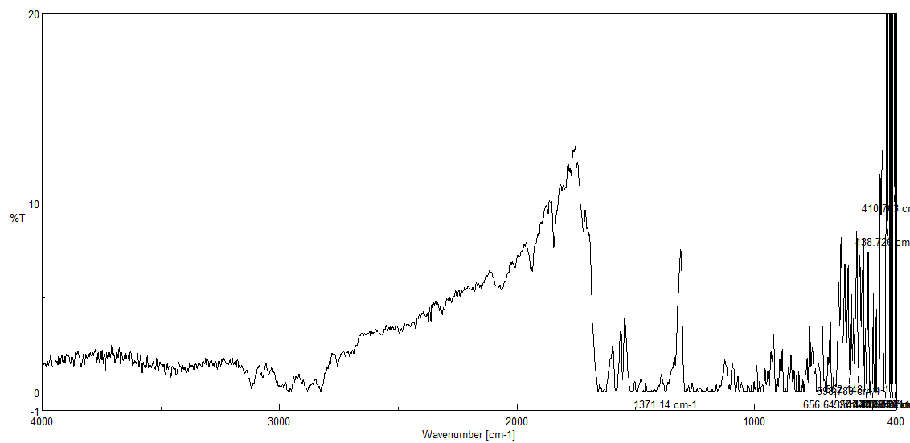
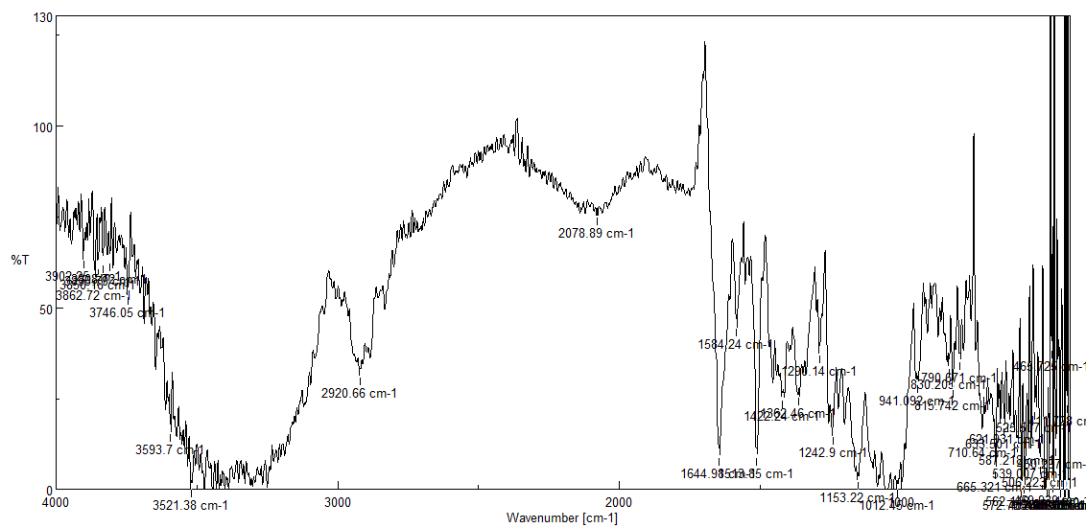
C
B
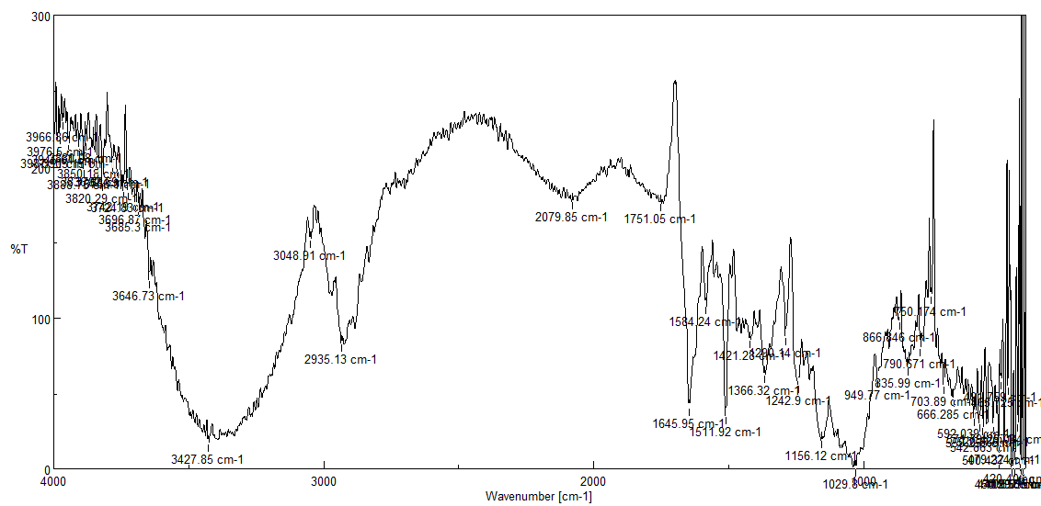
Fig 2 FTIR spectra of A) pure ketoconazole, B) inclusion complex of ketoconazole with beta cyclodextrin, C) inclusion complex of ketoconazole with hydroxyl propyl beta cyclodextrin
4.3 DSC analysis
The thermal behavior of the components shows thermal event characteristics such as the water loss, melting endotherm and the decomposition. The DSC curve of pure drug shows the sharp endothermic peak at 150.32°C corresponding the melting of the drug. The thermogram of KET-BCD complex (ratios as per tablet formulations in Table 2) shows a significantly decreased and broadened endothermic melting peak of drug along with an exothermic signal may be due to the decomposition of the sample. Appearance of a new endothermic peak at 151°C and 148°C signifies the inclusion of the drug into the BCD cavity.

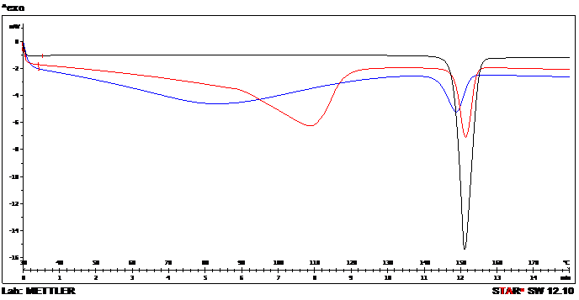
Fig 3 DSC thermogram of pure KTZ (black line), inclusion complex of KTZ with BCD (red line) and inclusion complex of KTZ with HPCD Complex,blue line-KHPCD complex
4.4 XRD analysis
Ketoconazole showed characteristic sharp intence peaks at 17.529, 19.326, 19.719 at 2 θ angle while their inclusion complex with beta cyclodextrin showed broaden peaks at 12.425, 17.417, 19.944 etc at 2 θ angle whereas its inclusion complex with hydroxyl propyl beta cyclodextrin showed characteristics peak at 17.585, 20.000 and 23.706 etc at 2 θ angle representing the stability of the compounds under various condition and their phase transitions.

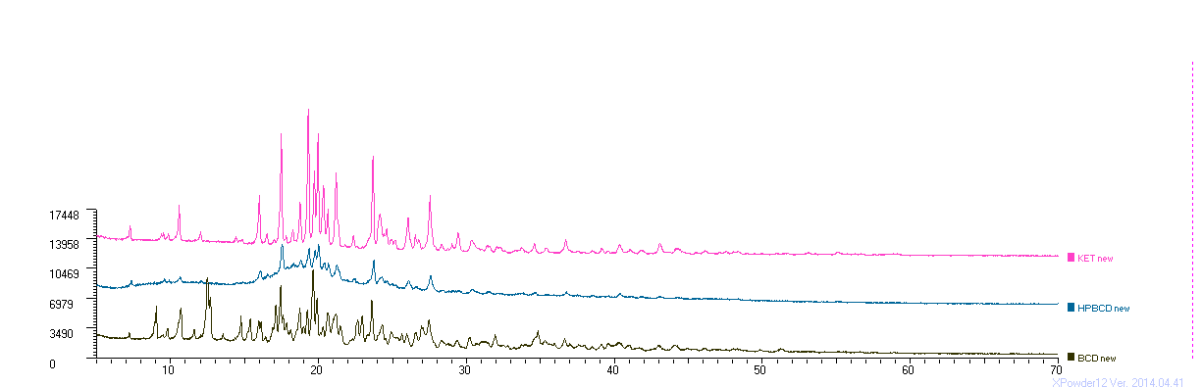
Fig 4 PXRD patterns of A) pure KTZ B) inclusion complex of KTZ with BCD, C) inclusion complex of KTZ with HPCD

Addition of β-CD to the matrix increased the flux by increasing the solubility of ketoconazole, thus improving the diffusible form of the drug species at the tablet membrane interface. Though the complex did not penetrate the membrane, the drug in the complex was in rapid dynamic equilibrium with the free drug, thus continuously supplying the drug molecules to the membrane surface in a diffusible form. β-CD/ HP β-CD act as penetration enhancers, Which increase the erosion rate of the tablet and an improved dissolution of the drug inside the polymeric matrix.
Conclusion
BCD and HPCD have been used for preparation of inclusion complex of poorly soluble ketoconazole. Bilayer buccal tablet was successfully prepared using inclusion complex as swellable drug layer and ethyl cellulose as non-swellable backing layer. Ethyl cellulose backing layer was used to protect the drug permeation through buccal mucosa uni-directionally. HPMC was used as muco-adhesive polymer for the formulation of bucco-adhesive tablet. In vitro drug release and ex-vivo permeation study confirmed the improved release of KTZ from the tablet formulation with cyclodextrin complex. Further, in vivo studies are warranted to establish the experimental formulation at clinical settings.

Acknowledgements

References

.

