Vitamin deficiency: Ocular manifestation
  - Arup Saha

Introduction:
Vitamin is very necessary for our body for normal growth, nutrition, immunity power, metabolism, muscular body growth, strength of bony structure, nerve function such as sensory stimulations, receptor function, motor function etc which are very essential for our day to day activity. We normally can get vitamins by having healthy foods which are enriched with vitamins but normally we need very small amount of this and in case of excessively increased amount in the body here can be chance for toxicity also. There are various types of vitamins and absence of any components may cause severe diseases and malfunctions in normal growth, metabolism and nerve malfunctions etc. In some case it works as bio-catalyst which helps in metabolismactivity by acting as co-enzyme. In case of very high temperature, during cooking with heat, excessive presence of sun rays and in high basic environment quality and efficacy of vitamin can be decreased. We can get vitamins from green and yellow vegetables, fruits, small fishes but vitamin d can be processed in our skin by presence of sun beam.
Vitamins is also very necessary for our Ocular health also as ocular system is connected with central nervous system (brain and spinal cord) as it enriched with many nerves, photoreceptors cells,ganglion cells nerve fiber layer functions, lots of motor and sensory functions as well as reflex arc etc. So, in case of deficiencies lots of ocular malfunction may occur.
Classifications:
Vitamin can be classified into
(1) Water soluble
(Vitamin B complex which can be further classified as Thiamine known as B1, Riboflavin known as B2, pantothenic acid known as B3, Niacin or nicotinic acid known as B5, pyridoxine known as B6 as well as folic acid, cyanocobalamin known as B12, biotin known as vitamin H etc).
And vitamin c (ascorbic acid)

(2) Fat soluble
Vitamin A (Retinol), Vitamin D (cholecalciferol), vitamin E (Tocopherol) and vitamin K (Phylloquinone and Napthoquinone)
Importance of vitamin
The names and functions of fat-soluble vitamins are:
(Fat soluble)
Vitamin A: very necessary for night vision and overall vision formation
VitaminD: very necessary for calcium and mineral absorption for bony structure to keep it strong.
Vitamin E: Keep well maintenance for hormonal balance, sterility, antioxidants andas well as reduce cell degeneration
VitaminK: Necessary for connective tissue function especially coagulant factors and control hemorrhage.
(Water soluble)
Vitamin B1: Helps in metabolism and prevent edema and dropsy
Vitamin B2: Also essential for metabolism and prevent skin diseases like stomatitis, glossitis etc)
Vitamin B3: plays vital role in metabolic activity.
VitaminB5: metabolism activity specially act on fatty acid conjugation
VitaminB6: Essential for carbohydrate metabolism prevent hair falls and skin degenerations also
VitaminB7: overall metabolic activity for carbohydrate, protein, fat and helps in general growth
Vitamin B9: Plays vital role in the cellular activity and division.
Vitamin B12: plays vital role in nerve function like sensory and motor functions.
Vitamin C: acts as antioxidants, increase immunity system maintain collagen formation and nerve activities prevent scarvy disease.

Vitamin deficiencies and ocular health:
Vitamins are very necessary for our ocular system as it consist of various types of nervous layer, ganglion and nerve fiber layers and photoreceptors and their functional activity. Vitamin A is very essential for maintain corneal layers and transparency.Beside this vitamin A plays a vital role in corneal dryness treatment also. Lack of vitamin A caused dryness to cornea and also increased the chance of corneal ulcer formation. Vitamin A lowers the chance of inflammation tendency in superior corneal junction with bulbar conjunctiva and palpebral conjunctiva (SLK,also linked with thyroid disfunction ).
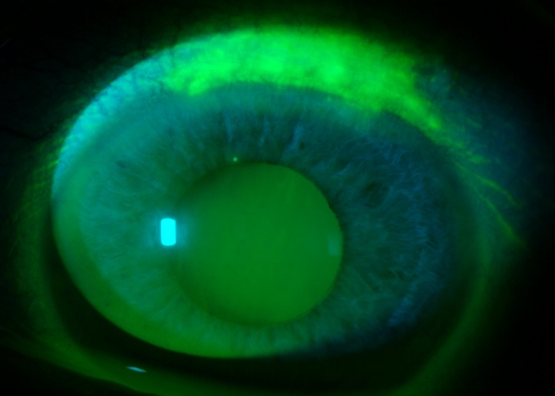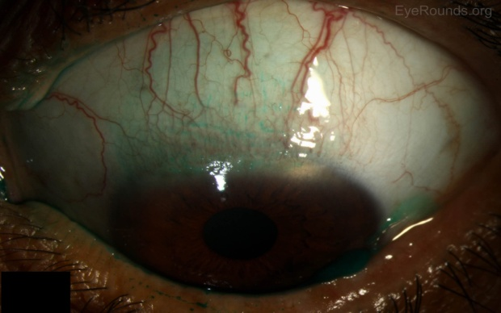
Vitamin B2(riboflavin)also may reduce corneal vascular formation and also helps to lower the chance of angular and blepharoconjunctivitis .
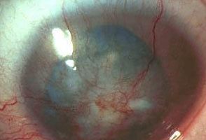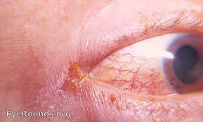
Neovascularization Angular and blepharon-conjunctivitis

Vitamins are also antioxidant so that it may control degeneration of cellular structure and improve surface quality. As it can delay aging so vitamin A, E,C with zinc and copper is essential to delay aging and age-related macular degeneration.
Another study from Harvard Medical School found that daily intake of at least 15000IU of vitamin A with 15mg of Lutein may lower the chance of Retinitis pigmentosa.
Beside this Colombia University also done a research that adequate vitamin A can slow the process of Stargardt’s disease in which the light sensing receptors and nerves inside the retina starts degeneration which may cause visual field defect.
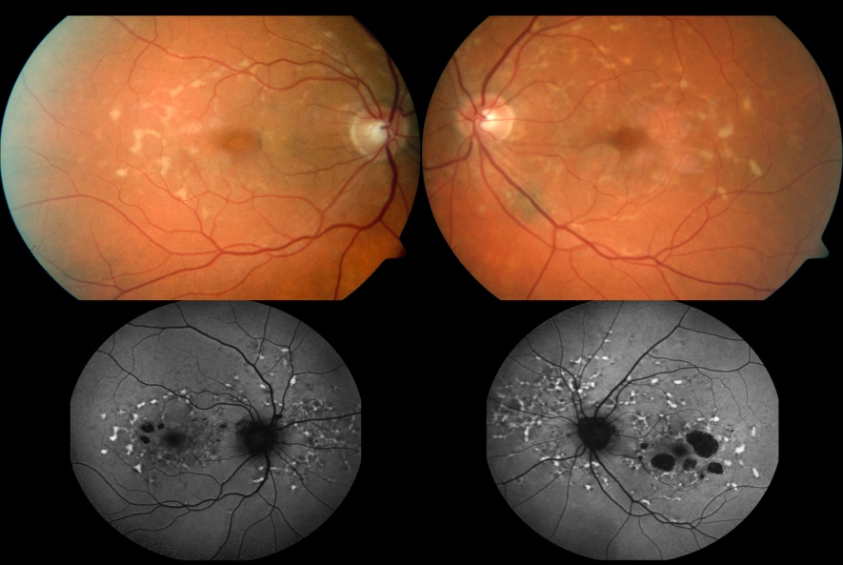
Stargardt’s disease and retinal changes
Vitamin A (retinol) helps rhodopsin cycle inside the retinal rod cell layers. Rhodopsin is a type of pigment very sensitive to light which acts most in dim light vision. It absorbed light and convert it to sensitive impulse and forwarded to brain. In case of vitamin A deficiency rhodopsin cycle hampered most so patient face problem in night vision formation as well as night blindness.
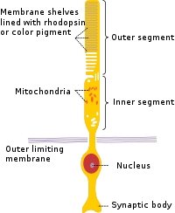
Rod cell and rhodopsin pigment

Vitamin B12 is also very necessary as its deficiency may cause lack of RBC formation and ultimately leads to anemia, dizziness, breathlessness etc. Vitamin b 12 lack may lead optic neuropathy which may cause optic nerve damage and color vision problems also. So patient face problem by central scotoma.
Vitamin c is powerful antioxidant can delay cataract formation and also can lower chance of ARMD and also slower the aging.
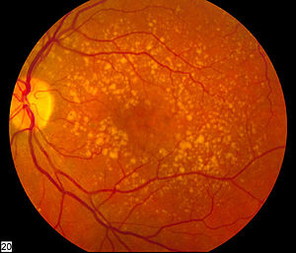
ARMD and drusen
Vitamin D increased corneal barrier function and boost immunity system so that eye infection, inflammation, dry eye symptoms, uveitis chance can be lower. Vitamin D plays a vital role in lacrimation and salivary system.
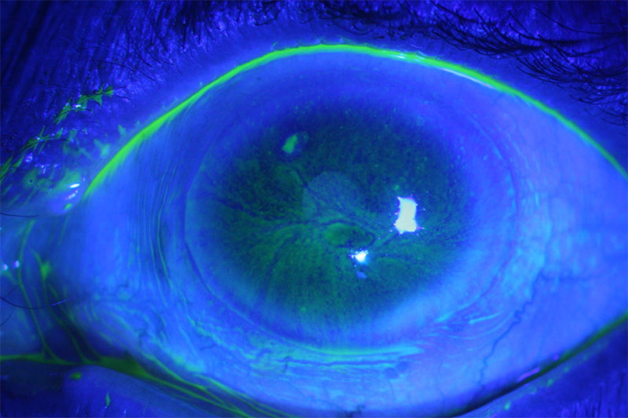
Dry eye investigation

Vitamin E also acts as immune booster and lower the chance of photoreceptor cells degeneration.
References
- https://www.ncbi.nlm.nih.gov/pmc/articles/PMC7508114/
- https://www.medicalnewstoday.com/articles/321800#symptoms-of-deficiency
- https://www.medicalnewstoday.com/articles/326758
- https://www.mayoclinic.org/diseases-conditions/vitamin-deficiency-anemia/symptoms-causes/syc-20355025
- https://www.rxlist.com/vitamins/drug-class.htm
- https://www.healthline.com/nutrition/vitamin-deficiency
- https://en.m.wikipedia.org/wiki/Vitamin

