Classical Encryption Techniques-
Classical encryption techniques refer to historical encryption methods that were widely used before the advent of modern cryptographic algorithms. While classical encryption techniques may not provide the same level of security as modern encryption, they can still be used for basic encryption purposes in certain scenarios. Here are a few classical encryption techniques that users can employ for operating system security:
- Caesar Cipher: The Caesar cipher is one of the simplest and most well-known classical encryption techniques. It involves shifting each letter in the plaintext by a fixed number of positions in the alphabet. For example, with a shift of 3, the letter 'A' would be encrypted as 'D,' 'B' as 'E,' and so on. The recipient would need to know the shift value to decrypt the message. 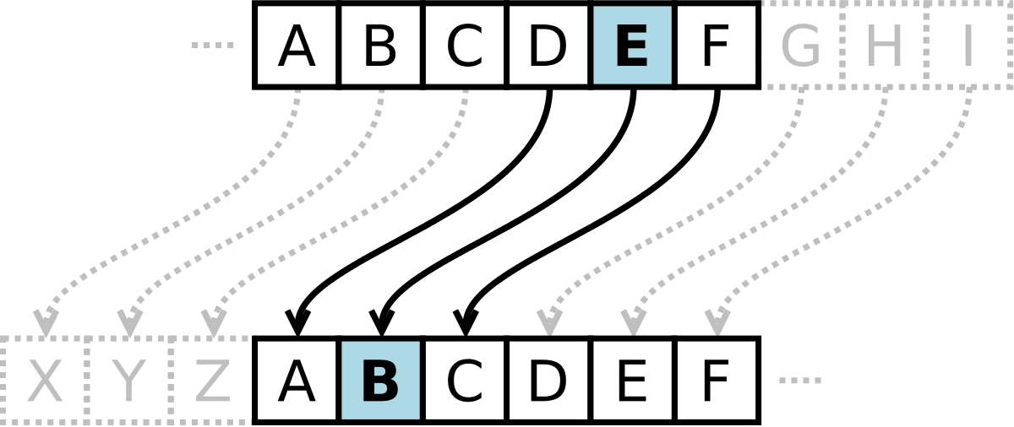
- Vigenère Cipher: The Vigenère cipher is a polyalphabetic substitution cipher that extends the Caesar cipher's concept. It uses a keyword or a phrase to determine different shift values for each letter in the plaintext. The keyword is repeated to match the length of the plaintext, and each character of the keyword corresponds to a specific shift value. The Vigenère cipher provides stronger encryption than the Caesar cipher but can still be vulnerable to certain attacks. 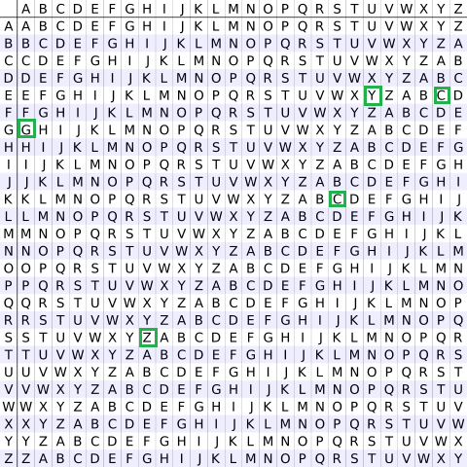
- Playfair Cipher: The Playfair cipher is a digraph substitution cipher that operates on pairs of letters instead of individual letters. It uses a 5x5 matrix containing a keyword to determine the letter substitutions. The plaintext is divided into pairs of letters, and specific rules are applied to determine the ciphered pairs. The Playfair cipher offers more security than simple substitution ciphers but is still susceptible to certain attacks. 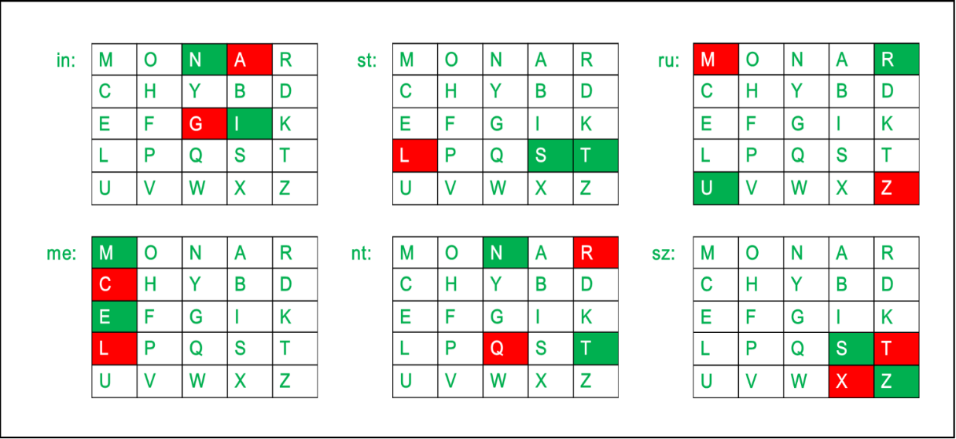
- Transposition Cipher: Transposition ciphers do not change the individual letters but rearrange them within the ciphertext. One example is the Rail Fence cipher, where the plaintext is written in a zigzag pattern along a set number of rails, and the ciphertext is read off row by row. Other transposition techniques, such as Columnar Transposition, involve rearranging the letters based on specific patterns or keys.
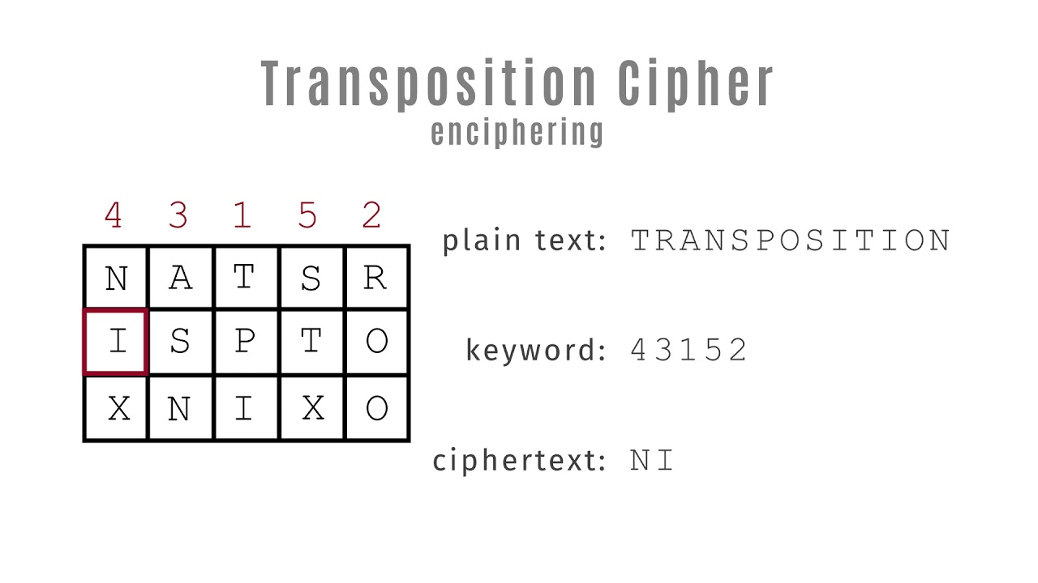
It's important to note that classical encryption techniques are generally considered to be weak by modern cryptographic standards and can be easily broken using various analytical methods. For robust operating system security, it is recommended to use modern encryption algorithms like AES (Advanced Encryption Standard) or asymmetric encryption algorithms like RSA. These modern encryption techniques offer significantly stronger security and are widely supported in operating systems and cryptographic libraries.

