Data Loss Prevention-
Data Loss Prevention (DLP) refers to a set of practices, policies, and technologies designed to prevent the unauthorized disclosure, leakage, or loss of sensitive data. DLP aims to protect sensitive information and intellectual property by identifying, monitoring, and controlling data in various states, including in transit, at rest, and in use. Here are some key aspects of Data Loss Prevention:
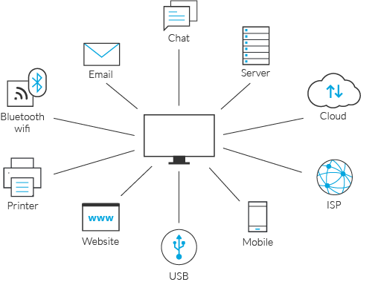
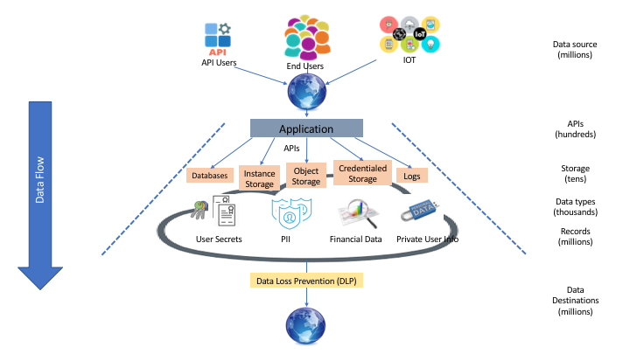
- Data Classification: Data classification involves categorizing data based on its sensitivity and importance. Organizations define classification schemes to label data as public, internal, confidential, or highly sensitive, for example. This classification helps determine the appropriate level of protection and controls required for each category.
- Data Discovery and Inventory: Conducting data discovery and maintaining an accurate inventory of sensitive data is crucial. Organizations utilize DLP tools to scan and identify sensitive data across various storage systems, databases, file shares, and endpoints. This helps to understand the data landscape and identify areas that require protection.
- Policy Development: Develop data protection policies and guidelines to define how sensitive data should be handled, shared, and protected. Policies may include guidelines on data access controls, encryption requirements, acceptable use of data, and data sharing with external parties. Policies should align with regulatory requirements and organizational objectives.
- Endpoint Protection: Implement DLP solutions on endpoints (e.g., laptops, desktops, mobile devices) to monitor and control data handling activities. This can include features such as content-aware scanning, blocking or encrypting data transfers, monitoring of USB ports, and preventing unauthorized software installations.
- Network Data Monitoring: DLP solutions can be deployed at the network level to monitor data flows and identify potential data leakage or unauthorized access attempts. This includes monitoring network traffic, scanning email attachments, and analyzing data in motion to detect policy violations or sensitive data being transmitted outside the organization.
- Data Encryption: Utilize encryption techniques to protect sensitive data both at rest and in transit. Encryption ensures that even if data is lost or stolen, it remains unreadable without the appropriate decryption keys. Encrypting sensitive data stored on devices, databases, and during transmission adds an extra layer of protection.
- User Awareness and Training: Educate employees about the importance of data protection and the role they play in preventing data loss. Conduct regular training sessions on data handling best practices, policies, and potential risks associated with mishandling sensitive information. Awareness programs promote a security-conscious culture within the organization.
- Incident Response and Monitoring: Implement mechanisms to detect, investigate, and respond to data loss incidents. This includes real-time monitoring of security events and alerts, establishing incident response plans, and conducting post-incident analysis to identify the root causes and implement corrective actions.
- Data Backup and Recovery: Implement robust backup and recovery procedures to ensure the availability and restore ability of data in the event of accidental deletion, system failures, or data breaches. Regularly test data restoration processes to verify their effectiveness.
- Regulatory Compliance: Ensure compliance with relevant data protection regulations, industry standards, and contractual obligations. This includes complying with data privacy laws (e.g., GDPR, CCPA), industry-specific compliance requirements (e.g., PCI DSS for payment card data), and adhering to data protection frameworks and guidelines.
Data Loss Prevention is an ongoing process that requires a combination of technology, policies, user awareness, and incident response capabilities. By implementing DLP practices, organizations can significantly reduce the risk of sensitive data loss, maintain regulatory compliance, and protect their reputation and intellectual property.
Content filtering, also known as web filtering, is the process of controlling and monitoring the content that can be accessed or transmitted over a network. It involves the use of filtering mechanisms and policies to restrict or allow access to specific types of content, websites, or online resources. Content filtering is commonly employed in organizations, educational institutions, and home networks to enforce acceptable use policies, enhance security, and protect users from accessing inappropriate or harmful content. Here are some key aspects of content filtering:
Content Filtering-
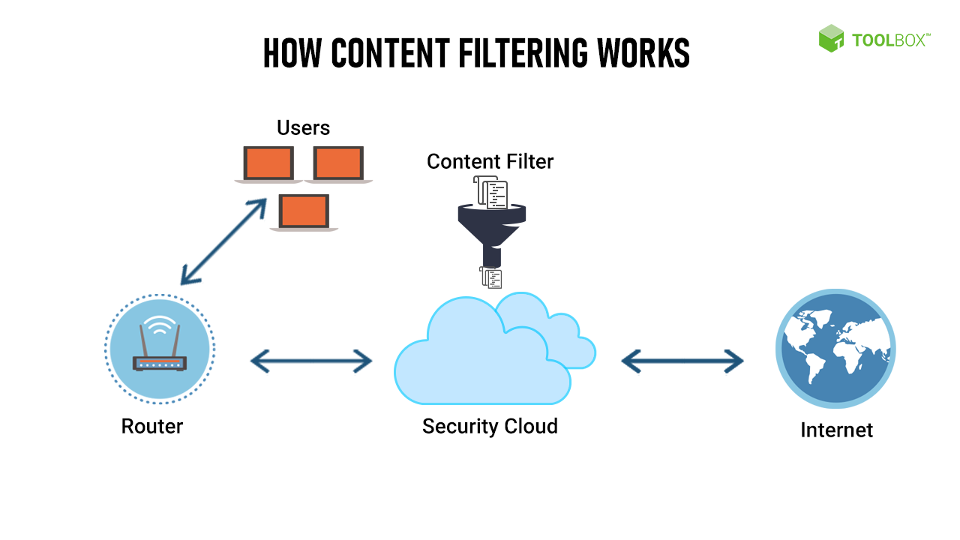
- URL Filtering: URL filtering involves blocking or allowing access to websites based on their URLs or domain names. It uses a database of categorized URLs to determine whether a website falls into a specific category (e.g., social media, gambling, adult content) and applies the appropriate filtering policy.
- Keyword Filtering: Keyword filtering scans web content, including webpage text, URLs, and metadata, for specific keywords or phrases. It can be used to block or allow access to content that contains certain keywords deemed inappropriate or sensitive. Keyword filtering is often used to filter out explicit or offensive language.
- Category-based Filtering: Category-based filtering involves classifying websites or content into predefined categories, such as social media, streaming media, news, gambling, adult content, or gaming. Administrators can define policies to block or allow access to entire categories based on organizational or individual requirements.
- Content Type Filtering: Content type filtering focuses on controlling access to specific types of media or file types, such as images, videos, audio files, executable files, or documents. It enables organizations to block or restrict the downloading or uploading of certain file types based on security considerations or policy enforcement.
- Malware and Phishing Protection: Content filtering can include mechanisms to detect and block websites or content associated with malware, viruses, or phishing attempts. This helps protect users from accessing malicious websites or inadvertently downloading harmful files.
- Time-based Filtering: Time-based filtering allows administrators to apply content filtering policies based on specific timeframes. For example, certain categories or types of content may be allowed during work hours but blocked during non-working hours. This helps enforce acceptable use policies and manage access privileges.
- User-based Filtering: User-based filtering allows customization of content filtering policies for individual users or groups. Different users or user groups can have different access permissions and restrictions based on their roles, responsibilities, or organizational requirements. User-based filtering provides granular control over content access.
- SSL/TLS Inspection: To enhance security, content filtering may include the ability to inspect encrypted traffic (SSL/TLS) by decrypting and analyzing the content. This allows for the detection and filtering of encrypted content based on predefined policies or the identification of malicious activities within encrypted communications.
- Reporting and Logging: Content filtering solutions often provide reporting and logging capabilities to track and record user activities, blocked content, policy violations, and security incidents. These logs can be used for auditing, compliance, and forensic analysis purposes.
- Whitelisting and Blacklisting: Whitelisting and blacklisting involve the manual creation of lists of allowed (whitelisting) or blocked (blacklisting) websites, URLs, or content. Administrators can add specific websites or content to these lists to ensure they are always allowed or blocked, regardless of other filtering policies.
Content filtering can be implemented using dedicated hardware appliances, software applications, or cloud-based solutions. It is important to regularly update filtering databases, review and refine filtering policies, and educate users about the purpose and limitations of content filtering to ensure its effectiveness and user acceptance.
Device Control-
Device control, also known as endpoint device control, refers to the implementation of policies and measures to manage and control the use of external devices, such as USB drives, smartphones, and portable storage devices, within an organization's network or computing environment. Device control aims to enhance data security, prevent data leakage, and minimize the risk of malware infections by controlling the types of devices that can connect to and interact with the organization's systems. Here are key aspects of device control:
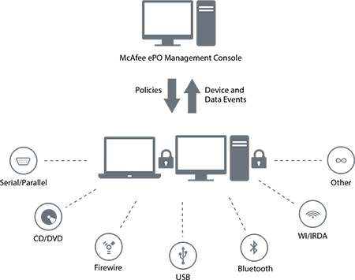
- Device Whitelisting and Blacklisting: Device control solutions allow administrators to define lists of approved (whitelisted) or blocked (blacklisted) devices based on device types, vendor IDs, or specific device identifiers. Whitelisting ensures that only authorized devices can connect to the network, while blacklisting prohibits the use of specific devices known to pose security risks.
- Access Control: Device control enables administrators to enforce access controls for external devices. This includes defining rules and policies to restrict or allow read/write access to specific devices or device classes. For example, an organization may allow read-only access for USB drives while prohibiting write access to prevent data theft or the introduction of malicious software.
- Data Encryption: Device control solutions often include the ability to enforce data encryption on external devices. Administrators can require that all data written to or read from a device be automatically encrypted, adding an additional layer of protection for sensitive data stored on portable storage devices.
- Device Authentication: Device control mechanisms may require authentication or identification of connected devices before granting access. This can involve device-specific authentication mechanisms, such as digital certificates or hardware tokens, to ensure that only trusted devices are allowed to connect to the network.
- Monitoring and Auditing: Device control solutions provide monitoring and auditing capabilities to track device usage and detect any unauthorized or suspicious activities. Administrators can monitor device connections, file transfers, and device usage patterns to identify potential security breaches or policy violations.
- Policy Enforcement: Device control policies can be enforced at the endpoint level through client software or via centralized management systems. These policies are typically defined and configured by administrators and pushed out to endpoints, ensuring consistent control and enforcement across the organization's devices.
- Offline Device Control: Device control mechanisms can also apply offline restrictions, meaning that devices are subject to control and policy enforcement even when not connected to the network. This helps prevent data leakage or unauthorized usage when devices are used in offline environments.
- Reporting and Alerts: Device control solutions often provide reporting and alerting capabilities to notify administrators of policy violations, suspicious activities, or attempts to connect unauthorized devices. These reports and alerts assist in incident response, policy refinement, and security monitoring.
- Remote Device Management: Some device control solutions offer remote management capabilities, allowing administrators to remotely configure and manage device control policies, update software, or perform remote actions on connected devices. This simplifies administration and provides greater control over device usage.
- Integration with Security Ecosystem: Device control solutions can integrate with other security solutions, such as data loss prevention (DLP), endpoint protection, and network access control systems. Integration enhances the overall security posture by combining multiple security measures and ensuring cohesive protection across the network.
Implementing device control practices helps organizations maintain control over the use of external devices, protect sensitive data, and mitigate the risks associated with unauthorized device usage. By defining and enforcing device control policies, organizations can reduce the likelihood of data breaches, enhance regulatory compliance, and safeguard their information assets.
Network DLP-
Network Data Loss Prevention (DLP) is a set of technologies and practices aimed at preventing the unauthorized disclosure, leakage, or loss of sensitive data as it traverses a network. Network DLP focuses on monitoring and controlling data in transit to ensure its confidentiality, integrity, and availability. Here are some key aspects of Network DLP:
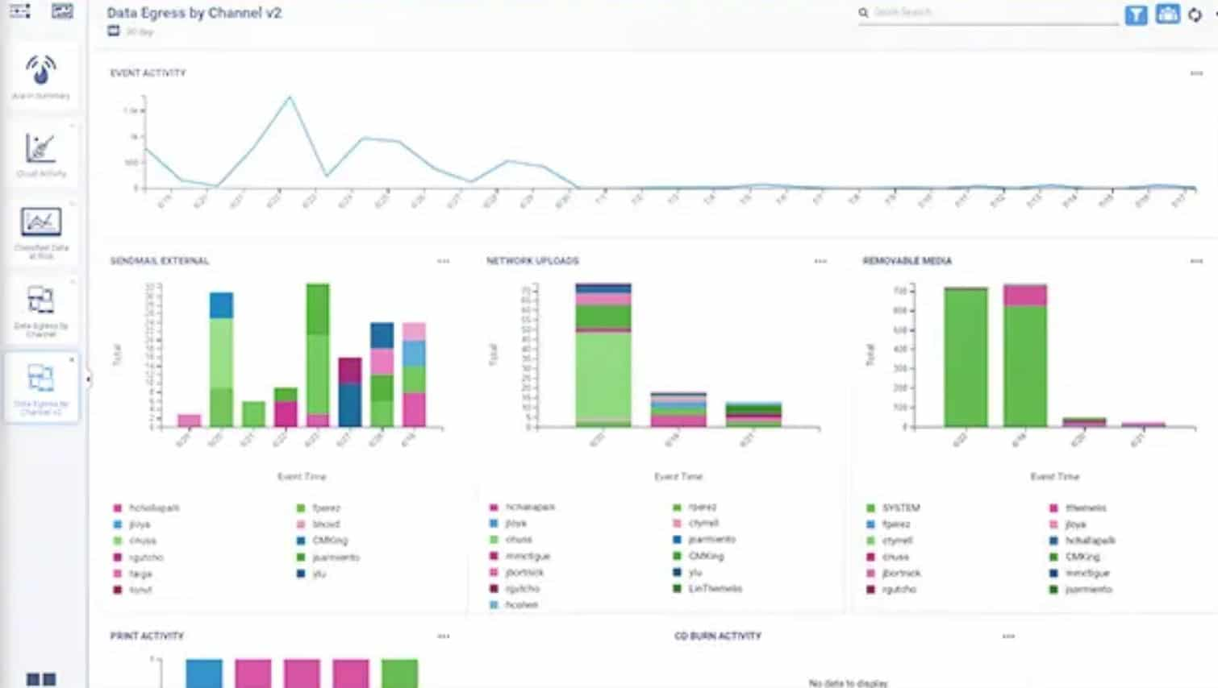
- Data Monitoring and Inspection: Network DLP solutions monitor network traffic in real-time to analyze and inspect data packets for sensitive content. This includes examining email communications, web traffic, file transfers, instant messaging, and other network protocols. By inspecting data packets, DLP systems can identify and classify sensitive information.
- Content Filtering and Policy Enforcement: Network DLP applies content filtering and policy enforcement measures to control the flow of data across the network. Policies are defined based on predefined rules, such as specific keywords, data patterns, file types, or regulatory compliance requirements. Content filtering ensures that sensitive information is not transmitted or accessed inappropriately.
- Data Classification and Categorization: Network DLP solutions utilize data classification and categorization techniques to identify and classify sensitive data. Classification labels are assigned to data based on its sensitivity level, enabling more accurate detection and handling of sensitive information. This helps organizations better understand their data landscape and apply appropriate security controls.
- Data Encryption and Data Loss Prevention: Network DLP can integrate with encryption technologies to protect data in transit. Encryption mechanisms, such as Secure Sockets Layer/Transport Layer Security (SSL/TLS), are employed to encrypt sensitive data as it moves across the network. This ensures that even if intercepted, the data remains secure and unreadable.
- Data Leakage Detection: Network DLP solutions include mechanisms to detect and prevent data leakage attempts. They monitor for unauthorized transfers of sensitive information outside the organization's network, such as through email attachments, file uploads, or cloud storage services. Data leakage detection helps organizations identify potential security breaches or policy violations.
- Incident Detection and Response: Network DLP systems enable the detection of security incidents or policy violations in real-time. When a potential data breach or policy violation is detected, alerts are generated to notify administrators or security teams. Rapid incident detection allows for timely response and mitigation of potential risks.
- Compliance and Regulatory Support: Network DLP solutions help organizations meet regulatory compliance requirements, such as those outlined in data protection laws (e.g., GDPR, HIPAA) or industry-specific regulations. These solutions assist in enforcing compliance by monitoring data flows, applying data protection policies, and providing audit trails and reports for compliance audits.
- Integration with Security Infrastructure: Network DLP solutions can integrate with other security technologies and infrastructure, such as firewalls, intrusion detection/prevention systems (IDS/IPS), or security information and event management (SIEM) systems. Integration enables correlation of DLP events with other security events and provides a holistic view of the network security posture.
- Policy Customization and Flexibility: Network DLP solutions offer customization options to tailor policies and rules based on an organization's specific requirements. Administrators can define policies to align with their data protection needs, industry standards, and regulatory requirements. This flexibility allows organizations to adapt to evolving security threats and changes in their data landscape.
- User Awareness and Training: User education and awareness play a crucial role in the success of Network DLP. Organizations should provide training to employees on data handling best practices, data protection policies, and the potential risks associated with data leakage. Promoting a culture of data security and user accountability is essential for effective Network DLP implementation.
Network DLP solutions are essential for protecting sensitive data as it moves across networks, preventing data breaches, and ensuring compliance with regulatory requirements. By implementing Network DLP practices, organizations can maintain control over data in transit, reduce the risk of data loss, and safeguard their valuable information assets.
Host DLP-
Host Data Loss Prevention (DLP) refers to the implementation of data protection measures and policies directly on individual endpoints or host systems. Host DLP focuses on preventing the unauthorized disclosure, leakage, or loss of sensitive data at the source, residing on the endpoint devices themselves. Here are some key aspects of Host DLP:
- Data Discovery and Classification: Host DLP solutions scan and analyze data stored on endpoint devices to discover and classify sensitive information. This involves identifying sensitive files, documents, or data based on predefined criteria such as file types, keywords, or data patterns. Classification labels are assigned to the data to enable better control and protection.
- Data Leakage Prevention: Host DLP systems employ mechanisms to prevent data leakage from endpoint devices. They monitor and control the movement of sensitive data within the host environment, including email attachments, file transfers, printing, copying to external storage devices, and cloud synchronization. Policies and rules are enforced to prevent unauthorized data transfers.
- Endpoint Encryption: Host DLP solutions often include encryption capabilities to protect sensitive data stored on endpoint devices. Encryption can be applied to individual files, folders, or entire drives, ensuring that data remains encrypted at rest. This provides an additional layer of protection, especially in the event of a device loss or theft.
- Content Filtering and Policy Enforcement: Host DLP solutions can apply content filtering and policy enforcement measures directly on the endpoint. This involves analyzing the content of files, emails, and other data on the host system to identify sensitive information or policy violations. Policies are enforced to control access, usage, and transmission of sensitive data.
- User Activity Monitoring: Host DLP systems monitor user activities on the endpoint devices to detect and prevent policy violations or suspicious behavior. They capture user actions such as file access, modification, printing, or data transfers. User activity monitoring helps identify potential data breaches, policy violations, or insider threats.
- Endpoint Device Control: Host DLP includes mechanisms for controlling and managing the use of external devices connected to the endpoint, such as USB drives, smartphones, or external hard drives. This allows administrators to define rules and policies to restrict or allow access to specific devices, control data transfers, and prevent unauthorized device usage.
- Data Quarantine and Removable Media Control: Host DLP solutions can automatically quarantine or restrict access to files or data that are identified as sensitive or policy-violating. They can prevent the copying or transfer of sensitive data to removable media devices, ensuring that sensitive information remains within the authorized boundaries.
- Endpoint Security Integration: Host DLP solutions can integrate with other endpoint security technologies, such as antivirus, endpoint protection, or data loss prevention solutions. Integration enables coordination and correlation of security events, providing a more comprehensive approach to protecting endpoint devices and data.
- Incident Detection and Response: Host DLP solutions include capabilities to detect and respond to security incidents in real-time. When a potential data breach or policy violation is detected, alerts are generated, and appropriate actions are taken, such as notifying administrators or triggering automated response measures. Rapid incident response helps mitigate risks and minimize potential damage.
- Policy Customization and Flexibility: Host DLP solutions offer customization options to tailor policies and rules based on an organization's specific requirements. Administrators can define policies that align with their data protection needs, industry standards, and regulatory compliance. This flexibility allows organizations to adapt the DLP measures to their unique environment.
Implementing Host DLP practices helps organizations maintain control over sensitive data at the endpoint level, prevent data breaches, and ensure compliance with data protection regulations. By safeguarding data on individual devices, organizations can reduce the risk of data loss, enhance security, and protect their valuable information assets.

