Database Security-
Database security refers to the protection of databases and their contents from unauthorized access, misuse, modification, or disclosure. It involves implementing security measures and best practices to ensure the confidentiality, integrity, and availability of the data stored within databases. Here are some key aspects of database security:
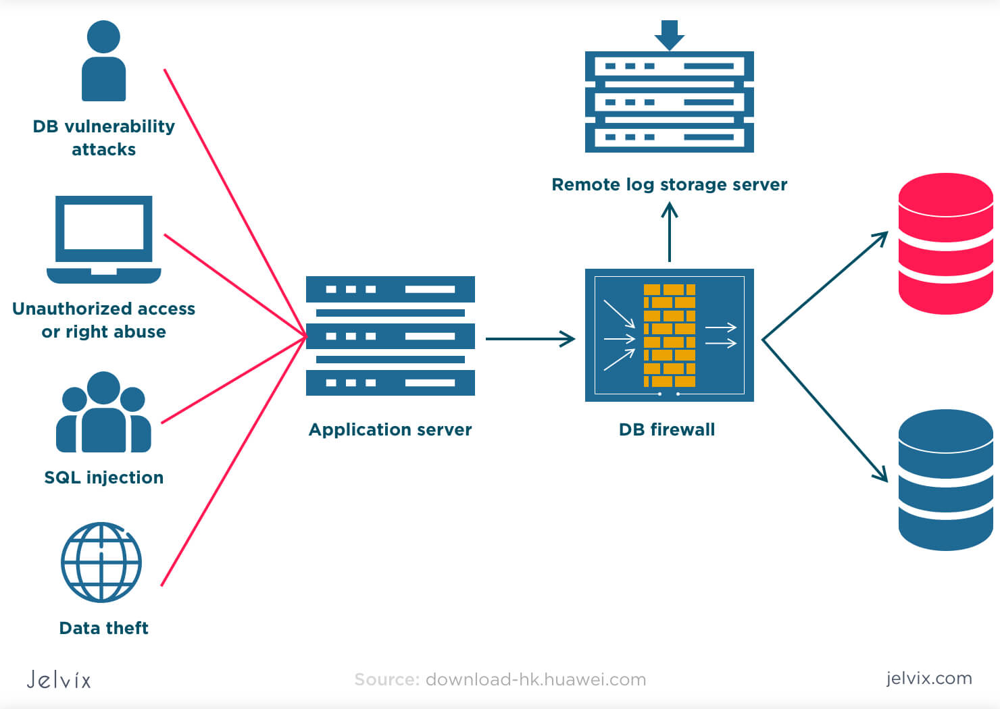
- Access Control: Implement robust access control mechanisms to restrict unauthorized access to the database. This includes user authentication, authorization, and privilege management. Use strong passwords, enforce password policies, and implement role-based access control (RBAC) to ensure that users have appropriate permissions based on their roles and responsibilities.
- Encryption: Employ encryption techniques to protect sensitive data at rest and in transit. Use encryption algorithms to encrypt the database files, backups, and network connections. Implement secure key management practices to safeguard encryption keys and ensure their integrity.
- Auditing and Monitoring: Implement auditing and monitoring mechanisms to track and log activities within the database. This includes monitoring user activities, data modifications, access attempts, and system events. Regularly review and analyze audit logs to detect any suspicious activities or policy violations.
- Data Backup and Recovery: Establish regular backup procedures to ensure the availability and recoverability of data in the event of data loss, system failures, or security incidents. Store backups securely and test the restoration process periodically to ensure its effectiveness.
- Patch Management: Keep the database management system (DBMS) up to date with the latest security patches and updates. Regularly monitor vendor announcements and security advisories for any vulnerabilities or patches related to the DBMS being used. Apply patches promptly to address known security vulnerabilities.
- Secure Configuration: Follow secure configuration guidelines provided by the DBMS vendor to ensure the database is configured securely. This includes disabling or removing unnecessary features and services, enabling necessary security features, and configuring access controls appropriately.
- Database Activity Monitoring (DAM): Deploy database activity monitoring tools to detect and prevent unauthorized access, suspicious activities, and insider threats. DAM tools provide real-time monitoring and alerting capabilities for database events and anomalies.
- Data Masking and Anonymization: Implement data masking and anonymization techniques to protect sensitive or personally identifiable information (PII) in non-production environments. This ensures that sensitive data is not exposed to unauthorized individuals during testing, development, or data analysis processes.
- Physical Security: Ensure physical security measures are in place to protect the servers, storage devices, and other infrastructure components hosting the database. This includes securing server rooms, controlling access to physical hardware, and protecting against environmental threats such as fire, water damage, and power outages.
- Regular Security Assessments: Conduct regular security assessments and vulnerability scans to identify potential weaknesses and vulnerabilities in the database environment. Perform penetration testing to validate the effectiveness of security controls and identify any gaps that need to be addressed.
Database security requires a comprehensive and layered approach to mitigate risks and protect the confidentiality, integrity, and availability of the data. It is important to establish clear security policies, train database administrators and users on security best practices, and regularly review and update security measures to address emerging threats and vulnerabilities.
Overview of Database -
A database is a structured collection of data that is organized, stored, and managed to efficiently retrieve and manipulate information. It serves as a centralized repository for storing and managing large volumes of structured or unstructured data, making it easier to access, query, analyze, and update information. Databases are widely used in various applications and industries to handle data in a structured and organized manner. Here's an overview of databases:
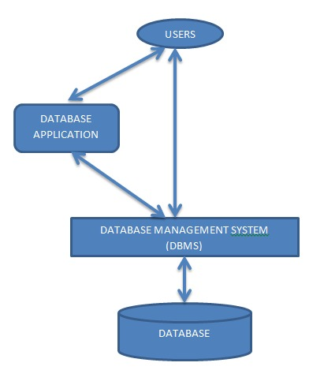
- Data Structure: Databases organize data in a structured format using tables, rows, and columns. The table represents a collection of related data entities, where each row represents a specific instance or record, and each column represents a data attribute or field. This structure allows for efficient storage and retrieval of data.
- Database Management System (DBMS): A Database Management System is software that facilitates the creation, organization, manipulation, and administration of databases. It provides a set of tools and interfaces to interact with the database, manage access, enforce data integrity, and perform data operations.
- Data Models: Databases follow different data models to represent the relationships between entities and attributes. Common data models include the relational model, hierarchical model, network model, and object-oriented model. The relational model, based on tables and relationships, is the most widely used model.
- Relational Databases: Relational databases are the most prevalent type of databases. They organize data into tables, with each table representing a specific entity and relationships established through keys. Relational databases use Structured Query Language (SQL) for querying and managing data.
- Database Design: Database design involves creating a logical and efficient structure for organizing data. This includes identifying entities and their attributes, defining relationships, and normalizing the data to reduce redundancy and ensure data integrity. Well-designed databases optimize data storage, retrieval, and performance.
- Database Operations: Databases support a wide range of operations, including data insertion, retrieval, modification, and deletion. Users can query the database to retrieve specific data using SQL or other query languages. Advanced operations include joining tables, aggregating data, sorting, filtering, and creating views.
- Data Integrity and Constraints: Databases enforce data integrity rules and constraints to maintain the accuracy and consistency of data. These include primary key constraints, unique constraints, foreign key constraints, and data validation rules to ensure that data meets specified criteria.
- Data Security and Access Control: Databases incorporate security measures to protect data from unauthorized access, manipulation, or disclosure. Access control mechanisms, authentication, and authorization ensure that only authorized users can access and modify data. Encryption techniques can be applied to secure sensitive data.
- Scalability and Performance: Databases are designed to handle large volumes of data and support concurrent user access. They provide mechanisms for optimizing performance, such as indexing, query optimization, caching, and partitioning, to ensure efficient data retrieval and processing.
- Database Types: There are various types of databases catering to specific needs. These include operational databases for transactional processing, analytical databases for data analysis and reporting, distributed databases for geographically distributed environments, and NoSQL databases for handling unstructured or semi-structured data.
Databases are essential for managing and organizing data efficiently, providing reliable data storage, retrieval, and manipulation capabilities. They serve as a foundation for various applications, including enterprise systems, websites, e-commerce platforms, healthcare systems, and more. Effective database design and management are crucial for ensuring data integrity, security, and optimal performance.
Database Application security model –
A database application security model refers to the set of practices, techniques, and security measures implemented to protect the confidentiality, integrity, and availability of data within a database application. It encompasses various aspects of security, including access control, authentication, authorization, data encryption, and auditing. Here are some key components of a database application security model:
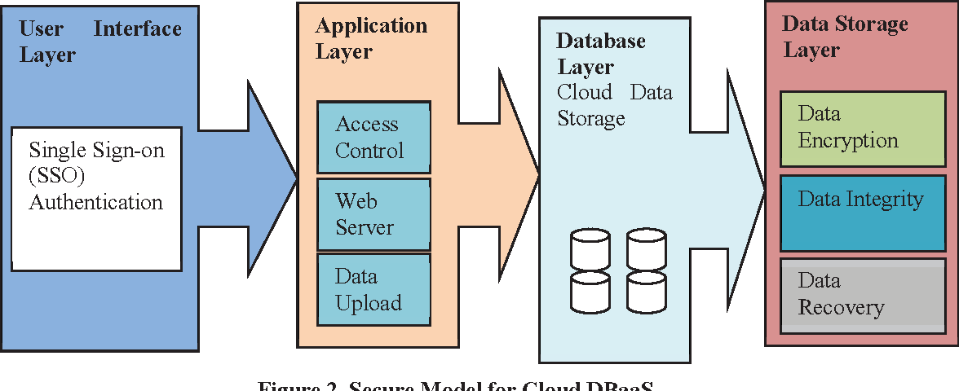
- Access Control: Access control mechanisms are implemented to restrict unauthorized access to the database application. This includes user authentication, ensuring that only authenticated users can access the application and its data. Strong password policies, multi-factor authentication, and secure login mechanisms are commonly employed.
- Role-Based Access Control (RBAC): RBAC is a widely used access control model that assigns permissions and privileges to users based on their roles within the organization. Users are granted appropriate access rights to perform their assigned tasks, minimizing the risk of unauthorized access or data breaches.
- Data Encryption: Encryption techniques are used to protect sensitive data stored within the database. Encryption can be applied to the data at rest (stored data) and data in transit (data being transmitted over a network). Strong encryption algorithms and secure key management practices should be implemented to ensure the confidentiality of the data.
- Parameterized Queries: The use of parameterized queries or prepared statements is encouraged to prevent SQL injection attacks. Parameterized queries separate SQL statements from user-supplied input, preventing malicious SQL code from being injected into queries.
- Secure Coding Practices: Database application developers should follow secure coding practices to mitigate common vulnerabilities. This includes input validation, output encoding, proper error handling, and protection against common attacks such as cross-site scripting (XSS) and cross-site request forgery (CSRF).
- Least Privilege Principle: The principle of least privilege should be followed, ensuring that users are only granted the minimum level of privileges necessary to perform their tasks. This reduces the potential impact of a compromised user account and limits unauthorized access to sensitive data.
- Audit Trail and Logging: Database applications should implement logging and auditing mechanisms to record user activities and detect any suspicious or unauthorized behavior. Audit logs should capture important events such as logins, data modifications, and access attempts, providing an audit trail for forensic analysis and compliance requirements.
- Regular Security Assessments: Regular security assessments, including vulnerability scanning and penetration testing, should be conducted to identify and address potential vulnerabilities in the database application. These assessments help to identify weaknesses, ensure compliance with security standards, and improve overall security posture.
- Patch Management: Keeping the database software and associated applications up to date with the latest security patches is essential. Regularly applying patches and updates helps address known vulnerabilities and reduce the risk of exploitation.
- User Training and Awareness: Training users on security best practices and raising awareness about common security threats is crucial. Educating users about secure password practices, recognizing phishing attempts, and following data handling procedures can significantly enhance the security of the database application.
Implementing a comprehensive security model for a database application requires a combination of technical measures, secure coding practices, user awareness, and ongoing monitoring. It is important to stay updated with the latest security practices, regularly review and update security measures, and adhere to industry standards and compliance requirements to protect the database application and its sensitive data.

